© 2014
Goryk A.V., Doctor of Technical Science
Kovalchuk S.B., Ph. D. in Technical Science
Yakhin S.V. Ph. D. in Technical Science
Poltava State Agrarian Academy
ANALYTICAL AND EXPERIMENTAL DETERMINATION OF CARRYING CAPACITY OF THE OF THE CARCASS ELEMENTS OF STADIUM “VORSKLA” NAMED AFTER ALEXEY BUTOVSKY (POLTAVA)
MESSAGE 2. NAVIGATION TESTS
Reviewer – Doctor of Technical Science, Professor A.A. Smerdov
The following report shows results of the following (second) stage of the complex research of operational reliability of construction tribune stadium (East tribune). This stage includes real-life operational tests of the direct natural rigidity of inclined crossbars of cross-section frames and follows after the determination of technical condition. According to a technical condition of the covering of the tribunes, inclined crossbars have appeared as defining model elements of the framework, from the point of view of reliable operation. This was shown from the natural experimental data tests that have laid down in a basis of modeling of working capacity of tribune construction of the stadium, which are also provided in this massage.
Keywords: tribune construction, crossbar, static tests, direct control method, deflection, rigidity.

Problem statement. According to the research results, that are shown in the message 1 [1], the technical condition of a tribune construction of the stadium “Vorskla” in Poltava demands complex research of work reliability of its' bearing constructions. Such research should include three main steps. Firstly, determination of the technical conditions of the construction according to the order of the State committee of construction, architecture and housing policy of Ukraine and Gosnadzorokhrantrud of Ukraine № 32/288 from 11/27/1997; Secondly, natural tests of elements of the framework with the smallest resource in accordance with GOST 8829-94 established from the results of the first stage, and third stage is identification of operational resource of the basic bearing constructive elements of construction which is based on the new model of deformation. The results of the first stage research are shown in the message 1 [1]. Results of the second stage are shown in this work (the message 2) and reported at the International conference [2]. The main findings of research (the third stage) are going to be published in the final message 3.
Analysis of the last research and publications. Periodical inspections of the stadium East tribunes' constructions technical condition had been carried out, since 1988. These inspections had local type and were organised specifically for some events. Materials from the last researches are presented in reports [3, 4] where a number of drawbacks of the various stadium bearing elements are recorded and their elimination actions are offered. However, complex researches of technical conditions, with a deep examination of all the construction bearing ability had not been performed.
The research purpose and goals. The second phase of a comprehensive study is experimental confirmation of either presence or absence of bearing structures safety reserve of the stadium tribune constructions. To achieve this goal, it was required to provide the organization and implementation of full-scale tests of the most vulnerable, according to the technical condition study [1], structural frame elements of stadium tribune construction, as well as a deep analysis of obtained experimental data by comparing them with the calculations results.
For achievement of this purpose it was required organization and conduction of natural tests of the most vulnerable, by results of research of a technical condition [1], constructive elements of frames by a tribune of a construction of stadium, and also the careful analysis of the received experimental data on the basis of their comparison with results of calculations.
The research methods and materials. The subject of research is composite ferro-concrete elements of spatial frame structures of the tribune. Results of the study were based on surveys of field and laboratory tests, as well as archival and analytical calculations. Used equipment and instruments for field, cameralistic works and laboratory tests have been certified in accordance with the metrological requirements. During work completion the requirements of the "normative documents on surveys, certification, safe and reliable operation of industrial buildings and structures" were followed.
The results of the study. In the first stage of research [1] the most vulnerable structural elements frame the stands (see Fig. 1), due to the design parameters have been inclined beams transverse frames of the East Stand (see Fig. 2). Crossbars frames consist of two elements: the first major console (P1), with a nominal span of 12.0m and 3.2m console, and the second (P2) with a nominal span of 6.0m. Tilt angle to the horizontal crossbars is about 25º.
The calculations separate console element pins P1 as simply supported beam in the case of actions the most unfavorable load combinations, taking into account the defects identified in the first phase of the study show almost deplete its bearing capacity [3]. This became the basis for setting the gain of the system, which over time has been improved further tensioning system, the study [4] conducted to evaluate the technical condition of the East Stand before the official matches of the Football League. Left open the question of granting a permit to operate the tribune due to lack of theoretical safety margin inclined crossbars. There was a problem identifying the bearing capacity of the reserve on the basis of experimental and theoretical study of the actual stiffness of beams, which determined the composition of the second phase of research – field tests. Additionally during the first stage of the study were limited deformation installed factors are capable of increasing the rigidity, and consequently the strength of elements. These factors are also needed to confirm their effectiveness, which can be installed only by a full-scale static test.

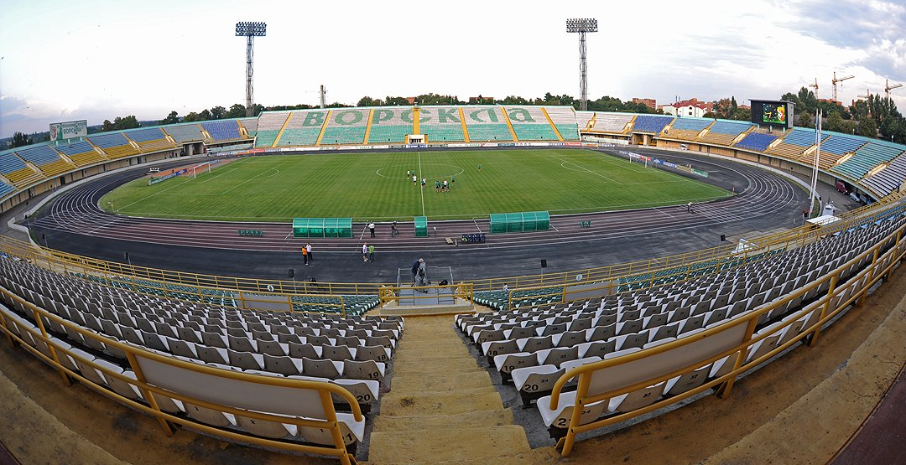
Figure 1. General view of tribune buildings

Figure 2. The design of cross frames

Evaluation of the strength static test in this case is an indirect method, since the bolt cannot be brought to destruction, and the highest value of the static load during the test shall be equal to the operational (i.e. without removing it from the structure). Therefore, a study was conducted to their rigidity (direct method of control) test load rating which control the amount of deflection.
Test pilot part-time during the ordinary games showed the ability to carry a payload of crossbars. It was therefore decided to conduct a full investigation of the stiffness during football matches in Super Cup of Ukraine between "Dynamo" (Kiev) and "Shakhtar" (Donetsk). Status bouts provide complete filling the stands with spectators.
Firstly, the three pins, the most vulnerable of the survey (1 message). The obtained results of the field test data showed an unexpected significant crossbars their stiffness, as measured by increase in deflection payload was much less acceptable for this type of regulatory structures. Thus arose the problem of theoretical basis of the results and determination of the causes of increased rigidity, load-bearing structures and re-baseline test.
In the baseline test investigated two pins, one of which – to compare the results be retested. Thus, it was investigated 4 of 22 crossbars of the East Stand.
Main and control test was carried out according to the scheme shown in Fig. 3 Key elements of the crossbars (P1) in the middle spans were fixed thin steel wires, which are then connected with the measuring instruments – deflectometer type PM-1 (see Fig. 4) with a scale of 0.01mm. Deflectometer on a rigid fixed points were located on the floor of the room under the stands, allowing free access to the observations. Besides conducted instrumental measurement rainfall supports bolt to determine whether its accounting.
Figure 3. Testing scheme | 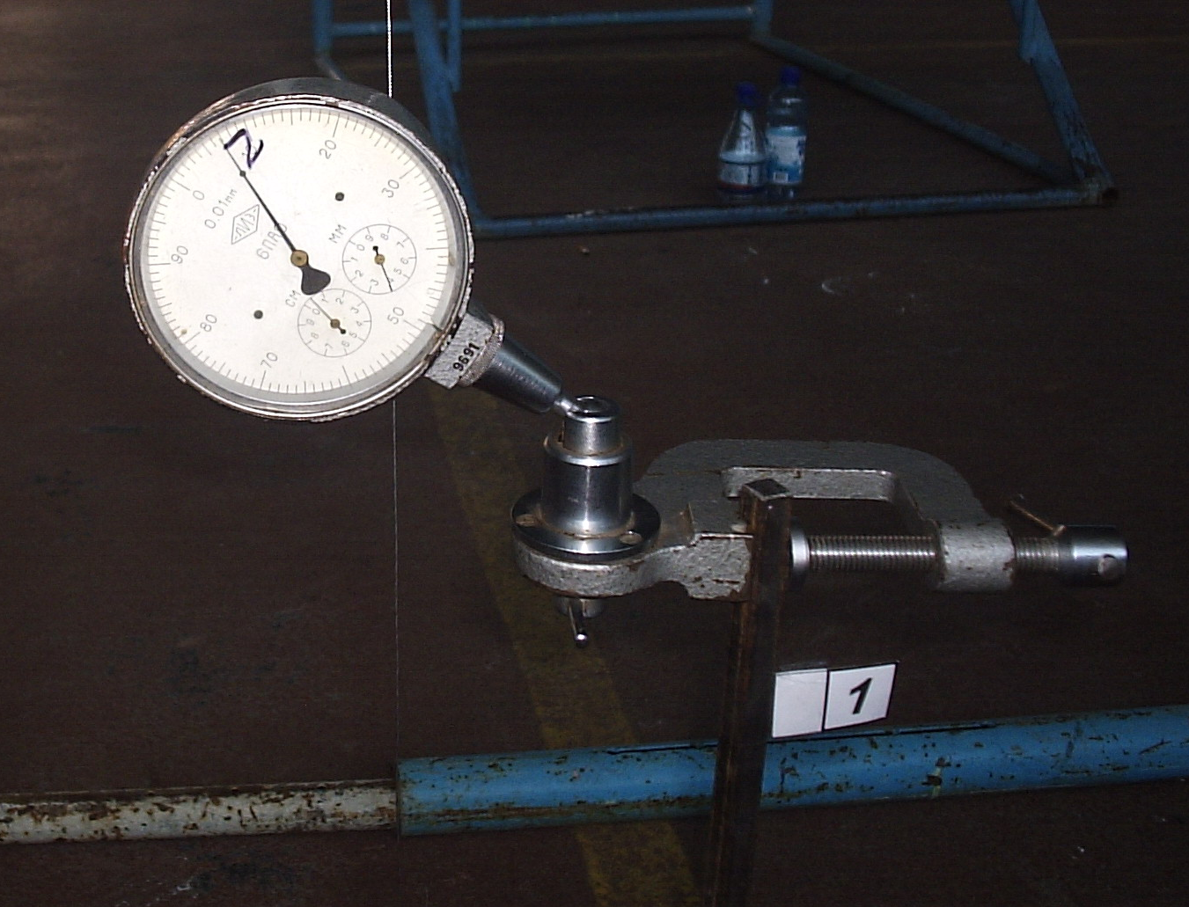  Figure 4. Installed the measuring appliance
In the process of filling the grandstand spectators crossbars frames loaded gradually to reach 100% of filling seats. Temporary payload from the audience to completely fill the stands was more than 30% of the design load.
When tested in accordance with [5] in the operational status of measures have been taken to meet the requirements of security. Strictly controlled by the normative number of spectators in accordance with gaps. Movement of foreign sector was limited, which allowed us to obtain more reliable results. Unauthorized access to the test area was banned. Was imposed to limit the filling seats on the results of field measurements in the case of the boundary values of deflections. Course of filling of seats and the actual number of viewers was monitored by observers who were directly on the platform. Data entry synchronized with measurement data of deflections and time to take readings of the installed measuring devices. Note that during the first and second tests the audience filling the stands was 100%.
The study began with the appearance of the first audience, and was discontinued on the day after the match, which allowed to check the absence of residual deformation structures. The research results are shown graphically in Fig. 5.
Figure 5. The development of deflections at researched crossbars

Graphs of deflections in time have the expected form, with clear areas corresponding to the stage of filling the stands, spectators stay on the podium during the game and the release of the stands from the audience. On a plot of the loading process of filling the tribune slightly ahead the development of deflections. During the match, the deflections crossbars were stable, except for some minor fluctuations during the break and at the beginning of discharge, which is caused by the movement of spectators. In contrast to the filling area, stands on the site of liberation, in the final part, unloading deformation ahead. However, over time the residual deflections completely disappeared, which was recorded deflectometer the next day after the match. This indicates the absence of permanent deformations supporting structure for a given level of loading and the work of their elastic material at least in the achieved range of payloads.
From the obtained results of the study it became clear that the crossbars work in more difficult conditions than the design scheme was modeled as a single cantilever beam on two supports hinge pins P1 element. In this model, the calculated values of the deflection, which correspond to the real time load from the audience, were much more experienced with the elastic work of reinforced concrete composite.
Output. On the basis of the direct method of control – static field tests of rigidity of the most vulnerable elements (inclined crossbars) reinforced concrete frame predictably enough reserves to their rigidity, does not coincide with the results of analytical calculations in the classic idealized model. This is a contradiction, on the one hand, possible to establish a satisfactory technical condition of the entire structure (category II), on the other hand, required a search for non-classical models of the spatial crossbars to establish the reliability of operation of the facility, which will be presented in the report 3.
BIBLIOGRAPHY
- Горик О.В. Аналітично-експерементальне встановлення ресурсу несучої здатності елементів каркасу стадіону «Ворскла» ім. Олексія Бутовського (м. Полтава). Повідомлення 1. Визначення технічного стану / О.В. Горик, С.Б. Ковальчук, С.В. Яхін [та ін.] // Вісник Полтавської державної аграрної академії. Наук.-виробн. фаховий журнал. – Полтава: ПДАА. – 2012. – №1(64). – С. 172–177.
- Горик О.В. Натурні дослідження жорсткості ригелів трибун стадіону «Ворскла» в м. Полтава / О.В. Горик, С.Б. Ковальчук, С.В. Яхін // Будівельні конструкції. – Вип. 78: у 2-х кн.: Книга 1. К.: ДП НДІБК, 2013. – С. 266–272.
- Звіти про обстеження будівельних конструкцій Східної трибуни стадіону «Ворскла» (№ 2114/01-31), (№ 2114/01-31), (№ 2423/05), (2696/07) // Полтавський національний технічний університет імені Юрія Кондратюка. (2003, 2004, 2005, 2007рр.).
- Звіт про технічний стан залізобетонних конструкцій Східної трибуни стадіону «Ворскла» у м. Полтава // Багатогалузевий наук.-техн. центр «Віра». – Полтава. – 2008. – 136с.
- Конструкції будинків i споруд. Вироби будівельні бетонні та залізобетонні збірні. Методи випробувань навантажуванням. Правила оцінки міцності, жорсткості та тріщиностійкості: ДСТУ Б В.2.6-7-95 (ГОСТ 8829-94). – [Чинний вiд 1996-01-01] – К.: Держкоммiстобудування України, 1997. – 23с.

