© 2014
Tsvilikhovskiy M. I., doctor of biological sciences
Golopura S. I., candidate of veterinary sciences
National University of Life and Environmental Sciences of Ukraine
CORRECTION OF CONTENT OF TOTAL PROTEIN AND UREA IN SERUM OF BLOOD OF NEWBORN CALVES DURING THE FORMATION PERIOD OF COLOSTRAL IMMUNITY
Іn this article the results of application of experimental liposomal macrocapsular preparation based on soyabean lecithin for correction of indexes of content of general protein and urea in the serum of blood of newborn calves in the formation period of colostral immunity are provided. It is shown that use of the drug per os newborn calves for 15-20 minutes before feeding them colostrum provides the predominance of catabolic anabolic processes, prevention of occurrence digestive disorders and improves detoxification mechanisms in these animals.
Statement of the problem. In the body of newborn animals after initiation of their process of gas exchange mechanisms of thermoregulation, detoxification, digestion and regulation of acid-base and electrolyte balances provided by general metabolic rearrangement in tissues are gradually improved. The particular importance in the adaptation of newborn calves belongs to extrauterine development of colostral immunity [1].
Analysis of the main researches and publications. Colostral immunoglobulins (Ig) are characterized by a high capacity to hemolysis, bacteriolysis, opsonization and they have significant importance in the prevention of colisepsis; the immunoglobulin G have a significant neutralizing effect on toxins and viruses. The concentration of the last in the colostrum of cows is 85–90% of Ig [2 – 5].
The aim of the research was to investigate indexes of total protein and urea in the serum of newborn calves.
To achieve the goal was necessary to solve the following problem: to make their adjustment during the formation period of colostral immunity for these animals by the usage of an experimental liposomal macrocapsular preparation based on soyabean lecithin.
Materials and methods. Research was conducted in the research station “Velykosnitynske named after O. V. Muzychenko” NULES of Ukraine. In the experiments calves in the age of 1 – 11 days were used. It was formed 2 groups of calves (control and experimental) each of 5 animals. Calves in both groups were given to drink the colostrum in an amount of 2 liters after birth, and then 1,5 liters every 4 hours during the 1st day, and every 6 hours – during the second and third days of calves` life. From 4-day age calves were switched on 3-time feeding. Calves from experimental group received per os experimental macrocapsular liposomal preparation based on soyabean lecithin in a dosage of 5 ml in the morning by 15 minutes prior to feeding by colostrum. The drawing a blood samples in calves was performed from a jugular vein in vacuum tubes in 6, 24 and 72 hours on 7th and 11th days of life. Indexes of total protein and urea in serum of calves were determined by standard methods using photometric biochemical analyzer «Lab Line 010». The reagents of Spine Lab firm (USA) were used in conducting of biochemical research.
Results. The low content of total protein in serum of calves before the first giving them colostrum (43,8 ± 1,5 g/L, table 1) is explained by lack in it of the proteins of immunoglobulin fractions because they are not able to cross the cow`s placenta in blood of the fetus [6].
After giving of colostrum the level of total protein in serum of calves of the control group grew and on the third day was 1,13 fold higher (p≤0,05) compared to the beginning of the experiment, and then remained relatively stable. Instead, in calves of the experimental group we have found a significant increasing of this index in 1,3 times (p≤0,001) even in 6 hours after birth and on the third day of life of animals – in 1,47 times (p≤0,001) (see table 1). This can be explained by more intense absorption of colostrum Ig in the native state in the small intestine of newborn calves under the influence of liposomal macrocapsular preparation.
Parallel with the processes of protein biosynthesis the process of their decay is taken place, which is greatly enhanced by the development of pathological phenomena. One of the most important products of protein metabolism is urea nitrogen, which content in the serum of newborn calves before giving of colostrum was 4,13±0,33 mmol/L (see table 1).
Table 1. The indexes of total protein and urea in serum of blood of newborn calves, M±m, n=5
Time after birth the calf | Total protein, g/L |  | Urea, mmol/L
Time after birth the calf | Control group | Experimental group | Control group | Experimental group
Before giving of colostrum | 43,8±1,5 | 43,8±1,5 | 4,13±0,33 | 4,13±0,33
6 hours | 45,3±1,2 | 56,9±1,7*** | 3,9±0,4 | 4,03±0,49
24 hours | 47,7±0,7 | 62,4±2,5*** | 5,73±0,42 | 3,57±0,28**
72 hours | 49,7±0,8 | 64,3±3,4** | 5,27±0,56 | 2,8±0,06**
7 days | 48,9±0,5 | 63,2±1,3*** | 9,83±0,46 | 7,33±0,13***
11 days | 47,5±0,6 | 59,8±1,6*** | 11,67±0,62 | 4,35±0,38***
Notes: p ≤ 0,05*, p ≤ 0,01**, p ≤ 0,001*** compared to the control group

In 24 hours after the birth the content of urea in blood serum of calves of experimental group compared with the control one was lower (Pic. 1) in 1,38 times (p≤0,01), and the maximum difference was 2,7 times (p ≤ 0,001) on the 11th day after the birth of the animals (Pic. 1).
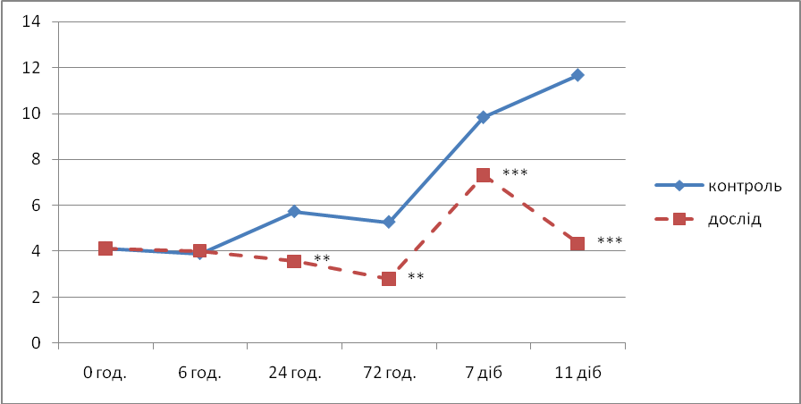
Pic. 1. The content of urea (mmol/L) in the serum of newborn calves, M±m, n=5
One of the possible reasons for lack of assimilation of non-protein nitrogen in the body of the calves in the control group may be a low intensity of the reactions of the tricarboxylic acid cycle, hypoglycemia and high level of ammoniogenesis processes in tissues and occurrence of acidosis [6].
Depending on the content of total protein, urea and their ratio in the serum of calves is an opportunity to assess the nitrogen balance in their body.
So, in 24 hours after birth in calves` blood serum of experimental group compared with the control one it was set higher in 1,31 times (p≤0,001) content of total protein and lower in 1,38 times (p ≤ 0,01) content of urea. The same pattern was also seen in 72 hours, and on the 7th and 11th days after the birth of calves in this group. Specifically, after 72 hours and on the 7th and 11th days after birth in calves` blood serum of experimental group the content of total protein was in 1,29 (p≤0,01), 1,29 (p≤0,001), and 1,25 (p≤0,001) times respectively higher and the content of urea in 1,47 (p≤0,01), 1,25 (p≤0,001) and 1,63 (p≤0,001) times respectively lower than in the calves of the control group. Increasing of the ratio of total protein/urea indicates a predominance of anabolic processes over catabolic ones in the organism of calves. This index for calves of the control group was significantly lower compared with such in the experimental group and in 6 hours was11,6 comparing to 14,1, in 24 hours – 8,32 comparing to 17,5, in 72 hours – 9,43 comparing to 23,0, after 7 days – 5,0 comparing to 8,6 and after 11 days – 4,0 comparing to 13,7 respectively. Thus, the usage of experimental liposomal macrocapsular preparation based on soybean lecithin for newborn calves of experimental group indicates a significant predominance of anabolic processes over catabolic processes in these animals compared with the calves of control group.
It is noted that during the experiment the calves in the control group in the age of the 2nd – 11th days had disorders of digestion, accompanied by diarrhea, dehydration, depression of animals and decreasing of appetite.
The calves of experimental group had insignificant disorders of digestion and symptoms disappeared on the 2nd – 3rd days of their onset.
Because of the physiologically high levels of protein synthesis in the body of the newborn calves the level of urea in their blood serum is lower compared to normal level of adult animals. Increasing of the level of urea in blood serum of calves of the control group could be explained by its increased synthesis due to dissimilation processes caused by suppression of redox processes in the tricarboxylic acid cycle and the development of energy deficiency in tissues. This reduces the intensity of usage of ammonium nitrogen in biosynthetic processes. Another factor influencing the increasing of urea in the blood serum of animals in the control group is a decreasing of filtration in the kidney as a result of violation of hemodynamics. However, increasing of content of urea may have extrarenal character, such as loss of fluids, enhanced protein dissimilation and so on.
Our obtained data indicate a membrane-stabilizing effect of liposomal macrocapsular preparation based on soybean lecithin, which may be caused by the ability of the phospholipids from its structure to support structure of plasmolemma enterocytes, hepatocytes and renal epithelial cells.
Conclusions:
1. Designed liposomal macrocapsular preparation based on soybean lecithin have positive effect on protein metabolism in the body of newborn calves providing the predominance of anabolic processes over catabolic ones.
2. Application of liposomal macrocapsular preparation based on soybean lecithin per os for newborn calves by 15 – 20 minutes before feeding by colostrum prevents the occurrence of digestion disorders and improves detoxification mechanisms of animal`s organism.

BIBLIOGRAPHY
- Любецька Т.В. Особливості метаболічної адаптації телят на ранніх етапах постнатального розвитку та шляхи корекції виявлених порушень: Автореф. дис. ... докторара вет. наук: 03.00.04 / Національний аграрний університет. – Київ, 2000. – 37 с.
2. Маринюк М.О. Рівень колострального імунітету і розвиток розладів травлення у новонароджених телят // М. О. Маринюк, С. І. Голопура, О. М. Якимчук [та ін.] / – Ветеринарна медицина України. – 2014. – № 5 (219). – С. 21–23.
- Мельничук Д.О. Нові дані щодо механізму формування колострального імунітету у новонароджених телят та їх застосування у ветеринарній медицині // Д. О. Мельничук, М. І. Цвіліховський, Т. В. Любецька, [та ін.] / Рекомендації. – К.: Вид. центр НАУ. – 2001. – 12 с.
- Godden S. Colostrum management for dairy calves / S. Godden // Veterinary Clinics of North America: Food Animal Practice. – 2008. – Vol. 24. – P. 19–39.
- Lang B. Colostrum of the dairy calf // B. Lang // Factsheet. – 2008. – № 411/23. – Р. 23–28.
- Quigley J.D. Drewry J.J. Nutrient and immunity transfer from cow to calf pre and past calving // J. Dairy Sci. – 1998. – V. 81. – Р. 2779–2790.
- Sing A.K., Pandita S., Vaidya M.M., Chandra G. Kushwada R. Colostral immunoglobulins and neonatal immunity in bovine // Wayamba Jornal of Animal Science – 2011. – P. 78–84.

