© 2015
Klymenko A. S., Candidate of Veterinary Sciences
Poltava State Agrarian Academy
DISTRIBUTION OF RABBITS’ PARASITOSIS
IN PRIVATE ECONOMIES OF POLTAVA REGION
Reviewer – Candidate of Veterinary Sciences S. A. Kravchenko
The analysis of literary data and own researches testify about considerable distribution of rabbits’ Parasitosis in the economies of different patterns of ownership in the most world countries. Almost general distribution of Psoroptosis, Eimeriosis and Passalurosis are set by laboratory researches of material from the rabbits of private economies of twelve districts in Poltava region. Extensivity of Psoroptes invasion presents 37,68 %, Eimeria – 47,69 %, Passalurus – 21,26 %, although in separate economies the indexes of defeat are 100 %. Obtained data testify the necessity of development and introduction of measures of fight against Parasitosis of rabbits in private economies.
Keywords: rabbits, distributions, Psoroptosis, Eimeriosis, Passalurosis.
Statement of the problem. Rabbit breeding is one of perspective industries of stock-raising, in fact rabbits differ in high intensity of reproduction, that is why in short space it is possible to get the far of dietary meat, cheap fur raw material and to the fuzz.
The feature of the rabbit breeding is mass character of distribution of him among a population, by confirmation what an increase of breeders-amateurs is not only among villagers but also due to the proprietors of garden and suburbanestatein cities. However, the system of diagnostic and medical and preventive measures with parasitic illnesses of rabbits in private economies is absent, and the proprietors of animals use advices of colleagues, and only in extreme cases call to the specialists.
Analysis of major studies and publications which discuss the problem. Parasitic fauna of rabbits is presented by the Protozoa, Helminths and Arthopods in a kind of mono- and polyinvasion. In the rabbit economies the Passalurosis is the most widespread helmintosis: extensivity of invasion hesitates within the limits of 40–90 % for intensities of invasion from a few helminths to one hundred thousand threadworms. The danger of this invasion is in high contagiousness and possibility of unlimited distribution [2, 5, 6].
A dangerous and devastating invasion it remains Eimeriosis of rabbits, when at sharp motion a death rate is 100 %. According to given numerous publications, an active fight from Eimeriosis is conducted in China, Japan, India, Spain and Canary Islands, England, France, Australia, South and North America and in countries of Near East. This protozoan disease is widespread also and in Russia, Belarus, Poland, Czech Republic, Georgia [1, 4, 7].
Strongly enough Psoroptosis restrains development of industry: mass of body of rabbit goes down on 10–35 %, quality of meat and skins gets worse, a young animal grows and develops bad, and a price of tribal animals goes down substantially [3]. Introduction of measures of fight and prophylaxis of invasive illnesses of rabbits is possible after the careful analysis of epizootology of diseases, the important component element of that is a study of distribution of rabbits’ Parasitosis, that became the aim of our researches.
The task of our researches was to examine the rabbits of private economies in Poltava region and define the indexes of extensivity and intensity of invasion.
Materials and methods of researches. Researches conducted in the private economies of Poltava region, where they took away the standards of faeces, scraping from the skin near anal folds and internal surface of ears of rabbits. Laboratory researches conducted the departments of parasitology of Poltava State Agrarian Academy in an educational-scientific laboratory. Faeces were examined by the method of
G. А. Kotelnikov and V. M. Hrenov (1978) with solution of ammonium nitrate. Scraping from the skin moistened with 50 % water solution of glycerin with a further microscopy. Crusts from ears were investigated with a method with 10 % solution of caustic soda.
The results of researches grounded to assert about considerable distribution Parasitosis of rabbitss in the economies of Poltava region. In feces of sick animals we found out the oocytes of Eimeria and eggs of Passalurus (Pic. 1, 2). In the scraping of skins invasive elements registered rarely enough. Crusts from the skin of ears contained the far of mites Psoroptes (Pic. 3).
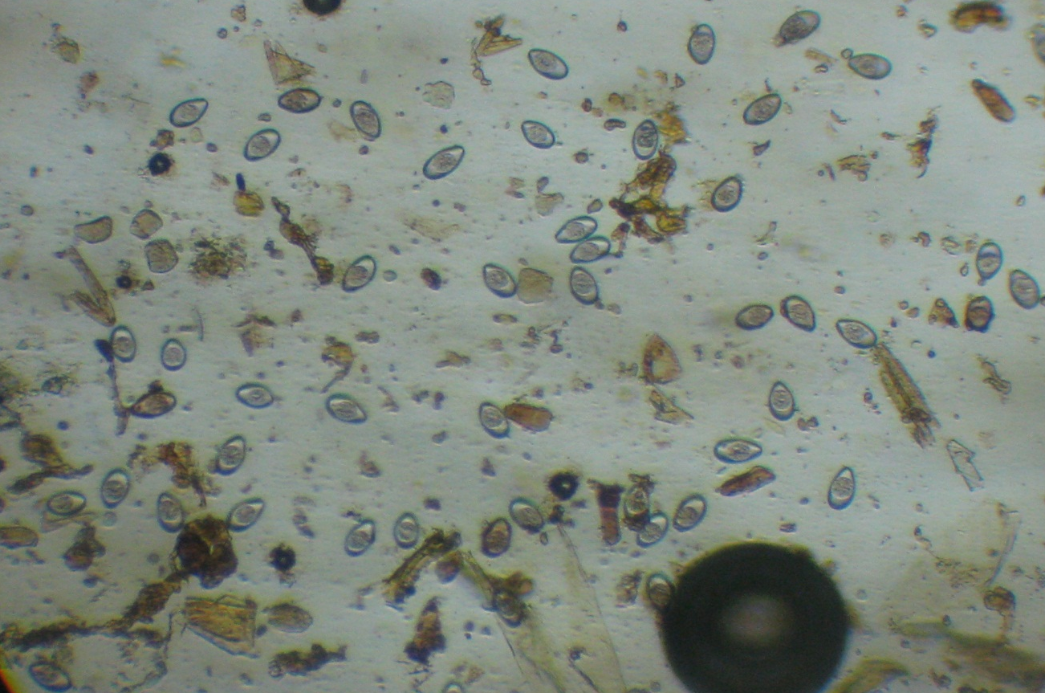

Picture 1. Oocystes of Eimeria (х270)

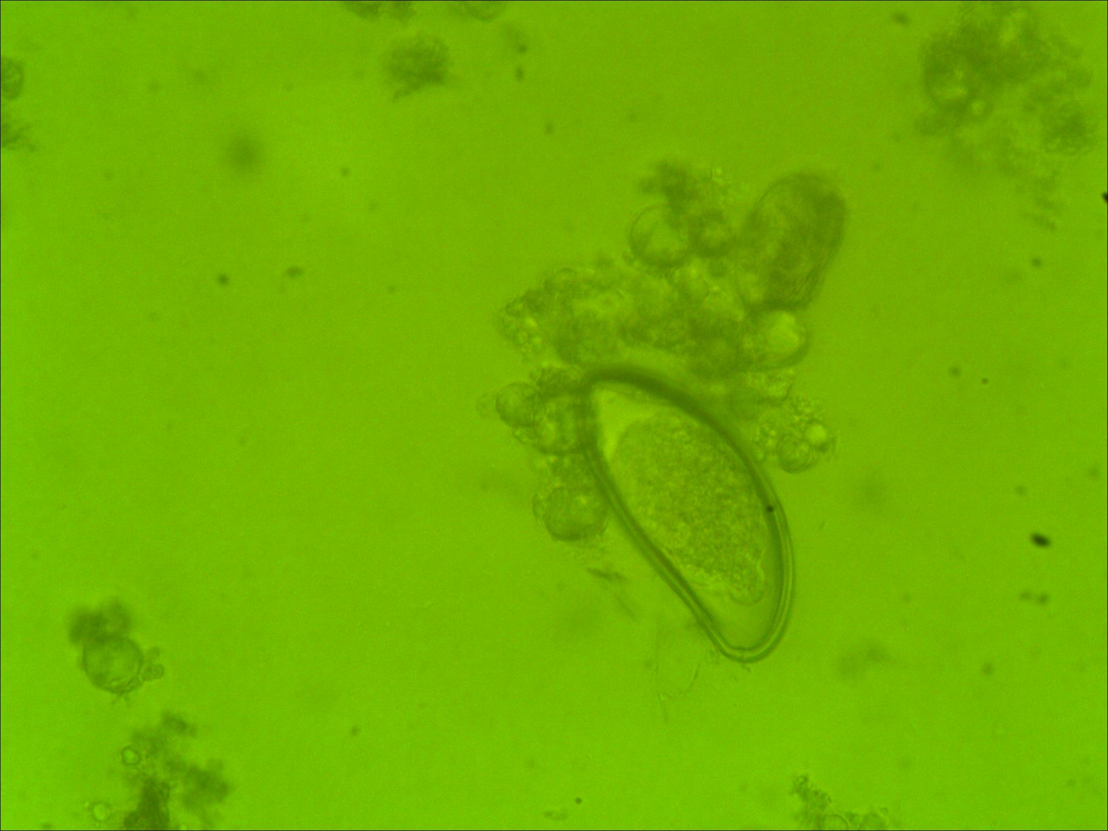

Picture 2. Egg of Passalurus (х 700)

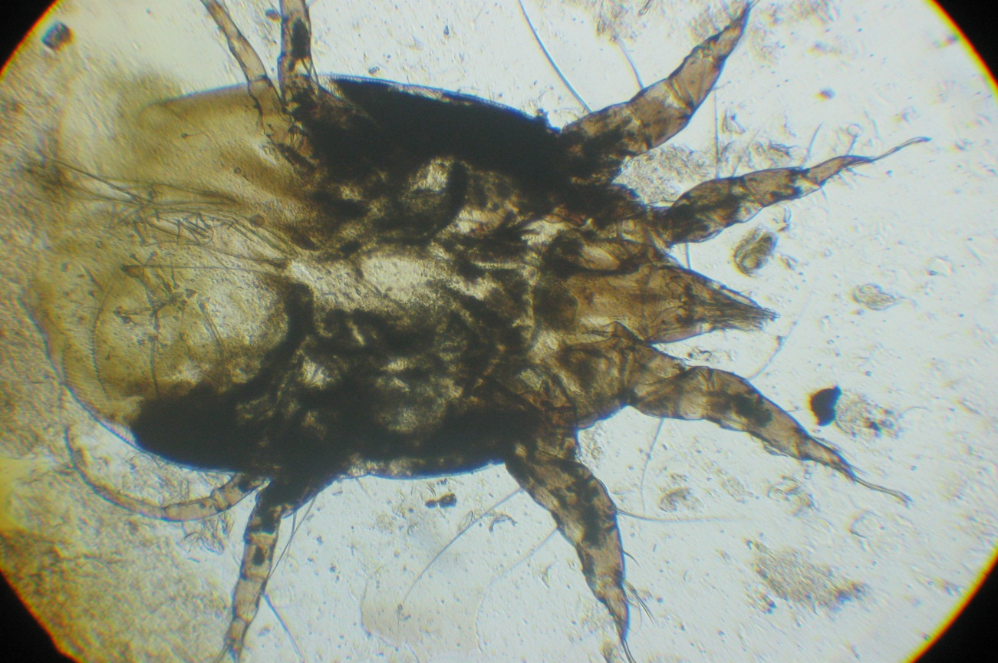

Picture 3. Psoroptes cuniculi (х270)

All material from 442 rabbits of private economies of twelve districts in Poltava region was investigated. Extensivity of Psoroptes invasion presented 37,68 % for intensities 28,76 pieces from 1 см² of surface of skin. The greatest indexes of defeat of animals of Psoroptes were registered in Kremenchuck, Myrhorod and Dykan’ka districts (see table).

Distribution of rabbits’ parasites in the private economies in Poltava region
Location of economies, district | Investigated, pieces | Psoroptosis |  | Eimeriosis |  | Passalurosis
Location of economies, district | Investigated, pieces | ЕІ, % | ІІ, pieces/of см² | ЕІ, % | ІІ, pieces/to view | ЕІ, % | ІІ, pieces/of drop
Globyno | 30 | - | - | 20 | 4,3 | 100 | 6,3
Dykan’ka | 100 | 37 | 15,2 | 35 | 32,3 | - | -
Zin’kiv | 25 | - | - | 20 | 4,3 | - | -
Karlivka | 17 | - | - | 100 | 35,4 | - | -
Kobelyaky | 22 | 50 | 33,3 | 9,1 | 3,3 | - | -
Kozel’schyna | 20 | 5 | 7,3 | 100 | 3,3 | 100 | 6,3
Kremenchuck | 20 | 100 | 32,3 | - | - | - | -
Lubny | 30 | 10 | 12,5 | 100 | 4,9 | 100 | 12,5
Myrhorod | 18 | 44,4 | 87,3 | 27,8 | 34,3 | - | -
Pyriatyn | 20 | - | - | - | - | 10 | 3,0
Poltava | 120 | 30 | 24,9 | 55 | 9,26 | 10 | 3
Reschetylivka | 20 | 25 | 17,3 | 10 | 15 | - | -
Poltava region | 442 | 37,68 | 28,76 | 47,69 | 14,64 | 21,26 | 6,22

Eimeriosis of rabbits were discovered in the economies of all districts except Kremenchuck and Pyriatyn: middle ЕІ is 47,69 %, and ІІ is a 14,64 oocystes in a view of microscope. Passalurosis has been diagnosed rarer, however in separate economies extensivity of invasion presented 100 % (Globyno, Kosel’schyna, Lubny), and intensity is 12,5 pieces of eggs in the drop of the investigated liquid at mean values for areas 21,26 % and 6,22 pieces accordingly.
Conclusions:
1. The private economies of Poltava region with the cellular type of maintenance of crawls are unhappy in relation to Eimeriosis, Passalurosis, Psoroptosis.
2. Extensiveness of Psoroptes invasion is 37,68 %, Eimeria – 47,69 %, Passalurus – 21,26 %.
3. The prospect of further researches are a test of efficiency of anti-parasite preparations and development of measures of fight against these diseases.
BIBLIOGRAPHY
- Богач М. В. Інвазійні хвороби системи травлення кролів в господарствах Одеської області / М. В. Богач, М. М. Трофімов // Аграрний вісник Причорномор’я : зб. наук. праць. – Одеса, 2007. – Вип. 39. – С. 96–99.
- Бырка В. И. К вопросу диагностики и лечения при пассалурозе кроликов /
В. И. Бырка : сб. научных трудов Харьковского с.-г. ин-та им. В. В. Докучаева. –
Т. 269. – С.60–63.
- Катаева Т. С. Псороптоз кроликов и меры борьбы с ним в Свердловской области [рекомендации] / Т. С. Катаева, А. Н. Давлетшин, С. М. Тихомиров. – Свердловск, 1989. – 14с.
- Манжос О. Ф. Еймеріоз кролів та перспективи його подальшого вивчення /
О. Ф. Манжос, О. О. Передера // Науковий вісник НАУ. – 2006. – Вип. 98. – С. 127–133.
- Фетисов В. И. Опыт лечения и химиопрофилактики пассалуроза кроликов /
В. И. Фетисов // Кролиководство и звероводство. – 1963. – № 7. – С. 25–26.
- Флориан Д. Д. Пассалуроз кроликов в условиях Московской области (биология возбудителя, эпизоотология и меры борьбы) : автореф. дис. на соиск. уч. степ. к. вет. н. / Д. Д. Флориан. – М., 1997. – 22 с.
- Ятусевич А. И. Еймериоз кроликов / А. И. Ятусевич. – Витебск, 2001. – 71 с.

