© 2015

Shcherbakova N. S., Сandidate of Veterinary Sciences, Docent
Peredera Zh. A., Candidate of Veterinary Sciences, Docent
Peredera S. B., Candidate of Veterinary Sciences, Docent
Lubenska A. Yu., student of the faculty of veterinary medicine
Poltava State Agrarian Academy
A DISINFESTATION OF SAUSAGE WARES WITH HELP OF MIKROWAVES
Reviewer – Doctor of Veterinary Science A. A. Zamazyi
The paper shows data of the disinfection of sausages by microwave waves. It is established that to reduce the number of microorganisms in sausage products affect mode power microwave and processing of samples.
It determined that the sample processing has a significant impact on reducing the number of microorganisms in it than the selected mode power microwave.
Prolonged exposure samples by microwave waves (within 3 minutes) favors reducing of more microorganisms, but the minimum time (1 minute) is sufficient to reduce the number of microorganisms sausage products of questionable freshness to assume it is not harmful to the human body after decontamination.
Keywords: microwave radiation, microorganisms, disinfection, food poisoning.

Statement of the problem. Currently, despite preventive measures, food poisoning is a danger to people almost everywhere.
Food poisoning of humans caused by eating meat products is often the result of insufficient heat treatment or the result of secondary infection when violations technology and the storage of meat and meat products [1].
In this context, great importance attaches to the question of disposal of meat and meat products, which guarantee the complete safety of finished products to consumers [2].
Analysis of major studies and publications which have a solution of the problem.
In the last few years to address these issues, in addition to existing methods of decontamination (boiling, freezing, salting), suggested the use of ultraviolet light, ionizing and electromagnetic radiation, etc. Along with them is definitely worth and ultra high frequency electromagnetic radiation or microwave food processing products [1, 3, 4].
Influence of microwave radiation on cells and the organism as a whole is subject for a thorough study. The use of microwave energy in the medical, food and microbiological industry due to the specificity of microwave heating of objects that are exposed to radiation, namely the ability to simultaneously heat the entire volume, adjust the rate of energy absorption and temperature of the sample. Heat treatment required sterilization of food and various biological objects with maximum preservation of their consumer properties [3, 4].
One of the main areas of application of microwave energy – use it as a factor active influence on the cells of microorganisms and to destroy their toxins. The elucidation of the mechanism of action of microwave energy for microbial cell remains the most important task of theoretical perspectives in the study of it’s use in veterinary medicine [1, 3].
Thus, the combination of all the material accumulated till now shows that microwave energy reveals diverse effects on organisms of different structure. In-depth study of these issues opens the prospect of the development of energy-saving technologies neutralization, sterilization or pasteurization using microwave energy of meat, meat products (including sausages), meat slaughter waste of fish [3].
Sausages – are products of minced meat with salt and spices, in the shell or without subjected to heat treatment or fermentation until ready for consumption. In the CIS countries produce more than 200 types of sausages. Depending on the manufacturing process are divided into sausages, smoked, boiled, liver, cereal, diet, blood sausage and jellies, meat loaves, Salceson and pate.
To prepare the sausages people use a variety of raw and auxiliary materials: meat, offal, fat, blood, milk, egg and flour products, protein stabilizers, salt mixture (salt, sugar, nitrates), spices, onions, garlic and other ingredients. They are a source of bacterial contamination of the finished product. Sausages’ microflora presented lactic acid bacteria, yeasts, bacteria of E. coli, Salmonella, Proteus, Staphylococcus aureus, Clostridium [2].
The purpose of research – the study of the influence of microwave radiation on sausages and determining it’s effectiveness.
Objective – to establish the optimal mode of influence of microwave radiation on sausages for their decontamination.
Materials and methods of research. Materials of our study were sausages of different level of freshness. Organoleptic evaluation of sausages was carried out according to GOST 9959-91. The microscopic analysis of smears from sausage products was carried out according to GOST 23392-78.
Results. To control the influence of microwave waves of different capacity and different exposures on the number of microorganisms in sausage products of varying degrees of freshness method was used smear prints sausages before and after treatment of by microwave. Results of microscopic are studies listed in the table.

Results of microscopic studies.
Number sample | Number of organisms present in the control sample (fresh sausage product) * | Number of organisms in a sample of questionable freshness in sausage products * | The processing of samples, min. | Power of microwave ovening, W | Number of microorga-nisms in samples after treatment *
1 | 2 | 26 | 1 | 450 | 11
2 | 7 | 24 | 3 | 450 | 3
3 | 3 | 23 | 1 | 600 | 9
4 | 2 | 25 | 3 | 600 | 2
5 | 2 | 29 | 1 | 950 | 3
6 | 2 | 28 | 3 | 950 | 1
 | * Means the arithmetic average after counting the number of organisms in 10 fields of each smears

As can be seen from Table microwave waves really affect on the number of microorganisms in the sausages. But the degree of impact depends on the mode of microwave power and processing time of samples that affect the result of irradiation products differently.
During the research it was found that the use mode power 950 W achieved the best results for decontamination of sausages than using 450 watts.
However, as shown in Table, a crucial indicator is the processing time of trial, because in the same mode power of 450 W, was destroyed by a large number of microorganisms in the processing of sausages for 3 minutes – in sight smears were found on average 3 microorganisms whereas the processing for 1 minute – 11 microorganisms in sight smears. The same applies to other modes of power: using the power of 600 W the result of processing the sample for 3 minutes was 2 micro specimens in sight and within 1 minute – 9; when using the power of 950 W for 3 minutes the number of microorganisms in sight smears decreased from 29 to 1 microorganism, and within 1 minute – from 28 to 3 microorganisms.
Also, it is possible to determine the effectiveness of decontamination of sausages using microwave irradiation as a percentage. For example, in sample number 1 before irradiation was found on average 26 microorganisms in sight smears. After processing of microwave wave power 450 W for 1 minute quantity of microorganisms was reduced to 11 by counting find the percentage of treatment efficacy, which is 57,7. Similarly, we can determine the percentage of effectiveness of treatment of other samples is presented in the histogram.

The efficiency of processing samples of sausages of questionable freshness

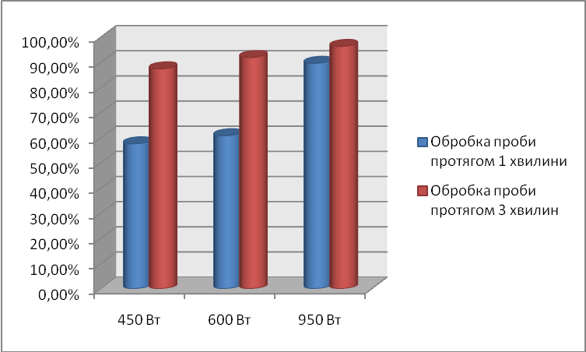

Therefore, to reduce the number of microorganisms in sausage products affect both mode power microwave and processing of samples. However, in the course of the research it was found a significant effect of time of exposure than used power mode.

Conclusions. Carefully examining and summarizing the scientific literature data and the results of their research, it is possible to conclude that the efficiency of processing of microwave waves on sausages of questionable freshness by the number of microorganisms:
1. On the reduction of microorganisms in sausage products affect mode power microwave and processing of samples.
2. Also during the analysis of the results revealed that the processing of samples has a significant impact on reducing the number of microorganisms in it than the selected mode power microwave.
3. Prolonged exposure samples by microwave waves (within 3 minutes) contributes to the destruction of more microorganisms, but the minimum time (1 minute) sufficient to reduce the number of microorganisms sausage products of questionable freshness to assume it is not harmful to the human body after decontamination.

BIBLIOGRAPHY:
- Баль-Прилипко Л. В. Технологія зберігання, консервування та переробки м’яса : [підручник ] / Л. В. Баль-Прилипко. – К., 2010. – 469 с.
- Бенников B. C. Резонансное поглощение миллиметровых волн бактериаль-ными клетками / B. C. Бенников, С. Б. Рожков // Доклады АН СССР. – М., 1980. – Т. 255. – №3. – С. 746–743.
- Болтовский B. C. Использование энергии СВЧ для стерилизации пищевых продуктов /
B. C. Болтовский, Г. П. Пинчук // Перспективы производства продуктов питания нового поколения. – Минск, 2005. – С. 91–94.
- Cирохман В. І. Товарознавство м’яса і м’ясних товарів : [підручник] /
В. І. Сирохман, Т. М. Лозова. – [2-ге вид., перероб. та доп.]. – К. : Центр учбової літератури, 2009. – 378 с.

