© 2015

Peredera S. B., Candidate of Veterinary Sciences
Kinash O. V., graduate student
(scientific supervisor – Candidate of Veterinary Sciences S. B. Peredera)
Poltava State Agrarian Academy
THE SUSCEPTIBILITY TESTING OF MUCOR AND ASPERGILLUS SPP. TO SOME PLANT ORIGIN SUBSTANCES
Reviewer – Doctor of Veterinary Sciences, Professor V. P. Berdnyk
The results of susceptibility testing of Aspergillus and Mucor to plant origin substances (infusion of Echinacea purpurea, Echinacea liquid extract, Echinacea tincture, essential oil of Basil, essential oil of Monarda, eugenol) are shown. There are numerous data in the literature relating to bactericidal and immunostimulatory activity of those substances, however, the data for their fungicidal properties described insufficiently. The studies was conducted by standard disc-diffusion method. We used medications of Echinacea purpurea and essential oils of pharmaceutical network. Plant origin substances are promising for use in veterinary medicine as an alternative to antibiotics and disinfectants simultaneously. In particular, essential oils and their components can be used to optimize the air of poultry premises, as a disinfectant and as chemicals of anabolic and immunostimulatory action.
Keywords: fungi of the genus Mucor, fungi of the genus Aspergillus, Echinacea preparations, essential oils, susceptibility testing of microorganisms.

Statement of the problem. Mycosis is fairly large group of livestock and poultry diseases. In particular, pathogenic fungi of genuses Mucor and Aspergillus are widespread in nature. They are quite resistant to factors such as UV radiation, high or low temperatures. To combat pathogenic fungi spores toxic to human and animal substances are used that can accumulate in the body and contaminate the environment. There are two complementary directions for prevention and treatment of fungal infection: the pathogen destruction in the environment and stimulation of susceptibles animals immune system.
Analysis of the main research and publications, which discuss the problem. Recently, much attention is paid to the study of herbal extracts and other phytopreparations (phytobiotics) by alternative plant resources to use them in a veterinary medicine. [9] The incentive to search a new alternative drugs for livestock was the ban of antibiotics as a growth promoters by Europe Union countries. Plant substances do not cause microbial resistance, allergic, immunotoxic and mutagenic effects even after prolonged usage [4].
The most effective for poultry considered some herbal adaptogens: Eleutherococcus, Ginseng, Echinacea purpurea [1]. Echinacea purpurea contains a complex of biologically active substances which interaction causes it’s high adaptogenic properties [1]. Echinacea purpurea is mostly known as an adjuvants, used in Europe and North America for prevention and treatment of infectious diseases, including in poultry [5, 7]. S. Merali, S. Binns, M. Paulin-Levasseur reports about components of plant by genus Echinacea, with antifungal activity, they can be used for the treatment of fungal infections [10, 11].
In our country, essential oils are thoroughly investigated by the specialists of humane medicine in 80th of the last century [3, 6]. Thus, Vladimir Nikolayevskyi fully explored most of the known essential oils not only in terms of their bactericidal action, but also by it impact on macroorganism. He found that the most pronounced antimicrobial activity have essential oils of Monarda fistulosa and eugenol Basil and experimentally proved the harmlessness of these oils in chronic experiments on laboratory animals [3]. Currently proposed to use essential oils as disinfectants for hatching eggs, which is rival to effectiveness of formalin action [7]. Established antifungal effect of aqueous extract of the aerial parts of Monarda didyma relatively to pathogenic fungus Fusarium oxysporum. Antifungal properties of plant extracts are primarily due to quantitative and qualitative composition of the natural essential oils [2]. Eugenol and carvacrol are the components of many essential oils, selected by particular product and recommended for the treatment of oral candidosis. We need to further study of their pharmacokinetic and toxicological properties. Eugenol and carvacrol does not cause poisoning in rats at therapeutic doses [8].
The aim of research – to determine the Aspergillus and Mucor suspectibility to some plant origin substances that is likely have immunostimulatory and fungicidal action.
The objective of research – to determine the most pronounced antifungal effect of plant origin substances (selected on the base of study literature) for Aspergillus niger, Aspergillus flavus, Mucor ramosissimus
Materials and methods. Isolation and identification of Aspergillus niger, Aspergillus flavus, Mucor ramosissimus we performed by standard methods. Determination of fungi suspectibility carried by disc-diffusion method. Determination of the number of colony forming units in 1 ml of suspension was performed by the standard method in hemocytometer. The studied substances: decoctum of herb Echinacea purpurea, Echinacea extract liquid, Echinacea tincture, essential oil of Basil, essential oil of Monarda, eugenol.
Procedures № 1. A collection of 5-7 day isolates of Aspergillus niger, Aspergillus flavus, Mucor ramosissimus was tested. Prepared stock inoculum in saline with required concentration 1-5х10⁶ CFU/ml. The number of spores in 1 ml of inoculum was adjusted by microscopic enumeration with a cell-counting in hemacytometer by the standard method. Inoculum in amount of 2 ml was applied to a Petri dish with Sabouraud agar and left for diffusion in agar for 10 minutes, the excess fluid was collected with a sterile pipette. Then placed on agar surface filtering paper discs with a diameter of 6 mm, soaked in the test substances. Petri dishes were incubated with crops in thermostat upside down at 25 ºC. Accounting of reaction was performed at 24, 48 and 72 h, diameters of growth inhibition and character of the growth were analyzed.
Procedures № 2. The 4 separate tubes with slanted Sabouraud agar was taken. Conducted sowing of 5-day isolate Mucor ramosissimus to each tube, then the tube wall fastened disk impregnated with essential oil of Basil, essential oil of Monarda and eugenol. In this case the contact among the nutrient medium and disk is missing. Prepared stock inoculum in saline with required concentration 1-5х10⁶ CFU/ml. The number of spores in 1 ml of inoculum was adjusted by microscopic enumeration with a cell-counting in hemacytometer by the standard method. The last tube without disk served as control. Accounting of reaction was performed at 24, 48 and 72 h, analyzed the character of growth inhibition and the number of sporangias in native smears.
Results. The experimental results № 1. The character of growth compared to control heterogeneous, colonies is flat, the Mucor ramosissimus and Aspergillus flavus colonies are completely colorless, in Aspergillus flavus was observed bleaching of colonies in sectors of interaction with essential oils and eugenol. Conidial heads were not formed even in the area of ​​growth for any of the isolates. Paper disc method showed that the essential oil of Monarda and eugenol exhibit pronounced fungicidal properties with respect to the test isolates, including Mucor ramosissimus was the most susceptible. Mucor ramosissimus is susceptible to Echinacea tincture. This indicates that among the baforementioned substances the more pronounced fungicidal properties have essential oil of Monarda and eugenol, and somewhat lower – essential oil of Basil. We can also argue that tincture of Echinacea has antifungal and fungiostatic influence only on certain isolates of pathogenic fungi (pic. 1).
A. niger | А. flavus | M.rаmosissimus
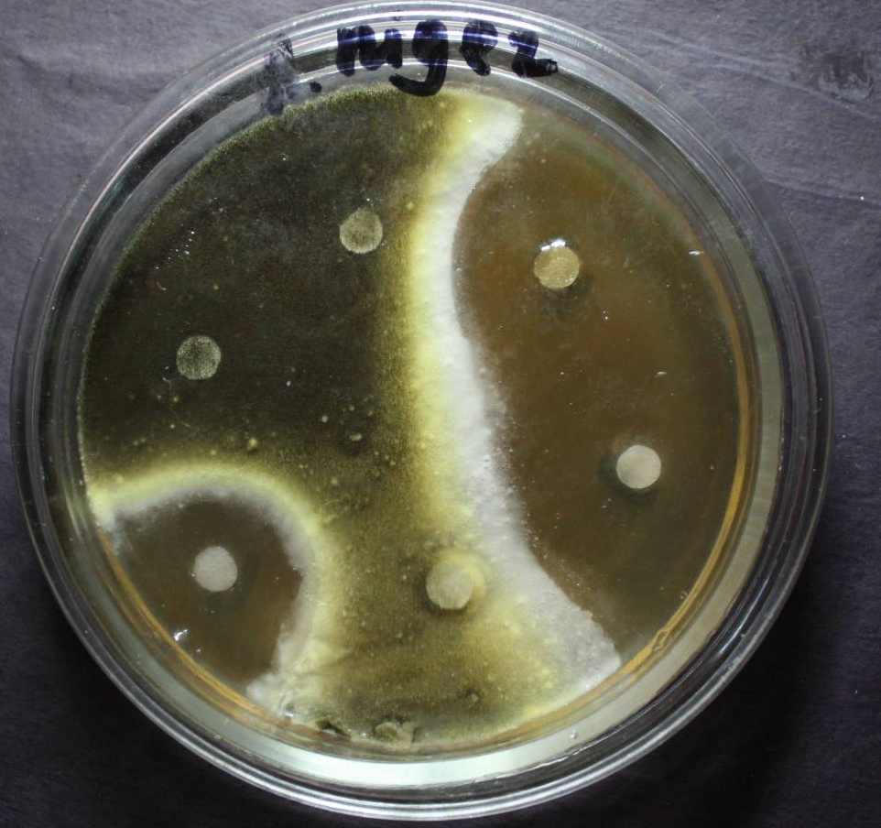 | 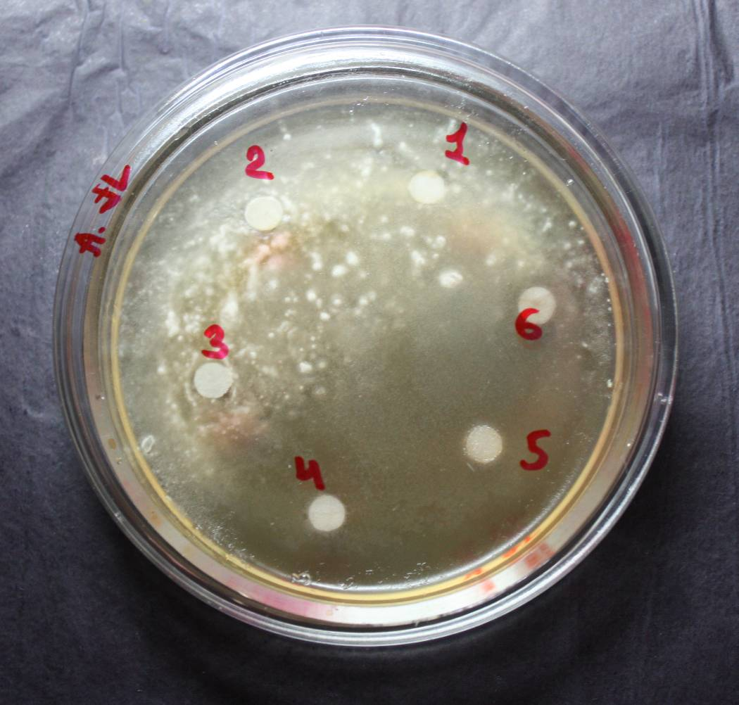 | 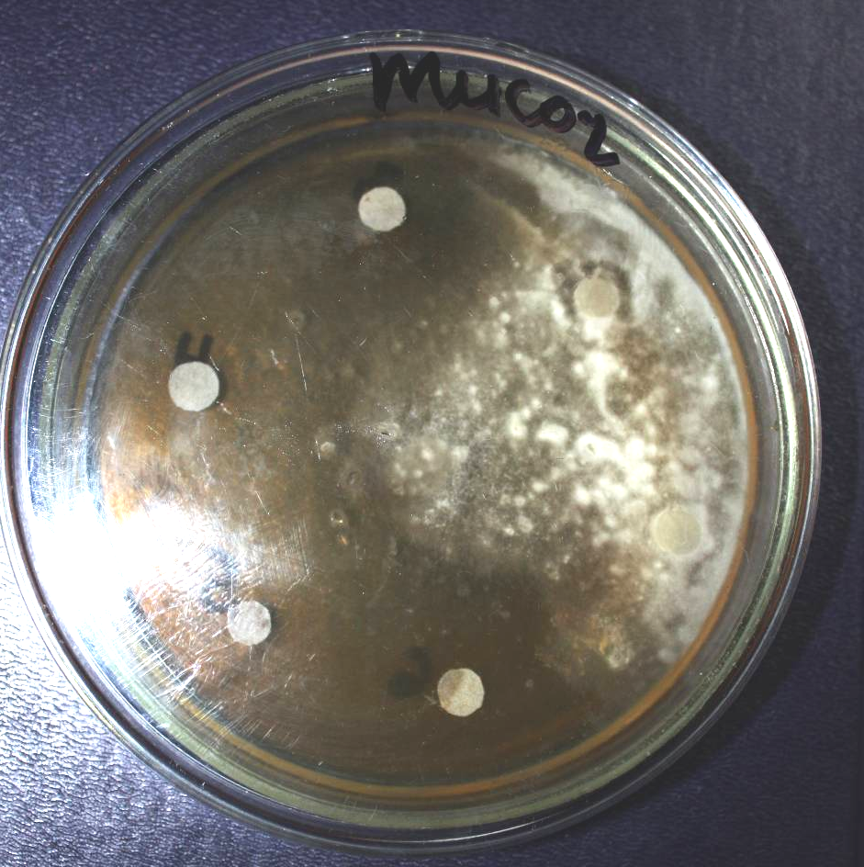
Picture. Determination of fungicidal activity of test substances, 48 hours
Table. Growth inhibition of test isolates
Name of research substance | Mucor rаmosissimus,  3,5х10⁶ CFU/ml |  |  | Aspergillus niger  4х10⁶ CFU/ml |  |  | Аspergillus flavus  3х10⁶ CFU/ml
Name of research substance | 24 hours | 48 hours | 72 hours | 24 hours | 48 hours | 72 hours | 24 hours | 48 hours | 72 hours
Decoctum of herb Echinacea purpurea | growth | growth | growth | growth | growth | growth | growth | growth | growth
Echinacea extract liquid | growth | growth | growth | growth | growth | growth | growth | growth | growth
Echinacea tincture | 40  ±1 | 22  ±  0,6 | 17  ±  0,2 | 6  ±  1,2 | 2  ±  0,6 | growth | growth | growth | growth
Essential oil of Monarda | 50  ±2,1 | 50  ±0,9 | 50  ±1,7 | 35  ±1 | 31  ±2,1 | 26  ±1,7 | 35  ±2 | 33  ±0,5 | 30  ±0,8
Eugenol | 44  ±  1,4 | 42  ±  0,1 | 41  ±  0,2 | 42  ±  1,3 | 39  ±  0,8 | 36  ±  1,5 | 30  ±  1,3 | 30  ±  0,9 | 28  ±  1
Essential oil of Basil | 40  ±  2,1 | 39  ±  1,9 | 39  ±  1,1 | 35  ±  1,3 | 31  ±  0,5 | 30  ±  0,9 | 20  ±  1,1 | 17  ±  2,2 | 14  ±  0,6
Control  (saline) | growth | growth | growth | growth | growth | growth | growth | growth | growth

The experimental results № 2. After 24 hours observed growth in all tubes except the top of the agar column, which is closer to the disk. In control tube growth is uniform across the surface of agar. Colonies is fluffy, white, with well-developed mycelium. After 48 hours in tube with the disk soaked by Monarda essential oil growth was less pronounced, colonies white, fluffy, at the bottom of the tube mycelium was smoky color. In tube with discs soaked by eugenol and essential oil of Basil colonies had slightly higher mycelium, painted in light gray. In control tube mycelium was high, gray at the bottom of the tube and slightly lighter. By microscopy of research material from test tubes showed decreasing of the number of sporangias formation compared with the control, the bulk was mycelium.
Conclusion. Discovered a high fungicidal activity of essential oil of Monarda and eugenol. Broth and herb extract of Echinacea have fungicidal activity relatively Mucor and Aspergillus. Tincture of Echinacea purpurea has weak antifungal activity relatively Aspergillus. Investigated essential oils have fungiostatic effect on Mucor even in the absence of direct contact with the fungi isolate.

BIBLIOGRAPHY:
1. Бегма Л. О. Ефективність використання препарату ехінацеї пурпурової в птахівництві /
Л. О. Бегма, Д. А. Бегма // Вісник ЛНАВМ імені С. З. Ґжицького. – Львів, 2007. – Вип. 1(33), Т. 9. – С. 3–6.
2. Котюк Л. А. Фунгіцидна активність екстрактів ефіроолійних рослин родини Lamifceae Lindl. відносно Fusarium Oxysporum / Л. А. Котюк, І. В. Іващенко // Біологічний вісник Мелітопольского державного педагогічного університету ім. Богдана Хмельницкого. – Мелітополь, 2013. –
Вип. 3(9), Т. 3. – С.70–82.
3. Николаевский В. В. Биологическая активность эфирных масел / В. В. Николаевский, А. Е. Еременко, И. К. Иванов. – М. : Медицина, 1987. – 144 с.
4. Патерега І. П. Протизапальна дія деяких фітопрепаратів при введенні всередину білим щурам / І. П. Патерега // Науково-технічний бюлетень Інституту біології тварин і Державного науково-дослідного контрольного інституту ветпрепаратів та кормових добавок. – Львів, 2008. – Вип. 9, №4. – С. 131–134.
5. Фитохимический состав представителей рода Эхинацея (Echinacea Moench) и его фармакологические свойства (обзор) / [Самородов В. Н., Поспелов С. В., Моисеева Г. Ф. и др.] // Химико-фармацевтический журнал.– М. : Изд. «Фолиум». – 1996. – №4. – Т. 30. – С. 32–37.
6. Талдыкин О. Е. Использование фитонцидной активности эфирных масел для оздоровления воздуха закрытых помещений. // Фитонциды. Роль в біогеоценозах, значение для медицины. – К., 1981. – С. 201–203.
7. Эфирные масла как средства дезинфекции в ветеринарии /
[К. Г Ткаченко, Н. В. Казаринова, Н. А. Шкиль и др.] // Научные ведомости Белгородского государственного университета. Серия: Естественные науки. – Белгород, 2009. – Вып. 11(66). –
С. 65–71.
8. Chami N. Antifungal treatment with carvacrol and eugenol of oral candidiasis in immunosuppressed rats / N. Chami, F. Chami, S. Bennis, J. Trouillas, А. Remmal // Brazilian Journal of Infectious Diseases. –V, 2004. – V. 8, №3. – Р. 217–226.
9. Kumar K. M. Pharmacological importance of Echinacea purpurea / K. M. Kumar and Sudha Ramaiah // International Journal of Pharma and Bio Sciences. – 2011. –V. 2, №4. – Р. 304–314.
10. Landy N. The effects of Echinacea purpurea L. (purple coneflower) as an antibiotic growth promoter substitution on performance, carcass characteristics and humoral immune response in broiler chickens. / N. Landy, Gh. Ghalamkari, M. Toghyani, F. Moattar // Full Length Research Paper. Journal of Medicinal Plants Research. – 2011. – V. 5 (11). – Р. 2332–2338.
11. Merali S. Antifungal and аnti-inflammatory аctivity of the genus Echinacea /
[S. Merali, S. Binns, M. Paulin-Levasseur et al.] // Pharmaceutical Biology. – 2003. –
V. 41, №6. – P. 412–420.

