© 2014
Lokes-Krupka T., postgraduate student
National University of life and environmental sciences of Ukraine
TYPICAL CLINICAL SYMPTOMS FOR HEPATOLIPIDOSIS IN DOMESTIC CATS
Reviewer – candidate of veterinary sciences N. S. Scherbakova
Most liver diseases in domestic cats have the same clinical picture, but each of them has its own features of display. The article presents clinical symptoms of hepatolipidosis in domestic cats: icterus of the conjunctiva, the mucous shell of oral cavity, nose and skin, vomiting, deterioration of the wool and itching. Established that obesity of animals, with subsequent manifestation of anorexia is a favorable factor for development of liver lipidosis. Explained age and pedigree susceptibility of domestic cats to liver lipidosis.
Keywords: cats, liver, hepatolipidosis, clinical signs, symptoms.

Statement of the problem. In modern world there is a tendency to maintenance domestic cats of various breeds that require a lot of attention and care. Violation of feeding and maintenance of these animals leads to the development of various internal diseases, especially diseases of the liver. Most liver diseases in domestic cats have the same clinical picture, but each of them has its own typical features of display. Thus, acute hepatitis, except conjunctival icterus manifested with significant intoxication of organism, cirrhosis - often accompanied by ascites and more. So establishing a characteristic clinical picture by hepatolipidosis in domestic cats can adjust the action of veterinarian in the required direction for selecting the additional methods and establishment of treatment.
Analysis of the main researches and publications. According to R. Kirk [9] in domestic cats lipidosis registered in 49% of cases, while inflammatory liver diseases account for 26% and lymphosarcoma - 7% of cases. Hepatolipidosis considered a primary idiopathic disease in many cats, but while collecting anamnesis in most cases reveal conditions or diseases that are accompanied by absence of appetite [1]. Often comorbidity by hepatolipidosis of domestic cats are diabetes, nephropathy, pancreatitis, koprostasis and diseases of the oral cavity. V. Biourge with co-authors [12] have confirmed that prolonged starvation, in the presence of obesity, may cause clinical manifestation hepatolipidosis in cats. Typical clinical signs and changes in biochemical parameters was observed after several weeks voluntary refusal of feed. These symptoms appear due to loss of 30-35% of body weight.
The aim of this study was the establishment of characteristic clinical signs by hepatolipidosis of domestic cats.
Materials and methods. The object of the study were 47 domestic cats of both sexes, aged from 2 to 13 years old suffering from hepatolipidosis. Cats with no visible signs of liver disease (n = 10) were included to control group. All animals were investigated by generally accepted scheme.
Results and discussion. By results of researches were established the basic general clinical symptoms in domestic cats suffering from hepatolipidosis (Table 1.).
1. Indicators of the clinical status of cats suffering from hepatolipidosis.
Clinical signs | Ill cats (n=47)
Clinical signs | quantity | %
Hiporeksiya | 45 | 95,7
Oppression | 42 | 89,4
Icterus of conjunctiva | 36 | 76,6
Pruritus | 31 | 66,0
Dandruff | 31 | 66,0
Obesity | 28 | 59,6
Progressive weight loss | 28 | 59,6
Liver pain | 26 | 55,3
Vomiting | 23 | 48,9

Most of animals noted by oppression of general condition (89.4%). As a result of a metabolic disorder or a primary disease in animals was observed deteriorated or completely disappeared appetite, frequent vomiting. These changes led to progressive weight lose of animals (Fig. 1.).
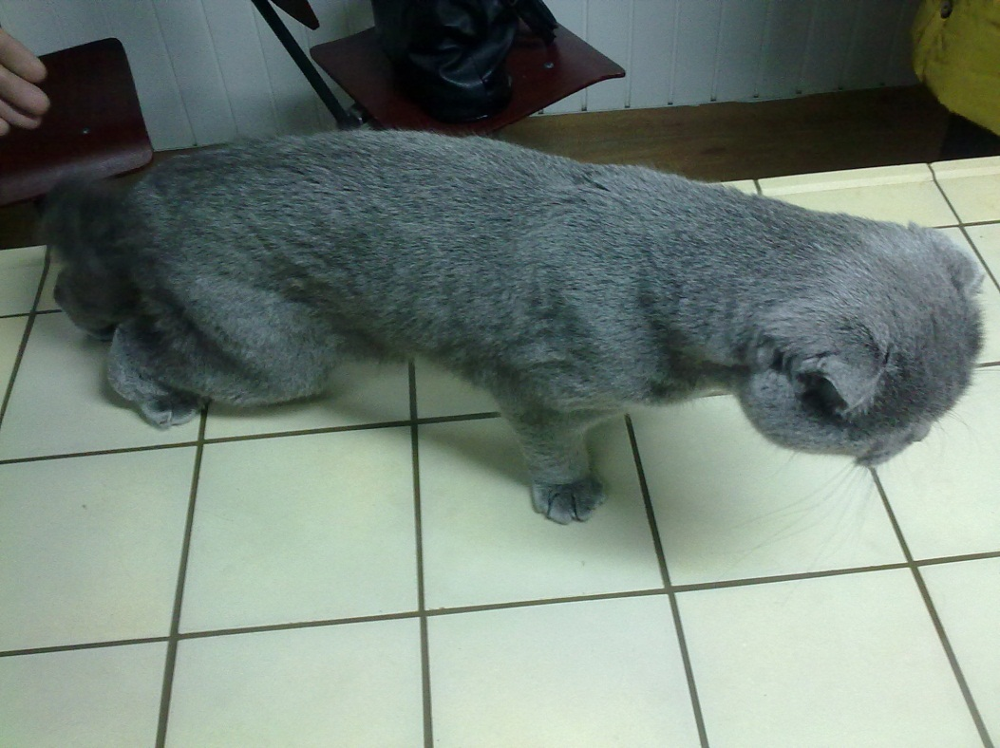
Fig. 1. General view of a cat suffering from hepatolipidosis, significant weight loss. Cat, a British breed, 8 years old.

In 76.6% of ill cats we observed: icterus of the conjunctiva, the mucous shell of oral cavity, nose and uncoated areas of the skin (Fig. 2.). It was the most common symptom for all liver diseases. Icterus also known as jaundice, general clinical symptoms in animals, manifested by an excess of bilirubin deposition in tissues.
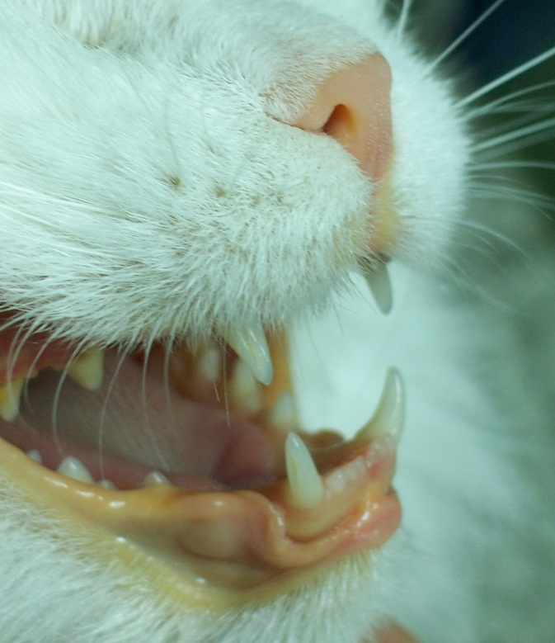
Fig. 2. Icterus of oral mucous membrane of the cat.

Тhe normal content of bilirubin in blood serum of cats, according to the authors, is less than 17.0 mmol/l [8], although many Ukrainian researchers believe that the upper limit of this index 12.0 mmol/l. Among researchers there is an opinion that jaundice develops when bilirubin reaches above 25,0-35,0 mmol/l [9]. Literature information about bilirubin rather contradictory, but they all share a common idea that icterus of mucous membranes developed primarily by increasing the content of direct bilirubin as a result of acquisition of them water-soluble form.
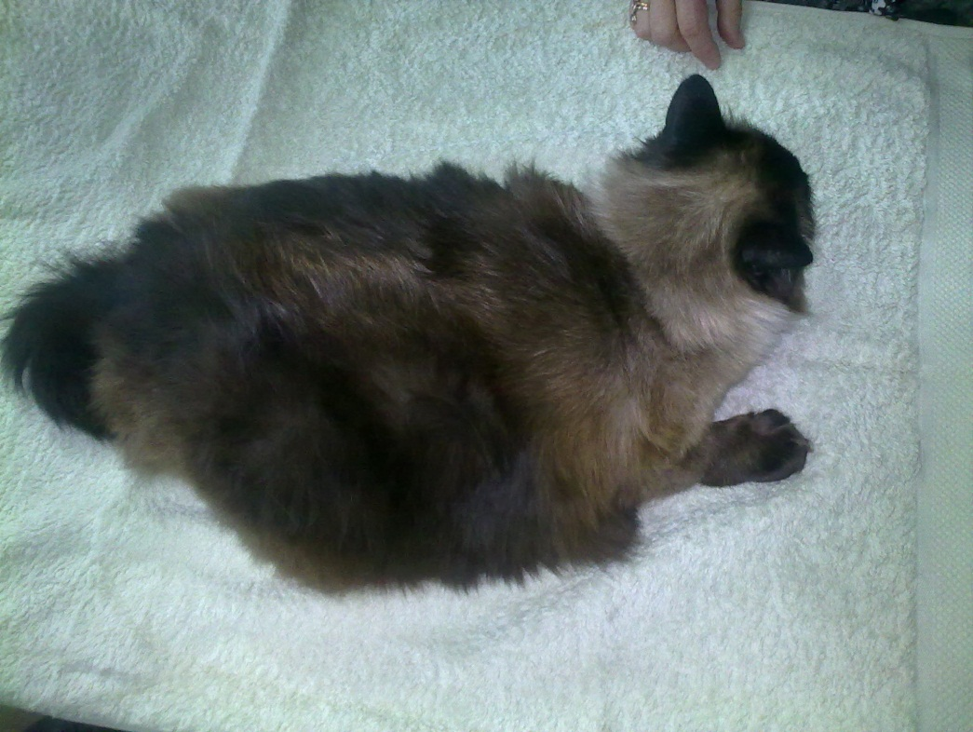
Fig.3. General view of a cat suffering from hepatolipidosis, significant obesity. Cat, mixed breed,7 years old.
More than half of ill domestic cats have changes in the state of wool. They noted by deterioration of the wool, dandruff and itching. These changes manifest as a result of irritating action of bile acids on sensitive receptors of the skin. After analyzing sexual addiction on the incidence on hepatolipidosis we have actually found the same susceptibility females and males to the disease (Table 2). Based on age dynamics of hepatolipidosis we can say that domestic cats under 2 years are not inclined to the disease as a result of time necessary factor in the pathogenesis of the disease. Most frequently this pathology is registered in domestic cats sterilized in middle age as a result of hormonal changes that lead to obesity and is a favorable factor of hepatolipidosis.
2. Gender and age susceptibility of domestic cats to hepatolipidosis
Age | Females |  | Males
Age | sterilized | not sterilized | neutered | not neutered
Up to 2 years | - | - | - | -
2-6 years old | 3 | 1 | 4 | -
7-10 years | 8 | 5 | 6 | 6
Older 10 . | 5 | 3 | 3 | 3
Total: | 16 | 9 | 13 | 9

Our results are basically consistent with the data of retrospective studies among cats over two years, indicating a slight predominance of the disease in females (48 out of 77 (62%)) [10]. After analyzing breed predisposition to disease we found that often the disease seen in domestic cats British and European shorthair breeds, namely 31.9 and 29.8% of cases, respectively.
There is a possibility of such incidence of these breeds in accordance with modern trends for their content. From 47 cases we have ten cases of sick animals accounted for the Persian cat breed, and 7 animals were mestizos. There was one reported case of incidence on hepatolipidosis of Sphynx cat breed. This case is more the exception than the rule for this breed.
Conclusions:
- Hepatolipidosis main clinical manifestations in domestic cats are conjunctival icterus and visible mucous membranes, frequent vomiting, refusal to feed, deterioration of the wool, the presence of itching and dandruff. Obesity is a favorable factor for the development of liver lipidosis.
- The most frequently hepatolipidosis registered at sterilized domestic cats 7-10 years old.
- Often hepatolipidosis of domestic cats registered in the UK and European shorthair breeds - at 31.9 and 29.8% of cases, respectively.
BIBLIOGRAPHY
1. Тирсіна В. І. Гепатопатії: гострі та хронічні / В. І. Тирсіна // Практична медицина. – 1999. – № 3–4. – С. 171–172.
2. Skin fragility syndrome in a cat with cholangiohepatitis and hepatic lipidosis / Daniel AG, Lucas SR, Júnior AR [and ath.] // J Feline Med Surg. – 2010 - № 12(2). – Р. 5.
3. Болезни собак и кошек. Комплексная диагностика и терапия болезней собак и кошек : учеб. пособие / [Т. К. Донская Г. Г. Щербаков, Г. В. Полушин] ; под ред. С. В. Старченкова. – СПб. : Спец. литература, 2006. – 655 с.
4. Внутрішні хвороби тварин [В. І. Левченко, І. П. Кондрахін, М. О. Судаков та ін.]; за ред. В. І. Левченка. – Біла Церква, 1999. – Ч.1. – 376 с.
5. Чандлер Э. А. Болезни кошек / Э. А. Чандлер, К. Дж Гакселл, Р. М. Гаскелл; пер. с англ. – М.: АКВАРИУМ ЛТД. – 2002 – 696 с.
6. Griffin B. Feline hepatic lipidosis. Treatment and recommendations / Griffin B. – Compend Contin Educ. – 2000. – № 22 – Р. 910-922.
7. Gary D. The Feline Patient / Gary D. Norsworthy, DVM, DABVP (Feline); [4th ed.], Blackwell Publishing Ltd. – 2011. – 1052 p.
8. Metabolic and hormonal alterations in cats with hepatic lipidosis / B. Brown, GE Mauldin, J Armstrong [and all] // J Vet Intern Med. – 2000. - №14(1) Р. 6.
9. Кирк Р. Современный курс ветеринарной медицины Кирка / Р. Кирк, Д. Бонагура.; [пер. с англ.] – М.: ООО «Аквариум принт». – 2005. – 1376 с.
10. Center S.A., Crawford M.A., Guida L., Erb H.N., King J. A retrospective study of 77 cats with severe hepatic lipidosis: 1975–1990 // J. Vet. Intern. Med. –1993 № 7 Р. 349–359.
11. Тилли. Л. Болезни кошек и собак / Л. Тилли, Ф. Смит: пер. с англ. – М.: ГЭОТАР-МЕД, – 2001. – 784 с.
12. Biourge V.C., Groff J.M., Munn R.J., Kirk C.A., Nyland T.G., Madeiros V.A., Morris J.G., Rogers Q.R. Experimental induction of hepatic lipidosis in cats. // Am. J. Vet. Res. – 1994 №55 Р. 1291–1302.

