© 2014
Samojlik M. S., Candidate of Economic Sciences
Poltava National Technical Yuri Kondratyuk University
METHODOLOGICAL PRINCIPLES OF RESOURCE-ECOLOGICAL SAFETY PROVIDING
IN THE REGION
Reviewe - Professor, Doctor of Economics Pisarenko V.V.
In the articles worked out methodological principles of resource-ecological safety providing in the region, it includes three stages: authentication of danger, determination of resource-ecological safety zones and forming of idea of problem decision; a choice of providing events of sufficient resource-ecological strength of region security (it comes true on the basis of optimization economic models and complex estimation of alternative scenarios of the naturally-economic potential use in the region that takes into account an ecological, economic and technological criterion); adjustment and concordance of decisions (it comes true on the basis of integral model of the economic- ecological systems development of the secondary material and power resources use in the region taking into account a regional specific).
Keywords: resource-ecological safety, region, secondary resources, solid wastes.

Statement of the problem. The problem of achievement of steady development in the region extends the sphere of influence of man on an environment and intensifies the use of natural raw material base that unavoidable takes away the problem of the rational use of secondary resources on the first plan. The basic sources of secondary resources are wastes of productive and consumer activity of men. A problem of the rational use of secondary resources is one of priority for every region in Ukraine [1]. In such aspect of increase of efficiency of the use of naturally-economic potential of territory, including on the basis of capitalization of production and consumption wastes, becomes one of foreground jobs of regional development.
The analysis of recent studies and publications discussing the problem. Considerable payment in development of theoretical and methodological principles of the balanced socio-economic development of regions was done by B. Burkinskiy, V. Voloshin. Z. Gerasimchuk, B. Danilishin, S. Doroguncov, D. Medous, V. Onischinko. V. Tregobchuc and other specialists. Fundamental research of cooperation of society and nature the devoted labours of V. Vernadskiy, O. Klimenko, L. Kupines, L. Melnik,
S. Podolinskiy, M. Rudenko, D. Forrester and other scientists. In the same time remain for the scientific search of question in relation to forming of the new going near providing of resource-ecological safety in the regions, increase of efficiency of management secondary resources, based on development of innovative methodology of development of socio-economic systems, determination of economic models and mechanisms of maintenance of acceptance of administrative decisions with the use of methodology of the systems analysis taking into account the ecological, technological and socio-economic terms of such system functioning is at regional level.
Task statement. It is necessary to work out and scientifically ground methodical principles of resource-ecological safety providing in the regions of Ukraine, oriented to the increase of efficiency of the use of naturally-economic potential of territory on the basis of capitalization of solid wastes (SW) and minimization of them negative influence.
Results of investigation. Resource-ecological safety in the region is the state of the regional naturally-socially-economic system that provides prevention of worsening of quality of ecosystems and health of man at the improvement of the socio-economic state of this system (minimum entropies), taking into account influence of destabilizing resource and ecological threats of external and internal environments, through the mechanism of increase of efficiency of the use of the naturally-economic potential of territory, oriented to maintenance of resources, including on the basis of capitalization of wastes of production and consumption as secondary resource, and also minimization negative influence waste on quality primary resource. The special place here must be taken to consideration of wastes as a specific commodity, that must be attracted in the repeated turnover in a maximal amount that will allow: to improve maintenance of resources and competitiveness of region, get an additional acuests from secondary resources, to save primary resources and to improve their quality, turn muddy earth in economic turnover of region (represents an economic and resource aspect); decrease a risk to the health of population from negative influence of wastes, to improve a socialpsychological climate in a region (represents a social aspect); to provide maintenance and proceeding in the environment of region, natural state of ecosystems and a minimum of entropy (represents an ecological aspect).
The complex providing of resource-ecological safety of region must include next constituents:
- authentication of danger and determination of zones of resource-ecological safety, on the basis of what the theoretic-methodical going is formed near the choice of strategies of providing of sufficient resource-ecological strength security;
- are scientifically-methodical principles of choice of events of providing of sufficient economic strength security on the basis of optimization economic models;
- it is adjustment and concordance of decisions on the basis of integral model of development of the economically ecological systems of the use of naturally-economic potential of region (Figure 1).
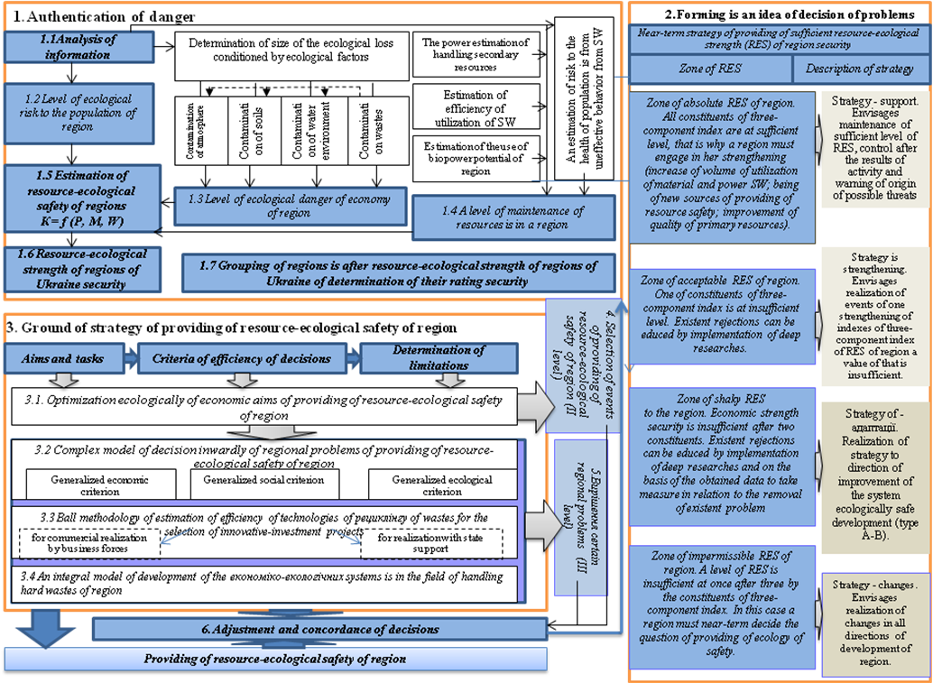
Figure 1. Methodological principles of providing of resource-ecological safety are in a region (it is made authors)
On the first stage, going out the theory of safety of ecosystems and taking into account influence on them of socio-economic factors [2] theory- methodological approach is worked out in relation to the estimation of resource-ecological strength of regions security in the system of steady development, that consists in the calculation of three-component index that takes into account ecological strength of economy of region (Р) security, level of ecological risk to the health of population (М) and level of proceeding in resources in the region (W) :
К = f (P, M, W), (1)
P, M, W →1, if P, S,W≥ P_{дост}, S_{дост}, W_{дост};
P, M, W →0, if P, S,W< P_{дост}, S_{дост}, W_{дост}.
where P_{дост}, M_{дост}, W_{дост} – sufficient value of indexes P, M, W.
Constituents of three-component index in relation to resource-ecological strength of region security it is suggested to determine so:
1) Index of ecological safety of economy of region settles accounts as a total economic loss for contamination of environment from the technogenic loading in a region on authorial methodology [3], the results of calculation of that allowed to define near-term strategy to direction of improvement of the system ecologically safe development of Ukraine regions (table 1).
Table 1. Grouping of Ukraine regions to direction of improvement of the system ecologically safe development of regions of Ukraine *
Type |  | Regions | Near-term strategy
Type А | А₁ | Ivano-Frankivsk, Kyiv, Vinnytsya to the area | Effective strategy of guard of atmospheric air
Type А | А₂ | Crimea, Lviv, Mykolaiv, Odesa, Kherson, Tcherkasy to the area, Kyiv and Sevastopol | Effective strategy of guard of water resources
Type А | А₃ | Zhytomyr, Poltava, Рівенська, Sumy, Volyn to the area | Effective strategy of guard of soils
Type А | А₁А₂ | Dnepropetrovsk, Donetsk, Zaporizhzhya, Luhansk of area | Effective strategy of guard of atmosphere and water resources
Type А | А₂А₃ | Chernihiv area | Effective strategy of guard of water resources and soils
Type А | А₁А₂А₃ | Kharkiv area | Effective strategy of guard of atmospheric air, water resources and soils
Type В |  | Zakarpattia, Ternopil, Khmelnytsk, Chernivtsi, Kirovohrad to the area | Effective strategy of improvement of the system of health protection
* - it is made authors.

2) The estimation of risk to the health of population it maybe to carry out by means of authorial model that represents different to interdependence in the system of relations "man-environment", and driven to [4], the results of grouping Ukraine regions on this index are brought around to figure 2.
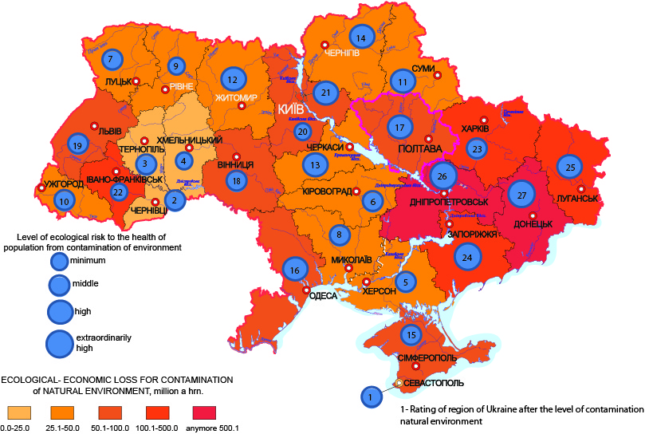
Figure 2. Estimation of ecological risk after to the regions of Ukraine,
generalized data for 2005-2012 (it is made authors)

3) Indexes of level of proceeding in resources in the region it is expected on the authorial methodology driven to [5], but includes next constituents: power-hungryness of handling solid wastes sphere in a region; economic efficiency of the use of secondary resources is in a region; economic efficiency of the use of biopower potential is in a region; an estimation of risk of health of population is from the existent system of handling solid wastes.
Eight values of three-component index of estimation of resource-ecological strength of region of К security are possible in theory, that answer 4 zones of resource-ecological safety of region, presented on figure 3.
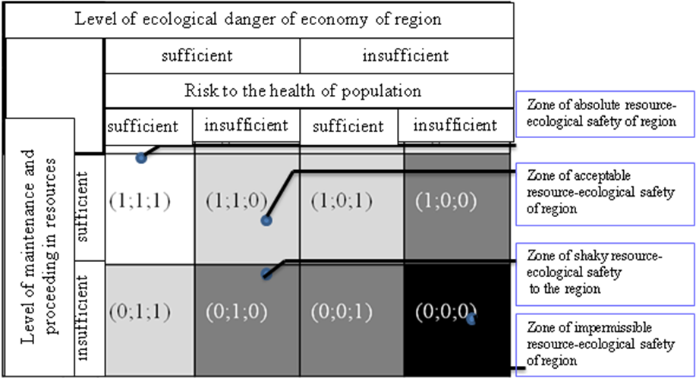
Figure 3. Zones of resource-ecological safety of region (it is made authors)

The brought research over the higher brought indexes over allowed to define the zones of resource-ecological safety of Ukraine regions (rice. 4). For each of the distinguished zones of resource-ecological safety optimal strategies offer providing of resource-ecological safety of region, descriptions of that are given figure 4.
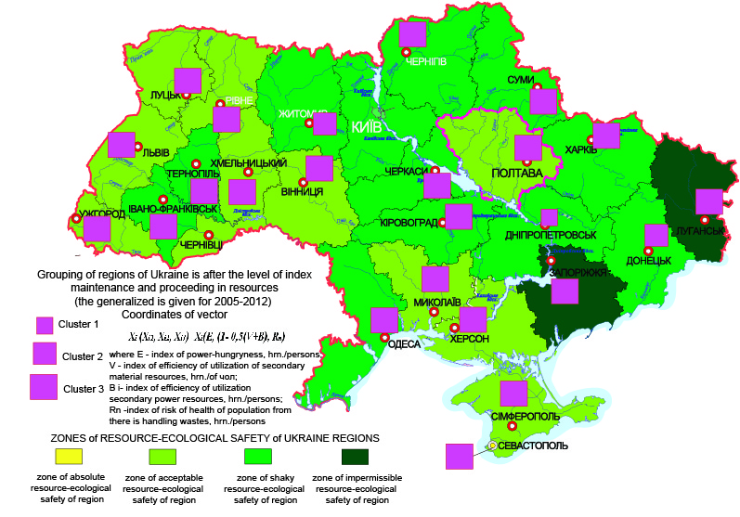
Figure 4. Grouping of regions of Ukraine after resource-ecological strength security,
the generalized is given for 2005-2012 (it is made authors)
On the second stage within the framework of every strategy the group of events is determined, on the basis of simulation economic models [6], introduction of that can be complex or priority, going out financial possibilities of region:
X=Ф(X,Y), subject to condition X≤X^{m}, Y≤Y^{m} , (2)
where - a great number of state of long course of conduct variables is from SW in a region; it is a great number of parameters of the state of this system in a region; X^{m}, Y^{m} – a great number of limits is on variables and parameters of the state of this system in a region; Ф – linear functional that links the value of state variables inter se at preset parameter of the state of the system (figure 5). So as a great number of Х is wider, than great number of connections is in the functional of Ф, then this system has a great number of feasible solutions and, accordingly, a choice offers the best of them. A task of choice of the best decision of the system and is the task of management of long course of conduct from SW, and decides she by means of objective functions: minimizations of formation of wastes; minimizations of total ecological risks; maximal exception of secondary resources; maximal receipt of profit from realization of utility waste; minimizations of total charges, including transport; maximizations of profit are for a region.
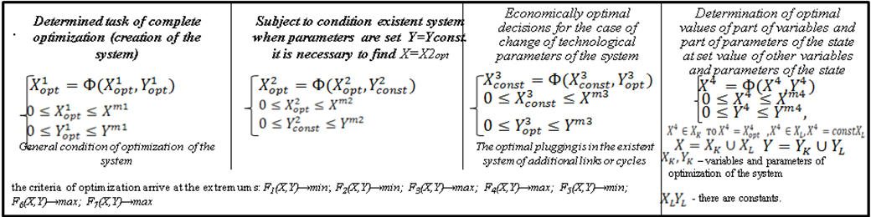
Figure 5. Tasks of optimization of development of sphere of handling the secondary resources of region [6, 7]

It is thus needed to take into account that systems behaviors from SW, that is based on the decision of partial problems of enterprises and separate inhabited cities, in spite of their high затратність, as a rule, not effective. Building of local objects of utilization of SW in every city, settlement or on every enterprise conduces to dispersion of money, groundless increase of charges on the burial place of wastes and does not allow effectively to solve problem handling wastes in the scales of region. An exit from a situation that was folded are development and realization of the regional complex systems of handling wastes. Therefore depending on the level of the territorial-localized formations the methodical going is worked out near the complex estimation of efficiency of development of solid wastes handling sphere taking into account a regional infrastructure and that takes into account the ecological, economic and technical criterion of this sphere and gives an opportunity at an existent situation and present money to pick up the complex of optimal decisions (figure 6).
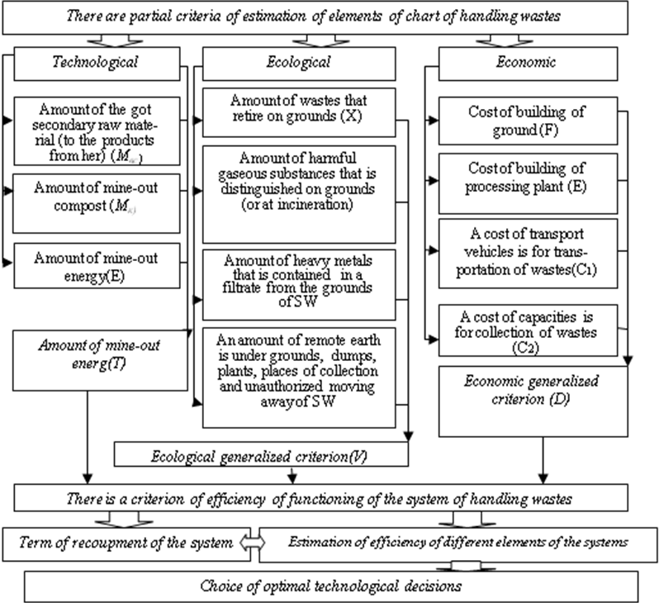
Figure 6. A complex model of efficiency of development of solid wastes handling sphere taking into account a regional specific (it is made authors)

On the third stage of providing of resource-ecological safety of region adjustment and concordance of decisions come true on the basis of integral model of development of the economical-ecological systems of the use naturally of economic potential of region [8], what takes into account influence of risks on the state of the socially economic systems and description inwardly regional specific:
(3)
where – a profit, that remains at disposal of object that works in the field of behavior from SW, hrn.; – paying for the acceptance of wastes, hrn.; –annual charges of production, that is attributed to the prime price, hrn.; – a function that takes into account the system of government, regional and local dues; – a function that takes into account the terms of participation of founders and investors in distribution of profit; – are material and other charges, that does not join in a prime price, hrn.; – it is a cost of earth, that hatch from agricultural turnover, hrn.; – are total additional payments that include paying for a credit, paying for понадлімітне contamination of environment and others like that, hrn.; ecological risk, shown in a money form, hrn.; Е_{ИН} – a coefficient of efficiency of capital investments in a variant that is examined.
Conclusion. In the articles worked out methodological principles of providing of resource-ecological safety of region, that include three stages: authentication of danger and determination of zones of resource-ecological safety, that allows to choose near-term strategy of providing of resource-ecological safety of region; a choice of events of providing of sufficient resource-ecological strength of region security is on the basis of optimization economic models and complex estimation of alternative scenarios, that takes into account an ecological, economic and technological criterion; adjustment and concordance of decisions are on the basis of integral model of development of the економіко-екологічних systems of the use of naturally-economic potential of region taking into account a внутрішньорегіональної specific. Thus realization of the pre-arranged strategies and events will allow: to improve ресурсозабезпеченість and competitiveness of region, get an additional acuests from вторресурсів, to save primary resources and to improve their quality, turn muddy earth in economic turnover in the region; decrease a risk to the health of population from negative influence of wastes, to improve a socialpsychological climate in a region; to provide maintenance and proceeding in the environment of region, natural state of ecosystems.
REFERENCES
- Онищенко В.О. Регіональна програма охорони довкілля, раціонального використання природних ресурсів та забезпечення екологічної безпеки з урахуванням регіональних пріоритетів Полтавської області / В.О. Онищенко, Ю.С. Голік, О.Е. Ілляш [та ін.]. – Полтава: Полтавський літератор, 2012. – 164 с.
- Реймерс Н.Ф. Природопользование / Н.Ф. Реймерс. – М. : Мысль,1990. – 424 с.
- Самойлік М.С. Оцінка ризику здоров'ю населення при використанні різних технологічних рішень у сфері поводження з твердими відходами на регіональному рівні / М.С. Самойлік // Таврійський науковий вісник. – Вип.82. – Херсон : Грінь, 2013. – С. 350–356.
- Самойлік М.С. Екологічне обґрунтування соціально-економічного розвитку сільських територій за рахунок утворення екопоселень / М.С. Самойлік // Вісник ПДАА. – Полтава. – 2013. – №4. – С. 10–14.
- Onyschenko V.O. Strategic management directions of solid domestic waste sphere in the Рoltava region / V.O. Onyschenko. M.S. Samojlik // Економіка і регіон. – 2013. – №3. – С. 3–8.
- Онищенко В.О. Теоретико-методологічні засади управління сферою поводження з твердими відходами на регіональному рівні: монографія / В.О. Онищенко, М.С. Самойлік. – Полтава: ПолтНТУ, 2013. – 524 с.
- Самойлік М.С. Оптимізаційна модель управління системою поводження з твердими відходами регіону / М.С. Самойлік // Матеріали міжнародної науково-практичної конференції «Соціально-економічні аспекти реструктуризації регіональної економіки – 2014» (6–7 лютого 2014 року, м. Вінниця)
- Самойлік М.С. Еколого-економічна оцінка забруднення навколишнього середовища в системі екологічно безпечного розвитку регіонів України: монографія / М.С. Самойлік, C.В. Онищенко. – Полтава : ПолтНТУ, 2012. – 269 с.

