© 2014
Sytiuk M.P., Candidate of Veterinary Science
Bezymennyі M.V., Researcher

Institute of Veterinary Medicine of the NAAS Ukraine, Kiev
ZONING MAP OF TERRITORY UKRAINE ACCORDING TO THE RESULTS
OF SEROLOGICAL MONITORING STUDIES TESCHEN DISEASE IN THE POPULATION OF WILD BOARS
Reviewer - Rizhenko V.P., Dr. of vet. sc., Professor, Corresponding member of NAAS
The results of serological monitoring of wild pigs concerning Teschen disease in the context of rayons (districts) of Ukraine are described. 6840 blood sera samples were collected from hunter-killed boars during 2001-2013 hunting seasons in 374 rayons in all oblasts of Ukraine. We used micromethod of neutralization test in a fetal pig kidney cell culture. As a result of the retrospective monitoring we mapped rayons where samples were collected and where positive serum samples were identified from.
Key words: Teschen disease, wild boars, serological monitoring, mapping

Problem definition and its relationship with scientific and practical tasks. Infectious diseases of agricultural animals should be studied comprehensively with accounting of all parts of the epizootic process and involving of wild fauna.
Conducting research of wild animals require the investment of time, involving hunters, necessity of shooting animals etc. Infectious diseases of wild boars in comparison with domestic pigs are poorly understood and require defining their role in the epizootic well-being of the pig industry.
Analysis of recent researches and publications. Teschen disease is a viral disease of pigs, which is characterized by encephalomyelitis and paralysis [3]. First disease was registered Trefni in 1930 in the town Tezen (Czech Republic) [3, 7]. Since that time, the disease was recorded in Europe, North America, South America, Africa [1, 8] and Australia [7]. Domestic and wild pigs are susceptible [7, 1, 4, 5]. Most often the disease is observed at the age of 2-6 months, rarely at the age of 7-10 months [4].
Laboratory diagnosis of Teschen disease is carried out by complement fixation test (CFT), enzyme-linked immunosorbent assay (ELISA), neutralization reaction (RN) [7, 4, 2, 6] and immunofluorescence reaction (IF) [7, 4, 2]. According to the OIE for identification of Teschen disease virus antigen are used a virus indication in a sensitive cell culture, IF, ELISA and polymerase chain reaction (PCR), and for serological diagnosis - RN and ELISA [8, 2]. Neutralization test is OIE recommended for detection of antigen and antibodies to the virus of Teschen disease [8].
In the literature there are data on the sensitivity of wild pigs to the Teschen disease virus particularly in Europe and Madagascar [7, 2]. However, in general the attention of researchers in relation Teschen disease in wild boar populations are small and in need of advanced study.
The purpose of the study. To map the results of a retrospective serological monitoring of wild boars population to Teschen disease across Ukraine.
Objectives of the study. Investigate the blood sera of wild boars to detect specific humoral antibodies against Teschen disease virus for the period 2001-2013 years. Present number of parameters investigated blood sera relatively of rayons regions of Ukraine with definition seroprevalence Teschen disease virus in wild boars.
Materials and methods. During the period of 2001-2013 we studied 6840 samples of blood sera of wild boars, collected in 374 rayons of Ukraine. We studied samples with neutralization test micromethod in a fetal pig kidney cell culture [5]. Fetal pig kidney cell culture, attenuated strain "Perechynsky-642" of Teschen disease virus with a titer of infectious activity 109,5 lg TCID50/sm3 and positive serum against Teschen disease virus 1:1000 were obtained from the head of the Laboratory of Immunology and Genetics IVM NAAS V. Romanenko. Selection of blood serum from wild boars was carried out in hunting season and did not provide continuous sampling in certain regions of Ukraine. We georeferenced the data on rayon level. The maps that show the results of serological tests were created in ArcGIS 10.0 (ESRI, USA).
Results. Conducted serological monitoring of Teschen disease in the population of wild boars in Ukraine demonstrates the presence of specific antibodies in their population (Figure 1).
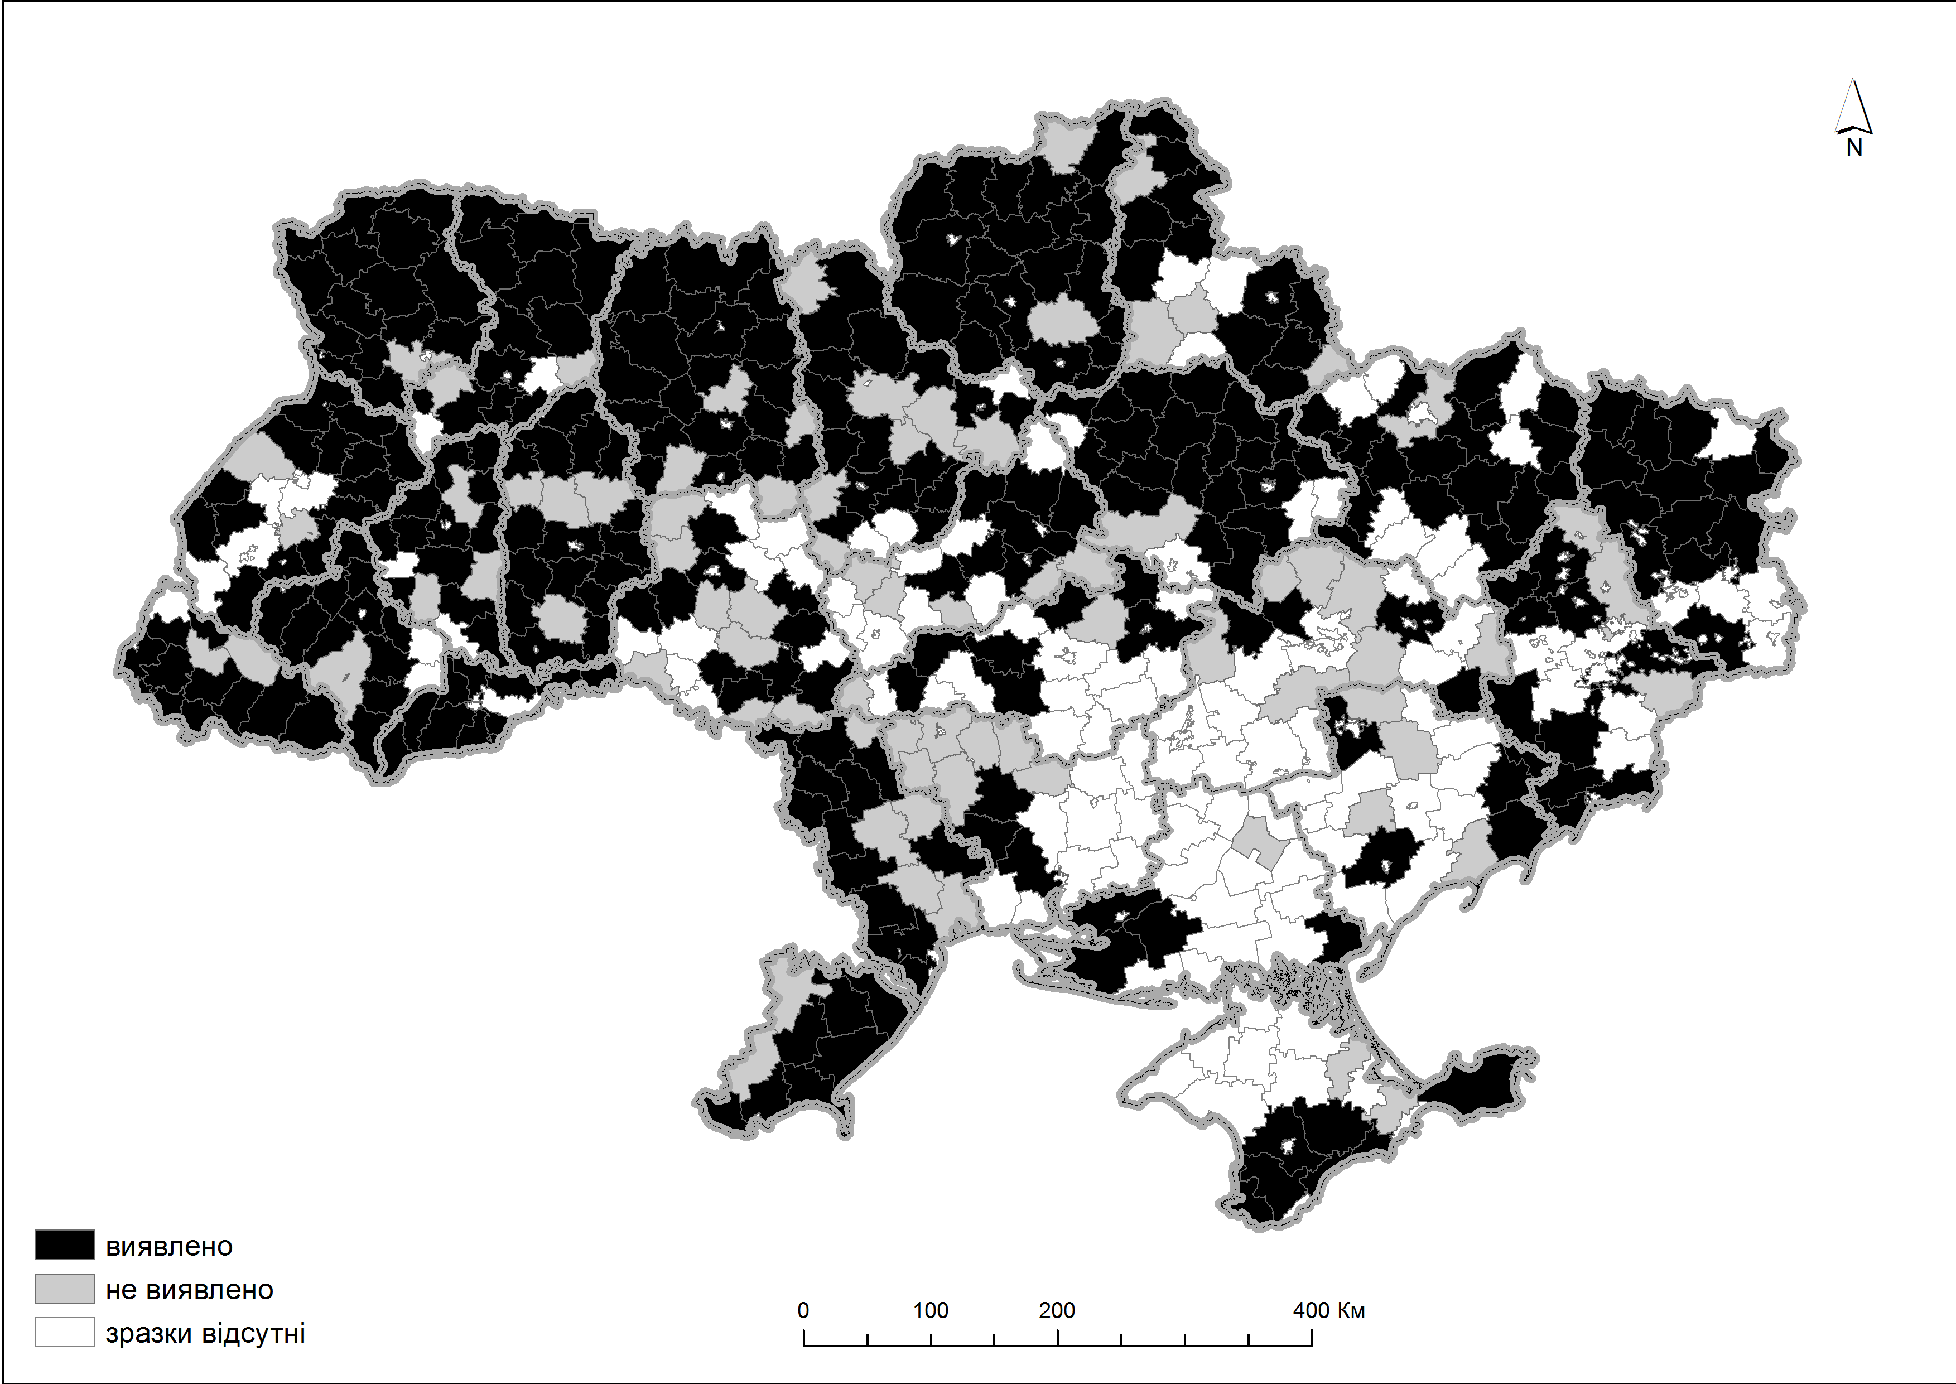
Figure 1. Mapping of rayons of Ukraine, where serological monitoring on Teschen disease was carried out in a population of wild boar in the period 2001-2013 years.
According to Figure 1 during 12 hunting seasons surveys was conducted in all oblasts of Ukraine, the total number of surveyed rayons is 374 (76.3%). Studies were not conducted in 116 rayons. In 292 rayons (59.6%) positive serum from wild boars were found in 1364 samples. The rayons where antibodies to the virus of Teschen disease were identified are distributed throughout Ukraine, but is more concentrated in the Northern, North-Western, Eastern parts of Ukraine and to a lesser extent in Central and South. The frequency distribution of positive samples to the number of rayons is shown in Figure 2.
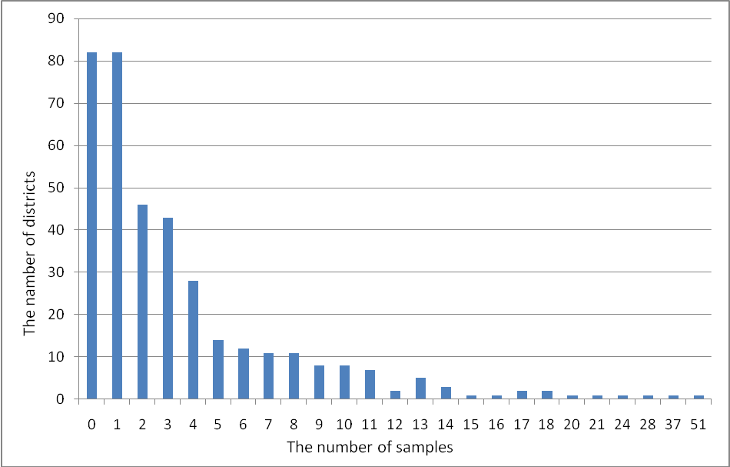
Figure 2. Frequency distribution of positive samples to the number of districts
On the territory of 82 rayons were not identified positive to the virus of Teschen disease serum samples of wild boars. On the territory of 82 districts was revealed only one positive to the virus of Teschen disease serum. Further distribution of positive sera to the number of regions is as follows: 2/46, 3/43, 4/28, 5/14, 6/12, 7/11, 8/11, 9/8, 10/8, 11/7, 12/2, 13/5, 14/3, 15/1, 16/1, 17/2, 18/2, 20/1, 21/1, 24/1, 28/1, 37/1, 51/1. Also we identified and presented on a map rayons where periodically for 12 years positive to the virus of Teschen disease sera were revealed. (Fig. 3).
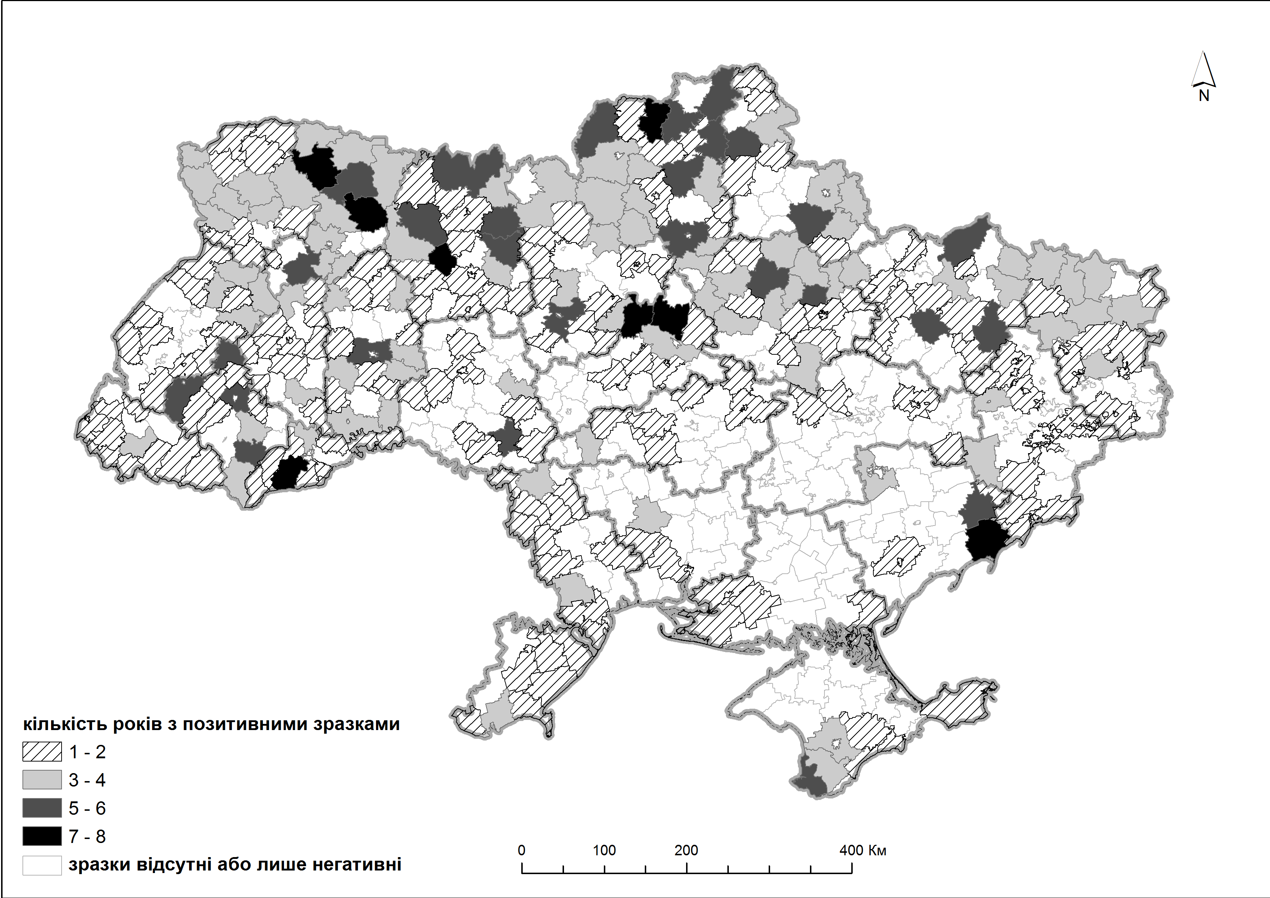
Figure 3. Rayons of Ukraine where periodically positive to the virus of Teschen disease serum were found
Positive to the virus of Teshen disease blood sera of wild boars were registered in 292 rayons for the 12-year period. Mostly these rayons are in the Northern , Western, Eastern parts of Ukraine and to a lesser extent in the Central and Southern parts. In all regions of Ukraine, especially in the South there are areas in which no positive sera were found.
Figure 4 shows the distribution of the number of studied regions by the number of years of revealing positive sera within their territory.

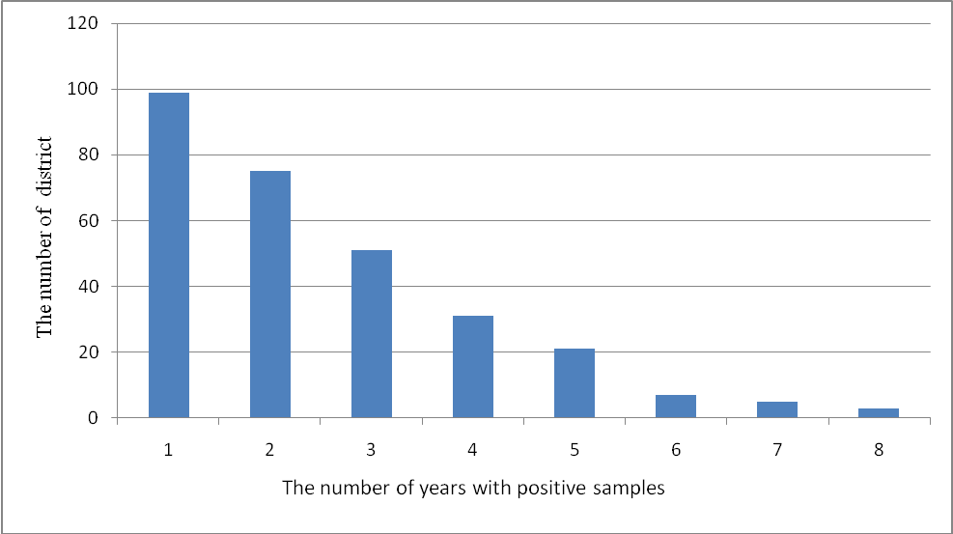
Figure 4. The distribution of the number of studied regions by the number of years of revealing positive sera within their territory.
As seen in Figure 4, in the territory of a number of rayons of Ukraine periodically over 7 years were recorded positive to the virus of Teschen disease wild boars. The distribution of the studied rayons by the number of years of revealing positive to the virus Teschen disease wild boars: 99/1, 75/2, 51/3, 31/4, 21/5, 7/6, 5/7, 3/8.
Discussion. The retrospective serological monitoring of Teschen disease among the population of wild boars indicates that their herds are infected with the virus of Teschen disease. The samples of blood sera from these animals manifested specific humoral antibodies. We have shown on the map 292 rayons of Ukraine, where wild boars were found to have antibodies to the virus of Teschen disease. These rayons are distributed throughout Ukraine, they are more concentrated in the North, North-West, the East parts of the country and to a lesser extent in the centre and in the South. Unfortunately, in some areas, no samples were taken. The state of Teschen disease infection in wild boars requires a more in-depth study.
According to [4] the infection of animals can occur by mechanical transfer of virus to the farms by people, animals, rodents and birds as well as infected pigs. Teschen disease is recorded mainly in private households. and it is due to human activities The virus can be included in the habitats for wild boars (forests, parks, forestry and hunting economy, etc.) as a result of human activity or as a result of wild boars contact with farm lands.
Wild boars as well as domestic pigs can get sick and be carriers of the virus. The spread of the infection also depends on the epizootic status of neighboring States. By migration routes boars can come to the territory of other States make contact with other herds and can be infected. Unfortunately, the study of this pathology among wild boars paid little attention, and in countries bordering Ukraine, such information is absent.
Conclusions. 1. The retrospective serological monitoring of Teschen disease among the population of wild boars in Ukraine indicates that their herds are infected, as the blood sera of these animals manifested specific humoral antibodies.
2. The registration of seropositive to the Teschen disease virus wild boars especially in the North, North-Western parts of the Eastern and Central regions of Ukraine reflects the stationarity of pathogen circulation in their population.
In the future it is necessary to continue serological monitoring of the Teschen disease with coverage of those rayons that have not previously been studied. It is also necessary to focus on the isolation of virus for the study of the antigenic structure.
REFERENCES
1. Коломыцев А. А. Эпизоотологический мониторинг и разработка средств иммунопрофилактики энтеровирусного энцефаломиелита свиней (болезни Тешена) / А. А. Коломыцев, В. М. Дубровин // Нейроинфекции: бешенство, губкообразная энцефалопатия крупного рогатого скота, Крейтцфелда-Якоба и другие прионные болезни; листериоз, болезнь Ауески, болезньТешена : материалы Междунар. науч.-практ. конф. 30–31 мая 2001 г. – Покров, 2001. – С. 160–165.
2. Романенко В. П. Ентеровірусні хвороби свиней / Романенко В. П. // Вет. медицина України. – 2010. – № 12. – С. 11–13.
3. Романенко В. П. Хвороба Тешена (ензоотичний енцефаломієліт свиней) / В. П. Романенко // Вет. медицина України. – 2009. – № 6. – С. 15–17.
4. Романенко В. Ф. Молекулярно-генетическая идентификация энтеровирусов свиней / В. Ф. Романенко // Ветеринария. – 2009. –№ 12. – С. 8–14.
5. Романенко В. Ф. Рекомендации по диагностике и мерам борьбы с энзоотическим энцефаломиелитом (болезнью Тешена) свиней / В. Ф. Романенко, В. И. Сорока, О. Г. Прусс. – К., 1992. – 17 с.
6. Хвороба Тешена. Боротьба і профілактика / Вабіщевич Ф. С., Собко Ю. А., Панченко О. А. та ін. // Вет. медицина України. – 2009. – № 3. – С. 14–15.
7. Энтеровирусная инфекция свиней : porcne enterovirus infections // Вирусные болезни животных / В. Н. Сюрин, А. Я. Самуйленко, Б. В. Соловьев, Н. В. Фомина – М.: ВНИТИБП, 1998. – С. 501–507.
8. Teschovirus Encephalomyelitis (previously enterovirus encephalomyelitis or Teschen/Talfan disease) [Electronic recource] / World Organisation for Animal Health (OIE). – Mode of access : http://www.oie.int/fileadmin/Home/eng/ Health_standards/tahm/2.08.10_TESCHOVIRUS_ENCEPH.pdf. – Title from the screen.

