© 2017
Kovpak V. V., Ph.D of Veterinary Sciences, doctoral student
(academic adviser – Doctor of Veterinary Sciences A. Y. Mazurkevych)
Kovpak O. S., post-graduate student
(academic supervisor – Doctor of Veterinary Sciences A. Y. Mazurkevych)
National University of Life and Environmental Sciences of Ukraine
COMPARATIVE ANALYSIS OF PHENOTYPIC CHANGES OF ADIPOSE TISSUE AND BONE MARROW CELL CULTURES IN THE COURSE OF CULTIVATION
Reviewer – Doctor of Veterinary Sciences, Deputy Head of the Department on Issues of Veterinary Medicine of the Apparatus of the Presidium of NAAS S. P. Doletskyj
This article describes the changes in phenotype of cultures of adipose tissue cells (ATCC) and bone marrow cells (BMCC) in the process of cultivation. Study of primary cultures of cells of the bone marrow and adipose tissue of rat has shown that they are morphologically heterogeneous, they included: a small number of cells of polygonal shape, and the bulk was fìbroblast-like cells. Process of transition from the heterogeneous cultures at zero passaging to the most homogeneous at the end of the study was noted during further cultivation. We noted differences in immunophenotype of bone marrow and adipose tissue cell cultures that did not disappear with passaging.
Key words: cell culture, bone marrow, adipose tissue, immunophenotyping, morphology, CD markers.
Statement of the problem. Year by year the regenerative therapy requires greater guarantees of safety and efficiency of cellular material, so the selection of optimal sources of cells is one of its key stages.
Analysis of main studies and publications laying the foundation for resolving the problem. Today, the bone marrow is fairly well researched as a source of stem cells of adult donors. Bone marrow is the only tissue of an adult organism, which normally consists of immature, undifferentiated and low-differentiated cells, called stem cells [25]. It has been proven that mesenchyme and endothelial cells in the bone marrow can develop into a variety of no hematopoietic cells – osteoclasts, chondrocytes, adipocytes, epithelium [5, 14].
Adipose tissue is an alternative source of cellular material, from which they can be obtained using less invasive methods in much larger quantities, in comparison with the bone marrow. Adipose tissue is composed of fat cells – adipocytes, and the cells that make up the Stromal Vascular Fraction (SVF): pre-adipocytes, endothelial and smooth muscle cells of blood vessels, the perivascular fibroblasts and supportive fibrous collagenous stroma [1, 11]. Stem cells in adipose tissue are multipotent. They are able to differentiate into a variety of cell lines, including adipose, bone, cartilage, nervous tissue, endothelium [16, 33] and liver cells [9, 27].
Transplantation of cell cultures has significant prospects in treatment of many diseases. In order to provide a basis for further research in the field of regenerative medicine, cells obtained from several sources were analysed. This study presents a comparison of the changes in phenotypic characteristics of cells for creation of an experimental system for evaluation and selection of best source of cellular material.
Study’s objective: to compare morphological and phenotypic changes in cell cultures of adipose tissue and bone marrow from the initiation to the fourth passage.
Task: to get the cell culture of bone marrow and adipose tissue, follow the morphological and phenotypic changes in the derived cultures through the cultivation process and analyse the obtained results.
Materials and methods. Animal experiments were conducted in compliance with the requirements of the law of Ukraine «On the protection of animals from cruelty» (article 230, dated 2006). The research used 3 males of non-pedigree rats at the age of 4 months and 9 non-pedigree young rats at the age of 12 days. Experimental animals were euthanized by decapitation under ether anaesthesia.
Cell culture of adipose tissue (ATCC) was obtained from subcutaneous adipose tissue using standard methods [10, 11, 18] modified by us. Bone marrow cell culture (BMCC) was obtained from the bone marrow of femur bone, shin bone and humerus of rats using standard methods [3, 18]. Obtained cell mass cells were cultured in standard environment: 80 % − DMEM; 20 % − FBS; 10 μl/cm³ − antibiotic-antimycotic agent («Sigma», United States) (Pic. 1); in a CO₂ incubator at 37 ºC and 5 % CO₂ concentration [3], to confluence 90–100 % (Pic. 2).
Cells were removed using standard methods (with 0,25 % trypsin/EDTA solution) [3]. Further passaging was carried out with 1:3 dilution. Microscopic analysis and evaluation of culture was carried out using inverted microscope Axiovert 40 (Carl Zeiss).
Phenotype change control was carried out by identifying CD markers (CD10, CD38, CD34, CD45, CD48, CD54, CD56, CD66e, CD96, CD227, CD326b, CD pan keratin). Drugs were prepared using standard methods [3]. Analysis of the results was carried out by the number of cells with expression (green glow of the cells) and estimated using conventional H-Score method: S=1xA+ 2xB + 3xC, where S is the «H-Score» indicator with values ranging from 0 (no protein expression) to 300 (strong expression in 100 % of cells); A – cells with weak expression; B – percentage of cells with moderate protein expression; C – percentage of cells with strong expression. Expression level was determined as negative if the number of points was ranging from 0 to 50; low — from 51 to 100; moderate – from 101 to 200; high – 201 and more [6]. The study was carried out using a fluorescent microscope Leica DMR (Germany).
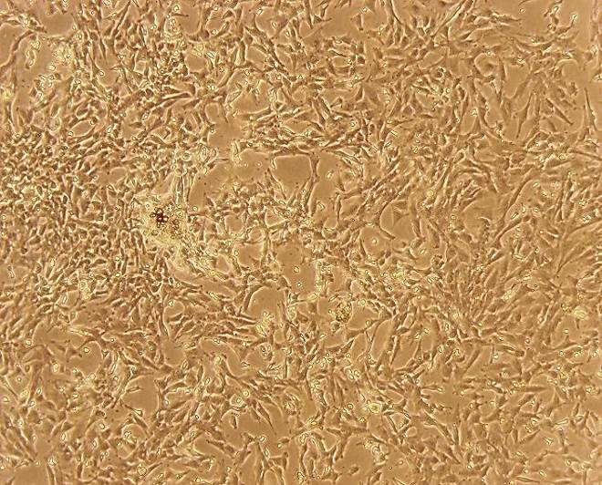
Results of research. Comparative analysis of ATCC and BMCC cell cultures. Primary culture of adhesive cells of adipose tissue and bone marrow of rats was characterized by morphological heterogeneity. Within a few days, after the inoculation a significant number of low-adhesive flat-angulated cells were observed which were removed during passaging. Beginning from the 3rd day for BMCC (Pic. 1) and 5th – for ATCC uniform growth of fibroblast-like cells was noted (Pic. 2). Primary ATCC reached confluence of 90–100 % with an average of 14 days, BMCC – in 8 days.
Pic. 2. Micrograph of a colony of cell culture of adipose tissue in vitro, 7th day of cultivation. Native drug . × 10, × 10
Pic. 1. Micrograph of culture of bone marrow cells in vitro, 7 days of cultivation (0 passage).
Native drug . × 10, × 5

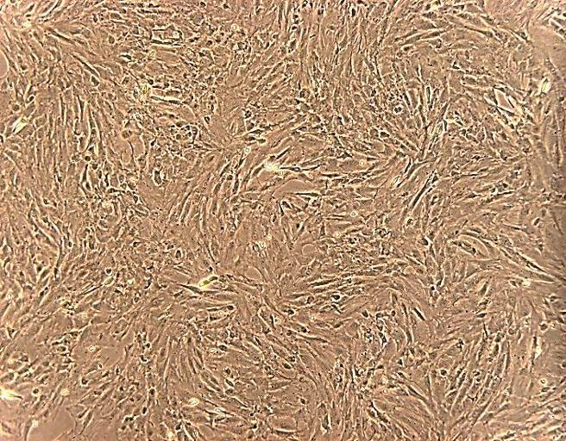
Pic. 4. Micrograph of adipose tissue cell culture monolayer in vitro, passage 1.
Native drug. ×10, ×5
Pic. 3. Micrograph of bone marrow tissue cell culture monolayer in vitro, passage 1.
Native drug. ×10, ×5

In the process of subculturing the time of reaching the confluence of 70–80 % was 4 days for ATCC and 3 days BMCC for 4 passages.
Heterogeneity of cultures both bone marrow (Pic. 3.) and adipose tissue (Pic. 4) was noted during first passage. Their composition included a small number of cells of polygonal shape and fìbroblast-like cells. With every passage the number of polygonal-shape cells decreased both in ATCC and BMCC. During the fourth largest homogeneous composition of cultures was noted. Morphology at passage 4 was marked by mostly fìbroblast-like structure (Pic. 5, 6).

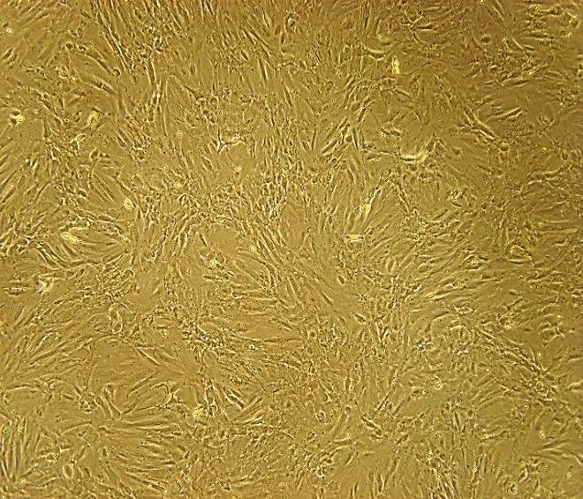
Pic. 5. Micrograph of adipose tissue cell culture monolayer in vitro, passage 4
Native drug . × 10, × 5
Pic. 6. Micrograph of adipose tissue cell culture monolayer in vitro, passage 4
Native drug . × 10, × 5

Characteristics of cells cultures of bone marrow and adipose tissue by surface markers. Study of cultures of the cells of the bone marrow and adipose tissue showed differences in their immunophenotype that do not disappear with passages. Detailed changes in expression of investigated CD markers are shown below.
CD10 or neutral endopeptidase belongs to metalloproteinase family [29], its expression level was determined as negative during the whole period of passaging in both investigated cell cultures.
CD34 – transmembrane monomeric glycoprotein Type I, mediating intercellular adhesion processes. It is a marker of hematopoietic stem cells, vascular endothelial cells and embryonic fibroblasts [20]. During the research maintenance of bone marrow cell culture expression at the same level with minor fluctuations was noted, while ATCC showed sharp decrease in the level of СD34 expression up to negative during passage 4.
Comparison of changes of CD markers expression in a pool of cells extracted from adipose and bone marrow tissue of rats from the first to the fourth passage (M ± m, n = 3)
CD markers | Investigated cell culture | Passage
CD markers | Investigated cell culture | І | ІІ | ІІІ | ІV
CD markers | Investigated cell culture | Score points by H-Score method (from 0 to 300)
10 | BM | 0 ±0 | 0 ±0 | 0 ±0 | 0 ±0
10 | AT | 0 ± 0 | 0 ± 0 | 11 ± 5 | 45 ±15*
34 | BM | 108 ± 8 | 97 ± 8 | 92 ± 2 | 97 ± 4
34 | AT | 93 ± 5 | 73 ± 7 | 41 ± 11* | 8 ± 5***
38 | BM | 116 ± 9 | 94 ± 8 | 57 ± 7** | 38 ±11**
38 | AT | 75 ± 9 | 55 ± 3 | 37 ± 5* | 14 ± 5**
45 | BM | 95 ± 12 | 83 ± 12 | 76 ± 13 | 45 ± 7*
45 | AT | 74 ± 6 | 52 ± 5* | 23 ± 7** | 5 ± 3***
48 | BM | 68 ± 11 | 75 ± 15 | 84 ± 15 | 115 ± 13*
48 | AT | 98 ± 14 | 76 ± 15 | 59 ± 12 | 26 ± 3**
54 | BM | 0 ± 0 | 0 ± 0 | 0 ± 0 | 0 ± 0
54 | AT | 0 ± 0 | 0 ± 0 | 0 ± 0 | 0 ± 0
56 | BM | 73 ± 12 | 85 ± 8 | 96 ± 7 | 84 ± 7
56 | AT | 0 ± 0 | 0 ± 0 | 0 ± 0 | 0 ± 0
66е | BM | 57 ± 12 | 78 ± 11 | 108 ± 14* | 115 ± 15*
66е | AT | 248 ± 10 | 201 ± 17 | 103 ± 16** | 66 ± 7***
95 | BM | 66 ± 13 | 79 ± 15 | 110 ± 7* | 119 ± 9*
95 | AT | 62 ± 7 | 91 ± 22 | 101 ± 5* | 126 ± 13*
227 | BM | 52 ±12 | 68 ±13 | 89 ± 11 | 83 ± 9
227 | AT | 28 ± 6.5 | 46,3 ± 15,3 | 72,7 ± 10,8* | 49,7 ± 9,0
326 | BM | 97 ± 21 | 87 ±19 | 76 ± 11 | 37 ± 6*
326 | AT | 0 ± 0 | 15 ± 3 | 86 ± 6*** | 87 ± 7***
Keratin | BM | 279 ± 15 | 259 ± 20 | 253 ± 19 | 193 ± 16*
Keratin | AT | 82 ± 7 | 85 ± 5 | 71 ± 4 | 83 ± 5
Note: * - Р<0,05; ** - Р< 0,01; *** - Р< 0,001 compared to blank (First passage was the blank for every CD marker).
CD38 – single chain transmembrane glycoprotein, type II, [7], its molecule turns out to be a mediator of several different kinds of activities, including transfer of signal, cell adhesion, and the synthesis of cyclic ADP-ribose [21]. Low expression of CD38 was noted during passage 1, which may indicate the presence of progenitor cells culture. Later on the level of the expression of this marker declined to negative both in BMCC and ATCC.
CD45 – transmembrane glycoprotein type I belonging to protein tyrosine phosphatases family and expressed on all hematopoietic cells except red blood cells and platelets [30]. This fact can explain reliable reduction of expression of this marker in the obtained BMCC from 95 (I passage) to 45 (IV passage) points. Throughout the study of ATCC during first passages, presence of cells that express CD45 was noted, which was mentioned in published data [8], but its level decreased to negative.
CD48 – transmembrane glycoprotein type I with the cell membrane by glycosylated phosphatidylinositol [28]. CD48 is expressed on some hemopoietic and endothelial cells. It participates in the activation and ways of differentiation of these cells. During the survey a fair reduction in the ATCC expression from low to negative degree, while in the BMCC the expression level of manifestation CD48 reliably increased from low to moderate.
CD54 – single chain transmembrane glycoprotein, type I, present on the membranes of endothelial cells and is essential for the adhesion of leukocytes [15]. During the entire period of cultivation its expression in both ATCC and BMCC was not found.
CD56 – transmembrane glycoprotein, type I, isoform of molecules of neurons cell adhesion, mediating development of the nervous tissue, marker of NK-cells and plasma cells [13]. During the entire period of cultivation its expression both in ATCC and BMCC was not observed, while BMCC was characterized by a low level of CD56 expression from the first to the fourth passage.
CD66e – glycosylated glycoprotein of epithelial cell surface membrane, that explains its detection in most organs [17]. In the culture of cells of adipose tissue its expression of it was decreasing beginning from the first to fourth passage, reverse pattern was observed in BMCC.
CD95 – transmembrane glycoprotein type I, mediates the signal that initiates apoptosis [32]. Beginning from the first passage expression intensity of this marker was increasing in either investigated cultures. CD95 expression growth data correlates with levels of apoptosis in bone marrow cell culture that was investigated by us earlier [2]. So with the obtained data we can conclude that increase in CD95 level is explained by the growths of cells in apoptosis.
CD227 – transmembrane glycoprotein, expressed by epithelial and some hematopoietic cells [19]. Hyper-expression of this marker leads to cell transformation of the cell and eliminates the stress-induced apoptosis through Akt or p53 cascades [26]. During the research we noticed the low level of CD227 expression with minor fluctuations, whereas in the adipose tissue cell culture expression level exceeded negative value only on the third passage and reached its maximum mark, 73 points.
CD326 – transmembrane glycoprotein, type I, is a marker of epithelial cells. Cells that express this marker have a reduced need for growth factors, increase in their metabolic activity and the ability to form colonies is observed [24]. Bone marrow cell culture showed decline of CD326 expression from low to negative degree, while in the adipose tissue cell culture the reverse pattern was noted.
Keratin is included in intermediate filaments of epithelial cell cytoskeleton [12]. Presence of a positive reaction with these antibodies indicates epithelial origin of the cells [23], cytokeratin was detected in adipose tissue by other scientists [1, 31], while according to our own results keratin expression level in adipose tissue remained at the same level, and was characterized as low. Culture of bone marrow cells showed accurate reduction of this protein from high to moderate level.
Conclusion and prospects for further research.
Results of our studies have shown that the primary culture of adhesive cells both of adipose tissue and bone marrow consists of different kinds of cells, which is associated with a diversity of the original pool. Increase of percentage content of fìbroblast-like cells in the studied cell cultures with passages was noted. During the passaging the CD-profile of the cells in the studied cultures was changing with certain patterns. Based on the range of used CD markers specific for non-specialized (poorly differentiated) cells, intense reduction of their expression with passages in ATCC (compared to BMCC) may indicate reduction in versatility of this culture and its differentiation ability. This hypothesis is confirmed by credible growth of CD95, indicating initiation of apoptosis in the culture.
Different phenotypes of cell cultures of bone marrow and adipose tissue allow their future use in cell therapy and different impact under similar conditions may be expected.

BIBLIOGRAPHY:
- Кирик В. М. Стволовые клетки из жировой ткани: основные характеристики и перспективы клинического применения в регенеративной медицине (обзор литературы) /
В. М. Кирик, Г. М. Бутенко // Журн. АМН України. – 2010. – Том 16, №4. – С. 576–604.
- Мазуркевич А. Й. Цитогенетичний аналіз мезенхімальних стовбурових клітин щурів на різних пасажах / А. Й. Мазуркевич, В. В. Ковпак, О. С. Ковпак та ін. // Ветеринарна біотехнологія. – 2016. – №28. – С. 165–172.
- Мазуркевич А. Й. Клітинні технології у ветеринарній медицині : навчальний посібник / А. Й. Мазуркевич, В. В. Ковпак, В. Б. Данілов. – К. : КОМПРИНТ, 2014. – 132 с.
- Петренко А. Ю. Стволовые клетки из жировой ткани / А. Ю. Петренко, Э. Н. Иванов, Ю. А. Петренко // Біотехнологія. – 2008. – Том 1, №4. – С. 39–48.
- Сухих Г. Т. Мезенхимальная стволовая клетка / Г. Т. Сухих, В. В. Малайцев,
И. М. Богданова // Бюлл. эксперим. биол. и мед. – 2002. – №2. – С. 124–131.
- Упоров А. В. Иммуногистохимическое изучение клеток рака молочной железы с использованием разных маркеров пролиферации / А. В. Упоров, В. Ф. Семиглазов,
К. М. Пожарисский // Арх. патологии. – 2000. – №2. – С. 26–30.
- Alessio M. CD38 molecule: structural and biochemical analysis on human T lymphocytes, thymocytes, and plasma cells / M. Alessio, S. Roggero, A. Funaro et al // Immunol. – 1990. – Vol. 3 –
Р. 878–884.
- Astori G. «In vitro» and multicolor phenotypic characterization of cell subpopulations identified in fresh human adipose tissue stromal vascular fraction and in the derived mesenchymal stem cells / G. Astori, F. Vignati, S. Bardelli et al // J. Transl. Med. – 2007. – Vol. 5, №1. – Р. 55.
- Aurich H. Hepatocyte differentiation of mesenchymal stem cells from human adipose tissue in vitro promotes hepatic integration in vivo / H. Aurich, M. Sgodda, P. Kaltwasser et al // Gut. – 2009. – №58. – Р. 570–581.
- Bunnell B. A. Adipose-derived stem cells: isolation, expansion and differentiation /
B. A. Bunnell, M. Flaat, Ch. Gagliardi et al // Methods. – 2008. – №45 (2). – Р. 115–120.
- Carswell K. A. Culture of Isolated Human Adipocytes and Isolated Adipose Tissue /
K. A. Carswell, Mi-Jeong Lee, S. K. Fried // Methods Mol Biol. – 2012. – №806. – Р. 203–214.
- Chang L. Intermediate filaments mediate cytoskeletal crosstalk / L. Chang, R. D. Goldman // Nat. Rev. Mol. Cell Biol. – 2004. – Vol.5, №8 – P. 601–613.
- Cunningham B. A. Neural cell adhesion molecule: structure, immunoglobulin-like domains, cell surface modulation, and alternative RNA splicing / B. A. Cunningham, J. J. Hemperly, B. A. Murray // Science. – 1987. – №236 (4803). – Р. 799–806.
- Dorshkind K. Stem cells and lineage plasticity: the challenge to existing paradigms /
K. Dorshkind // Immunological Reviews. – 2002. – Vol. 187. – P. 5–8.
- Gay A. N. Wound healing characteristics of ICAM-1 Null mice devoid of all isoforms of ICAM-1 / A. N. Gay, O. P. Mushin, D. A. Lazar et al // J. Surg. Res. – 2011. – №171 (1) – e1-7.
- Guilak F. Clonal analysis of the differentiation potential of human adipose-derived adult stem cells / F. Guilak, K. E. Lott, H. A. Awad et al // J. Cell Physiol. – 2006. – №206. – Р. 229–237.
- Hammarström S. The carcinoembryonic antigen (CEA) family: structures, suggested functions and expression in normal and malignant tissues / S. Hammarström // Semin. Cancer. Biol., 1999. – Vol. 9. – P. 67–81.
- Freshney R. Ian Culture of animal cells: a manual of basic technique / R. Ian Freshney. – [5th ed.]. – USA : John Wiley & Sons, 2005. – 642 p.
- Inagaki Y. Clinicopathology of sialomucin: MUC1, particularly KL-6 mucin, in gastrointestinal, hepatic and pancreatic cancers / Y. Inagaki, H. Xu, M. Nakata et al // Biosci. Trends. – 2009. – №6. – Р. 220–232.
- Krause D. S. CD34: structure, biology, and clinical utility / D. S. Krause, M. J. Fackler,
C. I. Civin, W. S. May // Blood, 1996. – Vol. 87, №1. – P. 1–13.
- Malavasi F. Human CD38: a glycoprotein in search of a function / F. Malavasi, A. Funaro, S. Roggero et al // Immunol. Today. – 1994. – №3. – Р. 95–97.
- Mitchell J. B. Immunophenotype of human adipose-derived cells: temporal changes in stromal-associated and stem cell-associated markers / J. B. Mitchell, K. McIntosh, S. Zvonic et al // Stem Cells. – 2006. – №24 (2). – Р. 376–385.
- Moll R. The catalog of human cytokeratins: patterns of expression in normal epithelia, tumors and cultured cells / R. Moll, W. W. Franke, D. L. Schiller, B. Geiger et al // Cell, 1982. – Vol. 31, №1. – P. 11–24.
- Münz M. The carcinoma-associated antigen EpCAM upregulates c-myc and induces cell proliferation / M. Münz, C. Kieu, B. Mack, B. Schmitt et al // Oncogene, 2004. – Vol. 23, №24. – P. 5748–5758.
- Ningning He. Bone Marrow Vascular Niche: Home for Hematopoietic Stem Cells /
He Ningning, Zhang Lu, Cui Jian et al // Hindawi Publishing Corporation: Bone Marrow Research, 2014. – Article ID 128436. – 8 pp.
- Raina D. The MUC1 oncoprotein activates the anti-apoptotic phosphoinositide 3-kinase. Akt and Bcl-xL pathways in rat 3Y1 fibroblasts / D. Raina, S. Kharbanda, D. Kufe // Biol. Chem. – 2004. – Vol. 279, №20. – Р. 20607–20612.
- Ruiz J. C. Differentiated human adipose-derived stem cells exhibit hepatogenic capability in vitro and in vivo / J. C. Ruiz, J. W. Ludlow, S. Sherwood et al // J Cell Phys., 2010. – №225. – Р. 429–436.
- Shin J. S. Glycosylphosphatidylinositol-anchored receptor-mediated bacterial endocytosis / J. S. Shin, S. N. Abraham // FEMS Microbiol Lett. – 2001. – Vol. 197, №2. – Р. 131–138.
- Shipp M. A. Common acute lymphoblastic leukemia antigen (CALLA) is active neutral endopeptidase 24.11 («enkephalinase»): direct evidence by cDNA transfection analysis / M. A. Shipp,
J. Vijayaraghavan, E.V. Schmidt et al // Proc. Natl. Acad. Sci. USA, 1989. – №86 (1). – Р. 297–301.
- Trowbridge I. S. CD45: an emerging role as a protein tyrosine phosphatase required for lymphocyte activation and development / I. S. Trowbridge, M. L. Thomas // Annu. Rev. Immunol. – 1994. – №12. – Р. 85–116.
- Yang J. In vitro expression of cytokeratin 18, 19 and tube formation of adipose‐derived stem cells induced by the breast epithelial cell line HBL‐100 / J. Yang, L. Xiong, R. Wang et al // J. Cell Mol. Med., 2015. – №19 (12). – Р. 2827–2831.
- Yonehara S. A cell-killing monoclonal antibody (anti-Fas) to a cell surface antigen co-downregulated with the receptor of tumor necrosis factor / S. Yonehara, A. Ishii, M. Yonehara // Exp. Med., 1989. – Vol. 169, №5. – P. 1747–1756.
Zuk P. A. Multilineage cells from human adipose tissue: implications for cell-based therapies / P. A. Zuk, M. Zhu, H. Mizuno et al. // Tissue Eng., 2001. – №7. – Р. 211–228.

