© 2014
Patyka M.V., Doctor of Agricultural Sciences
National Scientific Centre “Institute of Agriculture of NAAS”
Moskalevska Yu. P., post-graduate student
National University of Life and Environmental Sciences of Ukraine
(Supervisor - Doctor of Agricultural Sciences . V. Patyka)

MICROBIAL PROCESSES OF CARBON TRANSFORMATION IN RHIZOSPHERE OF SUGAR BEET IN TYPICAL CHERNOZEM
A reviewer is doctor of biological sciences I.I. Koshevskiy
The comparative analysis of the number by a functional targeting of the microbiota of sugar beet rhizosphere, which is involved in the transformation of carbon and its compounds, under different agrarian measures was conducted. The content of organic and labile water-soluble carbon in the chernozem typical and a condition of sugar beet crops is defined. It is established that localization of organic substances in the upper root-inhabited soil layer contributes to increase the number of microorganisms which involved in the carbon cycle in crop’s rhizosphere.
Keywords: sugar beet, rhizosphere, bacteria, multisubstrate testing, carbon, typical chernozem, agrarian systems

Statement of the problem. Carbon is the basic structural element of living organisms. It is a part of all organic compounds. The key role in the biospheric mechanisms of the Earth that are connected with biogeochemical cycles is played the carbon cycle [9]. In this cycle microorganisms play a significant role. Soil is a major reservoir of carbon in the biosphere (more than 70 % of the carbon is contained in the soil biosphere) and the natural environment of microorganisms that are involved in the formation and functioning of the soil and circulation of substances in the nature [7, 9, 10].
Significant influence on the distribution of different groups of microorganisms in the soil are determined the root exudates of plants that are nutritious substrate for microorganisms that are intensively function and interact with the root zone of plants [13]. Plant rhizosphere is a dynamic biological surrounds, which there are many factors in, that determine the structure and composition of microbial communities, which inhabite the plants rhizosphere. The microflora structure of rhizosphere of different plants is significantly different and determined by the type and the stage of plant development. Research of the structure and composition of these groups is a fundamental task for understanding the mechanisms of the influence of environment factors on the soil biological processes [14].
The analysis of the last researches and publications that discuss the problem. Researches of many domestic and foreign scientists are established, that the processes of microbic transformation of carbon and its compounds in soil define not only such important soil properties as fertility, biological efficiency, biodiversity, but also directly influence on the character and direction of global changes of the biosphere [1, 3-5, 7-9]. Besides, multifunctional and high sensitivity of microorganisms allows to register their fast response to change of environment characteristics and provides an opportunity to estimate and predict the ecosystem condition as a whole [6].
The microbial processes of carbon compounds transformation are changes under conditions of high pressures on soil surroundings in relation and intensive technology cultivation of crops. That changes are expressed in quantitative and qualitative redistribution in the structure of soil microbial complex, which do not always have a positive effect [4]. Therefore, taking into account the urgency of the problem, the purpose of the work was to evaluate the formation of soil microbial complex, which is involved in the carbon transformation and study characteristics of its metabolism in the application of different agrarian measures.
Research objectives is to define the number of basic functional groups of microbiota that are involved in the circulation of carbon compounds and determine the metabolism of carbon compounds, content of organic and water-soluble labile carbon under different agrarian systems and soil tillage in the rhizosphere of sugar beet of typical chernozem.
Materials and methods. The study of microbial complex of sugar beet (Beta vulgaris) rhizosphere was executed at the stationary field experiment of the Department of Agriculture and herbology of NUBiP of Ukraine «Agronomy Research Station» in the forest-steppe zone of beet-grain rotation in the phase before harvesting sugar beets. Soil is the typical chernozem which has such indexes: humus in the rhizosphere is 4,85-5,18 %, N_{total} - 0,253-0,26 %, P (mineral form) - 2,22-2,62 mg/100 g of soil, K - 7,32-9,45 mg/100 g soil, pH_{KCl} 7,43 - 7.62 , pH_{H2O} - 7,83-7,95, hydrolytic acidity - 0,34-0,45.
The scheme of experiment is provided to study of two factors: agrarian systems and measures of soil tillage:
1) industrial agrarian system - (control) - (application of N₉₂P₁₀₀K₁₀₈ fertilizer, 12 tons of manure per hectare of crop rotation) + surface tillage (cultivation of disk tools to a depth of 8-10 cm under all crops rotation);
2) industrial system + differentiated tillage - (to hold 6 times plowing on different depth, 2 times the surface tillage under winter wheat after peas and corn silage and 1 time – tillage under barley for crop rotation);
3) ecological agrarian system (application of N₄₆P₄₉K₅₅ fertilizer, 24 tons of organic fertilizer (12 tons of manure, 6 tons of non-commercial harvest (straw), 6 tons of green manure crop mass (radish)) per hectare of crop rotation + surface tillage;
4 ) ecological agrarian system + differentiated tillage;
5) biological agrarian system (24 tons of organic fertilizer) + surface tillage;
6) biological agrarian system + differentiated tillage [11].
The number of microorganisms that involved in the circulation of the major carbon compounds was determined by the inoculation of soil suspensions on solid culture media [5]. The number of different functional groups of microorganisms that are used in their metabolism of carbon sources was determined by a multisubstrate testing [1]. Total carbon content was determined by the Turin’ method in Simakov modification [2], labile carbon – by the method of Schultz and Kershens [12]. Statistical analysis of the research results was conducted in MS Excel.
Results. Microbial transformation of organic compounds, the bulk of which are cellulose, hemicellulose, pectin, starch, chitin, lipids, lignin, humus compounds, etc., is important in the mineralization and formation processes of the soil and the carbon cycle, which is including the structuring and formation of humus substances and returning the bulk of CO₂, required for diffusion to the atmosphere [5].
It is established, that the number of bacteria that are involved in the carbon cycle are varied within 0,86-10,29 million CFU/1 g a.d.s., the bulk of whom were bacteria (Fig. 1).

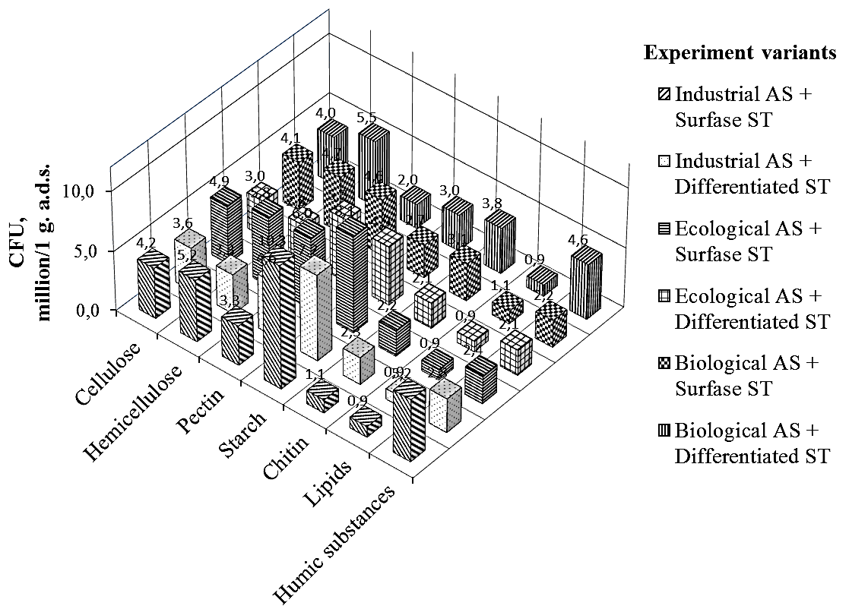
Fig. 1. The number of bacteria in sugar beets rhizosphere, that are participated in the circulation
of carbon compounds

The quantity of microorganisms that transform cellulose was 3,05-4,91 CFU/1 g a.d.s., hemicellulose - 2,85-5,83 million. The share of streptomycetes among hemicellulose transformers was 36,1 -59,7 %. The greatest number of these microorganisms was revealed by the biological AS - respectively 4,00-4,07 million and 4,68-5,48 million. At the ecological AS there was a decrease in the number of cellulose and hemicellulose transformers by 1,3 % and 17 %, at the industrial AS - by 2,6% and 19,7 %. It is established that the use of the surface tillage contributes to increase the number of microorganisms, which participate in the transformation of cellulose by 23,9% and hemicellulose by 33,6 %, due to localization lant residues in the upper root-inhabited soil layer.
The number of microbiota which are involved in the pectin transformation was 2,03-6,00 million CFU/1 g. a.d.s., 71,3-85,5 % of which were bacteria, 8,5-16,4 % - streptomycetes and 3,2-16,7 % - micromycetes. The smallest number of microorganisms that decompose pectin (2,03 million) is revealed at the application of biological AS with the differentiated ST, the greatest – at the ecological AS with surface ST (6.00 million). The number of microorganisms, that are transformed starch is varied within 2,75-10,29 million. The character of zones around colonies of microorganisms indicated that the hydrolysis took place to the stage of formation of sugar. The most active processes of starch transformation are occurred at the industrial AS, the least active are at the biological AS (by a 3 times less). The number of bacteria that transform pectin and starch are increased by 17,4% and 39,7 % at the application of surface ST.
The number of microorganisms, that are involved in the chitin transformation, are varied within 1,10-3,82 million CFU/1 g a.d.s. The most of them was revealed at the experiment variant - biological AS + differentiated ST (3,82 million), the least – at the industrial AS + surface ST (1,10 million). The number lipid-transforming microflora was 0,86-1,07 million. The most microorganisms, that convert lipids and chitin, was detected at the biological AS - 0,95-1,07 and 3,09-3,82 million. At the ecological AS the number of microbiota was lower by 12,8 and 60,2%, at the industrial AS – by 15,4% and in 2 times respectively. The quantitative structure of microorganisms that are involved in the lipids conversion was higher by 5,8 % and chitin, however, was lower by 28,7 % at the surface ST, due to the increase fungi biomass and chitin-containing remains of macrofauna in root-inhabited layer of the chernozem.
The number of a microbiota, which participates in the transformation of humic substances, was 2,13-5,21 million CFU/1 g a.d.s. Thus, more microorganisms are revealed at the industrial AS (5,21 million at the surface and 2,84 million at the differentiated ST), the least – at the ecological AS (2,36 million and 2,13 million respectively). The number of microflora was on 2,2 % higher at the surface ST, than at differentiated ST. That is, the localization of organic matter in the upper soil layer is contributes (in different degree) to increase the number of active microbial soil component, which are involved in the circulation of carbon compounds.
Metabolism of various carbon-containing compounds in the soil occurs differently due to differences in their structure and the great biodiversity of microflora, which are used the carbon sources in its metabolism [10]. It is establised by the multysubstrate testing, that the total number of functional groups of microorganisms was greater on substrates with tryptophan (1,48 million CFU/1g a.d.s.) and lemon acid (1,41 million) (Fig. 2, 3). The total number of microorganisms, that are used the carbon sources in their metabolism, was higher by 4% at the differentiated ST compared with the surface ST. The quantitative structure of the microbiota, which are used the carbon sources in its metabolism, was higher by 32,5 and 51,7 % at the biological AS, than at the industrial and ecological AS. Thus, the use of organic fertilizers contributes to the preservation of ecological and trophic relationships and high functional activity of soil microorganisms.

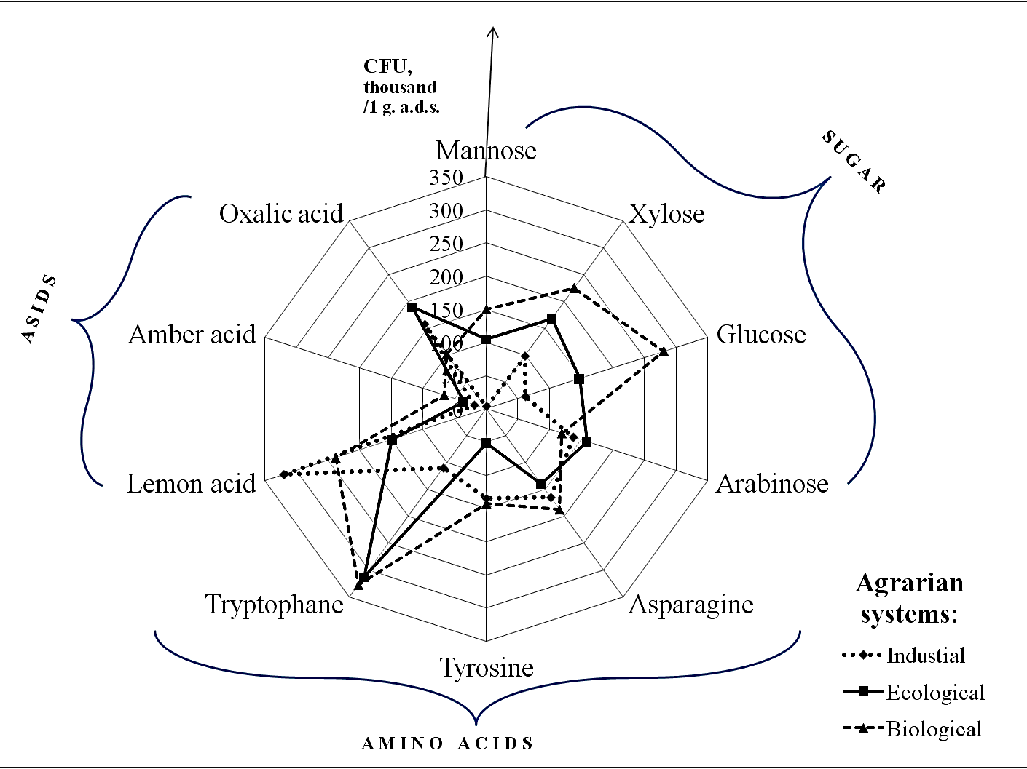
Fig. 2. The number of functional groups of microorganisms that utilize carbon sources at the surface ST
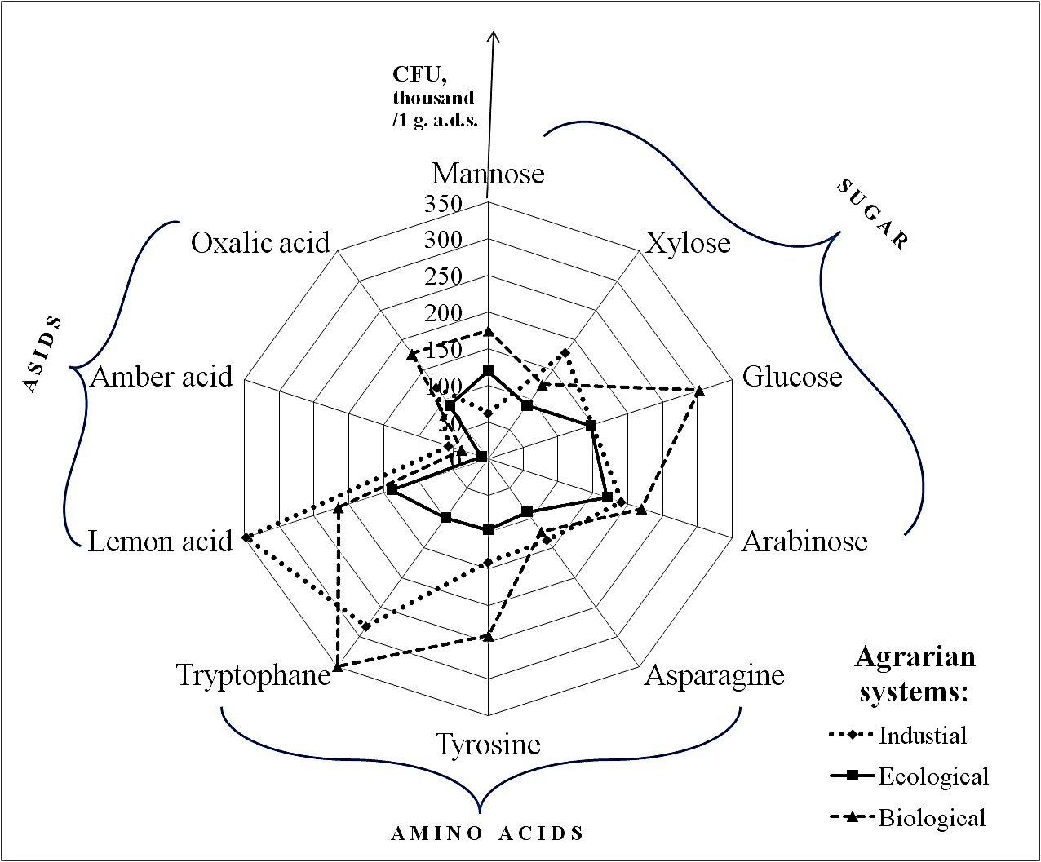
Fig. 3. The number of functional groups of microorganisms that utilize carbon sources at the differentiated ST
It is known that chernozems are characterized by the best indicators of soil quality that contribute to their fertility, than other soils. The content of total carbon in the rhizosphere of sugar beet was high and made 2,81-3,00 % (Table 1). The content of organic carbon was higher at the biological and industrial AS by 3% compared to the ecological AS. Application of the surface ST contributes to the accumulation of organic carbon in the soil by 3,5 % more, than at the differentiated ST. Chernozem typical are characterized optimum indexes of the content of labile water-soluble carbon (306,82-350,68 mg/kg) (Table 1). The stocks of labile carbon were higher at the biological and ecological AS than at the industrial AS. The application of surface ST contributes to the accumulation of organic C in the rhizosphere of sugar beet by 6,9% more, than at the differentiated ST.
1. The content of organic and labile carbon in the soil at the different agrarian systems
Experiment variant | Industrial AS |  | Ecological AS |  | Biological AS
Experiment variant | Sur. ST | Diff. ST | Sur. ST | Diff. ST | Sur. ST | Diff. ST
Content of С_{оrg.,} % | 2,97 | 2,88 | 2,89 | 2,81 | 3,00 | 2,87
С_{lab.,} mg/kg | 321,47 | 306,82 | 341,13 | 323,00 | 350,68 | 318,22

Biometric indicators of plants are integral indicators, which are estimated the impact of agrotechnical measures on soil fertility and crop productivity (Table 2). The largest area of leaf blade was at the ecological AS with surface ST (600,3cm²), and the greatest mass of root was at the industrial AS with surface ST (2,35 kg). Generally, the area of leaf blade was higher by 7,8 % at the surface ST than at the differentiated ST, and the soil tillage did not influence on root mass. The root mass is decreased with decreasing of mineral and organic fertilizers norm. The leaf blade was greater at 4,5 % and 1,1% at the application of ecological AS than at the industrial and biological AS.
2. Biometric parameters of sugar beet
Experiment  variant |  | L | H | L | H | M  root,  kg | S  leaf blade,  сm² | Index of correlation of leaf area to root area
 |  | root |  | leaf blade |  | M  root,  kg | S  leaf blade,  сm² | Index of correlation of leaf area to root area
 |  | сm |  |  |  | M  root,  kg | S  leaf blade,  сm² | Index of correlation of leaf area to root area
Industrial AS | Sur. ST | 35,9 | 16,0 | 41,4 | 11,3 | 2,35 | 509,2 | 0,89
Industrial AS | Diff. ST | 38,1 | 14,1 | 40,4 | 11,2 | 1,81 | 453,3 | 0,84
Ecological AS | Sur. ST | 29,0 | 14,0 | 44,1 | 13,6 | 1,49 | 600,3 | 1,48
Ecological AS | Diff. ST | 36,8 | 14,3 | 36,0 | 11,2 | 1,72 | 405,2 | 0,77
Biological AS | Sur. ST | 34,7 | 12,3 | 43,0 | 11,6 | 1,36 | 427,6 | 0,58
Biological AS | Diff. ST | 33,8 | 12,6 | 41,6 | 13,6 | 1,63 | 566,8 | 1,61
НІР, 5% |  | 5,90 | 3,57 | 5,80 | 3,01 | 3,01

Conclusions. Thus, there are formed specific microbial cenosis to the culture with varying quantity that are involved in the conversion of carbon, in the rhizosphere of sugar beet under different agrarian measures. It is occurred redistribution of functional activity of the microbial component. This is contributes to change the orientation of microbial metabolic conversion of carbon compounds. It is established, that the use of organic fertilizers promote to increase the numerical structure of microbiota, which is involved in the circulation of hemicellulose, chitin and lipid in 1,13-2,05 times, and in the transformation of sugars (mannose, xylose, glucose), amino acids (asparagine, tyrosine, tryptophan) and oxalic acid in 1,26-4,9 times compared with ecological and industrial AS. Localization of organic matter in the top layer of soil leads to increase of the content of labile carbon by 6,9% and organic carbon by 3,5% in the rhizosphere of sugar beet and increase the number of active microbial component of soil, which is involved in the circulation of carbon compounds by 2,2-39,7%. Application of intensive (industrial) technology of crops cultivation is promoted to increase the root mass of sugar beet by 29,7-37,5%.
REFERENCES:
- Gorlenko M.V. Мультисубстратное тестирование природных микробных сообществ /М.В. Горленко, П.А. Кожевин. – М.: МАКС, Пресс, 2005. – 88 с.
- Gorodniy M.M. Агрохімічний аналіз: /М.М. Городній, А.В. Бикін, А.Г. Сердюк [та ін.]. – К.: Арістей, 2007. – 624 с.
- Iutynska G.O. Грунтова мікробіологія. – К.: Арістей, 2006. – 284 с.
- Кruglov Yu.V. Изменение агрофизических свойств и микробиологических процессов дерново-подзолистой почвы в экстремальных условиях высокой температуры и засухи /Ю.В. Круглов, М.М. Умаров, Н.В. Патыка //Известия ТСХА. – 2012. – Вып. 3. – С. 79-87.
- Методы почвенной микробиологии и биохимии: Учеб. Пособие /Под ред. Д.Г. Звягинцева. – М.: Изд-во МГУ, 1991. – 304 с.
- Minaeva E.S. Влияние полевок (Microtus rossiaemeridionalis и Clethrionomys glareolus) на биологическую активность почв: автореф. дис. на соискание учен. степени канд. биол. наук: спец. 03.02.08 «Экология», 03.02.13 «Почвоведение» /Е.С. Минаева. – М., 2013. – 26c.
- Patyka N.V. Профиль полиморфизма длин рестрикционных фрагментов комплекса прокариотных микроорганизмов подзолистых почв /Н.В. Патыка, Ю.В. Круглов, И.А. Тихонович, В.Ф. Патыка //Доповіді Національної академії наук України. – 2009. - № 1. – С.187-192
- Patyka N.V. Исследование дерново-подзолистых почв при возделывании льна-долгунца в сверхдлительном опыте /Н.В. Патыка, Ю.В. Круглов, М.А. Мазиров [и др.] //Корми і кормовиробництво. – 2008. – Вип.62. – С. 258-268
- Pomazkina L.V. Устойчивость агроэкосистем к загрязнению фторидами /Л.В. Помазкина, Л.Г. Котова, Е.В. Лубнина [и др.] – Иркутск, Из-дво И-та географии СО РАН, 2004. – 225 с.
- Sydorenko O.D. Микробиология /О.Д. Сидоренко, Е.Г. Борисенко, А.А. Ванькова, Л.И. Войко. – М., 2005. – 287 с.
- Tanchyk S.P. Екологічна система землеробства в Лісостепу України. Методичні рекомендації для впровадження у виробництво /С.П. Танчик, О.А. Демідов, Ю.П. Манько. – К.: НУБІП України, 2011. – 39 с.
- Sсhultz E. Характеристика разлагаемой части органического вещества почвы и ее трансформации при помощи экстракции горячей водой /Э. Шульц, М. Кершес //Почвоведение. – 1998. – № 7. – С. 890-894.
- Davey M. E. Microbial biofilms: from ecology to molecular genetics /M.V. Davey, G.A. O’toole //Microbiology and molecular biology reviews. – 2000. – Т. 64. – №. 4. – С. 847-867.
- Lupwayi N. Z. Soil microbial diversity and community structure under wheat as influenced by tillage and crop rotation /N.Z. Lupway, W.A. Rice, G.V. Clayton //Soil Biology and Biochemistry. – 1998. – Т. 30. – №. 13. – С. 1733-1741

