© 2015
Velychko E. I., graduate student
Kharkiv National Agrarian University named after V. V. Dokuchayev
ECONOMIC EFFICIENCY OF MILK PRODUCTION IN AGRICULTURAL ENTERPRISES
Reviewer – Doctor of Economic Sciences, Professor O. M. Suprun
Economic efficiency of milk production is considered in agricultural enterprises. We investigated economic efficiency of milk production on the example of «Agricultural Firm named after T. G. Shevchenko» Vovchansk district of Kharkiv region. The basic statistical indexes of effectiveness of activity of the probed economy were used for this purpose. As a result of study and generalizations of experimental data of research are grounded that «Agricultural Firm named after T. G. Shevchenko» is an effective agricultural enterprise. The basic ways of increase of profitability of suckling stock-raising of enterprise are certain.
Keywords: milk, suckling cattle breeding, production, economic efficiency, agricultural enterprise.
A description of the problem. The suckling cattle breeding presently is on the stage of crisis which is accompanied sharp reduction of total number of livestock, diminishing of production of goods volumes and decline of it economic efficiency. To a great extent it is predefined by resource unbalanced of production, worsening of its technological parameters, violation of parity mutual relations between producers and processing of suckling products. Study of question of increase of efficiency of production of milk with the purpose of providing of population of Ukraine by food stuffs in accordance with the norms of the Ministry of health is topical. The complex research of nascent problems, related to organization and technological process of production, reorientation of it on eventual results is important, that predetermines actuality of the adopted research also.
The analysis of the last researches and publications testifies that to the questions of development of the suckling cattle breeding and problems, to related to economic efficiency of production of milk, attention of many research workers is spared. The far of scientific labours and researches of domestic scientists is devoted this theme, in particular: V. Andriychuk [1], P. Berezivskiy [2], M. Il'chuk [3], P. Sabluk [4], V. Mesel'-Veselyak [5], M. Parkhomets' [6], O. Suprun [7] and other. However, in connection with actuality, subsequent scientific researches in this industry are important and necessary.
Research purpose – to probe economic efficiency of milk production in agricultural enterprises.
Task of research – to probe efficiency of milk production in agricultural enterprises on the example of «Agricultural Firm named after T. G. Shevchenko» Vovchansk district of Kharkiv region and to define the ways of increase of profitability of suckling stock-raising.
Materials and methods of research. Theoretical and methodical basis of research were substantive provisions of economic theory, management theory, scientific labours of domestic and foreign scientists from the problems of economic efficiency of milk production by agricultural enterprises. For research of this problem, the basic statistical indexes of effectiveness of activity of «Agricultural Firm named after T. G. Shevchenko» Vovchansk district of Kharkiv region were used. For achievement of the purpose the methods of analysis of the systems, statistical and abstractly logical (theoretical generalizations and formulations of conclusions) were used.
Results of researches. The important element of suckling production of «Agricultural Firm named after T. G. Shevchenko» there is a milk farm whiсh Simmental breed of cows is on. These cows are well adjusted to the Ukrainian terms and that is why can be basis of herd. Presently on a farm on the whole 130 milk cows. In this economy apply milking options and aggregates of the individual milking in a milking bucket. In summer cows graze on a pasture. Probing efficiency of milk production, it is necessary to take into account that it depends on three constituents: amounts of the produced and realized milk, charges on its production and costs of realization.
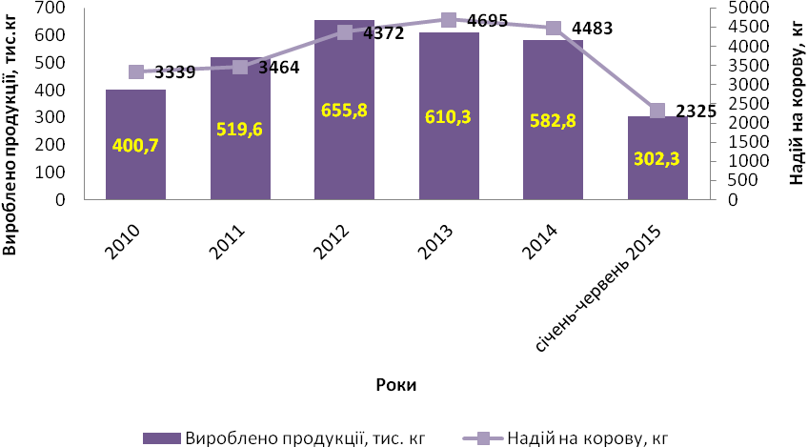
Picture 1. Dynamics of milk production in «Agricultural Firm named after T. G. Shevchenko»
Source: Author formed it from statistical data of «Agricultural Firm named after T. G. Shevchenko» [10].
In the suckling cattle breeding of Agricultural Firm total number of livestock of cows during the last years unchanging and there is the insignificant diminishing of production of milk (pic. 1, 2). The production of milk in 2014 years (comparatively with 2013 year) went down on 27,5 thousands of kg and made 582,8 thousands of kg. The productivity of milk herd also diminished on 212 kg and made in 2014 years 4483 kg of milk from a cow.
From January to June 302,3 thousands of kg of milk are got in 2015, and the productivity for these six months makes 2325 kg of milk from a cow. Principal reason of diminishing of production of milk was become by the decline of the productivity of suckling herd. The suckling cattle breeding is the important element of production of this Agricultural Firm.
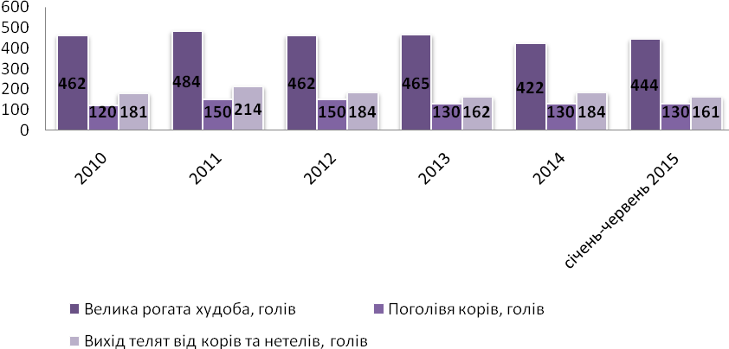
Picture 2. Dynamics of total number of livestock in «Agricultural Firm named after T. G. Shevchenko»
Source: Author formed from statistical data of «Agricultural Firm named after T. G. Shevchenko» [10].
The total number of livestock of cattle of economy in 2014 was 422 animals, that on 43 animals less than comparatively with 2013. Most quantity was observed in 2011 – 484 animals. In 2012 150 cows were counted in Agricultural Firm, and already from 2013 years it was 130 animals. In Agricultural Firm they apply whole-year fertilization of cows, but the most of calves are got in a winter period of year.
In suckling business the basic factors of profitable production is a low prime price and high cost of products. Charges on the production of milk depend on volumes and efficiency of the use of assets. Usually they are divided into current and superimposed. Current is charges on sterns, bedding, veterinary services, sale of products, combustible-lubricating materials, electric power, repair et al [8].
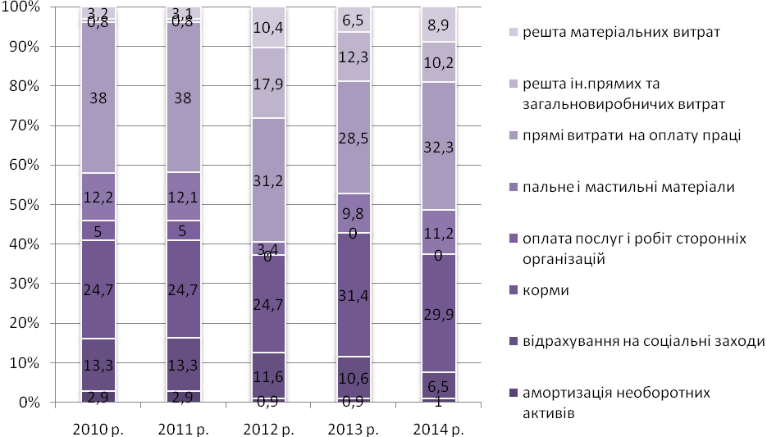
Picture 3. Structure of charges for the production of milk in «Agricultural Firm named after T. G. Shevchenko»
Source: Author formed it from statistical data of «Agricultural Firm named after T. G. Shevchenko» [11].
After analysing the picture 3 we may to draw a conclusion that most significant in «Agricultural Firm named after T. G. Shevchenko» there are charges on sterns. The structure of financial charges on the production of milk shows that a most particle is occupied by the cost of payment of labour with deductions and forages (in 2014 it was 38,8 % and 29,9 %). Large changes the structure of production charges during the last years did not test the particle of payment of labour with deductions and growth of cost of forages except for an insignificant decline.
Probing economic efficiency of production of milk, it follows to take into account that the mandatory member of technological production process is organization of permanent recreation of pestle total number of livestock due to growing valuable and more productive repair a sapling. However, as practice testifies, at the existent method accounting charges on the production of milk and standard of realization prices on the beef of growing repair a sapling for the recreation of own total number of livestock in economies is unprofitable. Therefore if to talk about stabilizing, and in future increase of production of milk, we must examine its economy indissolubly with the economy of recreation of pestle total number of livestock, that charges on growing of future cow must be compensated the got income from realization of milk for period of it the productive use. Only at such condition it is possible to attain sufficient efficiency of industry of the suckling cattle breeding at all [8].
It follows notices also that in the modern terms of development an artificial impregnation became the basic technological mean of recreation of animals (pic. 4).
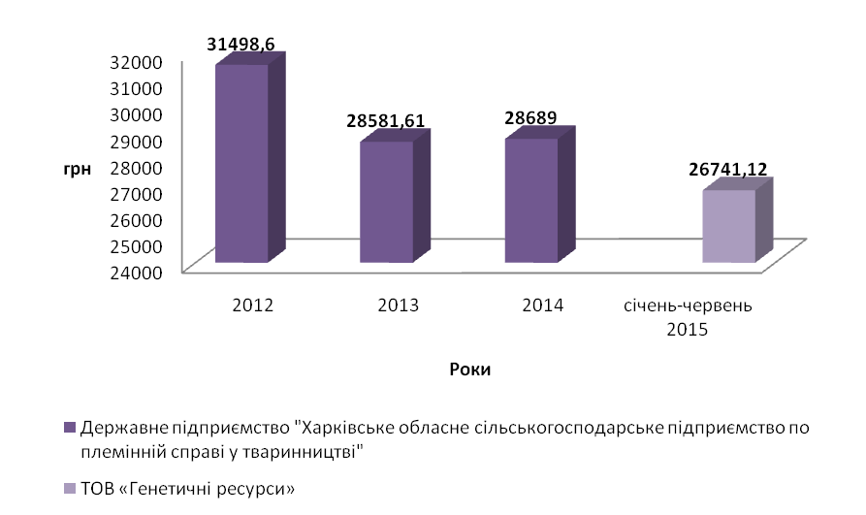
Picture 4. Dynamics of charges on the artificial impregnation of cows, UAH
Source: Author formed it from statistical data of «Agricultural Firm named after T. G. Shevchenko».
Agricultural Firm used services of artificial impregnation of state enterprise «Kharkiv regional agricultural enterprise in pedigree business in a stock-raising» till 2014 and from 2015 – by services of LTD «Genetic Resources».
Cost of sperm of breeding bulls in 2015 was 42,20 UAH/1 dose of sperm, and in 2014 it was 36 UAH/1 dose of sperm. Artificial fertilization is more progressive and economic by the advantageous method of recreation of herd which is positively represented on economic efficiency of economy. The important condition of development of suckling production is a recreation of herd. The number of calves from January to June in 2015 was 125 calves per 130 cows, or 96 %. Saving of calves in the probed enterprise is 100 %.
Agricultural Firm during the probed period realized milk for «Velykoburlutskiy cheese production factory» till 2014 year, and already from 2014 years it was begun to hand milk for «Kup’yanskyi dairy and canning plant» (pic. 5).
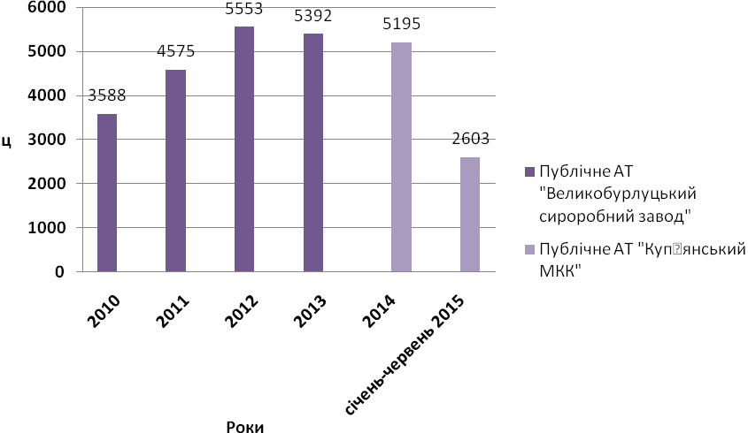
Picture 5. An amount of the realized milk on the milk processing factories, centners
Source: Author formed it from statistical data of «Agricultural Firm named after T. G. Shevchenko» [12].
During 2014 year 5195 centners of milk was handed for a milk processing factory, that on 197 centners less than in 2013. From January to May 2014 already 2603 centners of milk was handed. Since 2013 there is diminishing of handing of milk to the milk processing factory. Most volumes of handing over of milk to the milk processing factory were in 2012 years: 5553 centners (at 150 animals). But «Velykoburlutskyi cheese production factory» become the bankrupt and not liquidating a debt for the handed milk before «Agricultural Firm named after T. G. Shevchenko» in a sum 210 thousand of UAH. For today already other milk processing factory «Kup’yanskyi dairy and canning plant» ran into a debt an enterprise 586 thousands of UAH for the accepted milk.
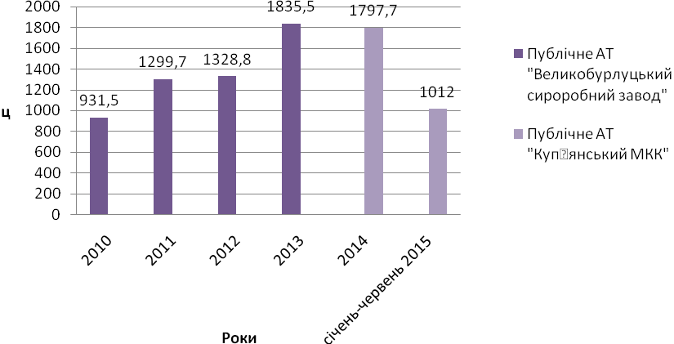
Picture 6. A receipts from the sale of milk to the milk processing factories, thousands of UAH
Source: Author formed it from statistical data of «Agricultural Firm named after T. G. Shevchenko» [12].
In July 2015 a middle purchase price of milk of chop for an enterprise was 4,70 UAH/kg. An income for six months of 2015 from the sale of milk was 1012 thousands of UAH (pic. 6).
The prospects of industry of the suckling cattle breeding will depend on as really today partner relations line up between all participants of market, which will allow through the mechanism of the equivalent pricing to create necessary economic terms for the increase of total number of livestock of sucklings cows due to the own recreation of herd, and also growth of production of milk volumes due to the increase of the productivity of milk herd.
Conclusion. The suckling cattle breeding is one of constituents of functioning and development of agricultural production of Ukraine. For producers this sector in a prospect remains advantageous as without regard to high enough primary investments an agricultural commodity producer can get circulating assets for the decision of exigent tasks. Achievement of high levels of profitability is possible only on condition of decline of prime price and the organization of the process of discipline of calculations of milk plants with milk producer. «Agricultural Firm named after T. G. Shevchenko» is an effective agricultural enterprise. For the increase of profitability of production of milk a primary value has growth of level of the productivity of cows, rational use of production resources, and also wide introduction of innovative technologies of production and improvement of quality of products. This question acquires greater value as an improvement of quality of suckling products is equivalent the increase of volume of receipt of additional profit yield.
BIBLIOGRAPHY
1. Андрійчук В. Г. Теоретико-методологічне обґрунтування ефективності виробництва / В. Г. Андрійчук // Економіка АПК. – 2005. – №5. – С. 52–63.
2. Березівський П. Економічна ефективність скотарства та шляхи її підвищення / Березівський П. – Львів : Укр. технології, 1998. – 156 с.
3. Ільчук М. М. Ефективне функціонування молокопродуктового підкомплексу України /
М. М. Ільчук. – К. : Нічлава, 2004. – 312 с.
4. Саблук П. Т. Економіка виробництва молока і молочної продукції в Україні : монографія / [за ред. П. Т. Саблука і В. І. Бойка]. – К. : ННЦ ІАЕ, 2005. – 340 с.
5. Месель-Веселяк В. Я. Оптимальні розміри сільськогосподарських формувань промислового типу в Україні / В. Я. Месель-Веселяк // Економіка АПК. – 2008. – №3. – С. 13–20.
6. Пархомець М. К. Організаційно-економічні основи розвитку молокопродуктового підкомплексу в ринкових умовах : монографія / М. К. Пархомець. – Тернопіль : Економічна думка, 2005. – 345 с.
7. Супрун О. М. Економічне регулювання аграрного виробництва : монографія / О. М. Супрун. – К. : ННЦ «Ін-т аграр. економіки», 2011. – 350 c.
8. Костенко В. Економіка виробництва молока / В. Костенко // Агробізнес сьогодні. – 2015. – №8 (303). – С. 54–56.
9. Самаріна І. Сімейні ферми та молочні кооперативи: прибуток і заможність селян / І. Самаріна // Агробізнес сьогодні. – 2014. – №18 (289). – С. 48–50.
10. Форма 24-сг (місячна) : Стан тваринництва січень–червень 2015 року СТОВ «АФ
ім. Т. Г. Шевченка».
11. Форма 50-сг (річна) : Основні економічні показники роботи сільськогосподарських підприємств за 2014 рік СТОВ «АФ ім. Т. Г. Шевченка».
12. Форма № 21-заг (місячна) : Реалізація сільськогосподарської продукції за січень–червень 2015 року СТОВ «АФ ім. Т. Г. Шевченка».

