© 2014
Lyashenko A., postgraduate
Cherkassy experimental station of bioresources NAASU
MORPHOLOGICAL ANALYSIS OF BULL SEMEN OF LONG-TERM STORAGE
Reviewer – PhD in Agriculture O. Gonchar
The morphological characteristics of frozen bull sperm of different breeds the Bank of genetic resources the long-term storage in liquid nitrogen were studied. A significant difference between the indicators of pathological and dead forms of bull semen with different terms of storage was set. The result studies, by the terms of storage 10-45 years, in bulls of dairy breeds were observed above normal ​​of pathological forms of sperm in an average of 2,5 %, except for sperm Ukrainian Black Pied dairy breed. In semen bulls of Simmental and beef breeds above an average of 5 %.
Keywords: cryopreserved sperm, morphological characteristics of sperm, pathological forms, long-term storage, breed.

Statement of the problem. Conservation of genetic resources sires of local breeds has great importance in breeding and maintaining biodiversity. The full implementation of measures to preserve livestock breeding resources is provided through the creation genetic reserve herds combined with long-term storage and cryopreservation of genetic material in cryobanks [2]. It is important to conduct periodic monitoring of the quality of genetic resources to setting appropriate to their subsequent storage and possible to use in the selection process.
Analysis of major studies and publications which discuss the problem. Metabolism in spermatozoa is slowing down in million times in extremely low temperatures of liquid nitrogen. Long-term storage of semen in liquid nitrogen is becoming increasingly important due to the possibility of preserving breeds, types and lines of endangered and rare animals [4, 6]. Experimental studies of some authors were found that motility, survival and fertilizing capacity cryopreserved of sperm bull at a high level during storage up to 10 years [3, 5, 8]. Morphology is one of the key indicators that can characterize fertilizing capacity of sperm. Morphological changes may relate to all areas of the spermatozoa. Most morphological violations of spermatozoa linked, and can lead for decreased motility of spermatozoa [1, 7, 9, 10]. Literature has not enough information about morphology cryopreserved sperm of bulls of different breeds which depends on the duration of storage, which determines the relevance of our research in this direction.
Aim and objectives of the research. Aim: to investigate the morphological characteristics of sperm bulls of different breeds under conditions of long-term storage of semen in liquid nitrogen. Objective: to assess the morphology of bull sperm the bank of genetic resources IBGA NAAN.
Material and methods of the research. We used cryopreserved semen of 85 bulls 9 breeds in research. Term of storage in studied sperm was from 10 to 45 years. We have divided the semen of bulls into three groups: first - the term of storage of 10-20 years, second – 21-30 years and third – 31-45 years. The study of the morphological characteristics of bull spermatozoa was performed in the laboratory Main tribal venture Cherkassy PC SPA «Progress» using microscope Olympus CX-31. Determination of the percentage of live-dead sperm and parameters of morphology of sperm bulls was performed by conventional method. Under the microscope, we determined the number of sperm with abnormalities in the structure of the head, neck, mid-piece and tail.
The results of research. The research found that the amount of abnormal sperm forms by the term of storage of 10-45 years, in bulls of dairy breeds, were higher normal an average on 2,5 %, except for sperm Ukrainian Black Pied dairy breed (hereinafter - UBP), in sperm of Simmental and beef breeds above an average of 5 %.
Determined that the lowest percentage of dead sperm and abnormal shapes observed in the semen of bulls UBP that significantly higher on average by 5 % than in bulls other breeds for the term of storage of 10-20 years (p<0,05). Sperm of Ukrainian Red Pied dairy breed (hereinafter - URP) has more dead and abnormal sperm forms by an average of 4,5 %, than the semen of bulls UBP (p<0,05). Accordingly, in semen of bulls of Holstein breed had more dead and pathological forms an average of 5 %, than in sperm of bull UBP (p<0,01) (Table 1).
- Characteristic morphological forms of sperm bulls of different breeds
by terms of storage 10-20 years, %

Type of pathology | Breed (M±m/С_{v})
Type of pathology | simmental | holsteins | UBP | URP | angler
dead cells | 32,0±1,7  27,6 | 32,0±2,5  31,6 | 24,1±1,3*  18,7 | 31,6±1,2  28,0 | 27,1±3,7  43,7
pathology of head | 7,2±0,2  15,5 | 6,3±0,2  15,7 | 5,7±0,2  10,0 | 6,0±0,1  15,4 | 7,3±0,2  9,8
pathology of tail | 7,3±0,2  15,5 | 6,5±0,2  15,8 | 5,6±0,2  9,6 | 6,0±0,1  15,9 | 7,0±0,3  11,7
pathology of neck | 2,0±0,1  17,2 | 1,6±0,1  12,7 | 1,7±0,1  11,6 | 1,7±0,1  18,9 | 2,1±0,1  9,0
pathology of mid-piece | 2,1±0,1  14,9 | 1,7±0,1  10,2 | 1,6±0,1  13,7 | 1,8±0,1  19,8 | 2,0±0,1  7,0
other types | 3,9±0,1  17,3 | 3,6±0,1  12,5 | 3,3±0,1  13,7 | 3,7±0,1  19,0 | 3,4±0,1  15,7
total defects | 22,4±0,6  13,5 | 19,8±0,5  10,4 | 17,8±0,4*  8,5 | 19,2±0,4  14,5 | 21,7±0,7  9,4
Note: * - р<0,05; UBP - Ukrainian Black Pied dairy breed; URP - Ukrainian Red Pied dairy breed

Was found that the percentage of abnormal forms in semen bulls of Angler breed was higher an average by 3,2 % than in bulls of domestic (Ukrainian) dairy breeds (p<0,01). It should be noted that the percentage of abnormal forms in bulls semen of Simmental breed for the term of storage of 10-20 years was higher an average of 4 %, than in bulls of Ukrainian dairy breeds (p<0,01) (Table 1).
Was found that the percentage of dead and abnormal forms of sperm bull of Limousine breed for the term of storage of 10-20 years was higher an average by 4.6 % than for Volyn and Ukrainian beef breeds (p<0,05). It was determined that sperm bulls of Limousine breed has significantly lower number spermatozoons with pathology of the head by an average of 1.4 % than for Volyn and Ukrainian beef breeds (p<0,05). Most numerous at the term of storage of 10-20 years were pathologies of the head and tail in sperm of Simmental, Angler and some beef breeds. Accordingly, for indicators of dead and abnormal forms of sperm bulls Simmental, dairy and beef breeds for the term of storage of 10-20 years have the average variability that is Cv,% = 7,0-43,7% (Table 2) .
2. Characteristic morphological forms of sperm bulls of beef breeds by terms of storage 10-20 years, %
Type of pathology | Breed (M±m/С_{v})
Type of pathology | limousine | volyn beef | ukrainian beef
dead cells | 29,5±2,6*  23,6 | 35,6±1,6  24,2 | 36,1±2,0  32,1
pathology of head | 5,5±0,2*  8,6 | 6,7±0,2  15,2 | 7,1±0,1  10,7
pathology of tail | 6,7±0,5  13,6 | 7,2±0,2  16,8 | 7,2±0,2  12,3
pathology of neck | 1,4±0,2*  23,8 | 2,1±0,1  16,7 | 1,8±0,1  7,8
pathology of mid-piece | 2,6±0,4  44,2 | 2,0±0,1  15,9 | 1,9±0,1  11,8
other types | 3,7±0,1  17,1 | 4,0±0,1  15,1 | 3,6±0,1  11,5
total defects | 18,9±1,1*  11,5 | 21,9±0,6  13,6 | 21,5±0,3  9,0

It was established that during the term of storage of 21-30 years, sperm of bulls Simmental breed has higher percentage of pathological forms, more abnormalities of the head and tail on average by 1,8 % than for the sperm bulls of Holstein breed (p<0,05) (see figure).
Established that for sperm bull of Simmental breed for the term of storage of 31-45 years were more spermatozoon’s with head abnormalities an average of 1 %, than in bull sperm in other periods of storage (p<0,05). It should be noted that the amount of abnormal forms of sperm was significantly higher an average by 2,1 % than for other periods of storage. The percentage of dead sperm was higher by 10 % than for the term of storage of 21-30 years (Table 3).
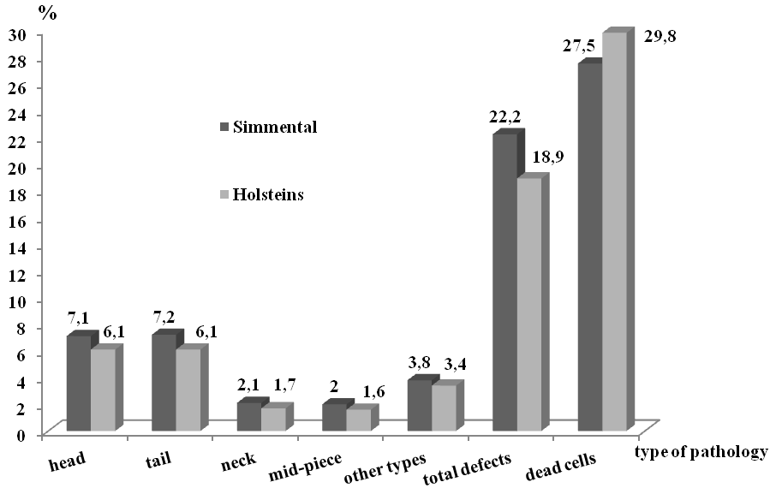
Figure. Characteristic morphological forms of sperm bulls of different breeds
by terms of storage 21-30 years

It was established that for term of storage of 31-45 years, the number of dead cells in sperm bull of Limousine breed was significantly lower an average by 14,5 % than in the semen of bulls of other breeds (p<0,05). However, number of dead sperm and abnormal forms in bulls of Limousine breed were higher an average by 7,5 % than in the semen of bulls of the breed for the term of storage of 10-20 years (p<0,05) (Table 3).
3. Characteristic morphological forms of sperm bulls of different breeds
by terms of storage 31-45 years, %

Type of pathology | Breed (M±m/С_{v})
Type of pathology | simmental | angler | charolais | limousine
dead cells | 37,8±3,2  29,2 | 29,4±2,9  22,0 | 37,0±1,6  10,7 | 20,2±3,2*  22,7
pathology of head | 8,1±0,3  14,8 | 7,8±0,5  14,5 | 7,7±0,3  8,5 | 8,0±0,2  3,4
pathology of tail | 7,9±0,3  11,8 | 7,7±0,5  13,1 | 8,2±0,3  8,9 | 8,4±0,6  10,0
pathology of neck | 2,0±0,1  9,6 | 2,0±0,1  10,3 | 2,1±0,1  9,1 | 2,1±0,1  6,8
pathology of mid-piece | 2,2±0,1  9,3 | 1,9±0,1  19,7 | 2,1±0,1  11,0 | 1,9±0,1  7,2
other types | 4,4±0,1  10,2 | 3,7±0,1  8,8 | 3,9±0,1  9,0 | 4,4±0,1  13,5
total defects | 24,4±0,8  10,6 | 23,2±1,3  12,4 | 24,1±0,8  7,2 | 24,8±1,4  7,8

Conclusions. It was established that for term of storage of 10-20 years, were observed above normal number of pathological forms of sperm bulls of dairy and beef breeds an average of 2,5 %, except for sperm Ukrainian Black Pied dairy breed, and in semen of bulls of Simmental and beef breeds for the term of storage of 31-45 years higher an average by 6,4 %. Sperm of some bulls the Simmental, Charolais and Limousine breeds for the term of storage of 31-45 years had high values of pathological forms (over 23 %) and a high number of dead cells (over 35 %). Positive highly probable correlation between the morphology and the number of dead sperm was defined (r = 0,5).
Inference. The obtained results indicate the need for periodic monitoring of quality indicators of sperm the above breeds to confirm feasibility of further storage and possible use in the selection process.

Bibliography
- Гончар О.Ф. Шляхи підвищення запліднювальної здатності сім'я бугаїв-плідників /
О.Ф. Гончар, С.В. Кузебний // НТБ. – Х.: ІТ УААН, 2008. – № 97. – С. 117-122.
- Зубець М. В. Методологічні аспекти збереження генофонду сільськогосподарських тварин /
М. В. Зубець, В. П. Буркат, Ю. Ф. Мельник та ін.; Наук. ред. І. В. Гузєв. – К.: Аграрна наука, 2007. – 120 с.
- Наук В.А. Структура и функции спермиев сельскохозяйственных животных при криоконсервации. − К.: Штиинца, 1991. – 199 с.
- Осташко Ф.И. Глубокое замораживание и длительное хранение спермы производителей / Ф.И. Осташко / - К.: «Урожай», 1978. – 256 с.
- Сірацький Й. З. Життєздатність сперміїв від плідників різних молочних порід /
Й. З. Сірацький, О. В. Бойко, Є. І. Федорович // Тваринництво України, 2010. – № 3. – С. 12-16.
- Смирнов І. В. Стан і перспективи тривалого зберігання сперми / І. В. Смирнов // Розведення та штучне осіменіння великої рогатої худоби: Респ. міжв. тематичний наук. зб. – К.: Урожай, 1978. – Вип. 10. – С. 33-37.
- Clement F. Sperm morphology and fertility / F. Clement, Y. Ladonnet, M. Magistrini // Anim. Reprod. Sci. – 2001. – № 68. – Р. 362-363.
- Dinnyes A. Novel gamete storage / A. Dinnyes, J. Liu, T. L. Nedambale // Reproduction, Fertility and Development. – 2007. – № 19. – Р. 719-731. www.publish.csiro.au/journals/rfd.
- Johnson W.H. The significance to bull fertility of morphologically abnormal sperm /
W.H. Johnson // Vet. Clin. North Am. Food Anim. Pract. – 1997. – № 13. - Р. 255-270.
- Soderquist L. Sperm morphology and fertility in A.I. bulls / L. Soderquist, L. Janson, K. Larson, S. Einarsson // J. Vet. Med. A. – 1991. – № 38(7). – Р. 534-543.

