© 2015
Ivanov O. N., PhD, Associate Professor,
Arendarenko V. N., PhD, Associate Professor,

Tshedgo Wako Gi Patrice, master
Poltava State Agrarian Academy
DEFINITIONS OF COOLING CAPACITY OF PELTIER THERMOELECTRIC MODULES BASED ON MULTIFACTOR EXPERIMENT
Reviewer – PhD, Associate Professor V. I. Levchuk
The technique of determining the cooling capacity of Peltier thermoelectric module that converts the energy of the electrical current to thermal flows with different direction vectors was presented. Studies were conducted using the methodology of planning and carrying out multivariate experiments. On the basis of experimental and analytical calculations we derived approximation equation of the second kind that allows you to determine the value of cooling capacity thermoelectric module in a wide range of changes of two determining factors: the magnitude of the current and temperature of the heat-releasing side of the module.
Keywords: cooling capacity, the Peltier effect, thermoelectric module, determinants, experiment, current, equation approximation.
Statement of the problem. Using thermoelectric converter based on the Peltier effect (module of Peltier) as a means of artificial cooling is known for a long time. The rapid development of the method of obtaining low temperatures began with the mid-twentieth century through the fruitful work of scientists led by Academician A. F. Ioffe on the study and application of semiconductor components in various industries, particularly in designing gensets based on semiconductor thermocouples [2].
Nowadays Peltier application module, regardless of the value of his way and sufficiently low thermodynamic efficiency, has gained widespread use. This module is used not only in the domestic sphere (automobile and mobile equipment, portable refrigerators and microclimate), but also in high-tech fields such as medicine, aerospace, electronics, precision engineering, energy and others [4].
Therefore, the application module of Peltier in scientific and applied home plan calls for solutions aimed at bringing its economic and technical feasibility of using, based on his study of electrical and thermodynamic characteristics. In particular, the study of changes of Peltier module cooling capacity of the determining factors that influence the formation of numerous key characteristics of this parameter.
Analysis of recent research and publications, which discuss the problem. It is well known that the positive cooling effect – cooling capacity of thermoelectric module directly depends on the heat balance of power among the three mutually exclusive components: heat of Peltier that determined by the amount of heat absorbed from the outside cold side of the thermoelectric module Joule’s largest integrated heat and heat flux that due to the effects of high heat conductivity transferred to the low-side module of Peltier. The first of these – forms part of a positive balance sheet and the other two – in its totality is a leveling factor, which reduces the potential amount of heat absorbed on the cold side of the thermoelectric module [1].
From the foregoing it is not difficult to determine from which parameters Peltier module of cooling capacity will depend. Thus, Joule’s heat and heat of Peltier determined mainly one functional parameter – power of current flowing through thermocouples module. And the amount of heat energy transferred from the hot to the cold side, is caused by differences in temperature and heat-radiating side of the module. Then we can assert influence in shaping the compact cooling capacity characteristics of two factors: the strength of the current and temperature differences on opposite sides of the Peltier module. Thus, thermodynamic and electrical parameters of semiconductor thermocouple module of Peltier are not taken into account because of the inability to vary their values ​​during operation of the module.
Technical documentation of thermoelectric modules is the current strength and the difference in temperature (temperature hot side) bringing as determinants for which formed numerous baseline characteristics change cooling capacity. But dependences, in most cases, were determining only the «sterile» lab, which is somehow away from the real conditions of the module [5].
The aim of this study was set search display mathematical thermoelectric module depending cooling capacity on the defining factors contributing its technical results and determine its thermodynamic efficiency. The objective is a clear statement of values consistent algorithm module cooling capacity in one point, the coordinates of which are given amperage and temperature of the hot side of the module.
Results. As mentioned above, the thermoelectric module of cooling capacity is a function of two variables: current strength and temperature of the hot side of the module. From which it follows that the study of unknown function changes the nature of the defining parameters must find, using the methodology of multivariate experiments, particularly the part that involves the planning of experiments, the result of which depends on the combined action of two factors [3].
In general, the cooling capacity as a function can be described as a dependency:
$Q=f\left(I;T_{h}\right)$, (1)
where Q – cooling capacity, W;
І – current, А;
Т_{h} – temperature of hot side of thermoelectric module, °С.
In accordance with the methodology of two-factor experiment dependence (1) can be represented as a second order polynomial [3]:
$Q=a_{0}+a_{1}⋅I+a_{2}⋅T_{h}+a_{\text{11}}⋅І^{2}+a_{\text{22}}⋅T_{h}^{2}+a_{\text{12}}⋅І⋅T_{h},$ (2)
where а₀, а_{1,} а_{2,} а_{11,} а_{22,} а₁₂ – dimensionless coefficients approximation.
To search for coefficients of approximation of the experimental design was selected (pic. 1) with the central placement of experimental points, due to the established practice thermoelectric module operation in moderate values of current strength and the hot side. At the same time as the determining factors was estimated, made of extremes: for current – І_{min}= 0,7 А та I_{max}= 9,3 А; to the hot side – $T_{h}^{\text{min}}={\text{30}}^{∘}C$ та $T_{h}^{\text{max}}={\text{50}}^{∘}C$. Step rationing was: for current – ΔІ=2,2 А, to the hot side – ΔТ_{h}=5 °С.
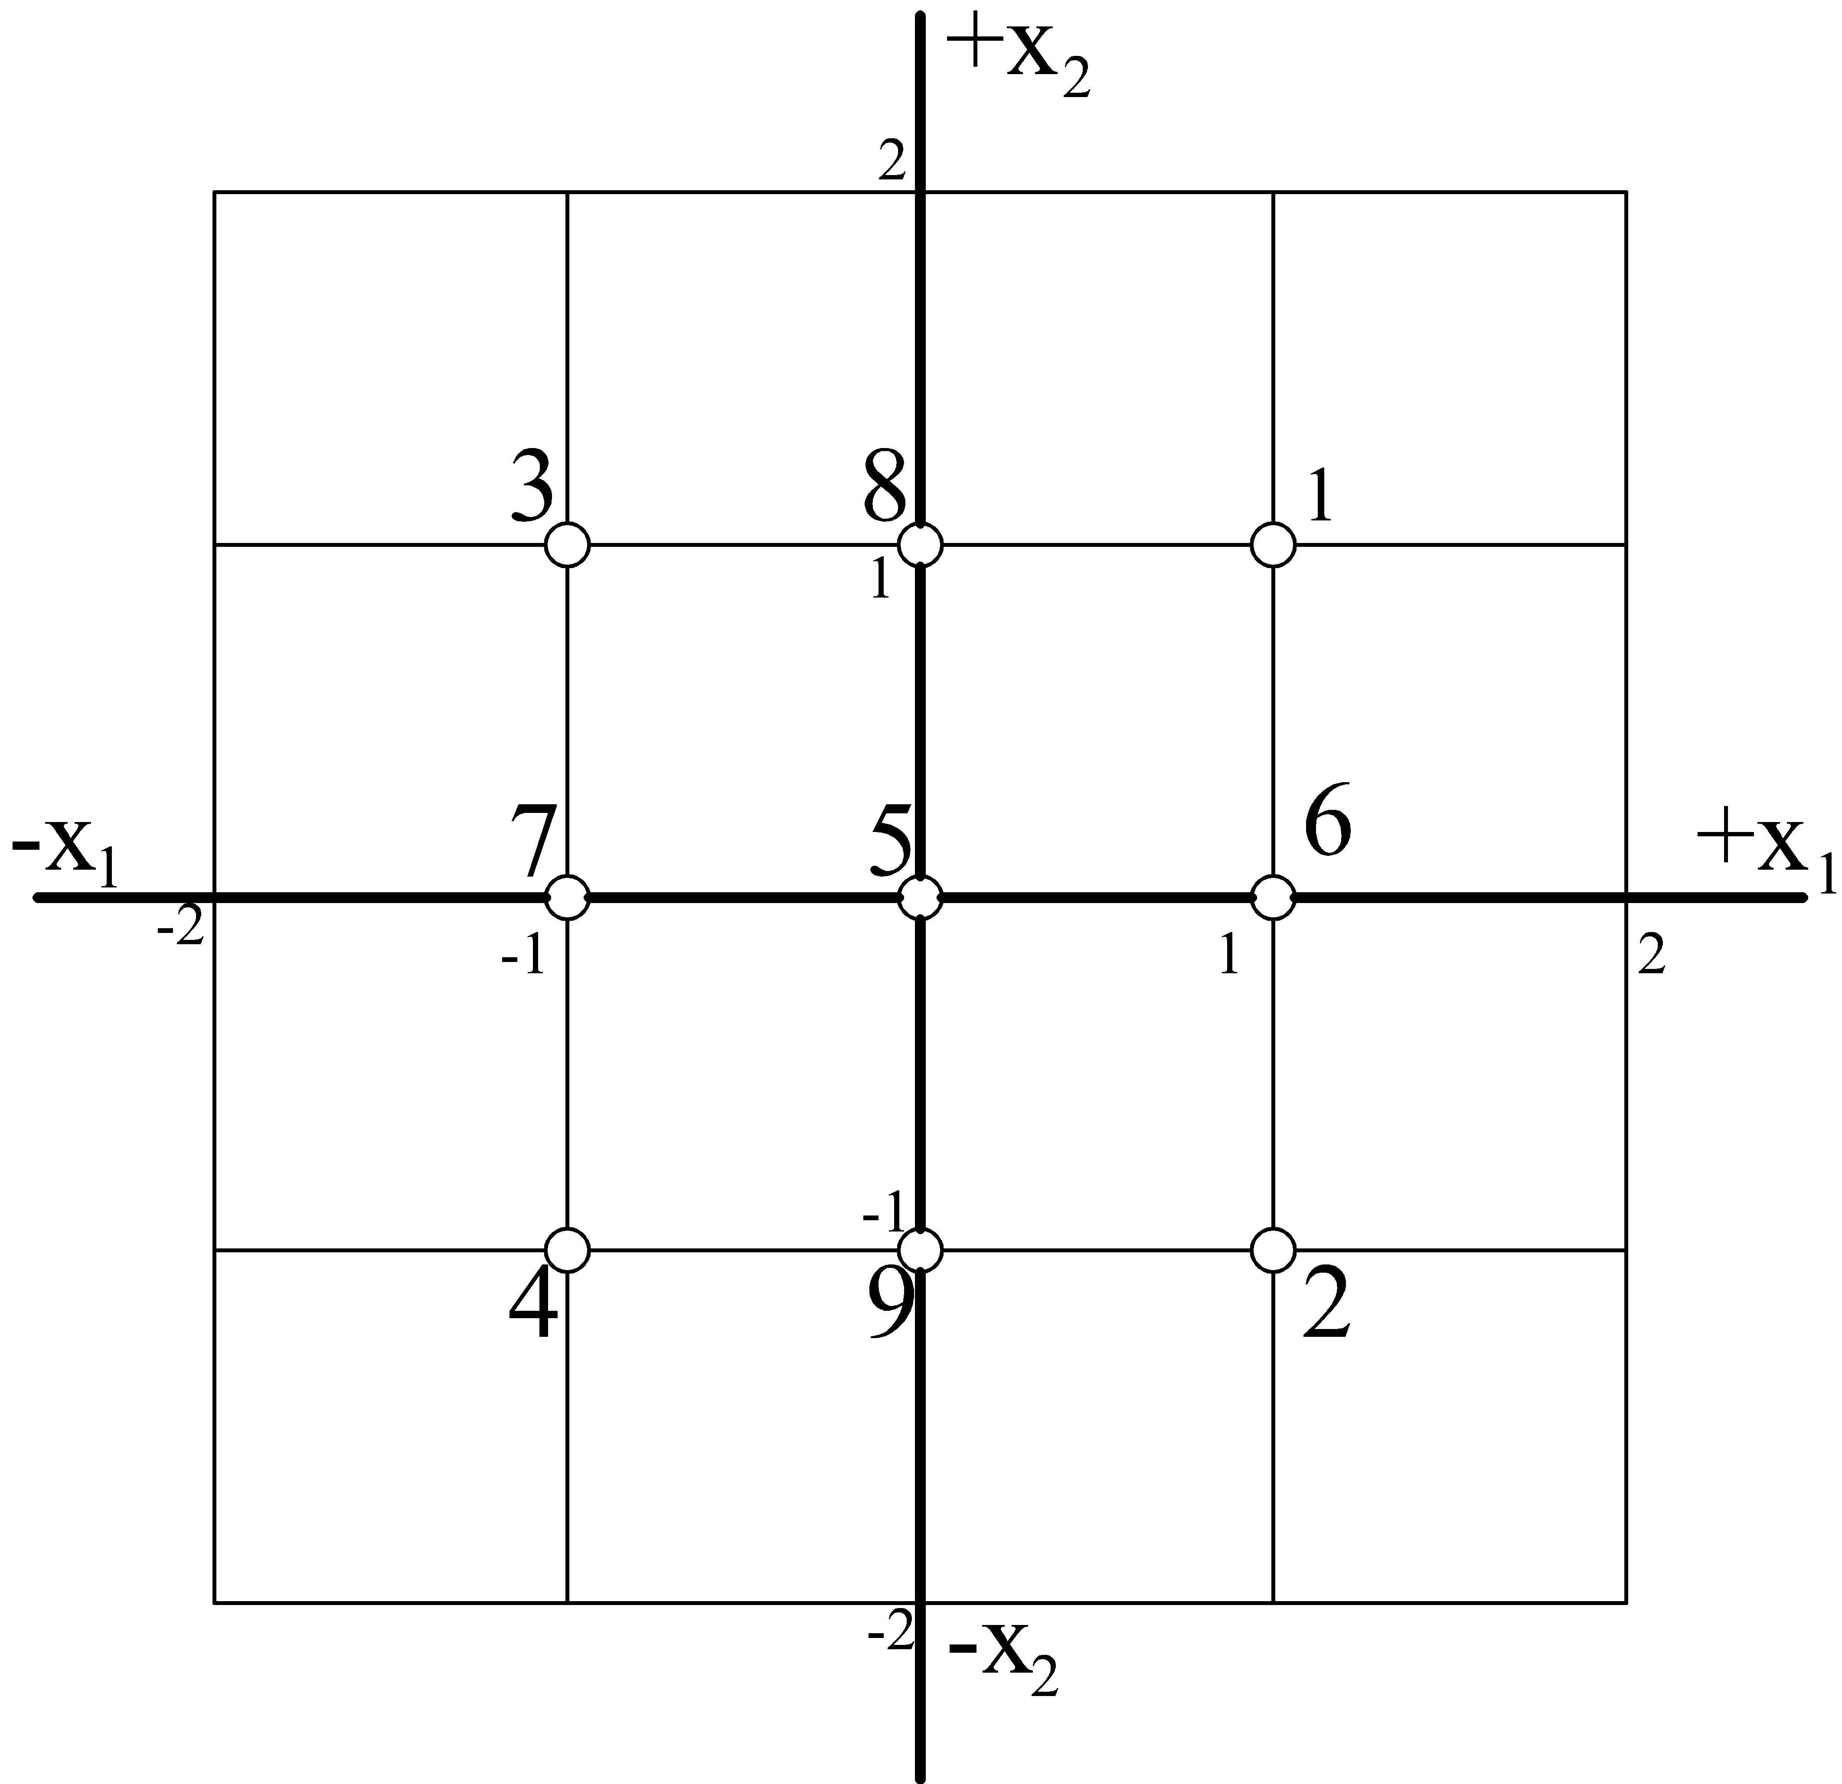
Picture 1. Location of research at the central points of the plan variant of the experiment
For the planned experiments was created laboratory setup (pic. 2), a key element of which is a thermoelectric module of Peltier – TEC-12710.
On the hot side of the module surface mounted water heat exchanger that removes the surface from excessive heat and the cold side is cooler, which acts as a cooling body. To prevent the flow of heat by convection to the radiator we used insulation that envelops the cooling body from all sides.
To monitor changes in temperature radiator we used digital temperature sensors, mounted at several points, diagonally, on the surface of the radiator (pic. 3). Tracking changes in temperature hot side temperature sensor was performed, which was placed directly on the hot side of the module (inside a heat exchanger element of water). All temperature recorded, multi-channel switching microcontroller thermometer accurate to 0,1 °С.
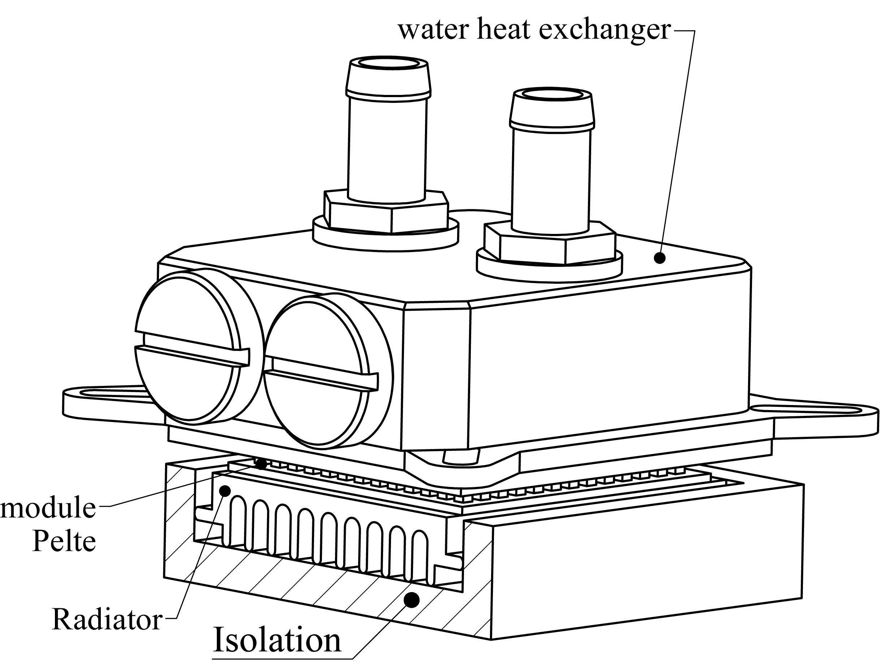 | 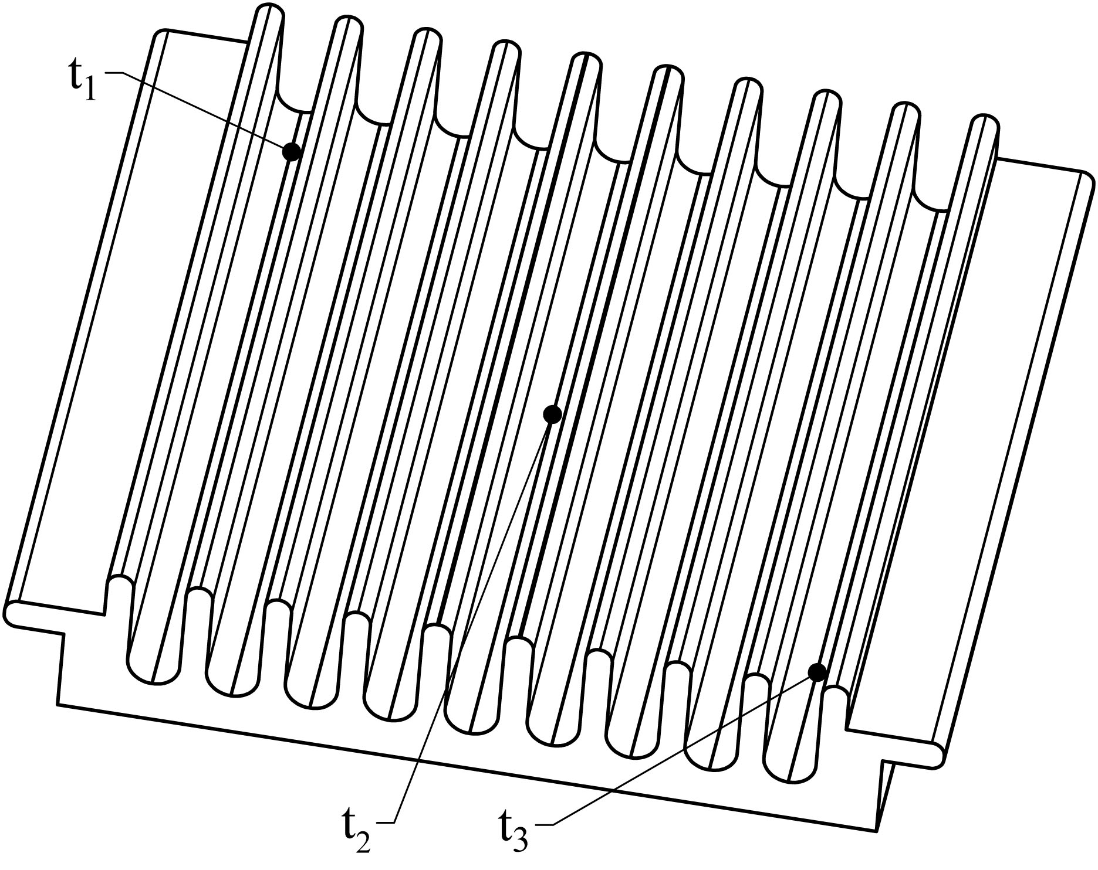
Picture 2. Experimental installation | Picture 3. Location of temperature sensors on the surface of the radiator
To improve heat exchange contact between the planes in contact with each other, and to avoid the formation of air insulation layer between them coated with a thin layer of heat conducting paste KPT-8. This articulated connection setup minimizes heat transfer elements influence the thermal resistance of this layer to heat the spread between the surfaces.
Power module of Peltier carried on DC power, which allowed to ensure sustainability of the current strength across the range of changes defined the terms of the planned two-factor experiment.
Variation and sustainability of the hot side of the Peltier module, according to the plan of the experiment, provided by changing the amount of cooling water to water heat exchanger reported the selection of heat from a heat element conjugate with the hot side of the module.
The procedure of the experiment for each experimental point plan was to track changes over time in temperature radiator at three different points from the beginning of the power supply with a given power supply to terminals thermoelectric module until stabilization of temperature in the radiator control points.
Cooling capacity is defined as the ratio of allocated heat from the radiator to the value of a discrete time period that was chosen as the experiment was a step timekeeping:
$Q=\frac{E_{\text{heat}}}{τ}$, (3)
where Е_{heat} – assigned amount of heat from the radiator, J;
τ – discrete time interval, с, τ = 1 s.
Number allotted heat from the radiator calculated by the expression:
$E_{\text{heat}}=m_{\text{rad}}⋅c_{\text{rad}}⋅Δt$, (4)
where $m_{\text{rad}}$ – radiator weight, kg, $m_{\text{rad}}$=0,01935 kg;
$c_{\text{rad}}$ – specific heat of the material of which the radiator, J/(kg∙К), $c_{\text{rad}}$=880 J/kg∙К;
Δt – change in temperature during cooling radiator within a discrete period of time τ, °С.
The resulting sample cooling capacity of each point subjected to experimental analysis on the subject of finding the maximum value:
$Q_{e}=\underset{1≤i≤n}{\text{max}}\left\{Q_{i}\right\}$.
Found extreme test sample was identified as thermoelectric module cooling capacity values for the respective values of the current strength and the hot side of the module.
The resulting set of values of cooling capacity of all experimental plan was exposed regression analysis was therefore find approximation coefficients а₀, а_{1,} а_{2,} а_{11,} а_{22,} а₁₂ curvilinear dependence (2).
Output approximation equation provides a mathematical description of characteristics change cooling capacity of thermoelectric module:
$Q=\text{19},\text{9367}+3,\text{7184}⋅I−0,\text{6871}⋅T_{h}−0,\text{3647}⋅І^{2}+0,\text{0028}⋅T_{h}^{2}+0,\text{0463}⋅І⋅T_{h},$ (5)
The obtained experimental data and results of analytical and statistical calculations to the construction table 1.
Table 1. Two-factor experiment
Point plan | Current І, А | Temperature Т_{г}, °С | Experimental cooling capacity Q_{e}, W | Rated cooling capacity Q_{r}, W | Error δ, W
1 | 7,3 | 45 | 17,574 | 17,525 | 0,049
2 | 2,9 | 45 | 8,616 | 8,370 | 0,246
3 | 7,3 | 35 | 18,683 | 18,807 | -0,124
4 | 2,9 | 35 | 11,761 | 11,688 | 0,074
5 | 5,1 | 40 | 16,038 | 15,793 | 0,245
6 | 5,1 | 45 | 14,417 | 14,713 | -0,295
7 | 5,1 | 35 | 17,062 | 17,012 | 0,050
8 | 7,3 | 40 | 18,171 | 18,097 | 0,075
9 | 2,9 | 40 | 9,640 | 9,960 | -0,320
$$\sum{δ_{i}=}$$ |  |  |  |  | 0
Table 1 shows that the deviation of the experimental and calculated cooling capacity is quite small, indicating a high enough quality of the experiment and the good reproducibility of experimental statistical model expressed by an equation approximation.
Conclusion. The offered method of determining the cooling capacity thermoelectric module using the principles of planning and conducting multivariate experiments allows to provide a reasonable estimate of the thermodynamic properties of thermoelectric Peltier modules. The equation approximating cooling capacity of one of these modules will allow much flexibility to use its capabilities in actual use.
BIBLIOGRAPHY
1. Холодильная техника. Энциклопедический справочник / [Бадилькес И. С., Бухтер Е. З., Вейн-берг Б. С. и др.]. – Л. : Госторгиздат, 1960. – 543 с.
2. Иоффе Абрам Фёдорович [Электронный ресурс]. – Режим доступа : http://ru.wikipedia. org/wiki/ Иоффе_Абрам_ Фёдорович.
3. Рафалес-Ламарка Э. Э. Некоторые методы планирования и математического анализа биологических экспериментов / Э. Э. Рафалес-Ламарка, В. Г. Николаев. – К. : Наук. думка, 1971. – 119 с.
4. Что такое эффект Пельтье и термоэлектрический модуль? Элементы Пельтье [Электронный ресурс]. – Режим доступа : http://peltier. narod.ru/#Что.
5. TEC1-12710. Datasheet [Електронний ресурс]. – Режим доступу : http://www.hebeiltd. com.cn/peltier.datasheet/TEC1-12710.pdf.

