UDC 631.559:633.11:631.5
Rozhkov A. O., Candidate of Agricultural Sciences
Kharkiv National Agrarian University named after V. V. Dokuchayev

spring Triticale grain productivity and bioenrgy efficincy of its growing depending upon different sowingand sowing methods

Reviewer –Doctor of Agricultural Sciences, Professor of the chair of Genetics, Crop Breeding and Seed Growing of KhNAU named after V. V.Dokuchayev – T.I.Goptsiy.

The results of the three-year researches according to the coenotic factors influence: sowing methods and sowing rates on the grain productivity of spring triticale plants are given. The advantage of the striped sowing method on the increase of economic and bioenergy efficiency indices of spring triticale growing is established in the article.
The crop capacity is higher while using the striped sowing method as well as economic and bioenergy efficiency indices of spring triticale growing are higher at a sowing rate of 550 seeds / m²; at the same time during the drill sowing method – at a sowing rate of 500 seeds / m².The established regularity is caused by weakening of coenotic tension in the striped sowing method which creates conditions for the full development of a larger number of plants per unit of the sown area.
Key words: coenotic tension, sowing rate, sowing method, spring triticale, crop capacity, economic and bioenergy efficiency.
Statement of the problem. During the last period both in the world practice of agriculture and in our country there is a tendency to reduce the cost of crops growing. In this regard there is a need to improve the technology elements of their cultivation in order to increase productivity while reducing costs for obtaining production unit.
Analysis of recent researches and publications which underlie in the solution of the problem. Numerical studies have shown that the optimal plants standing density is a key factor in increasing their productivity [1, 2]. There is no consensus as to the plants standing density at which it is possible to obtain maximum yield yet. To elucidate the problem it is necessary to understand the process of crop formation in its dynamics taking into account the development of productivity elements. All these processes occur in different ways depending upon the complex influence of endogenous and exogenous factors. Therefore, the standard cannot be developed in relation to the sowing rate; they should be established considering weather conditions, variety peculiarities and growing technology.
The increase of crop capacity and improvement of product quality are always accompanied by the additional costs. That is why the benefits of their use depend not only upon the increase in productivity but upon the economic efficiency which is an important indicator for assessing expediency of introduction in production of investigated elements of growing technology which provides productivity increase [3, 4].
Recently along with the economic assessment, bioenergy evaluation of effectiveness of growing technology as well as certain agricultural activities have largely attracted the attention of scientific researchers [5]. The identification of energy saving variants (plant varieties, technologies, agricultural activities) is associated with the assessment of the correlation of the energy accumulated by plants with the cost of anthropogenic energy [6]. Nowadays such assessment is universal and allows comparing energy consumption of any agricultural activity in different conditions [7, 8, 9, 10, 11].
The intensification of agricultural production and the crop productivity increase are accompanied by an increase of non-renewable energy costs, including by the costs of the crops growing technology improvement. That is why there is a need to develop crops energy-saving technologies to use less energy.
Purpose of the researches. The aim of the conducted researches was to determine the influence of the main effects of the studied variants and their interaction on the grain productivity, economic and bioenergy efficiency of spring triticale plants growing.
Methods of the researches. The researches were conducted during 2008 – 2010 using the generally accepted method [12]. The objects of the researches were the plants of spring triticale variety Korovay Kharkivs’ky, the subjects of the researches were sowing methods and sowing rates.
Sowing of spring triticale was made using the drill sowing method and the striped sowing method with the seed sowing rate from 400 to 600 seeds / m² with the gradation step of 50 seeds / m². Sowing in the drill sowing method was performed with a seed drill C3 –3.6,and in the striped sowing method with a sowing machine APP-6 ВАТ«Fregat».In the striped sowing method seeds were sown with in the strip of 15 cm wide with a width between the strips centers of 30cm. The difference between sowing methods is explained by the constructive peculiarities of seeders. The seed drill C3 – 3,6provides seed sowing with a disk coulter, when the sowing machine APP-6 has a hoe with a working width of 40 cm.
Results of the researches. A characteristic biological feature of spring cereals including triticale is their low ability to form lateral shoots; in this connection the optimization of crop density and the character of their distribution over the nutrition area are of special importance.
In the experiment concerning the influence of coenotic factors – the sowing methods and the sowing rates on grain productivity of spring triticale it was defined sufficiently strong plants reaction to the application of different variants of coenotic tension among plants in crops (Table 1). Depending upon the use of different gradations of the sowing rate, the range of the change of the spring triticale plants productivity exceeded 25% (from 2,64 t / ha at a sowing rate – 40 seeds / m²to 3,32 t / ha at a sowing rate – 600 seeds / m²).
- Spring triticale plants productivity depending upon the influence of sowing methods and sowing rates, t / ha(average within the period of 2008-2010)
Factor А – sowing rate, seeds/m² | Factor В – sowing method |  | Average
Factor А – sowing rate, seeds/m² | drill sowing  method | striped sowing  method
400 | 2,59 | 2,69 |  | 2,64
450 | 2,78 | 3,00 | 2,89
500 | 2,95 | 3,29 | 3,12
550 | 3,01 | 3,56 | 3,29
600 | 3,01 | 3,63 | 3,32
Average | 2,87 | 3,23 | 3,05
LSD₀₅ of the main effect of the sowing rate − 0,27;
LSD₀₅ of the main effect of the sowing method – 0,14.
LSD – lowest significant difference
There were identified two homogeneous groups according to the grain productivity depending upon the influence of different sowing rates on average over the three years of researches (Picture). The productivity significantly increased with the increase of a sowing rate from 400 to 500 seeds / m²; at the same time it should be noted the established regularity of the effect reduction by a gradual increase of a sowing rate. Thus, with the increase of a sowing rate from 400 to 450 seeds / m² the grain productivity increased by 0,25 t / ha, with its further increase in constant value – 50 seeds / m²the productivity increased accordingly by 0,23 and 0,17 t / ha. With the increasing of a sowing rate from 550 to 600 seeds / m², the productivity increase was in general only 0,03 t / ha.
In the conducted experiments the effect of a sowing rate application was largely dependent upon the sowing method. The grain productivity of spring triticale plants depending upon the application of different sowing rates on the variants of the drill sowing method varied in the range from 2,59 to 3,01 t / ha (divergence – 0,42 t / ha or 16,2%),the striped sowing method –from 2,69 to 3,63 t / ha (divergence – 0,94 t / ha or 34,9%). According to the results, the optimal sowing rate for the drill sowing method and the striped sowing method was – 500 and 550seeds / m²appropriately.
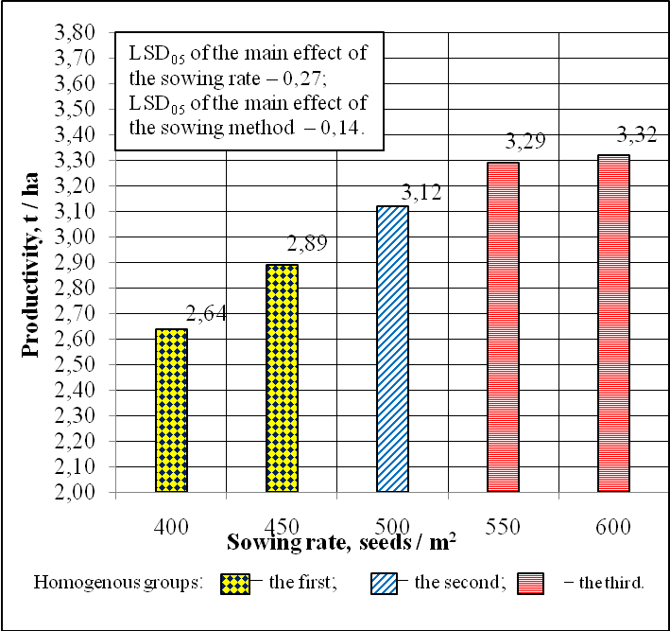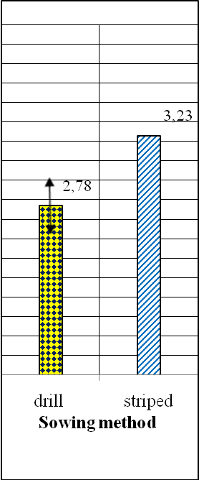
Picture. Grain productivity of spring triticale plants under the influence of
different sowing rates and sowing methods, t / ha (average within the period of 2008 – 2010).

The efficiency of the application of different sowing rates on the striped crops was fundamentally different from the effect of sowing rates obtained on the drill crops. The highest grain productivity on the variants of the striped sowing method– 3,56 t / ha was achieved using the sowing rate of 550 seeds / m². Only the tendency to increase productivity was marked with the increase of a sowing rate from 550 to 600 seeds / m².
The lowest efficiency of the striped sowing method application was marked using the sowing rate – 400 seeds / m². Thus, the increase of productivity while applying the striped sowing method comparatively with the drill sowing method using the sowing rate 400 seeds / m²was – 0,10 t / ha at the lowest significant difference – LSD₀₅of the partial comparisons of the effect – 0,30 t / ha. The efficiency of the striped sowing method was shown to a greater degree using the sowing rates – 550 and 600 seeds / m². The productivity increase while applying the striped sowing method at these sowing rates was 0,55 and 0,62 t / ha appropriately.
The calculations of the energy efficiency of spring triticale growing using different variants of sowing rates and sowing methods show high efficiency of these agricultural activities (Table 2). On average over the three years of researches the energy efficiency ratio (EER) of spring triticale growing was 4,68–on the variants of the striped sowing method while on the drill crops – 4,16. Energy efficiency ratio growth if applied the striped sowing method was due to a higher index of accumulated energy by crops at nearly equivalent energy costs.
The sowing rate – 550 seeds / m² provided the highest indices of bioenergy efficiency. The reduction of the sowing rate as well as its increase resulted in a decrease of energy efficiency ratio; in the first case – due to the lowering of the accumulated energy by crops, in the second – due to the significant increase in the non-renewable energy consumption at a slight increase in grain productivity. The effect of the sowing rate depended on the character of the plants distribution over the nutrition area. The highest bioenergy indices were on the variants of the drill sowing method at the sowing rate of 500 seeds / m² and on the variants of the striped sowing method at the sowing rate of 550 seeds / m².
2..Bioenergy efficiency of spring triticale growing depending upon the application of different sowing rates and sowing methods
(average within the period of 2008 – 2010).
Factor А – sowing rate, seeds/m² | Factor В – sowing method | Productivity, t / ha | Non-renewable energy consumption,  MJ |  | Accumulated energy by crops,  MJ/ ha | Energy efficiency ratio(EER)
Factor А – sowing rate, seeds/m² | Factor В – sowing method | Productivity, t / ha | per 1 ha | per 1 tof grain | Accumulated energy by crops,  MJ/ ha | Energy efficiency ratio(EER)
400 | drill | 2,59 | 10654 | 4114 | 42994 | 4,04
400 | striped | 2,69 | 10674 | 3968 | 44654 | 4,18
450 | drill | 2,78 | 11046 | 3973 | 46148 | 4,18
450 | striped | 3,00 | 11066 | 3689 | 49800 | 4,50
500 | drill | 2,95 | 11438 | 3877 | 48970 | 4,28
500 | striped | 3,29 | 11458 | 3483 | 54614 | 4,77
550 | drill | 3,01 | 11830 | 3930 | 49966 | 4,22
550 | striped | 3,56 | 11850 | 3329 | 59096 | 4,99
600 | drill | 3,01 | 12230 | 4063 | 49966 | 4,09
600 | striped | 3,63 | 12250 | 3375 | 60258 | 4,92
Average according factor А | 400 | 2,64 | 10664 | 4041 | 43824 | 4,11
Average according factor А | 450 | 2,89 | 11056 | 3831 | 47974 | 4,34
Average according factor А | 500 | 3,12 | 11448 | 3680 | 51792 | 4,52
Average according factor А | 550 | 3,29 | 11840 | 3630 | 54614 | 4,61
Average according factor А | 600 | 3,32 | 12240 | 3719 | 55112 | 4,50
Average according factor B | drill | 2,87 | 11440 | 3991 | 47642 | 4,16
Average according factor B | striped | 3,23 | 11460 | 3569 | 53618 | 4,68
Average |  | 3,05 | 11450 | 3780 | 50630 | 4,42

In conditions of the economic activity liberalization the efficiency of the agricultural production is largely determined by products competitiveness. The effective competitive production is largely dependent upon the choice of technology and optimal management of technological processes.
The conducted calculations of the economic efficiency of spring triticale growing showed high efficiency of the striped sowing method which was a significant increase in profitability and profit comparatively with the control (Table 3).
On average over the sowing rates, while applying the striped sowing method net profit growth as compared to the control was 563 UAH/ ha (33,2%). The level of profitability was higher by 26%. Significant increase of economic efficiency on the variants of the striped sowing method was provided by a much higher cost of grain per hectare at practically equivalent costs for growing.
The difference among the economic efficiency indices according to the researched sowing methods gradually increased with the increase of the seed sowing rate and it was the greatest at the sowing rate of600 seeds /m². Thus, at the sowing rate of 400 seeds / m², profit growth from the use of the striped sowing method as compared to the drill sowing method was 190 UAH / ha, and at the sowing rate of 600 seeds / m²it was918 UAH / ha.
From the perspective of the economic efficiency the best variant was with the applying of the striped sowing method at the seed sowing rate – 550 seeds / m². In this variant, the cost was the lowest – 667 UAH / t, the level of profitability was the largest – 110%. With the increase of the sowing rate to 600 seeds / m², net income decreased by5 UAH / ha while the cost increased by 16 UAH / t and the profitability decreased from 110 to 105%.
3..Economic efficiency of spring triticale growing depending upon the influence of different sowing rates and sowing methods
(average within the period of 2008 – 2010).
Sowing rate (А), seeds / m² | Sowing methods*  (В) | Productivity,  t / ha | The cost of the grain,** UAH/ha | Expenses, UAH/ha | Profit, UAH/ha | Profit increase, UAH/ha | Cost, UAH/ha | Profitability, %
400 | 1 | 2,59 | 3626 | 2114 | 1512 | - | 816 | 72
400 | 2 | 2,69 | 3766 | 2064 | 1702 | 190 | 767 | 82
450 | 1 | 2,78 | 3892 | 2219 | 1673 | 161 | 798 | 75
450 | 2 | 3,00 | 4200 | 2169 | 2031 | 519 | 723 | 94
500 | 1 | 2,95 | 4130 | 2320 | 1810 | 298 | 786 | 78
500 | 2 | 3,29 | 4606 | 2270 | 2336 | 824 | 690 | 103
550 | 1 | 3,01 | 4214 | 2425 | 1789 | 277 | 806 | 74
550 | 2 | 3,56 | 4984 | 2375 | 2609 | 1097 | 667 | 110
600 | 1 | 3,01 | 4214 | 2528 | 1686 | 174 | 840 | 67
600 | 2 | 3,63 | 5082 | 2478 | 2604 | 1092 | 683 | 105
Average according factor А | 400 | 2,64 | 3696 | 2089 | 1607 | - | 791 | 77
Average according factor А | 450 | 2,89 | 4046 | 2194 | 1852 | 245 | 759 | 84
Average according factor А | 500 | 3,12 | 4368 | 2295 | 2073 | 466 | 736 | 90
Average according factor А | 550 | 3,29 | 4599 | 2400 | 2199 | 592 | 729 | 92
Average according factor А | 600 | 3,32 | 4648 | 2503 | 2145 | 538 | 754 | 86
Average according factor B | 1 | 2,87 | 4015 | 2321 | 1694 | - | 809 | 73
Average according factor B | 2 | 3,23 | 4528 | 2271 | 2257 | 563 | 703 | 99
Average |  | 3,05 | 4271 | 2296 | 1975 | 767 | 753 | 86
* −sowing methods: 1−drill; 2 – striped;** −calculatedbasedonthepricein 2012.
The drill sowing method unlike the striped sowing method ensured better indices of the cost and profitability at the seed sowing rate of 500 seeds / m². The increase of the seed sowing rate from 500 to 600 seeds / m²sharply reduced the indices of the economic efficiency.
Conclusions. As a result it should be noted that the level of realization of the potential productivity of spring triticale plants was largely conditioned by the seed sowing rate and the sowing method. The optimization of these technological elements provided the increase of spring triticale plants productivity under the changing weather conditions over the years of the researches. The highest grain productivity of the plants was formed on the variants of the striped sowing method with the seed sowing rate of 550 seeds / m². The striped sowing method with the optimization of the seed sowing rate ensured the receiving of higher indices of energy and bioenergy efficiency of spring triticale crops growing.
БІБЛІОГРАФІЧНИЙ СПИСОК.
- Тооминг Х.Г. Экологические принципы максимальной продуктивности посевов / Х.Г. Тооминг. – Л.: Гидрометеоиздат, 1984. – 264с.
- Томащівський З.М. Продуктивність озимого жита залежновідобробіткуґрунту і удобрення в умовахПоліссяУкраїни / З.М.Томашівський, А.П.Білітюк, А.І.Макарук // Зб. наук.пр. Інститутуземлеробства УААН. – К.: Нора –Прінт, 1999. – Вип. 3. С. 3–8.
- Овсянников Ю.И. Эколого-экономические аспекты применения средств химизации / Ю.И. Овсянников, М.П. Данько // АПК: достижения науки и техники. − 1999. −№8. − С. 12 – 14.
- Терехов А.И. Экономические проблемы развития производства проса / А.И. Терехов // ВАСХНИЛ ВНИИ зернобобовых и крупяных культур. – Орел, 2001. – С. 3 – 7.
- Фатыхов И.Ш. Озимая пшеница в адаптивном земледелии Среднего Предуралья: монография / И.Ш. Фатыхов, Л.А. Толканова, Н.Г. Туктарова; под ред. И.Ш. Фатыхова. – Ижевск: РИО ФГОУ ВПО «Ижевская ГСХА», 2005. – 156с.
- Биоэнергетическая оценка севооборотов: метод.рекомендации / РАСХН. Сиб. отделение. Сиб. НИИСХ. – Новосибирск, 1993. – 36 с.
- Бозолова Е.И. Методика биоэнергетической оценки технологии производства продукции растениеводства / Е.И. Бозолова, Е.В. Глинка. – М.: Колос, 1983. – 45 с.
- ГорбачоваО.Ю.Біоенергетична оцінкаресурсозберігаючоїтехнологіївирощуваннясільськогосподарських культур в умовахстеповоїзони УРСР / О.Ю. Горбачова, М.В.Орешкін //Вісник с.-г. науки. – 1988. − № 9. – С.28 – 33.
- Коринец В.В. Теоретические основы системно-энергетического подхода обработки почв / В.В. Коринец // Науч. тр. ВАСХНИЛ. – Курск, 1989. – С. 101 – 108.
- Медведовський О.К.Енергетичний аналіз інтенсивних технологій в сільськогосподарському виробництві / О.К. Медведовський, П.І. Іваненко. – К.: Урожай,1988.– 208с.
- Методические указания для подготовки и написания дипломних проектов (работ по экономической и энергетической оценке результатов исследований) / сост. В.П. Мартьянов. – Х., 1996. – 30 с.
- Доспехов Б.А. Методика полевого опыта / Б.А. Доспехов – М.: Агропромиздат, 1985. – 351с.

