© 2014

Melnyk A. V., doctor of agricultural sciences
Sumy National Agrarian University
Sobko N. G., Dubovik O. O.
IANS NAAS

PRODUCTIVITY OF WINTER WHEAT VARIETIES DEPENDING ON TERMS OF SOWING IN THE CONDITIONS OF NORTHERN PART OF THE LEFT BANK STEPPE OF UKRAINE
Reviewer – Doctor of agricultural sciences, Professor M. Y. Shevnikov

Thus, the optimal conditions for the northern part of the Left Bank steppe of Ukraine sowing dates should be considered 10-th – 20-th of September. For most varieties sowing on September the 20-th contributed to greater performance of their genetic potential in terms of productivity. The stated regularity of productivity loss have been stated at a deviation from the optimum sowing time to earlier (September the 10-th) and later (1-st and 10-th of October). Sowing in the later periods in most years leads to greater yield reduction than at early sowing.
Keywords: winter wheat varieties, productivity, number of productive stems, number of grains, grain weight per year.

Problem setting. According to the FAO in 2013, the gross grain yield of wheat in the world is 674.9 million tons, in Europe 195.4 million tons. In the last three years in Ukraine the wheat production is about 16,0-22,3 million tons by yields capacity of 2,7-3,4 t/ha. In 2013, 6691.9 Thousand hectares were under winter and spring wheat, which is 26.08% of cultivated areas [9, 11].
In Ukraine, the leading branch of agriculture is grains production, and the main crop is winter wheat . One of the main components of winter crops cultivation is the right choice of sowing. Sowing is the first and the most crucial period, which largely determines the time and complete emergence, subsequent growth and development of plants in the autumn growing season, the continuation phase hardening, frost and winter hardiness, resistance to other stressful phenomina, diseases, pests, weeds in the final stage are critical factors for obtaining high yields of winter crops, especially winter wheat [1, 3, 10].
Analysis of major studies and publications which consider the problem. The basis of the future harvest of winter is grounded on the establishment of optimum sowing time. The scientists proved that the deviation from the optimum sowing time is 15-20 days leads to a decrease in productivity as a result.
Purpose of the research is to determine the influence of sowing on the performance of modern varieties of winter wheat varieties.
Objective is to determine the optimum sowing of winter wheat in the conditions of the northern part of the left-bank forest-steppe of Ukraine.
Terms and method of research. Research was conducted in the grain and tilled crop rotation agriculture at the department of the Agricultural Institute of North-East NAAS. The soil on which the research was conducted is typical black soil, low humus, low-lawned, large-dusted and medium-clay with such agrochemical characteristics of topsoil (for the period of the experiment making): salt extraction pH is 5,8-6,3 and the amount of absorbed bases is 31,2-41,7 mEq , P₂O₅ and K₂O according to Chirikov is 14.8 and 11.0 mg per 100 g of soil humus according to Turin is 4.2 % nitrate nitrogen is 1,12-2,35 mg, ammonia is 0.05 - 0.29 mg slightly hydrolyzed nitrogen is 8,4-10,9 mg per 100 g of soil.
Terms of winter wheat vegetation in the years of research vary considerably among themselves and the perennial values. Vegetation of winter crops in autumn 2010 was characterized by significant shortfalls of precipitations in late August and early September, a cold and rainy period in October, high temperature mode in November. By 1 of October sowing crop appeared on the 20-th day and by 10 of October on the 15-th days. It was caused by the low temperature conditions during sowing and growing. 2011 was marked by a shortage of precipitations in August and September, cold at the beginning of October that changed into high temperature conditions in the third decade of October and the first decade of November. Conditions of the early autumn caused concern in terms of moisture providing. Moisture providing of soil at the end of the optimum sowing time was unsatisfactory. In sowing depth moisture was absent, and in 10 cm it was only 3-5 mm. Under such conditions, plant shoots were not received on time. Autumn 2012 was moderately warm with average precipitations. Moisture reserves in the per-sowing period were characterized as good and contained in sowing layer about 20 mm, more than 30 mm in arable and in half-meter layer was 81,5-96,4 mm. Under these conditions full-scale crops were got in all sowing periods. Suspension of the active vegetation of winter wheat occurred on the 25-th of November, on the 6-th and 14-th of November respectively in 2011, 2012 and 2013.
A characteristic feature of the weather conditions of 2011-2012 was high temperature and uneven distribution of precipitations during the growing season. In 2012-2013 precipitations distribution was more equal, which improved the relative humidity and contributed to higher plant productivity compared to other years.
The technology of growing winter wheat was common for this area. Sowing was performed by sowing machine SS-16 united with a tractor T-25, harvesting was done by direct combine harvesting "VOLVO", converted to a row collection.
Scheme of the research. Factor A - winter wheat varieties: Doskonala, Rozkishna, Podolyanka, Sonechko; factor B – sowing terms (September 10, September 20, October 1, October 10). Parameters of the research: la = 4 lb = 4; n = 4. Placement areas are regular. Plots of sowing area are 28 m2 and under accounting is 24 m2. Repetition in research is three times.
Related analysis and accounting performed by conventional methods: selection of material was carried out by one or two days prior to the harvesting on the area of 0.25 m2 plots in four locations, structural analysis of the harvest was performed by "Method of State variety testing of crops" [4-5] . Statistical analysis of the acquired results of yield capacity was carried out by the method of dispersive analysis according to the methods of B. O. Dospyehov using nonprofit computer software such as STATISTICA, SPSS and others [2].
Results of the research. During the years of research on winter wheat crops parameters forming the elements of productivity of plants depending on the varietal characteristics of sowing time were established and were established found their differences were established out. Among the varieties studied on average of the highest were the were established crops of Sonechko variety ( 88.3 cm). Significantly lower plant height was characterized by Rozkishna variety (78.1 cm) by NIP₀₅ of 3,9 sm. In sowing terms height varied within 87,0-93,3 cm ( for sowing in September 10) , to 84,0-93,0 cm (20 of September), 70,3-86,7 cm (1 October) and 70,7-80,0 cm (10 October). A significant reduction in height was marked in delayed sowing after September 20 (NIR₀₅ = 7.5 cm). The maximum height was recorded in Sonechko variety of sowing in September 20, 2012 - 105.3 cm and in accordance with other varieties of higher plants, it was observed by sowing on the 20-th of September, indicating a favorable environment for the growth and development of plants.
During the formation of yield capacity an important indicator of the impact on its volume is the density of productive stem that in our research depended on variety and sowing. Among the varieties studied an average of the highest density variations productive stems were formed by plants of Podolyanka (433.3 pieces/m²), Doskonala was the lowest (399.7 pieces/m²). A marked change in reaction to sowing time in Podolyanka should be noted, which ranged from 312.3 to 500.7 pieces/m².
The largest number of productive stems in the bulk of varieties was marked for sowing on 10 and 20 September, indicating a high capacity for productive bushing just for this sowing term. Formation of the most productive stems was found in Doskonala variety (498 pieces/m2) Rozkishna (474.3 pieces/m²), Sonechko (436.0 pieces/m²) sowing on September 10, and in Podolyanka (500.7 pieces/m² on September 20. It should be noted that sowing in the latest dates (1-10 October) led to a significant decrease in this indicator.
1. Performance indices of winter wheat under different sowing terms (average for 2011-2013)
Сорт  (фактор А) | Term  of sowing  (factor В) | Height ,  sm | Quantity of productive stems, unit./m² | Quantity of seeds in one ear,  unit./ear | Seeds weight per  a ear,  gr
Doskonala | 10 September | 93,0 | 498,3 | 29,6 | 1,46
Doskonala | 20 September | 84,0 | 420,0 | 38,5 | 1,91
Doskonala | 1 October | 81,3 | 370,7 | 32,0 | 1,51
Doskonala | 10 October | 75,0 | 309,7 | 31,0 | 1,49
Rozkishna | 10 September | 87,0 | 474,3 | 33,8 | 1,54
Rozkishna | 20 September | 85,0 | 422,3 | 39,7 | 1,91
Rozkishna | 1 October | 70,3 | 416,3 | 34,1 | 1,57
Rozkishna | 10 October | 71,7 | 370,7 | 31,3 | 1,43
Podolyanka | 10 September | 90,0 | 458,7 | 32,5 | 1,56
Podolyanka | 20 September | 86,7 | 500,7 | 30,7 | 1,45
Podolyanka | 1 October | 73,0 | 461,3 | 27,7 | 1,31
Podolyanka | 10 October | 77,7 | 312,3 | 36,0 | 1,59
Sonechko | 10 September | 93,3 | 436,0 | 36,3 | 1,58
Sonechko | 20 September | 93,0 | 430,3 | 38,1 | 1,74
Sonechko | 1 October | 86,7 | 421,0 | 33,2 | 1,57
Sonechko | 10 October | 80,0 | 341,7 | 31,6 | 1,45
Duncan test | Factor А | 3,9 | 36,9 | 2,6 | 0,11
Duncan test | Factor В | 7,5 | 54,6 | 4,7 | 0,26
Duncan test | Factor АВ | 10,9 | 93,2 | 7,3 | 0,33

Research has established that a smaller number of grains ear was received in a dry 2011year - 27,7-39,7 units/ ear. On an average, the highest number of seeds per ear was formed in Rozkishna ans Sonechko varieties (34,7-34,8 pcs.), The lowest in Podolyanka (31.7 pc.). For the bulk of varieties sowing in September 20 guaranteed getting full grain ear on the level of 30,7-39,7 units.
By the weight of grains per an ear varieties of winter wheat were not significantly different. There was a slight decrease in weight of grains in the ear of Podolyanka variety. It should be noted that in most varieties high rates of grains weight per ear were recorded in 2012 and 2013 (Fig. 1).
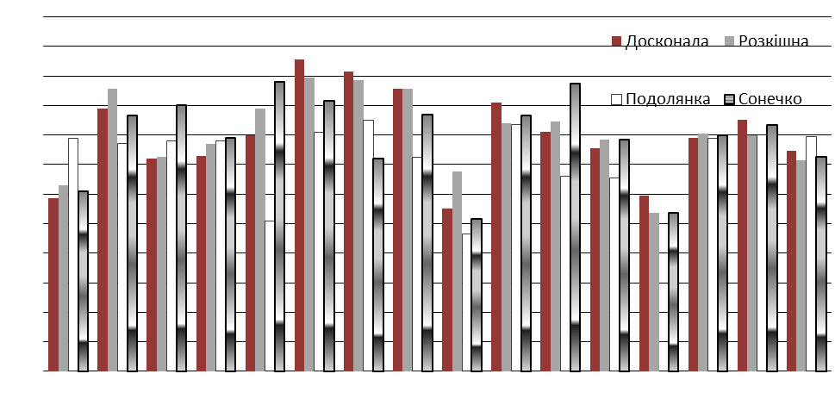
Pic. 1. Indices of grains weight per ear of winter wheat according to the sowing terms.
(2011-2013)

Based on the obtained experimental data it different reaction of winter wheat to sowing was found. In three varieties of winter wheat (Doskonala, Rozkishna, Sonechko) the highest rates of ear grain weight ( 1,8-1,9 g) were formed by sowing on 20 September. In Podolyanka the largest grain weight per ear was obtained by sowing in early September 10, delayed sowing indicated the decrease of productivity.
The results of this research indicate the trends of shaping higher productivity indices of winter wheat that are planted in the optimum time.
Conclusions:
It was established that higher levels of plant productivity (number of productive stems, number and weight of grains from the ear) are formed by sowing from 10 to 20 September. For most varieties sowing of September 20 contributed the greatest manifestation of their genetic potential. Thus, the optimal conditions for the northern part of the left-bank forest-steppe of Ukraine sowing should be considered the 10-20 of September. Sowing in later periods leads to a sharp decline in the productivity of winter wheat.
LITERATURE
- Звягін А. Ф. Особливості селекції сортів пшениці озимої універсального типу з підвищеним адаптивним потенціалом у східному Лісостепу України / А.Ф. Звягін, З.В. Усова, В.З. Іодковський, О.О. Кібліцька // Вісник ЦНЗ АПВ Харківської області, 2012. – С. 89–94.
- Комп’ютерні методи в сільському господарстві та біології: навчальний посібник [О. М. Царенко, Ю. А. Злобін, В. Г. Скляр, С. М. Панченко]. – Суми: “Університетська книга”, 2000. – 203 с.
- Лебідь Є. М. Наукові основи підвищення ефективності виробництва зерна в Україні /
Є. М. Лебідь, М. С. Шевченко // Бюлетень інституту зернового господарства. – Дніпропетровськ.: Інститут зернового господарства, 2008. – № 33–34. – С. 3–7.
- Методика проведення експертизи та державного випробування сортів рослин зернових, круп’яних та зернобобових культур – К, 2003. – Вып. 2, частина 3. – С. 193–199.
- Методичні вказівки щодо проведення польових досліджень і вивчення технології вирощування зернових культур. – Чабани : Інститут землеробства УААН, 2001. – 22 с.
- Наукові основи агропромислового виробництва в зоні Лісостепу України / [В. М Зубець та ін.]; за ред. В. М. Зубця. – К. : Логос, 2004. – 776 с.
- Дем’яненко В.В. Вплив строків сівби на рівень продуктивності зерна та насіння сучасних сортів озимої пшениці. Сайт ТОВ «Агроскоп Україна» [Електронний ресурс]. – Режим доступу : http://agroscop.com.ua/ua/news/54.html.
- Нетіс І. , Оптимізація строків сівби пшениці озимої. Сайт «Пропозиція» [Електронний ресурс]. – Режим доступу : http: // propozitsiya.com/?page=146&itemid=3403
- Площі зернових та олійних культур. Урядовий портал. Сайт Міністерства аграрної політики та продовольства України [Електронний ресурс]. – Режим доступу : http//www.minagro.kiev.ua.
- Програма Зерно України –2015. Сайт Національної академії аграрних наук України [Електронний ресурс]. – Режим доступу : http://www.uaan.gov.ua/sites/default/files/zerno.doc.
- Food and agriculture organization of the United Nations. FAO [Електронний ресурс]. – Режим доступу : http://faostat.fao.org/site/636/default.aspx#ancor.

