© 2013
Radionenko V. M., Ph.D., Associate Professor,
Pyankova Y., assistant
Donetsk National University of Economics and Trade named after Mykhailo Tugan-Baranovskyi
Kochetov V. P., PhD., Associate Professor,
Odessa National Academy of Food Technologies
FEATURES OF LETTUCE STORAGE IN A CONTAINER WITH A MODIFIED GAS MEDIUM
Recommended for publication by Ph.D., Professor, Dean of Physical and Metallurgical Faculty, Chair of industrial power of Donetsk National Technical University Safyants Sergey Matviyovych
The aim of the paper is to confirm the effectiveness of the structural choice of membrane for the application of additional factor of impact SCI lettuce during storage at refrigerated cargo spaces. In the course of experimental studies modules with semi-polymeric membranes were used. Modified gas medium was formed as a result of gas exchange between the environment and lettuce into a confined space module, as well as between the environment and the outside air through the membrane material having selective permeability to gas medium components. Our studies confirm that the cooling storage technology using a modified gas medium (MGM) as an additional factor of influence is an effective means of reducing costs and increasing the duration of storage of perishable plant products in existing refrigerators APK of Ukraine. Scientific novelty is the optimal size of a semipermeable membrane of specific designs for specific varieties of lettuce leaves and a certain total weight of the package, which justifies further research to choose the best alternative design solutions for the implementation of MGM membranes, taking into account the properties of other types of crop production. These results suggest the feasibility of using a modified gas medium (MGM) to prolong the storage of perishable plant products as applying to existing refrigerators does not require the introduction of structural changes and of additional use of equipment.
Keywords: fruit and vegetable production, storage time, quality, technology, measurement of color.

Published statistics show that in 2012 were collected 9,1 × 106 tons of vegetables, 23 × 106 tons of potato, 1,9 × 106 tons of fruits and berries, 490 × 103 tons of grapes that allows fully to provide the market of Ukraine with vegetables and fruit. [1]. Putting into operation in 2012, 38 hectares of new high-tech greenhouses allowed obtaining harvest greenhouse vegetables at the level of 445 × 103 tons, up 12% over the previous year [2].
Data of the Ministry of Agrarian Policy and Food of Ukraine (MAPaFU) suggest that the increase in production of vegetable products in recent years led to increase attention to the development of agricultural market infrastructure, particularly the construction of vegetable -, fruit , potato storage facilities and wholesale markets of agricultural products [3 ]. This is due primarily to the fact that the general lack of capacity storage with an increase in the production of fruits and vegetables and potatoes leads to a sharp increase in the loss of this latent energy production and, as a result – the need to increase its export and import growth overseas, or re-export their products, requirements to ensure national food security.
However, expression of attention to the construction of new vegetable, fruit-, potato storage facilities in the absence of attention to the state of moral and physical deterioration of existing facilities the refrigeration sector can not solve the problem of the optimal balance of the agricultural sector. This is primarily due to the fact that in the long process of long-term operation of refrigerators to store food quality has a negative impact not only wear cooling systems and thermal insulation structures, but also aging refrigeration technology of processing and storage. In recent decades in developed countries with a view to extension of storage and preservation of the quality of production in refrigerated areas additional influencing factors are used, among which may be called controlled atmosphere (CA), modified gas medium (MGM), ozonation, etc. A survey of the many results of research on the efficiency of these factors showed that each of them definitely has advantages and disadvantages. However, in our opinion, for refrigerator, made obsolete by the project design, the most appropriate is the use of modified gas environment because there is no need to use more energy-consuming equipment (gas generator), or costly medications such as antiseptics.
The main purpose of this study was to determine the effectiveness of using MGM by lettuce during storage, which is one of the greatest that easily deteriorate vegetable products. To achieve this goal in the work we used compact module-pack with a semi permeable membrane made ​​of polymer materials, selective gas permeability which provides self-correcting gas exchange between the gas medium (GM) within the packing and the air environment in the chamber of the refrigerator.
At this time, to create a barrier mechanism in filtering gaseous medium two main types of membranes are used:
- solid film that provide filtering CO2 and O2 through the membrane surface;
- perforated film with small holes or micro perforation as the primary gas exchange transport network.
Manage permeability is achieved by selecting the molecular structure of the membrane material, its thickness, surface area, and the gradients of temperature and pressure of the gas medium.
Permeability of CO2 and O2 for solid films increases with increasing temperature, while the diffusion of gases through perforated holes is practically insensitive to changes in temperature.
Key indicators of polymeric membranes were used in the experiments:
- The diameter of the working area - 23,0 ± 0,5 mm;
- The thickness of the membrane - 0,120 ± 0,020 mm;
- Membrane area - 4.15 cm2;
- Capillary membrane diameter 5 ... 25 mkm .
Modified medium was formed as a result of gas exchange between the environment and lettuce in a confined space module, as well as between the environment and the outside air through the membrane material having selective permeability to gas medium components.
This environment is formed naturally by “breathing” of vegetable crops.
It is established that the duration of the formation of gas environment by breathing the product does not exceed 3 days since their sealing.
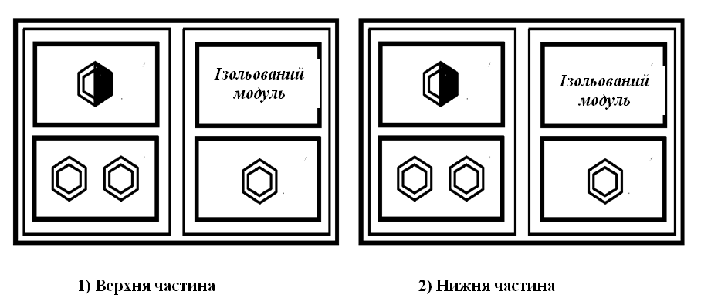
Figure 1. Location of modules in the refrigerator

4 types of locations of membranes in packing modules were studied: one module is isolated (no membrane), one half of the membrane, a membrane, the two membranes;
After initial measurement following measurements were carried out at 3, 5, 10, 20, 30 days (until the damage). The average weight of favorite is = 811 ± 5 g. Ongoing studies of the temperature was maintained at t = 2-3 ºC, and relative humidity – not lower φ = 95%.
Determination of gas composition was performed on a gas chromatograph “Color 5000”. According to the specifications of the unit, the error did not exceed 0.5%. (Figure 2).
Keeping lettuce in modules with a modified gas medium allowed to slow down the process of ripening and prolonged shelf life of the commodity without reducing quality.
Organoleptic after 4 weeks showed the worst performance (including total decay) observed in isolated modules.
Initial content of vitamin C was 102.4 mg / kg. Figure 3 shows a graph of the content of vitamin C during storage of lettuce leaves in a module with a modified gas medium. As can be seen from the graph, change of the content of vitamin C started after 3 days of storage. Further, the best results were vitamin C content in the module with 2 membranes.
During the study, both the definition and measurement of gas composition concentration of vitamin C, we have carried out measurements of colored letters, describing the change of lettuce during storage. The feasibility of controlling color changes confirmed that the color of the leaves of lettuce is the most important indicator that indicates its quality.
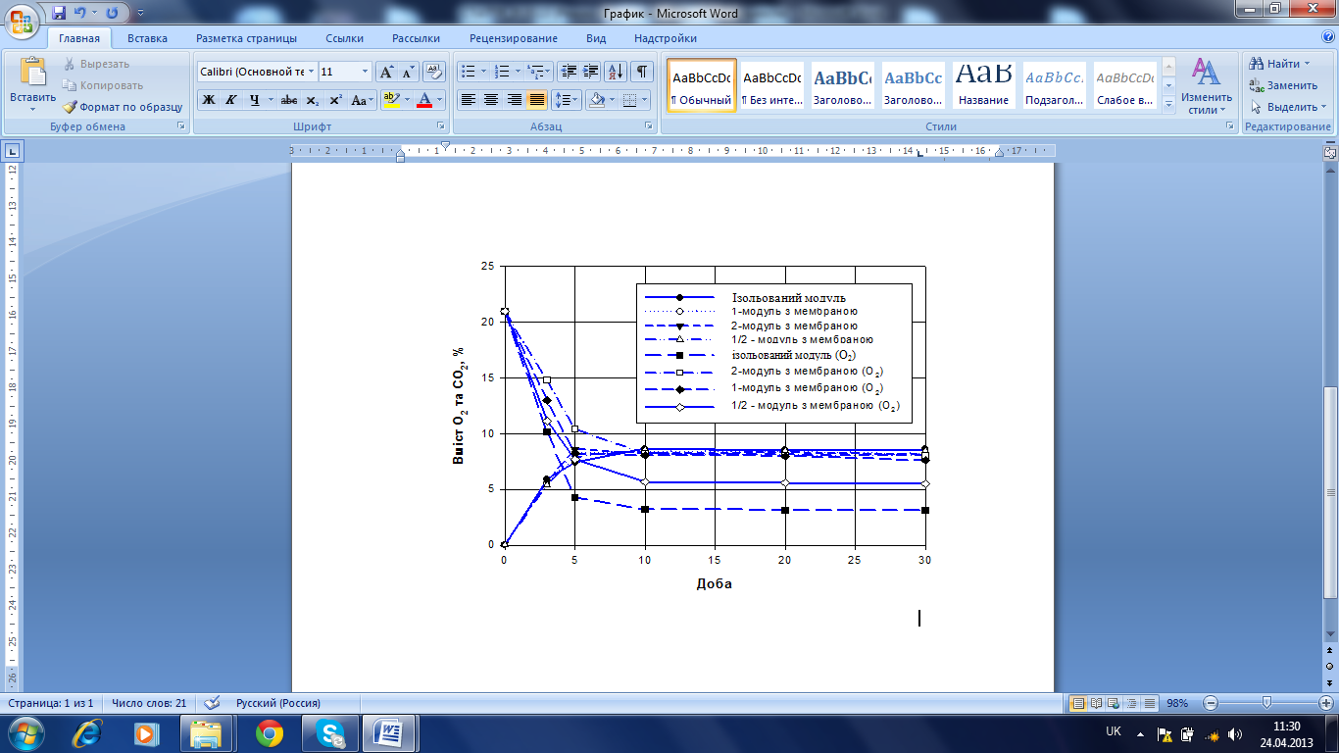
Figure 2. Changes in the gas composition of CO2 and O2 within modules
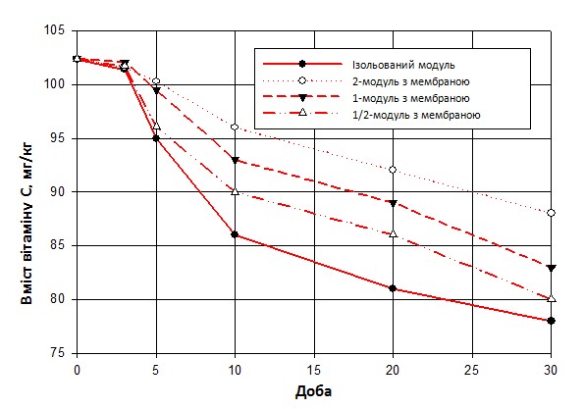
Figure 3. Change in content of Vitamin C
Experimental data on the measurement of colored leaves of lettuce using spectral densitometer are shown in Table 1. Mean values ​​were obtained on the basis of measurements during the three samples of lettuce, taken from the top of the refrigerator. Statistical differences between selected letters were found. In order to distinguish quality of lettuce were also conducted measurements for yellowed letters. Better results showed variant of 2 membranes.
Table 1. Changes in the color of leaves of lettuce during storage
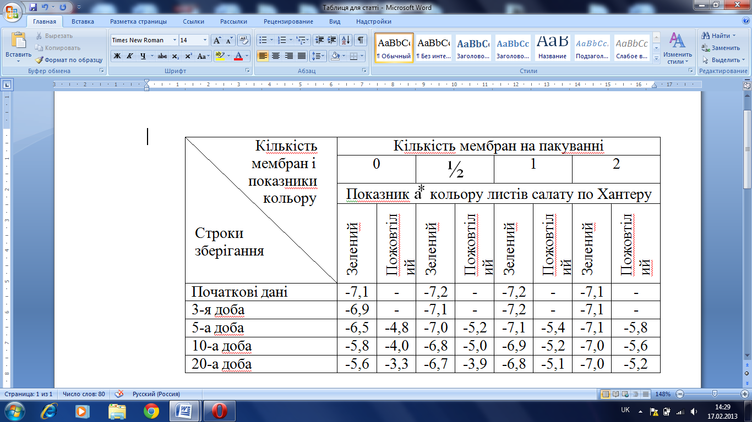
The results of this work suggest that the storage technology using as an additional factor, impact modified gaseous medium (MGM) is an effective way to reduce losses and increase the duration of storage of perishable plant products in existing refrigerators APK of Ukraine.
REFERENCES:
      - Газета «Урядовий Кур'єр» №230, від 13.12.2012 р., C. 1.
      - http://economics.unian.net/rus/news/.54469-minagroprod-prognoziruet-stroitelstvo-52-ga-teplits-v-2013-godu.html.

3. Проект Закона Украины "О продовольственной безопасности" от 28.04.2011 p. № 8370-1.

