© 2018
Fediaieva A. S., postgraduate student
IMPROVEMENTS OF THE CONDITIONS OF KEEPING OF BOARS OF FOREIGN BREEDING, THE IMPACT OF EXERCISE ON THE PRODUCTION OF SPERM
In the article materials are given on the use of exercise and the improvement of technological conditions for keeping of boars of foreign selection. Also the impact of the exercise on the production and quality of semen under the conditions of the current economy of the state enterprise «National Plus» of the private enterprise «National» of the Dnipropetrovsk region was studied.
We established that the introduction of the exercise and the improvement of the conditions of keeping of boars of foreign breeding positively influenced on the physiological state of the boars, which led to an improvement in the quality of the sperm. Also in the conditions of farming, the best genotypes of boars-producers are revealed. One of the main is the terminal boars of the Macster line (Canadian breeding), which in all respects exceeded all other boars.
Key words: pig breeding, exercise, sperm, terminal boars, content.
Formulation of the problem. At present, industrial pig production with a complete cycle of production uses mainly an impassable system of keeping the bud, which leads to a deterioration of the status of the hams (obesity, hypodynamia or extreme mobility of animals, various diseases of the limbs, decrease in sperm production, etc.). Thus, the main task of pig-breeding is to improve the conditions for their maintenance, and mainly the introduction of animals into a motile (from the Latin motionis – movement) to improve their physiological state [1–6].
Research analysis. The data from literary sources indicate the dependence of the boars’ reproductive function on the conditions of their keeping and the exercise used in them, which improves both the overall functional state of the organism and the reproduction function.
Permanent exercise (in the fresh air) helps to normalize the metabolism and body functions, improves resistance, fertility and productivity. Bulls should receive daily exercise at a distance of 1.0–6 km, with the speed of movement should be within their physiological norm.
During the warm season, the horses can be kept around the clock on a walk-in platform with a canopy in the event of rain and heat. The walks throughout the day serve as a tireless mosition that promotes the strengthening of the muscles and skeletal system, improves the functional activity of the digestive tract and the cardiovascular system, and also increases the volume of ejaculate by 8–20 %, increases the concentration of sperm by 6–13 % and enhances sperm motility for 4–8 %. Bulls are made more active in the artificial taking of sperm.
In winter, before the day's feeding, puppy-breeders are necessarily let out for a walk, and on return, rest for 35–40 minutes. In bad weather, horses are thrown twice a day for 2.5–3 hours. Kennels-pedigrees are kept in individual machine tools. According to the norms, the area of the machine should be not less than 2.5 m² for verifiable and 7.0 m² for the main peduncles. The walls can be both solid and lattice, and their height is about 1.5 m, but not lower than 1.4 m. The central passage is not less than – 2.3 m. The mounting height and fasteners must be mounted in the machine, which is 80–85 cm, with the calculation of the front feeding 45–50 cm per chicken. In industrial pig-breeding complexes, where it is difficult to provide barns, use simulator designs (Pic. 1) for its forced reception.
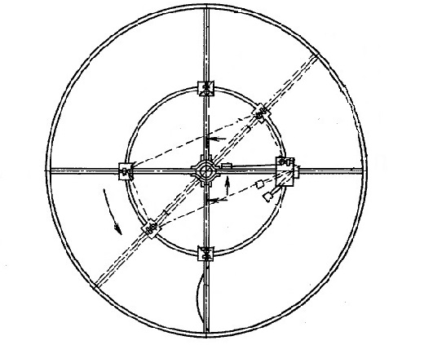
Pic. 1. Schematic image of the simulator for coercion of animals
The purpose of the research was to provide a comparative analysis of the chickens of foreign selection in the «National Plus State Enterprise» of the PE «National» with the use of motions, and to improve the conditions for their maintenance in individual machines to increase the efficiency of semen production.
Material and methods of research. The «National Plus» subsidiary of «National» NP ensures that the chickens are kept in individual machines, the parameters of which are met by all technological norms. Characteristics of the machine: the floor area is 7 m², the height of the machine is 1.45 m, the passage for the barn is 2.5 m, the height of the feeder mount is 80 cm. For the bins of the terminal lines, we have improved the individual machine (Pic. 2), its characteristic was changed, as the parameters of the horses were larger than the standard, which is unacceptable for keeping machines in place for all other harnesses. Characteristics of the advanced machine: the floor area was increased to 7.8 m², the height of the machine was 1.65 m, the passage was 3 m, the height of the support of the feeder 95 cm.
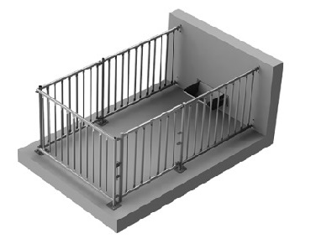
Pic. 2. Improved machine for individual maintenance of a puppy-breeder
Handling the barns was calm, violence and beating were not allowed. The brooms periodically cut the fangs and paid special attention to the hoofs. Therefore, they quickly grow, especially with insufficient motility, which in the future leads to lameness and low sexual activity.
Special attention was paid to specialized beef breeds and lines because they are more prone to diseases of the limbs. In studies, it was important to study the role of regimen on comparatively derived semen from experimental breeding puppies of different genotypes.
By such indicators: volume, activity, concentration, color, moving and immovable sperm, sperm survive in each ejaculate. The received digital material is processed using the standard package of applied statistical software MS Excel.
Main results of the study. In the conditions of the National Plus State Enterprise, the National Company of Dnipropetrovsk region in the pig complex investigated the native semen of sexually-reared donkeys of different genotypes: large white breed – 3, Landraces – 3, Durok – 3, Piétrain – 3, terminal bows – 6 (see table).
Biological indicators of semen of experimental kennels using regimen
The breed of experimental kennels
♂BW | ♂D | ♂L | ♂Т  OptiMus | ♂P | ♂Т  Macster
Volume of sperm, ml
M±m
243  ±9,94 | 218  ±4,57** | 267  ±5,38 | 276  ±8,33* | 205  ±6,53* | 283  ±8,10***
Sperm activity, score
M±m
8,6  ±0,12 | 8,4  ±0,11** | 7,3  ±0,09*** | 8,4  ±0,08** | 8,6  ±0,06* | 8,7  ±0,13**
Concentration of sperm, mln/ml
M±m
447  ±8,73 | 484  ±8,76 | 395  ±14,21** | 478  ±12,35 | 462  ±8,56 | 498  ±8,94***
Survive sperm
M±m
262,5  ±8,2 | 317,4  ±9,3* | 260,8  ±5,3*** | 516,7  ±7,4 | 508,8  ±6,3 | 549,6  ±4,8
Experimental breed boars had a slight discrepancy between themselves by the sperm volume indicator. The Large White boar has produced on average 243±9,94 ml, which is more than Durok has – 218±4,57 ml and Piétrain – 205±6,53 ml, but less than Landrace – 267±5,38 ml (increase by 24 ml) and terminal OptiMus – 276±8.33 ml (increase by 33 ml), Macster – 283±8.10 ml (increase by 40 ml).
The most informative indicator of sperm quality is the sperm motility and its concentration. Thus, according to the sperm motility rate, the experimental groups of animals have produced almost the same number of points and have been within the range of 7.3–8.7 points, which is a rather high indicator.
Estimated sperm concentration, which is one of the main indicators of the quality of reproductive cells in our study, was better in Macster boar line – 498±8.94 million/ml, which was an increase by 51 million/ml or by 11,40 % respectively, compared to Large White boars.
Conclusion. In the conclusions, it can be noted that the introduction in the conditions of the maintenance of monkeys, the mothers positively influenced not only their physiological state, and their quality sperm. Significant differences in all of the biological parameters of sperm were not detected, but we found that in the terminal macsters of the Macster line, sperm concentration and activity were better. We believe that an individual machine for terminals we have improved by us is expedient to use in industrial farms.
BIBLIOGRAPHY
1. Сусол Р. Л. Методологія створення і використання нових генотипів свиней вітчизняного та зарубіжного походження в умовах півдня України [текст] : дис…к. с.-г. н. : 06.02.01 : захищена 2015 році /
Р. Л. Сусол. – К., 2015. – 438 с. вик. У розд. 1.2.
2. Davidson H. P. The production and marketing of pigs / H. P. Davidson. – London, 1954. – 406 с.
3. Свинарство і технологія виробництва свинини : Підручник для підготовки фахівців у аграрних вищих навчальних закладах III – IV рівнів акридитацій із спеціальності «Зооінженерія» / [Герасимов В. І., Цицюрський Л. М., Барановський Д. І. та ін.] : за ред. В. І. Герасимова. – Х. : Еспада, 2003. – 448 с.
4. Лоза А. А. Потенціал розвитку свинарства в Україні Асоціація свинарів України АСУ [Електронний ресурс]. – Режим доступу : http://www.eurotier.com/fileadmin/downloads/2014/Programme/ Russland/1_Loza_ru.pdf.
5. Технологія виробництва продукції тваринництва : підручник / [Бусенко О. Т., Столюк В. Д., Могильний О. Й. та ін.] ; за ред. О. Т. Бусенка. – К. : Вища освіта, 2005. – 496 с.
6. Інтенсивна технологія виробництва свинини / [Рибалко В. П., Баньковський Б. В., Коваленко В. Ф. та ін.] ; за ред. В. П. Рибалко. – К. : Урожай, 1991. – С. 176.

