© 2018
Prykhod’ko Yu. O., Doctor of Veterinary Sciences, Professor
Kharkiv State Agrarian Academy
Korchan L. M., Candidate of Veterinary Sciences,
Korchan M. I., Candidate of Veterinary Sciences
Poltava State Agrarian Academy
STENOPHONENDOSCOPE FOR GROUP AUSCULTATION OF ANIMALS
Reviewer – Doctor of Veterinary Sciences, Professor A. A. Zamazii
The offered stethophonendoscope for group auscultation of animals has two interchangeable sound-absorbing flat heads: one with a membrane, the second – with a stethoscopic head; sound-distributing device with an internal spherical acoustic chamber, which, with the help of an underwater and four bypass nozzles, is connected by standard flexible sound-lines with a sound-receiving head and spring headboards with vernal olives. Stethophonendoscope for group auscultation of animals is easy to manufacture, it is easy to use for different positions of the body of animals, it ensures equal and uniform sounding, enables simultaneous joint listening of sounds by several specialists during the consultative diagnostics, can be used to improve the quality of the learning process while mastering the technique auscultation by students.
Key words: stethofondoscope, auscultation, listening, animals, diagnostics, sounds, instrument.
Formulation of the problem. Despite technological progress and great equipment of equipment during the comprehensive study of both human and animal remains an indispensable diagnostic auscultation by listening to the noise of the internal organs: lungs, heart, stomach, intestines; to determine the method of blood pressure Korotkoff recognition of intracranial aneurysms and arteriovenous in obstetric practice and so on.
Most hold indirect auscultation with a stethoscope, phonendoscope, or thereof combinations – phonendoscopes. There are both mechanical and electronic versions of some of these devices for auscultation [1, 2, 4, 5–9].
Nowadays both humane and veterinary medicine for auscultation more available and preferably used mechanical Phonendoscopes that sound receptors have two heads, one with a membrane (phonendoscope), second without it (stethoscope), sound-conductor flexible headband and spring with tips for the ears of the doctor (ear oils).
Analysis of basic research and publications, which initiated a solution of the problem. In literary sources, many modifications of the stethophonendoscope [2, 7–9] have been highlighted, which are not effective enough, have certain disadvantages and in practice have not yet found the necessary application.
However, as practice shows, with a stethoscopic head, low (low-frequency) sounds are listened better, and with a head with a membrane, higher (high-frequency) sounds that are amplified by the device. Such stethoscopes and phonendoscopes have a simple design, a low price, even available to ordinary citizens. However, such mechanical devices for auscultation do not allow simultaneous listening to the animal by several specialists, which is very important during the advisory diagnosis. They are also not sufficiently effective to study auscultation, do not allow the teacher to work effectively – at any moment he is busy with one student, besides, they do not guarantee the identity of the perception of a sound picture.
Electronic stethoscopes or phonendoscopes, which are currently used only in some clinics of humane medicine, significantly expand the functionality of auscultation, visualize the signals ideal for teaching auscultation, allowing multiple users to simultaneously listen to the same sounds. However, electronic devices for auscultation also have a number of shortcomings: their price is high enough, they do not allow listening to sound phenomena in organs in their pure form, as their elastic tubes are subject to fluctuations of the air (no vibration protection). In the electronic phonendoscope, the modification of sound phenomena may be due to the noise of its own sensors and amplifiers.
For group auscultation a mechanical phonendoscope is offered, which is used in laboratory and practical classes of students for the study of animal organs [6]. The design of this folendoscope introduces a new detail – a splitter that allows simultaneous listening to the investigating body to a teacher and three students, or simultaneously to listen to the body by several specialists.
The splitter is the three brass nozzles that are connected from the side to the main soundboard with soldering. Length of branch pipes 25 mm with an internal diameter of 6 mm. The front edge of the main soundboard is bended in the opposite direction of the soldered brass nozzles and a membrane head connected to it. All other elements are flexible sound lines, spring headband with eartails standard. However, the disadvantage of such a phonendoscope design is that the acoustic energy that comes from the head of the phonendoscope is distributed unevenly on four channels – in one straight line of sound and in three side solder pipes. The intensity of the sound in each of the four channels will not be the same. In the lateral channels of such a phonendoscope, the intensity of the sound, of course, decreases. So, and the process of connecting the sound conductors with the main sound pipe with the help of soldering can change the diameters of their holes.
The disadvantage of this design of the phonendoscope is that the above described connection of the head with the main sound pipe and soldered to it by three lateral sound conducting nozzles create a volumetric accumulation of parts, due to which the head is inconvenient to bring, for example, under the shoulder or blade of an animal for holding auscultation of the heart, lungs, etc., especially during the forced lying position of the animal. In this device for auscultation of animals there is no stethoscopic head.
The purpose of the work is to create a simple in the manufacture of a stethophonendoscope for the group auscultation of animals by eliminating the shortcomings of a close construction, namely: by expanding its structural and functional capabilities to ensure uniform and even conducting of sounds, better listening not only higher but also low sounds; enhancement of acoustic properties, ease of use in different positions, especially large animals.
Description of the device and its use. The offered stephophonendoscope for group auscultation of animals (Pic. A) includes two removable interchangeable sound-perceiving heads: one with a diameter of 63 mm (1), the other with a stethoscopic with the same diameter of its funnel (2); sound distribution device (3), standard flexible sound conductor length 200 mm (4); standard flexible ducts with a length of 540 mm (5) and spring headband (6) with eartails (7).
The large area of ​​the heads of the stethophonedoscope contributes to a sufficient depth of listening to the internal organs of large animals and can easily be tucked under the shoulder, shoulder and other parts of the body, especially when the lying position of the body is forced.
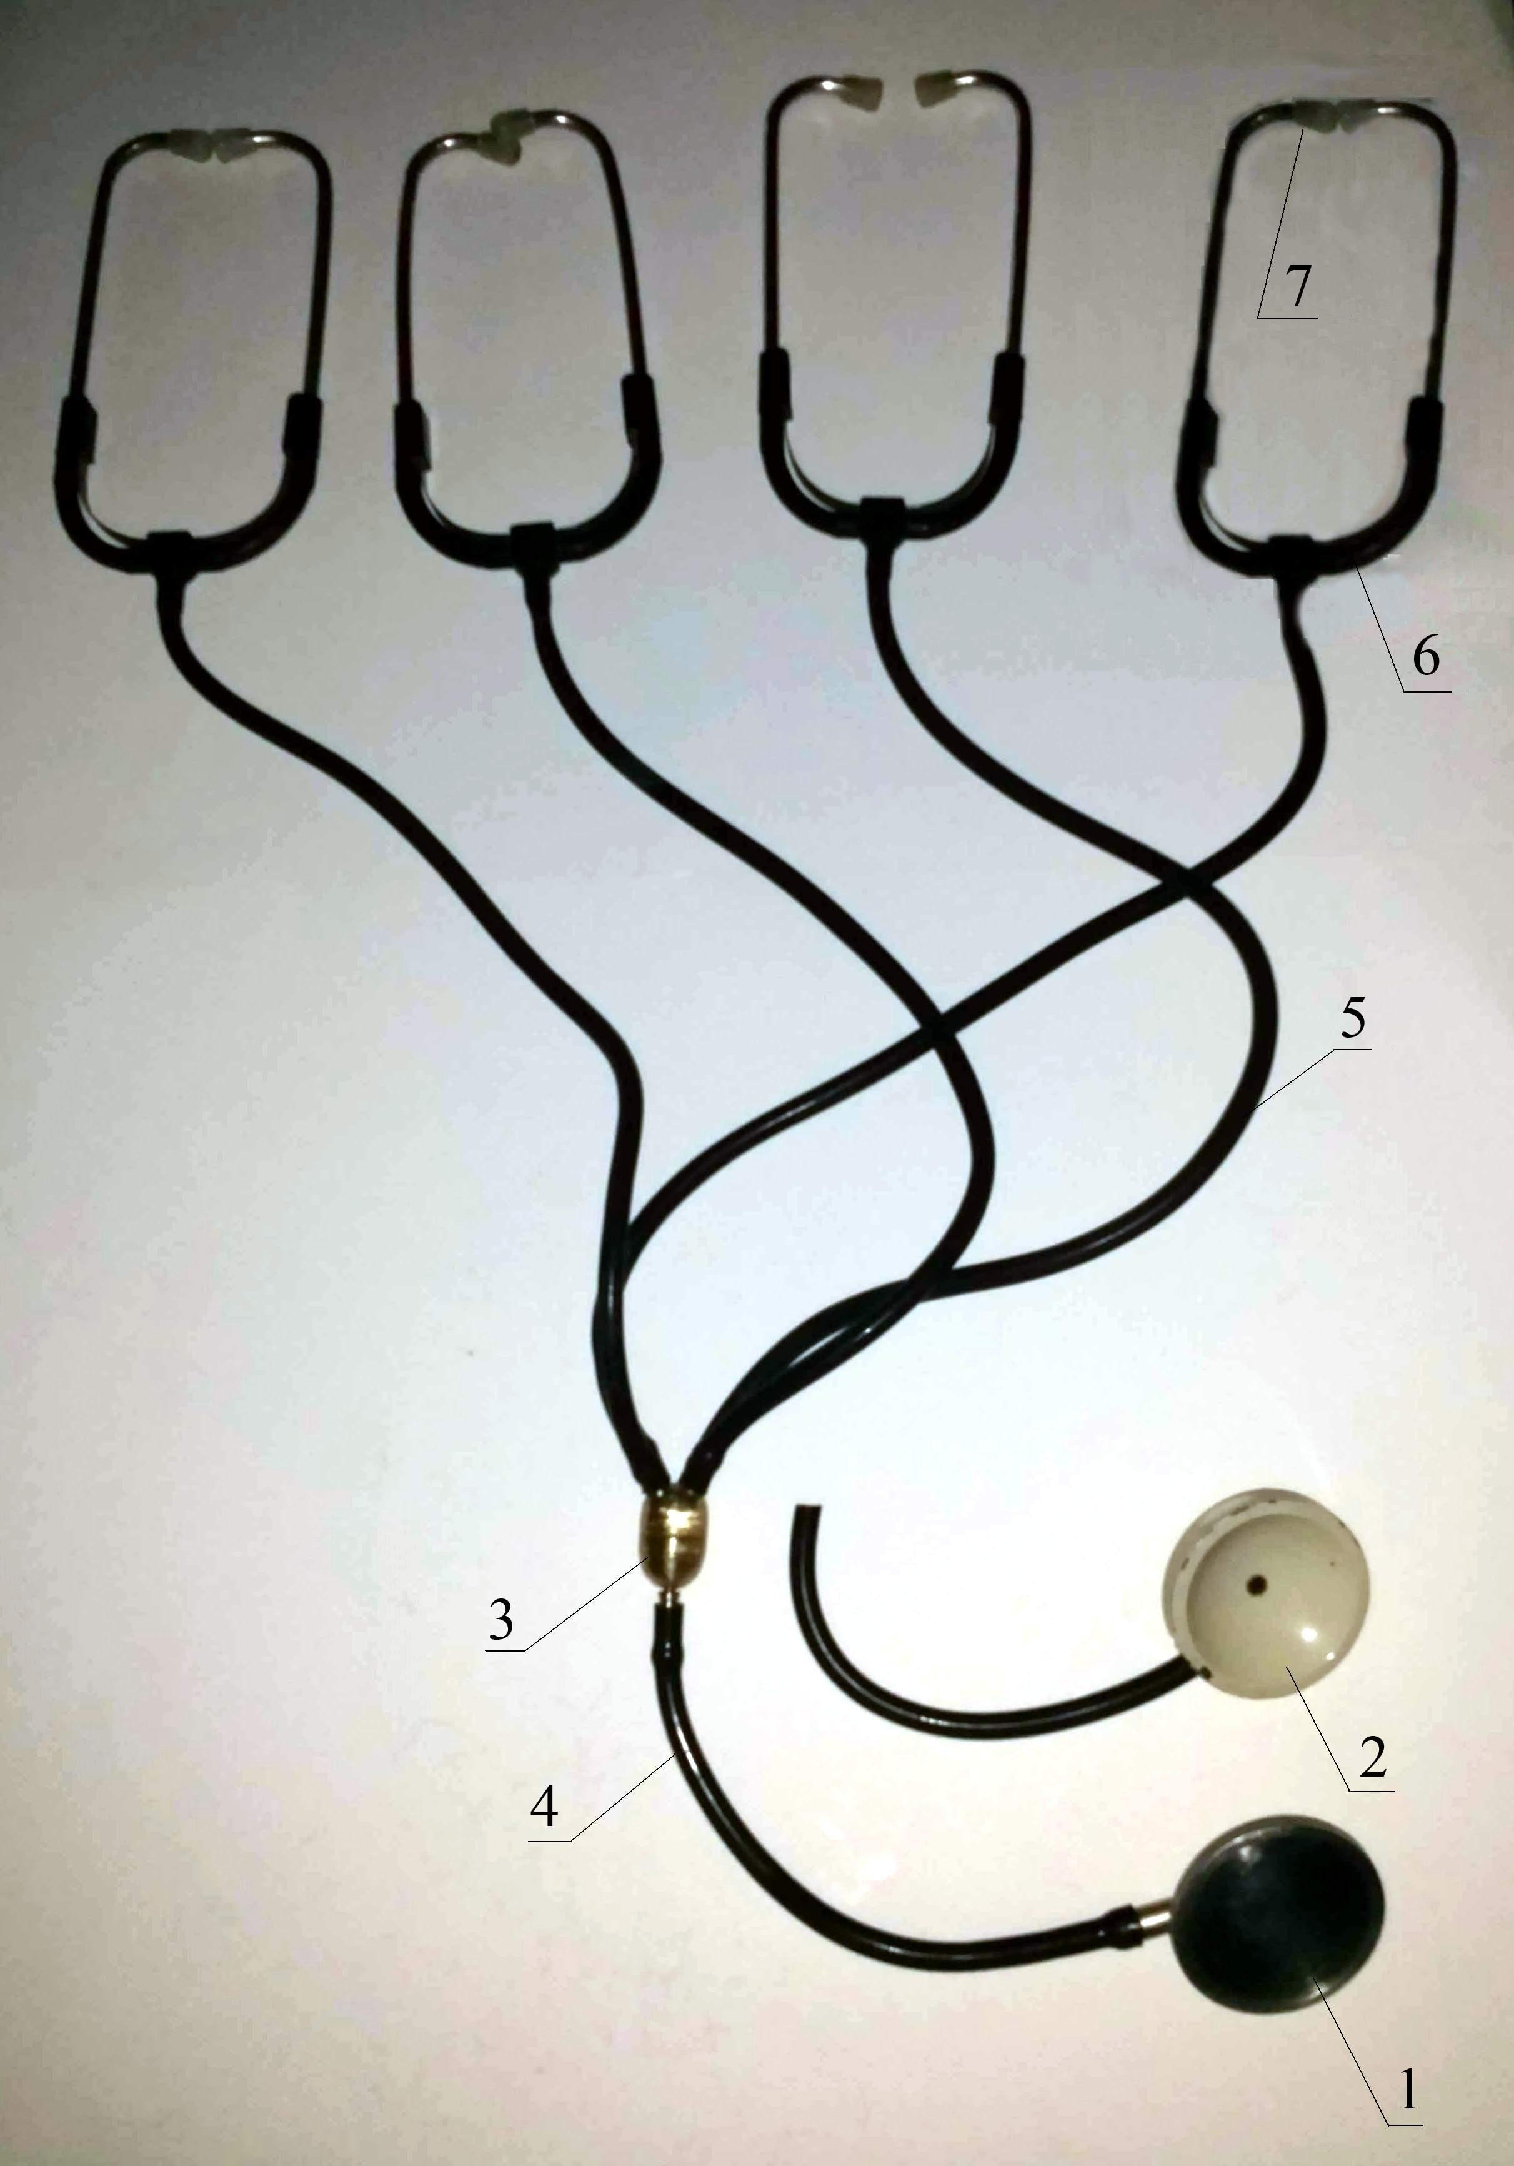
Pic. A. Phonendoscope for group auscultation of animals
The sound distribution device (pic. B) consists of a housing (1), inside which is ground and polished spherical acoustic chamber with a diameter of 25 mm (2); an outlet (3) and four outlet ports of 20 mm in length (4) which, at an angle of 45°, have a threaded connection to the acoustic chamber at the same distance from each other. The internal diameter of the nozzles for the warning modification of the sound corresponds to the internal diameter of the standard flexible conductors and is 6 mm. Such a design of the sound distribution device facilitates the even distribution of acoustic energy coming from the head and is directed to its four output channels.
The free end of the inlet of the sound distribution device is connected by a flexible sound conductor of
200 mm in length with the head, and the free ends of the discharge nozzles are connected through standard 540 mm flexible conductors with spring nippers and ear plugs.
A sound distribution device to prevent its own resonant sound phenomena is made of brass.
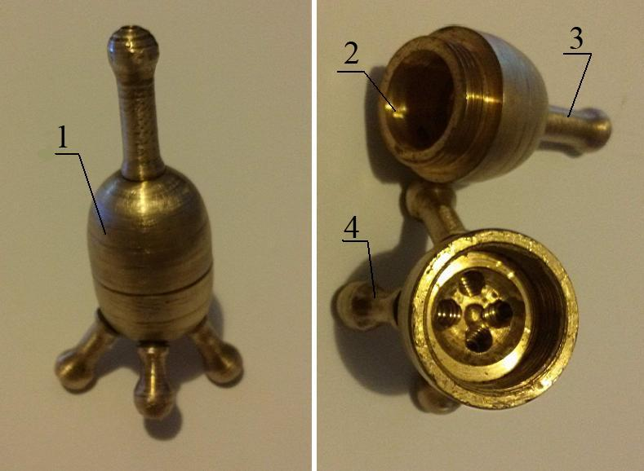
Pic. B. Sound-distributing device
Research results. We offered a stethofondoscope for group auscultation of animals, which is used as follows.
Several auscultation faces (up to four, for example, a teacher and three students) put a spring headband and insert ear-oils into their ears, and the sound-receiving head (with a membrane or stethoscopic) lift and press to the required area of ​​the animal's body (heart, pulmonary field, etc.). At the same time, the sounds from the animal under investigation through the sound-receiving head on the flexible soundboard come to the sound distribution device, where again the flexible sound pipes are directed to the ears and perceived by the auscultation faces.
The developed stethofendoscope for group auscultation of animals was tested on a large number of large and small cattle, horses. For this stevephonendoscope for group auscultation of animals received declarative patent [3].
Therefore, we consider it appropriate to establish commercial production phonendoscopes for auscultation group of animals and to implement it in practice veterinary medicine.
Conclusion. The offered stethophonedoscope for group auscultation of animals has a simple design, easy to use, especially for the forced lying position of large animals, providing uniform and even conduction of sounds (of the same frequency); provides the possibility of simultaneous joint listening of animals by several specialists during the advisory diagnostics; can be used to improve the quality of the learning process while mastering the method auscultation of students.
BIBLIOGRAPHY
- Внутрішні незаразні хвороби тварин : підручник. – 2-ге вид., доп. / [Судаков М. О., Цвіліховський М. І., Береза В. І. та ін.] ; за ред. М. О. Судакова. – К. : Мета, 2002. – 352 с.
- Вовк И. В. Экспериментальное исследование помех, возникающих при регистрации дыхательных шумов электронными стетофонендоскопами / И. В. Вовк, А. А. Макаренкова // Акустичний вісник. – 2007. – Т. 10, №4. – С. 28–34.
- Деклараційний патент на корисну модель № 9163/ЗУ/15 від 04.06.2015 Україна, МПК А61В7/00 (2015.01). Стетофонендоскоп для групової аускультації тварин / Корчан Л. М., Корчан М. І., Приходько П. Ю. // № u 2015 00802 ; заявл. 02.02.2015.
- Каталог ветеринарных и зоотехнических инструментов, аппаратов, приборов и оборудования стран-членов СЭВ / под общ. ред. А. С. Макеева, Л. М. Соколовой. – М. : Колос, 1972. – С. 10–11.
- Клінічна діагностика внутрішніх хвороб тварин / [Левченко В. І., Влізло В. В., Кондрахін І. П. та ін.] ; за ред. В. І. Левченка. – Біла Церква, 2004. – С. 18–21.
- Лукъянчиков О. Н. Фонендоскоп для групповой аускультации / О. Н. Лукъянчиков, А. Т. Лабзина, М. П. Артамонов // Ветеринария. – 1986. – №12. – С. 71.
- Обзор нескольких моделей кардиологических стетоскопов: личный опыт. Блог Шпака Я. В. [Электронный ресурс]. – Режим доступа : http://medicalmanuscript.blogspot.com/2012/07/blog-post_26.html.
- Олийнык В. Н. Частотные искажения, вносимыми контактными датчиками при одно- и двухканальной регистрации шумов дыхания / В. Н. Олийнык // Гидромеханика. – 1997. – Вып. 71. – С. 89–97.
- Стетоскопы MDF и электронный стетоскоп Jades [Электронный ресурс]. – Режим доступа : http://heaco.ua/stetoskops.

