© 2016
Goryk O. V., Doctor of Technical Sciences, Professor,
Brykun O. M., assistant
Poltava State Agrarian Academy
Chernyak R. E., engineer
Public joint-stock company «Autokraz»
CHOICE OF OPTIMUM PARAMETERS OF TECHNOLOGY OF SHOT BLASTING OF INTERNAL SURFACES OF OVERSIZE ELEMENTS OF MOTOR-CAR TECHNIQUE
Reviewer – Doctor of Technical Sciences, Professor A. A. Smerdov
On the basis of results of last known researches of theory of shock cooperation of particulate matters (pellets) with resiliently plastic half-space concerning shot-blast cleaning of cavities of cylinder capacities, as bodies of rotation. We generalized technological criteria of such process, as final options for creation of some technical equipments of automation preparing of surfaces to coverage by a non-metal protective layer. Determination for the most important descriptions of motion of imprint of abrasive torch on the processed curvilinear internal surface of product on condition of the even and high-quality cleaning was given.
Keywords: shot-blast cleaning, cavities of cylinder capacities, technological modes, automatic manipulator, abrasive torch, trajectory of motion.
Statement of the problem. Mechanization of process of cleaning of internal surface of oversize cylinder capacities is one of the largest orders of agricultural and transport engineer, which, in spite of the repeated attempts, it was not succeeded to decide during the last 50 years. Similar tasks are not decided also on machine-building plants, which make nuclear reactors, oil-cars, chemical and biological vehicles et cetera.
To the present tense this labour intensive and insalubrious for man operation is executed, mainly, by a hand method. From the mechanical methods of cleaning of surface of hardwares from mechanical and oxidizing contaminations before causing of the non-metal sheeting got the shot-blast cleaning (SBC) [6]. Application appears especially effective SBC for cavities of oversize hardwares, where another ways of tooling of the little uses. It is explained technological flexibility, ecological safety, high performance, operating reliability and economic efficiency to BC. But the wide use of this process restrains a temper by not perfect construction of facilities of mechanization and automation, which do not answer modern requirements in force of not complete co-ordination of technological bases at development of the proper technical decisions [2]. These problems need permanent attention of researchers.
Analysis of the last researches and publications, which initiated solving of the problem. To deep the analysis of methods and facilities of mechanization of stream-abrasive treatment of surfaces is resulted in [1], where the list of the last patents is given on the inventions of various devices, metallic surfaces related to treatment. But they do not light up technology and automation of process of cleaning of internal surfaces of hollow capacities practically. That touches cleaning of internal surfaces of oversize circular cylinder wares; here it follows notices works [2, 4, 7] which light up facilities of automation, but without the proper concordance with technological bases of cleaning process. In [8], opposite, the flow sheet of cleaning of cavities needs tying up with the technical decisions of facilities of mechanization.
Research purpose: analytical concordance of technological parameters with technical decisions on facilities of mechanization of process BC the internal surface of corps of biological vehicles for the improvement of methods of automation of stream-abrasive treatment of surfaces.
A task is generalization of technological and technical indexes of process of cleaning of metallic surfaces and use of these indexes abrasive torches at development of technical decision of automatic manipulator.
Research methods are the built models of shock cooperation of particulate matters (to the shot) with resiliently plastic half-space, statistical estimation of the known and got experimentally analytical information concerning to SBC.
Results of researches. Let’s generalize basic parameters to SBC as an output data for establishment of technological criteria of automation of process which consists of tooling free abrasive grains (by pellets) of the processed surface under a certain corner and speed (picture 1). Thus, there is a mass speed output of elementary volumes of material [5].
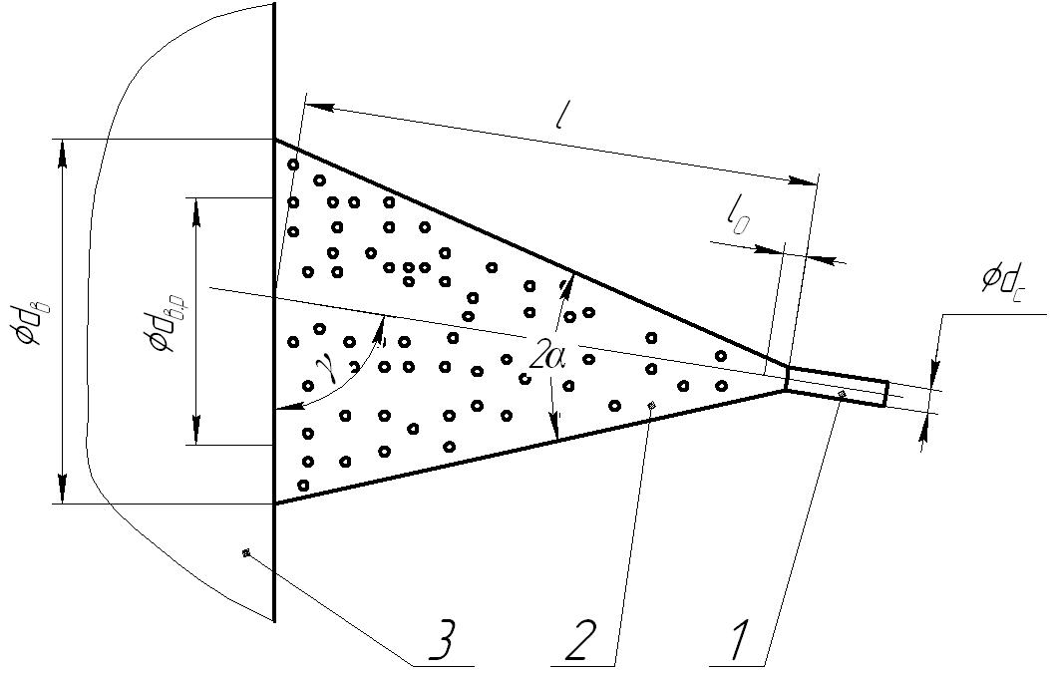
Picture 1. Chart of abrasive torch
Air-abrasive mixture is formed by a cylinder nozzle 1 with a worker diameter from which mixture takes off in a kind of conical torch 2 with the corner of opening and attacks the processed surface 3. The diameter of nozzle makes depending on the diameter of shot . Most speeds pellets arrive at the distance from the cut of nozzle after the complete smoothing of pressure of the compressed air with pressure of environment. Farther speed of pellets falls on an exponential law.
In practice distances stick from a nozzle to the processed surface . In spite of diminishing of initial velocity of pellets approximately on 20–50 %, it enables optimum to outlay energy of the compressed air, maximally to engulf the processed surface and effectively to use cuttings properties of pellets.
For making shot they use steel, cast-iron, glass and other materials which answer chemical composition of metallic basis or sheeting, and at the same time have high enough durability and hardness (HRC 45–50 on Rockwell). Most technological productivity of cleaning depending on a degree of contamination of the processed surface it gives steel shot of fraction № 1, that .
For the strong tripping of soil of sheeting with metallic basis, the last one must be high-quality cleared with formation of even roughness [5]. For this purpose from the surface of detail a layer is taken off in thick .
Snuffled with the financial opening diameter throws out a shot with diameter a mass serve at working pressure of power medium in the corps of shot-blast vehicle , providing the technological by volume productivity and superficial productivity at the depth of treatment .
At the real diameter of imprint of torch on the surface such productivity is arrived at speed of moving of imprint in relation to the processed surface .
Arithmetic medium-altitude of inequalities of the processed surface depends on factious composition of abrasive particles and set on correlation: .
For the reliable tripping of soil of sheeting with metallic basis, the thickness of which makes it is necessary to have a certain roughness of metallic surface, namely . Such roughness can be got at the diameter of abrasive particles which also responds to the condition of the greatest productivity.
For achievement of optimum criteria of cleaning process corner of attack pellets for low-carbon steel 10 must make [3].
For realization of process SBC the surface of hardwares of different configuration the arbitrary trajectories of moving of imprint of torch are possible on the processed surface at the observance of requirement – an imprint must not pass twice at the same surface.
For mechanization of process to SBC the trajectory of motion of imprint of torch on the processed surface acquires a decision value. It must be well-organized and simple enough. Reality of creation of executive mechanism depends on complication of trajectory.
Such generalized parameters of process to SBC we use for creation of flowsheet cleaning of cavity of the all-welded cylinder capacity (picture 2) which consists of the cylinder shell 1 with a radius and bottoms: front 2 with the opened hatch with a radius and back (rear) 3 with the initial union coupling with a radius or without it.
The basket elements of motor-car technique, corps of biological (chemical) vehicles are executed as bodies of rotation, formative of which elliptic and direct lines are [8]. It is therefore possible to come to the conclusion, that by the most suitable trajectories of moving of imprint of torch on the processed surface curves with a permanent step, which is, will be broken a secret: a screw spiral for shell and spiral of Archimedes is for bottoms (picture 2).
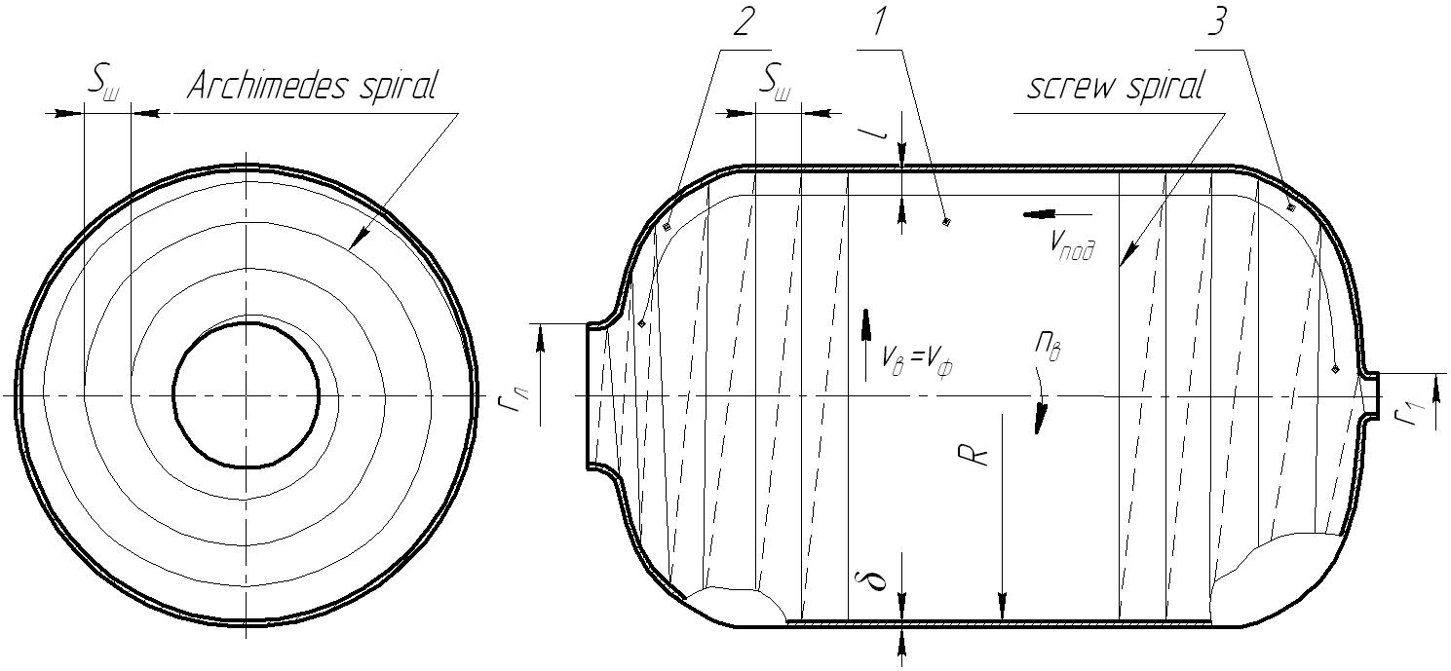
Picture 2. Cylinder capacity with a flowsheet to SBC

In accordance with such our requirements in [4, 7] an automatic manipulator, which provides motion serve of imprint of torch, beginning from the initial union coupling of back bottom 3 and farther motion takes place on formative of elliptic curve of back bottom, passes to formative direct of the cylinder shell 1 and then on formative of elliptic curve of front bottom 2, is offered, arrives at the opened hatch. Thereon SBC of the cavity of product finishes.
Technological possibilities of such manipulator conform to the next parameters of automation of process SBC of the cavities of overall cylinder capacities.
On condition of safe work the processed product must be revolved with linear speed of shell . Then frequency of rotation of capacity is at a radius will make motion of imprint of torch:
. (1)
Homogeneous treatment of surface of product as a body of rotation it is possible to attain for terms, when an imprint of torch is with a diameter will move with speed on the broken spiral which step must not be more real diameter of imprint of torch that and simultaneously on a formative curve at a speed of serve which provides the necessary ceiling by the torch of the processed surface.
As circular speed to product straight proportional radius to motion of torch imprint and frequency rotation of product, for component parts of corps of chemical vehicle – elliptic bottoms and cylinder shell, frequency of rotation of product will change for the observance of requirement:
. (2)
Thus, at the change of radius of motion of torch imprint it is necessary to change frequency of rotation of product round own axis which (axis) determines speed of moving of imprint of shot-blasting torch at cleaning of separate constituents of corps of vehicle.
For a back elliptic bottom which has the initial union coupling a radius frequency of rotation (1) will be a variable: at the initial radius of treatment and eventual radius (radius of shell ) namely
. (3)
During cleaning of shell a corps must be revolved with permanent frequency
. (4)
For a front bottom which has a central hatch with a radius at the initial radius of cleaning and eventual radius of treatment
, . (5)
In accordance with the accepted chart of motion of torch imprint on the processed surface: back bottom – shell – front bottom, serve of torch imprint along the formative cavity of corps will change on a law
, (6)
where - it is time of movement of torch from one coil on other, min.
As for the even cleaning frequency of rotation of product must not be less than maximal frequency of rotation of corps at treatment with the least radius of initial union coupling, frequency of rotation of product we accept even and permanent
. (7)
If possible frequency of rotation of product (1) can not provide necessary speed of moving of torch imprint, main motion must carry out an instrument. And the additional rotation of product with safe frequency will allow more evenly to process a surface and use tumbling surfaces by an exhaust shot which is in the cavity of product.
Conclusion. General results of any technical indicators of the shot-blast cleaning the internal surface of cylinder basket capacities for some protective non-metal coating as the final options, they allow to create the optimal design of some automatic manipulators but at the same time for making hardworking and dangerous operation for human health as for abrasive surface preparation products such as bodies of rotation and, as well, more increase the level of automation of this process.

BIBLIOGRAPHY
1. Андилахай А. А. Анализ струйно-абразивных методов обработки поверхностей /
А. А. Андилахай // Сборник научных трудов «Вестник НТУ "ХПИ"» : Технології в машинобудуванні. – 2010. – №53. – C. 4–10.
2. Визначення оптимальних технологічних режимів дробеструменевого очищення металевих поверхонь / [Горик О. В., Чернявський А. М., Ландар А. А., Шулянський Г. А.]. – Полтава : ПДАА, 2012. – 100 с.
3. Горик О. В. Динаміка та міцність енергетичних і сільськогосподарських машин та біотехнічних систем : колективна монографія / О. В. Горик, С. Б. Ковальчук. – Полтава : Видавництво «Сімон», 2015. – С. 77–84.
4. Патент на винахід №105279. Маніпулятор дробеструменевого очищення / [Горик О. В., Чернявський А. М., Ландар А. А., Шулянський Г. А.]. – № а 2012 10574 ; заявл. 07.09.2012 ; опубл. 25.04.2014, Бюл. №8.
5. Смирнов Н. С. Очистка поверхности стали / Н. С. Смирнов, М. Е. Простаков,
Я. Н. Липкин. – М. : Металлургия, 1978. – 232 с.
6. Спринг С. А. Очистка поверхности металлов / С. А. Спринг. – М. : Мир, 1966. – 349 с.
7. Шулянський Г. А. Автоматизація технологічного процесу дробеструменевого очищення сільськогосподарських резервуарів / Г. А. Шулянський, О. М. Брикун // Динаміка та міцність енергетичних і сільськогосподарських машин та біотехнічних систем. – Полтава : видавництво «Сімон», 2015. – С. 84–87.
8. Шулянський Г. А. Визначення параметрів пересування відбитку дробеструменевого факелу при очистці порожнин виробів // Галузеве машинобудування, будівництво : зб. наук. праць. – Полтава : ПДТУ, 2012. – Вип.2 (32). – Том 2. – С. 122–127.

