© 2016
Skrypnіchenko S. V., PhD of Agricultural Sciences, Associate Professor,
Kotsyuba І. G., PhD of Technical Sciences, Associate Professor
Zhytomyr State Technological University
TRANSFORMATION OF PEAT DURING DRYING AND LONG-TERM
AGRICULTURAL USE
Reviewer – Ph.D. of Agricultural Sciences, Associate Professor of Department of Ecology in ZhSTU I. V. Davydov
The results of years research and development impact of drainage on soil formation peat soils and environmentally friendly measures are presented, we offered their rational and effective use. It was determined that the rate of destruction linen is intensive in cultivated rotation. Drainage and long-term development of peat soils occur with significant changes in their properties: increasing the density of soil and ash, and the total moisture content decreases.
Keywords: drainage, crop rotation, peat soils, fertility, soil formation.
Statement of the problem. Drainage improvement is a powerful factor that radically changed the soil formation. Many researches focus on the problem of reducing the organic matter of peat («operation») under heavy use of them. Some scientists understand with the term volume reduction peat in three-dimensional measurement, and other power reduction of peat deposits [2, 3]. And weight reduction of peat is considered without taking into account qualitative change organic and physical-chemical transformations. We know that mineralization is accompanied by humification processes that take place simultaneously. In some circumstances decomposition processes prevail, in the other – synthesis [1]. If the drainage in the soil organic prevailed loose mass of peat-forming plants and low carbon and nitrogen, in the process of humification formed complex of macromolecular compounds with high content of organic elements.
Analysis of recent research and problem definition. The problem of transforming peat soils under the influence of agricultural use devoted a lot of papers. However, Western Polissya of Ukraine [1] data on the patterns and directions of groundwater flow processes, changes in the properties and modes influenced by drainage and long-term development is insufficient. [3]
Therefore, despite the considerable existing experience the use of organic soil urgent is revision of some provisions and technological aspects of improvement at this stage, to develop scientifically-based set of measures sustainable use of peat lands.
The purpose of the research – to identify features of the transformation of drained peat soils in long-term agricultural use and to develop and implement environmentally friendly measures for their conservation.
Research objectives – to establish patterns and trends of soil processes to justify and implement a set of measures for the conservation and wise use of peat lands.
Objects and methods of research. The object of research is process of transformation of peat soils under the influence of drainage and agricultural use, and productivity of agrophytocenosis in crop rotations of different species groups. Methods of research are commonly used.
The results of the research. The results of years of research done by scientists at the experimental station of Sarny (Rivne region) in conditions of Western Polissya, were used to identify and to track the General trends of soil forming processes under the influence of drainage and agricultural use. Based on the analysis of archival material involving recent research found that intensive period of use of peat array contributes to the intense rates of organic matter mineralization and partial humification. If the increase in the degree of mineralization of peat from the point of view of soil formation – a positive thing, that intense their mineralization – the phenomenon negative, as it is accompanied by a decrease in the reserves of organic matter, increased hydrophobicity, the formation of excess nitrogen, and so on. Tillage, application of chemicals crops, the functioning of individual physiological groups of microorganisms determine the specifics of the dynamics of soil regimes aimed at strengthening of oxidizing processes, and the intensive destruction of organic substance of peat.
The appropriate combination of reclamation and agro-technical measures can be considered as a complex of factors of properties, its modes and processes. Under the influence of prolonged drainage and intensive use of radically changing of chemical and water-physical properties of peat soil. So, the density of the soil layer 0–30 nearly 90 years of use has increased from 0,151 g/cm³ to 0,296 g/cm³, total moisture content decreased, respectively, from 546 to 295 %, ash content of the soil increased from 14 to 28 %.
However, long-term development is not reflected in the amount of total nitrogen and potassium in the peat soil. The mineralization of peat is also not conducive to the retention of colloidal complex of potassium in non-exchangeable form, and leads to its release and transfer in mobile, available to plants connection. So, the percentage of available forms of this element in rotary crop rotation reached 70, whereas in monoculture perennial grasses only 28 %. 30 % increase of phosphorus content due to the intensive agricultural use due to: partial fixing it with fertilizers and due to the significant presence of phosphorus in VTI layers that occurred in the soil profile. In addition, there is a clear trend of reducing growth of phosphorus as the prevalence in the crop rotation perennial grasses. To prevent a total mineralization of peat when agricultural use is impossible, but the process can be adjusted. An important factor that reduces its intensity is the optimization of water-air regime, i.e. the choice of the norms of drainage. Less intense peat and the removal of dust particles by the wind takes place under planting crops and perennial herbs.
The archive material, supplemented by the results of recent studies have allowed to analyze the transformation of the peat soil. Analyzing the use of soil under field crop rotation (56 % – tilled and 44 % grain) and forage (11 % – row crops, 33 % of cereals and 56 % of perennial grass) it should be noted that for the first 20 years of development in a field crop rotation was lost to 25 t/ha of organic matter of peat. Over the next 60 years, these figures had dropped to 60 %. Loss of organic matter in the fodder crop rotation 2–3 times less than in the field of crop rotation. Introduction to the structure of sown areas up to 100 % of row crops leads to significant annual reduction of organic substance of peat (20–22 t/ha).
On the processes of humification and mineralization of organic compounds is also affected by temperature and humidity. For the development of microbiological processes in soils there are temperature optimum around 30 °C and humidity about 60–80 % of full capacity. Excess or deficiency of heat and moisture leads to inhibition of the biological processes of mineralization and humification. So, extreme conditions slowed the rate of decomposition linen cloth (technique applications), which is annually laid at a depth of 0–30 cm at 60 days to assess the intensity of mineralization of organic substance of peat under the influence of different climatic conditions and activities of agricultural use.
The results of many years observations show that the rate of destruction of flax the most intense in the rotation of rotary – 60,8 %, eight-year meadowy period in 4 times slows down the process of mineralization of organic substance of peat – to 15,8 % (see picture).
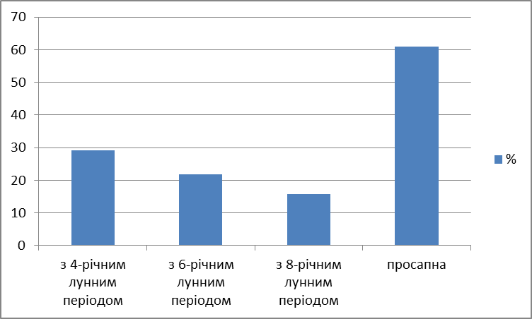
Pic. 1. The decomposition of flax in crop rotations of various intensity
(average for 5 years in 0–30 cm soil layer)
When you use the applications you need to keep in mind that they give results about the consequences of the destruction of the only fiber in the soil, and in the composition of organic matter is dominated by the more resistant components: humic substances, lignin, non-hydrolyzed residue, and so on, which are destroyed much more slowly. In the peat soil along with biochemical decomposition of organic substances into smaller monomeric structure, growth, synthesis of high-molecular compounds of a specific nature such as humic acid. The main symptom of chemical soil-formation process of peat soils is the accumulation of organic acids, insoluble in water and soluble. Although lignin is a stable substance, however, in the context of the soil environment it is destroyed, forming a number of phenolic products.
Crops have different effects on mineralization of peat soil at the expense of root and crop residues. Studies have shown that most of them leave long grass and maize silage, respectively 57,0 and 42,3 t/ha, the lowest fodder beet – 3,1 t/ha. Grain crops (barley, winter rye) occupy an intermediate position, respectively of 25,0 % and 30,1 kg/ha.
Thus, perennial grasses are an important factor in the regulation of fertility of peat soils and they should take a leading place in the structure of sown areas. Duration of use of perennial grasses depends on the thickness of the peat layer, the degree of drainage of the soil and its schedules. According to the results of our investigations the highest level of productivity is in perennial grasses 2–3 years of use (89 and 96 t/ha of hay). Starting from 4th year of use, performance, declined to 70,5 kg/ha, while the yield of herbs 7–8 years was the lowest and amounted to 47,2 and 38,5 t/ha.
Conclusion. Under the influence of drainage and long-term development of peat soils there are significant changes of their properties: increasing soil density and ash content, and total moisture content decreases.
It should be noted that the rate of mineralization of organic substance of peat mainly depends on the nature of agricultural use. The largest average of annual loss of organic matter is in rotary crop rotation (20–22 t/ha). Meadow long period of use inhibits this process 3–4 times. In this regard, it is necessary to observe retrench system of agriculture that will provide: saving and conservation of peat soils; an integrated optimization of the principal components of soil fertility.
BIBLIOGRAPHY
1. Бамбалов Н. Н. Баланс органического вещества торфяных почв и методы его изучения / Н. Н. Бамбалов. – Минск : Наука и техника, 1984. – 81 с.
2. Прістер Б. С. Підвищення родючості і охорона осушених земель гумідної зони : довідник / Б. С. Прістер, Р. С. Трускавецький, М. М. Мостовий. – К. : Урожай, 1993. – С. 74–76.
3. Писаренко В. М. Агроекологія : навчальний посібник / В. М. Писаренко, П. В. Писаренко, В. В. Писаренко. – Полтава, 2008. – С. 83–97
4. Сільськогосподарське використання осушених земель гумідної зони : рекомендації. – К. : Аграрна наука, 2000. – С. 3–28.

