© 2016
Ts’ova Yu. A., Applicant
(scientific leader – Doctor of Agricultural Sciences, Professor P. V. Pysarenko)
Poltava State Agrarian Academy

THE DISCRIMINANT ANALYSIS OF AGROECOLOGICAL INFLUENCE OF WAYS OF MACHINING OF SOIL
Reviewer – Doctor of Biological Sciences A. V. Zhukov
The article presents the results of discriminant analysis on the state of soil on edaphic parameters of the system, which are formed as a result of different methods of machining. Two initial discriminant axes are enough for discrimination of results of chisel cultivation, subsurface cultivation, minimum tillage, and also «no till». Canonical axes 1 discriminates ways of machining with high depth of ploughing and ways with small depth or zero processing. Canonical axes 2 discriminates each of the first groups on subgroups with smaller depth of ploughing in each pair. Deeper variants of a ploughed land differ by the big levels of nutrients (nitrogen, phosphorus, potassium) in soil. Values of canonical variables are considered as markers of axes of space in which limits variability of edaphic indicators is reflected.
Keywords: tillage, soil, the discriminant analysis, edaphic properties.
Statement of the problem. Development and introduction of resource-saving technologies is one of directions of effective menage and environmental preservation [11]. In the general charges of material and technical resources which are using in plant-grower industry almost 40 % compose GSM that is why the cutback of their spending acquires a primary value. In technologies of growing of agricultural cultures most reserve of resource-saving have methods of tillage with introduction of subsurface and minimal tillage by the use of tillage instruments of the newest constructions and perfection already known for the farmers [23]. But diminishing of active influence on the surface of soil weakens the rotation of nourishing elements, that from one side is instrumental in saving of fertility, from other – to the decline of the productivity of plough-land through the known «avarice of humus». References to the necessity of resource-saving technologies and increase of economic efficiency in this case not always are justified through high subjectivity of this estimation. A decline of the productivity of cultures after abolition of intensive tillage often is the main retentive factor of introduction of minimal technologies [22].
Character of influencing of different methods of mechanical tillage on the edaphic indexes is the actual problem which needs the solution.
Analysis of the last researches and publications on this problem. The methods of tillage influence on the aggregate structure of soil [8]. Fertility of soils (especially with heavy granulometric composition) in a large measure depends on a structure which determines its air, water, nourishing, and other modes [6]. Subsurface tillage helps in the accumulation of moisture in soil [2, 9, 15, 20].
The methods of tillage influence on other properties of soil, in particular is a closeness. Most researchers came to the conclusion that the closeness of soil rises at using of superficial basic tillage to 0,94–1,26 g/cm³, while at conventional tillage and zero tillage it is less – 0,86–1,17 g/cm³ [3, 13, 19]. At the same time there are other conclusions too. Volume mass of soil fundamentally does not differentiate depending on common tillage as vibrations of closeness of soil are in optimum limits for growth of agricultural cultures. In proof we will cite data long-term experiment conducted by I. P. Talanov [17]. Replacement of the annual ploughing small or flat tillage did not result in excessive loosening of soil.
The methods of tillage variously influence on soil microflora. It takes place mainly due to the change of closeness and mode of humidity of soil [10, 16, 21]. It is known that the long-term use of subsurface cultivation results in differentiation of arable layer, to the increase of biological activity its overhead and to the decline of lower part [4, 12, 14, 18].
Thus, the different methods of mechanical tillage influence on the complex of soil properties and its dynamics. For swingeing majority of researches typical methodical approach which explores a separate index or aggregate of similar indexes, and influencing on them of the different systems of tillage.
The research purpose is within the framework of approach of the systems offer the procedure by which it is possible to define a place of various systems of tillage in multidimensional space, which is determined the difficult totality of edaphic indexes as indicators of the state of agroecosystem.
Materials and methods of research. The field researches were conducted in the protracted experiment which was started in 2010–2015 in a private agricultural firm «Field» in Shyshaky region of Poltava area. Laboratory analytical researches were conducted on a base of Poltava Center «Oblderzhrodyuchist'» in village Stepne and on the department of agriculture and agricultural chemistry of Poltava State Agrarian Academy.
Researches were conducted in the link of crop rotation: a corn on grain (Pioner PR38R92) – spring barley (Commandor R2) – pea (a sort is Madonna). Experiment includes the followings variants of technologies (their elements):
- Traditional which is based on the ploughing of different depths on 27–30 cm;
- Deep tillage without inverting of hunk of chisel deep-fluffer on 40 cm;
- Soil-protection with minimal tillage on a depth 4–5 cm;
- Technology of the direct sowing without tillage of soil (zero tillage or No-till).
Content of general humus identify by the Tyurin’s method in Simakov modification (DSTU 4289:2004). The substance of nitrate nitrogen is identified by a ion-selective electrode, ammonium nitrogen – by the Nessler’s reagent, maintenance of mobile connections of phosphorus and potassium – in one extraction after the Chirikov’s method in modification of CINAO with next determination of phosphorus by photometric after the Denizhe’s method, potassium – on fire photometer [1].
Discriminant analysis is conducted by the program Statistica 7.0.
Results of researches. The dynamics of agro-ecological indexes can be determined by result of influencing of different ways of tillage and ecological factors of other nature. For clarification of specific of influencing of tillage methods we suggest to apply a discriminant analysis. This technique belongs to classification procedures with studies [7], that has for an object to find mathematical rules which by the best appearance would allow to distinguish (to discriminate) category variables or quality states of the system.
Such states are methods of mechanical tillage and predictors are edaphic indexes. A task is put so that it is needed to find rules for determination of that method of mechanical tillage which was applied on edaphic indexes which was a result of such influencing.
The so-called canonical variables which are by the best appearance able to distinguish the probed category states of the system are selected in a discriminant analysis.
We made x²-test for determining the amount of meaningful canonical variables (table 1).
1. χ²-test for remote radicals
Remote  radicals | Actually  value | Canonical  R | Wilks’ Lambda | χ² | Degrees | p-  level
0 | 0,59 | 0,61 | 0,50 | 166,41 | 60 | 0,00
1 | 0,16 | 0,38 | 0,79 | 55,18 | 38 | 0,04
2 | 0,08 | 0,27 | 0,92 | 18,74 | 18 | 0,41
The first line of table gives the criterion of statistical meaningfulness for all radicals. So as a level of meaningfulness less than 0,05 there is even one canonical radicals which is statistically meaningful. The second line characterizes meaningfulness of radicals which will remain after a delete of first. So as a р-level less than 0,05, among remained radicals there are statistically meaningful radicals. After remote the second radical meaningful canonical radicals no longer remained. Thus, for discrimination of methods of mechanical tillage after their influence on the dynamics of the ground properties two canonical radicals can be applied.
Nature of these canonical radicals can be probed for correlation from variables-predictor (table 2). The got results testify that major methods for differentiation of mechanical tillage are such edaphic indexes as content of humus, nitrogen, phosphorus and potassium, and also derivatives from them nonlinear variables – [рН]², [R₂O₅]² [рН]·[ P₂O₅], [рН]·[K₂O].
Canonical function 1 differentiates the methods of tillage by the influence on general maintenance of fertility factors (all nutritives and humus). Canonical function 2 sensible to maintenance in soil of complex NPK. Also this function is sensible to corrective influencing of рН and liaison some nutritives.
2. Correlation of discriminant function with edaphic variables
Variables | Discriminant functions
Variables | 1 | 2 | 3 | р-level
Linear variables
Humus (H) | –0,52 | 0,08 | 0,01 | 0,00
Acidity (рН) | –0,07 | 0,09 | –0,46 | 0,42
Nitrogen (N) | –0,14 | –0,28 | 0,27 | 0,05
Phosphorus (P) | –0,20 | –0,38 | –0,15 | 0,00
Potassium (P) | –0,22 | –0,52 | 0,01 | 0,00
Nonlinear variables
H^2 | –0,07 | 0,17 | –0,14 | 0,55
pH^2 | –0,03 | 0,08 | –0,41 | 0,05
N^2 | –0,13 | –0,29 | 0,29 | 0,78
Р₂О₅^2 | –0,20 | –0,32 | –0,19 | 0,05
К₂О^2 | –0,24 | –0,46 | 0,01 | 0,20
H*pH | –0,08 | 0,21 | –0,42 | 0,58
H*N | –0,13 | –0,13 | 0,13 | 0,46
H*P | –0,20 | –0,31 | –0,19 | 0,66
H*P | –0,24 | –0,49 | –0,04 | 0,75
pH*N | –0,18 | –0,27 | 0,11 | 0,23
pH*P | –0,22 | –0,39 | –0,23 | 0,01
pH*P | –0,23 | –0,50 | –0,04 | 0,01
N*P | –0,25 | –0,47 | –0,05 | 0,09
N*P | –0,24 | –0,54 | 0,11 | 0,11
P*P | –0,24 | –0,44 | –0,09 | 0,14
By the edaphic indexes it is possible right to identify the method of mechanical tillage in 56,75 % cases (table 3). It should be noted that at a casual alternative this index would be 25 %.
Most specificity is characterize influencing of chisel plow (70,00 % of right classifications), and the least is ploughing on a depth 25–27 cm (48,33 of right classifications).
A zero tillage is the nearest to conservation tillage and ploughing on a depth 25–27 cm, conservation tillage – to a zero tillage, ploughing on a depth 25–27 cm – to chisel plow and vice versa.
3. A classification matrix of quality of classification of tillage methods by the edaphic indexes
Tillage methods | % of right classifications | Results of classification
Tillage methods | % of right classifications | No till p=0,29 | Till_25_27 p=0,24 | Till_40 p=0,24 | Till_4_6 p=0,24
No till | 52,78 | 38 | 13 | 9 | 12
Till_25_27 | 48,33 | 11 | 29 | 15 | 5
Till_40 | 70,00 | 2 | 13 | 42 | 3
Till_4_6 | 56,67 | 13 | 5 | 8 | 34
All | 56,75 | 64 | 60 | 74 | 54
Tsentroids for each type of tillage it is possible to put in space of the first two canonical functions (picture 1). Tsentroid is the most typical place for this category object within the limits of space of discriminant functions. Than more near site of the real object in space of canonical functions to the proper tsentroid that with a greater confidence we can classify it as such that belongs to the proper category. Therefore the topology of discriminant space can be represented by Voronyi’s diagrams. Limits between every pair of tsentroid draw as an aggregate of points which equidistant from these tsentroids. So, if a point is within the limits of the proper area, it can be attributed to the proper category [5, 7].
Pic. 1. Voronyi’s diagrams for tsentroid methods of mechanical tillage in space of canonical radicals
In addition, the topology of space of discriminant (canonical) functions can be content interpreted. So, canonical function 1 divides the methods of mechanical tillage with the high depth of ploughing (chisel plow on a depth 40 cm and ploughing on a depth 25–27 cm) from methods with a small depth and zero till. Thus, deep mechanical tillage results in the decrease of humus and diminishing of maintenance of nutritives in soil. Canonical function 2 distinguishes each of the first groups on sub-groups with the less depth of ploughing in a pair (zero tillage against conservation and ploughing in a depth 25–27 cm against chisel tillage). In this case more deep variants of ploughing differ the greater levels of nutritives (nitrogen, phosphorus, potassium).
The selected grounds are areas of tillage methods in space of discriminant functions.
The values of canonical variables also can be as markers of axes of space within the limits of which it is possible to show changeability of edaphic indexes and, thus, compare category variables – methods of mechanical tillage and continual variables (edaphic indexes) (picture 2).
It is possible by virtue of that the proper space is distributed between the methods of mechanical tillage so that these methods are well-organized within the limits of this space. Also it follows marks once again that this space has unique property: borders in it between areas of tillage methods are straight lines.
All edaphic descriptions have big variability in the probed space of canonical functions. It follows once again to mark specific property of this space – linearness of limits between the areas of the category states of the system. It very contrasts from extremely variability attitude of continual edaphic variables. Such conduct can be explained if to present that circumstance that edaphic indexes are markers of difficult and dynamic groundcreating processes which have mainly swaying nature.
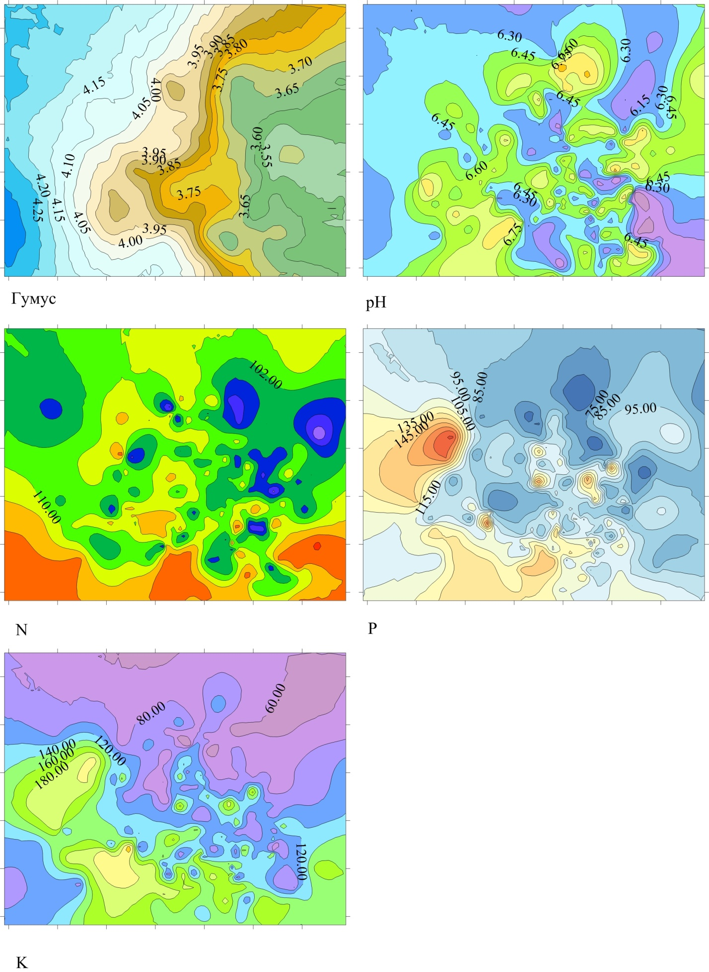
Pic. 2. Varying of edaphic indexes in space of the first two canonical radicals.
Marks are conditional: abscise an axis is a canonical function 1, y-axis is a canonical function 2.
In this case mechanical tillage looks like stimulation which starts the plural of swaying processes of different frequency and amplitude. At such approach soil which has been processed in any way passes not to one separate state but transformed to the plural of the dynamic states, aggregate of which characterizes that result which appears as a result of tillage.

Conclusions:
- Discriminant analysis allows to classify the states of the ground system which are formed as a result of different methods of mechanical tillage by the edaphic indexes. For discrimination of chisel ploughing, subsurface cultivation, minimal tillage and «zero tillage» sufficiently two canonical discriminant axes.
- Canonical function 1 divides the methods of mechanical tillage with the high depth of ploughing (chisel ploughing on a depth 40 cm and ploughing on a depth 25–27 cm) from methods with a small depth and zero tillage. Canonical function 2 distinguishes each of the first groups on sub-groups with the less depth of ploughing in a pair (zero tillage against conservation and ploughing in a depth 25–27 cm against chisel tillage). In this case more deep variants of ploughing differ the greater levels of nutritives (nitrogen, phosphorus, potassium).
- The values of canonical variables also can be as markers of axes of space within the limits of which it is possible to show changeability of edaphic indexes and, thus, to confront category variables – methods of mechanical tillage and continual variables (edaphic indexes). All edaphic descriptions has big variability in the probed space of canonical functions.
- The got results can be explained based on that mechanical tillage looks as stimulation which starts the plural of swaying processes of different frequency and amplitude. At such approach soil which was influencing of some mechanical tillage passes not to one separate state but transformed to the plural of the dynamic states, aggregate of which characterizes that result which appears as a result of tillage in a proper period of time.
BIBLIOGRAPHY
- Агрохімія: лабораторний практикум : навч. посібник / [під ред. Лісовала А. П.]. – К. : Вища школа, 1994. – С. 108–116.
- Бараев А. И. О научных основах земледелия в степных районах / А. И. Бараев // Вестник с.-х. науки, 1976. – №4. – С. 22–35.
- Бенц А. В. Особенности обработки почвы на склонах северной лесостепи Западной Сибири / А. В. Бенц // Научно-технический бюлл. ВАСХНИЛ. – М., 1986. – №432. – С. 3–6.
- Ершов В. А. Биологическая активность почвы при длительном предшествующем применении минимальной обработки / В. А. Ершов // Земледелие. – 1991. – №2. – С. 34–36.
- Жуков О. В. Екоморфічний аналіз консорцій ґрунтових тварин / О. В. Жуков. – Дніпропетровськ : вид-во «Свідлер А. Л.». – 2009. – 239 с.
- Качинский Н. А. Физика почвы / Н. А. Качинский. – М. : Высшая школа, 1965. – Ч. 1. – С. 75–79.
- Ким Д. О. Факторный, дискриминантный и кластерный анализ / Д. О. Ким, Ч. У. Мьюлер. – М. : Финансы и статистика. – 1989. – С. 5–77.
- Медведев В. В. Структура почвы / В. В. Медведев. – Харьков. – 2008. – 406 с.
- Метелев В. Я. Особенности обработки почвы под яровую пшеницу на Алтае / В. Я. Метелев, П. И. Талышев // Земледелие. – 1979. – №7. – С. 25–28
- Немцев С. Н. Агроэкологическая эффективность почвозащитных технологий на склоновых землях Ульяновской области / С. Н. Немцев : автореф. дис. на здобуття наук. ступеня к.с.-х.н. – Кинель, 1996. – 27 с.
- Опара М. М. Родючість ґрунтів і енергозбереження в землеробстві / М. М. Опара, П. П. Ярошенко. – Полтава, 2006. – 62 с.
- Влияние агротехнических приемов на микробиологические процессы трансформации гумуса в мощном черноземе левобережной лесостепи Украины / [Ромейко И. Н., Битюкова Л. Б., Плишко М. К., Зиль Л. М.] // Бюллетень ВНИИСХМ. – 1988. – №49. – С. 30–36.
- Семешкина П. С. Способы основной обработки серой лесной почвы / П. С. Семешкина // Земледелие. – 1994. – №5. – С. 24.
- Силиченков Г. В. Совершенствование обработки почвы в Белоруссии / Г. В. Силиченков // Земледелие. – 1991. – №4. – С. 45–47.
- Сираев М. Г. Совершенствование минимальной обработки почвы в степи Башкортостана / М. Г. Сираев // Земледелие. – 1997. – №8. – С. 27–28.
- Биологическая активность чернозема выщелоченного юго-западной Сибири в зависимости от обработки / [Слесарев В. Н., Святская Л. Н., Хамова О. Ф., Щитов А. Г.] // Почвоведение. – 1987. – №4. – С. 137–142.
- Таланов И. П. Эффективность плоскорезной обработки почвы / И. П. Таланов // Земледелие. – 1995. – № 8. – С. 13.
- Тихомирова А. Д. Изменение микрофлоры и ферментативной активности почвы в связи с разной периодичностью оборачивания пахотного слоя : сборник научных трудов / Тихомирова А. Д., Гамзикова О. И. // Вопросы численности, биомассы и продуктивности почвенных микроорганизмов. – Л. : Наука, 1972. – С. 258–265.
- Ульченко В. Я. Минимализация обработки почвы в зернопаровых севооборотах / В. Я. Ульченко // Земледелие. – 1992. – №6. – С. 23.
- Хабирахвганов X. X. Обработка почвы под яровую пшеницу и горох в Татарстане /
X. X. Хабирахвганов, И. Г. Гайнзадинов // Земледелие. – 1993. – №8. – С. 20.
- Чепрасов A. A. Влияние систем основной обработки почвы на биологическую активность и агрохимические свойства чернозема выщелоченного лесостепи Приобья при разном уровне интенсификации / A. A. Чепрасов // Сиб. Вестник с.-х. науки. – 1999. – №1, 2. – С. 8–13.
- Шевченко М. В. Наукові основи систем обробітку грунту в польових сівозмінах Лівобережного Лісостепу України : дис. … д.с.-г.н. : 06.01.01 «Загальне землеробство» /
М. В. Шевченко. – Харків, 2015. – 539 с.
- Ярошенко П. П. Мінімальний обробіток ґрунту – основа екологічного землеробства /
П. П. Ярошенко, М. В. Іванюта // Конструювання, виробництво та експлуатація сільськогосподарських машин (фахове видання). – Вип. 34. – Кіровоград, 2004. – С. 36.

