© 2016
Moroz M. S., Candidate of Biological Sciences, Associate Professor
National University of Life and Environmental Sciences of Ukraine
THE OPTIMIZED NOURISHING ENVIRONMENT FOR CULTIVATION OF
PODISUS MACULIVENTRIS SAY. (HETEROPTERA: PENTATOMIDAE)
It is set that an optimized nourishing environment for cultivation of Podisus maculiventris Say. provides the high level of development of population. The offered nourishing environment provides a survival at certain high level, a reduction to duration of post-embryonic development, an increase of indexes of mass of imago, amount of the set aside eggs. The predatory bedbugs grown on a nourishing environment are able to find and destroy for a day on 27,91 and 41,86 percents more eggs of the Colorado potato beetle comparatively with a control variant.
Keywords: Podisus maculiventris Say., optimized nourishing environment, reproductive potential, industrial cultures, post-embryonic development, searching possibility.
Statement of the problem. It is known that an increased use of insecticides in agrocenosis negatively affects the ecological state of environment, cleanness of agrarian products, quality of life of people. An improvement and permanent search of alternative environmentally sound methods of defence of plants are conducted in this connection, including introduction and seasonal colonization of useful parasites.
Taking into account the global changes of climate, biological and ecological features of predatory bedbug, industrial breeding of Podisus maculiventris Say. has a positive value in relation to adjusting of quantity of harmful phytophages of agrocenosis. In fact the potential victims of predatory bedbug are about one hundred types of insects from nine rows, mainly Lepidoptera and Coleoptera [13, 15]. Further improvement of technology of the mass growing and seasonal colonization of Podisus maculiventris Say. will assist the successful use not only in the protected soil, and also adjusting of quantity of forest, garden, and agricultural harmful phytophages.
Analysis of the last publications. Considerable attention to the trophic factor is spared in technologies of entomologist [2–5, 16]. The terms of feed, food specialization, quality of feed, substantially affect survival, increase and duration of development of larvae, fecundity of females of Podisus maculiventris Say. [1, 13, 15, 19].
Larvae of the first age of Podisus maculiventris Say. exists due to backlogs of yolk in their bowels and additionally consume water or juice of plants. The valuable feed of larvae with an animal meal is begun from the second age. In laboratory terms for their feed one uses larvae of harmful phytophages of Hyphantria cunea Drury, Galleria mellonella L., Ephestia kuehniella Z., Tenebrio molitor L., Spodoptera exigua Hbn., Pieris brassicae L., Gastroidea viridula De Geer., Diprion pini L.
An unpretentiousness to the natural feed and successful cultivation on artificial diets assisted commercialization of predatory bedbug for biological control of harmful Lepidoptera and Coleoptera phytophages after growing of early vegetable cultures. [10–12]. For the best vital necessities of predatory bedbugs in a ontogenesis period, their high efficiency as biological agents we optimize technologies of breeding improve on cheap artificial nourishing environments and phytophages-owneres [6, 9, 17, 18].
Modification of trophic parameters influences on physiology processes and ethology of useful insects, that it is important to take into account at their industrial reproduction [7, 8, 14, 19].
Aim of the research – to learn efficiency of the created nourishing environment for cultivation of Podisus maculiventris Say.
For the achievement of the aim the following tasks were solved:
- to create the optimized nourishing environments for cultivation of Podisus maculiventris Say.;
- to learn the features of biology of Podisus maculiventris Say. for the use of nourishing environment;
- to estimate potential possibilities grown on the nourishing environment of Podisus maculiventris Say. as a biological agent of control of harmful phytophages.
Researches were conducted during 2012–2015 on the experimental base of the National University of Life and Environmental Sciences of Ukraine in accordance with the biological features of kind. Efficiency of the offered nourishing environment was investigated on the laboratory field culture of Podisus maculiventris Say. A nourishing environment for cultivation was prepared as follows. In accordance with the extreme and middle sizes of components of experience variants presented in a table 1, component parts are self-weighted liver beef, meat beef, saccharose, ascorbic acid, Wesson salt, chicken vitelluss, homogenate of larvae Galleria mellonella L., it a nano aqua citrate germanium, nano aqua citrate vanadium, nano aqua citrate magnesium were preliminary mixed up in blender to get a homogeneous mass.
1. Content of components in the nourishing environment of experience variants
used for cultivation of Podisus maculiventris Say.
Name of components | Concentration, the masses, %
Name of components | Variants
Name of components | А | B | C | D | E
Beef liver | 38,55 | 40,28 | 42,37 | 43,00 | 43,25
Beef Meat | 37,25 | 39,15 | 40,83 | 41,50 | 42,00
Saccharose | 0,65 | 0,73 | 0,86 | 1,05 | 1,25
Ascorbic acid | 0,15 | 0,17 | 0,21 | 0,25 | 0,50
Wesson salt | 0,25 | 0,36 | 0,43 | 0,50 | 0,60
Chicken vitellus | 3,75 | 3,98 | 4,16 | 4,25 | 4,75
Homogenate of larvae Galleria mellonella L. | 4,90 | 5,41 | 5,49 | 5,75 | 6,00
Nano aqua citrate of germanium | 0,0002 | 0,0003 | 0,0005 | 0,0006 | 0,0007
Nano aqua citrate of vanadium | 0,0001 | 0,0002 | 0,0003 | 0,0004 | 0,0005
Nano aqua citrate of magnesium | 0,00005 | 0,0001 | 0,0002 | 0,0003 | 0,0004
Water | 14,49965 | 9,9194 | 5,649 | 3,6987 | 1,6484
A nourishing environment, in obedience to variants, was laid out in the packages wrapped in foil. Cultivation of Podisus maculiventris Say. was conducted for the temperatures of 23±1 ⁰С, relative humidity of air 75±5% and to the photoperiod 16 hours. A nourishing environment was kept for temperatures minus 22 ⁰С. Larvae and imago Podisus maculiventris Say were placed in plastic containers of the size 15х12х6 cm and 30х24х12 cm, accordingly. At a supervision of Podisus maculiventris Say was done with the known methods [7].
Reproductive potential (Rp) was determined after a formula:
R_{p} = (S_{r} × d)n,
where Sr is correlation of the articles (♂ : ♀), d is a quantity of posterity, n is a number of generations.
Larvae and imago of control variants of the laboratory field culture of Podisus maculiventris Say. grew on a nourishing environment in composition of: a beef liver 200 g; beef meat 200 g; solution of 5 % saccharose – 24 ml, ascorbic acid 1 g; Wesson salt 2 g; chicken vitelluss 20 g.
Results of researches. Consequences of influence of nourishing environment on ontogenesis of Podisus maculiventris Say. are presented in a table 2. An analysis confirms, that the best indexes in relation to the survival of the first, second and third generation of Podisus maculiventris Say. were got in experiment variants B, С, and D. In these variants of survival of Podisus maculiventris Say of first generation was 69, 78,5 and 66 percents, second – 68 %, 72 %, and 67 %, third – 70 %, 73 %, and 68 %, that accordingly on 4, 13,5 and 1 %, 3,5, 7,5 and 2,5 % and 7, 10 and 5 % more in comparing to the control variant. The offered component composition of nourishing environment of experiment variants not only provides the high indexes of survival of predatory bedbug in three generations of laboratory population, and also positively influences on the increase of quantitative and quality biological indexes. There is a reduction to duration of development of larvae, increase of mass of females and males of the first day of life. If we take the middle index of control variant of mass of females and males of the first day of life of predatory bedbug for one hundred percents, then percent of mass of females of the first day of life in experience variants B, С, and D has substantially a high difference and arrives at 107,22, 110,31 and 106,01 %, and males of the first day of life – 110,95, 112,42, and 106,53 % accordingly.
2. Influence of nourishing environment on ontogenesis of Podisus maculiventris Say.
Indexes | Variants
Indexes | А | B | C | D | E | Control
Survival F₁, % | 64 | 69 | 78,5 | 66 | 65 | 65
Survival F₂, % | 65 | 68 | 72 | 67 | 65 | 64,5
Survival F₃, % | 62 | 70 | 73 | 68 | 64 | 63
Duration of development of larvae, hours | 675 | 666 | 641 | 658 | 673 | 683
Mass of females of the first day of life, mg | 59,3 | 62,4 | 64,2 | 61,7 | 59,4 | 58,2
Mass of males of the first day of life, mg | 49,1 | 52,7 | 53,4 | 50,6 | 48,7 | 47,5
An amount of eggs in laying of female F₂, pcs | 231 | 247 | 259 | 240 | 224 | 219
An amount of eggs in laying of female F₃, pcs | 216 | 238 | 245 | 233 | 225 | 217
Due to the improvement of nourishing internals of the offered nourishing environment of female of the second and third generation Podisus maculiventris Say. put aside on the average in experience variants В, С, and D of laying in the second generation 247, 259 and 240 things in the third – 238, 245, and 233 things, that on 112,79, 118,26, and 109,59 and 109,68, 112,90, and 107,37 percents more comparatively with a control variant.
Thus, it is experimentally well-proven that the additional components brought in to the nourishing environment in optimal concentrations come forward as nourishing biologically and physiologically active operating constituents of parts, and in the process of ontogenesis of three generations provide a high level development of population. On condition of cultivation of predatory bedbug on the offered nourishing environment in the process of ontogenesis provided at for certain high level of survival, reduction to duration of post-embryonic development, increase of indexes of mass of imago, amount of the set aside eggs.
It should be noted that the increase of quantitative sizes of component parts of nourishing environment and decline of water in him, as it is shown in the variant Е, substantially does not increase the survival of population of the first, second, and third generation of predatory bedbug, and also does not assist reduction to duration of post-embryonic development, an increase of indexes of mass of imago females and males of the first day of life, an amount of the set aside eggs the females of F₂ та F₃ from it economically is inadvisable.
Influence of nourishing environment on reproductive potential of Podisus maculiventris Say. it is presented in picture 1. In accordance with got results, the additionally brought in components of experience variants of nourishing environment increased the rates of reproduction of Podisus maculiventris Say. considerably. Thus, as a result of reproduction only for two generations reproductive potential of one individual (♀) of predatory bedbug in experience variants В, С, and D presented 791,58, 858 and 686,4, that on 32,37 %, 43,48 %, and 14,78 % more comparatively with a control variant. Certain middle indexes of reproductive potential of Podisus maculiventris Say. Of three generations of experience variants В, С, and D also appeared the greatest and presented accordingly 1099,56, 1131,9 and 1053 units of posterity, that on 9,68 %, 12,90 %, and 5,03 % more comparatively with a control variant.
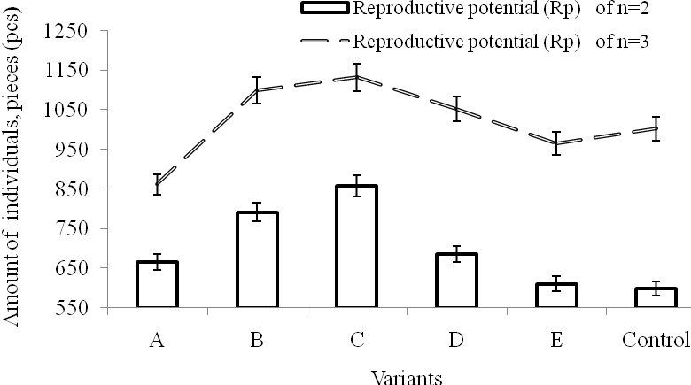
Pic. 1. Influence of nourishing environment on reproductive potential of the second and third generation Podisus maculiventris Say.
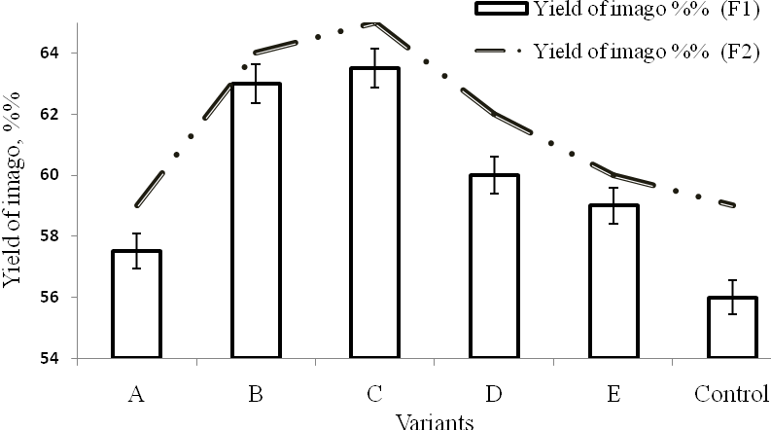

Pic. 2. Influence of nourishing environment on the exit of imago of the first and second generation Podisus maculiventris Say.
On picture 2 the result is given in relation to influence of nourishing environment on the yield of imago of the first and second generation of Podisus maculiventris Say. from the presented data on picture 2 it is obvious that for the use of the offered nourishing environment for cultivation of Podisus maculiventris Say. the yield of imago of the first and second generation increases considerably. Thus, in experiment variants B, C and D the yield of imago of first generation presented in middle 63, 63,5 and 60 %, second – 64, 65 and 62 %, that accordingly on 7 %, 7,5 %, and 4 % and 5 %, 6 %, and 3 % more comparatively with a control variant.

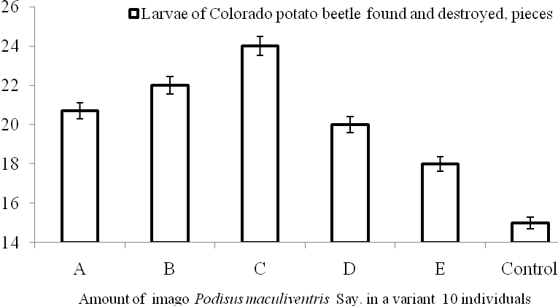
Pic. 3. Influence of nourishing environment on searching possibility and voracity of predatory bedbug in relation to the larvae of Colorado potato beetle (average for 2012–2015 years).

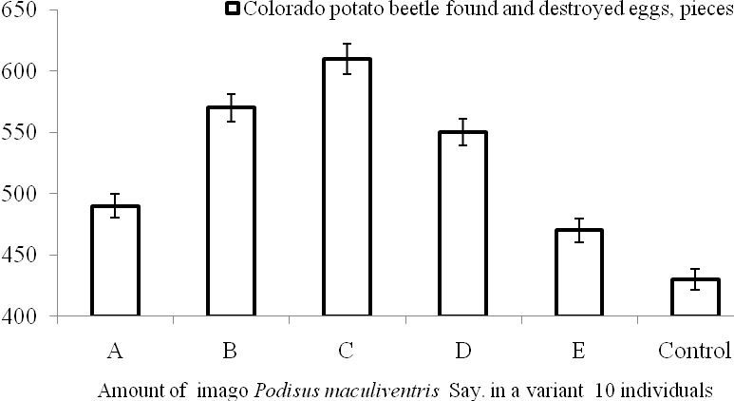
Pic. 4. Influence of nourishing environment on searching possibility and voracity of predatory bedbug in relation to elimination of eggs of the Colorado potato beetle (average for 2012–2015 years).
There is a correlation between the increase of indexes of reproductive potential of three generations and yield of imago of the first and second generation of Podisus maculiventris Say. shows that with the help of mixture in the nourishing environment of larvae homogenates of Galleria mellonella L., a nano aqua citrate germanium, vanadium and magnesium, it is possible to attain such balance of his components that provides in a sufficient measure the necessities of organism of predatory bedbug on all period of ontogenesis.
The consequences of influence of nourishing environment on searching possibility and voracity of predatory bedbug in the period of post-embryonic development are represented on figure 3 and 4. Accordingly with results presented on figure 3, a predatory bedbug in experience variants is characterized by the high indexes of searching possibility of larvae of the Colorado potato beetle with their further elimination. Thus, ten individuals of imago of Podisus maculiventris Say. for a day in experience variants B, С and D found and destroyed larvae of the Colorado potato beetle accordingly 22, 24 and 20, that on 46,67 %, 60 % and 33,33 % more comparatively with a control variant.
There is obvious efficiency of predatory bedbug of experience variants in relation to a search and elimination of eggs of the Colorado potato beetle. From presented on picture 4 experimental results it is evidently, that for the use of the offered nourishing environment for cultivation of Podisus maculiventris Say. ten adult predatory bedbugs in experience variants В, С and D is capable for a day to find and destroy accordingly 570, 610 and 550 eggs of the Colorado potato beetle, that on 32,56 %, 41,86 % and 27,91 % more comparatively with a control variant.
Conclusion. On the all studied properties experience modifications of nourishing environment with functional ingredients excel the indexes of control variants.
Due to the use as feed of the offered nourishing environment:
- optimization of terms of survival of Podisus maculiventris Say. is provided;
- duration of post-embryonic development diminishes;
- the indexes of mass of imago grow;
- the amount of the set aside eggs increases;
- reproductive potential increases;
- the yield of imago increases;
- searching possibility gets better and voracity of predatory bedbug rises in the period of post-embryonic development.
Next researches. The improvement of technology and search of price reduction in nourishing environments for the mass growing of Podisus maculiventris Say. is envisaged.
BIBLIOGRAPHY
- Влияние пищевого фактора на развитие и фотопериодическую реакцию хищного клопа Podisus maculiventris (Hemiptera, Pentatomidae) / [Горышин Н. И., Саулич А. Х., Волкович Т. А., Борисенко И. А., Симоненко Н. П.] // Зоол. журнал. – 1988. – Т. 67, Вып. 9. – С. 1324–1332.
- Мороз М. С. Оптимізація штучного живильного середовища для вирощування Ephestia kuehniella Zell. як господаря Habrobracon hebetor Say. / М. С. Мороз // Науковий вісник Національного університету біоресурсів і природокористування України. – 2009. – Вип. 140. –
С. 134– 142.
- Мороз М. С. Оптимізація розведення зоофагів із родини Anthocoridae за рахунок розширення видового складу їх господарів / М. С. Мороз // Науковий вісник Національного університету біоресурсів і природокористування України. – 2010. – Вип. 145. – С. 168–179.
- Мороз М. С. Оптимізація культивування афідофагів за рахунок поліпшення трофічних якостей попелиць-хазяїв / М. С. Мороз // Наукові доповіді Національного університету біоресурсів і природокористування України [Електронний ресурс]. – 2012. – Вип. 6 (35). – Режим доступу : http://www.nbuv.gov.ua/e-journals/Nd/2012_6/12mms.pdf.
- Мороз М. С. Особливості онтогенезу Macrolophus nubilis H.S. залежно від трофічного чинника / М. С. Мороз, О. І. Омельченко // Наукові доповіді Національного університету біоресурсів і природокористування України [Електронний ресурс]. – 2012. – Вип. 2 (31). – Режим доступу : http://www.nbuv.gov.ua/e-journals/Nd/2012_2/12mms.pdf.
- Coudron T. A. Life history and cost analysis for continuous rearing of Podisus maculiventris (Say) (Heteroptera: Pentatomidae) on a zoophytophagous artificial diet / T. A. Coudron, J. Wittmeyer, Y. Kim // J. Econ. Entomol. – 2002. – Vol. 95. – P. 1159–1168.
- De Clercq P. A mead-based diet for rearing the predatory stinkbugs Podisus maculiventris and Podisus sagitta [Het.: Pentatomidae] / P. De Clerco, D, Degheele // Entomophaga. – 1992. – Vol. 37 (1). – P. 149 –157.
- Toxicity of diflubenzuron and pyriproxyfen to the predatory bug Podisus maculiventris /
[De Clercq P., De Cock A., Tirry L., Vinuela E., Degheele D.] // Entomol. Exp. Appl. – 1995. – №74. –
P. 17–22.
- De Clercq P. Unnatural prey and artificial diets for rearing Podisus maculiventris (Heteroptera, Pentatomidae) / P. De Clercq, F. Merlevede, L. Tirry // Biol. Control. – 1998. – Vol. 12. – P. 137–142.
- De Clercq P. Dark clouds and their silver linings: exotic generalist predators in augmentative biological control / P. De Clercq // Neotropical Entomology. – 2002. – №31. – P. 169–176.
- De Clercq P. Predation by Podisus maculiventris on different life stages of Nezaraviridula /
P. De Clercq, K. Wyckhuys, H. N. De Oliveira, J. Klapwijk // Florida Entomologist. – 2002. – №85. –
P. 197–202.
- Toxicity of diafenthiuron and imidacloprid to the predatory bug Podisus maculiventris Say. (Heteroptera: Pentatomidae) / [De Cock A. , De Clercq P., Tirry L., Degheele D.] // Environ. Entomol. – 1996. – №25. – P. 476–480.
- Choosing natural enemies for conservation biological control: use of the prey detect ability half-life to rank / [Greenstone M. H., Szendrei Z., Payton M. E., Rowley D. L., Coudron T. C., Weber D. C.] // Entomol. Exp. Appl. – 2010. – Vol. 136. – P. 97–107.
- Effects of diet on development and reproduction of the predatory pentatomids Picromerus bidens and Podisus maculiventris / [Mahdian K., Kerckhove J., Tirry L., De Clercq P.] // BioControl. – 2006. – №51. – P. 725–739.
- McPherson J. E. Pentatomoidea (Hemiptera) of North-eastern North America / J. E. McPherson // South Illinois Univ. Press. – 1982. – Carbondale and Edwardsville, Illinois, U.S.A. – 240 p.
- Moroz M. S. Nanoaquachaelats as biogenic chemical elements during optimization of feeding of zoophags in the artificial biotechnical system / M. Moroz, V. Maksin // International Scientific Electronic Journal «Earth Bioresources and Life Quality» [Електронний ресурс]. – №4. – 2013. – Режим доступу : http://gchera-ejournal.nubip.edu.ua.
- Prey capture ability of Podisus nigrispinus (Dallas) (Heteroptera, Pentatomidae) reared for successive generations on a meridic diet / [Saavedra J. L. D., Zanuncio J. C., Zanuncio T. V., Guedes R. N. C.] // J. Appl. Entomol. – 1997. – Vol. 121. – P. 327–330.
- Thompson S. N. Nutrition and culture of entomophagous insects / S. N. Thompson // Annu. Rev. Entomol. – 1999. – Vol. 44. – P. 561–592.
- Wittmeyer J. L. Ovarian development, fertility and fecundity in Podisus maculiventris Say. (Heteroptera: Pentatomidae): an analysis of the impact of nymphal, adult, male and female nutritional source on reproduction / J. L. Wittmeyer, T. A. Coudron, T. S. Adams // Invertebrate Reproduction & Development. – 2001. – Vol. 39. – №1. – P. 9–20.

