© 2016
Semirenko V. V., postgraduate student
(scientific supervisor – Doctor of Veterinary Science, Professor B. P. Kyrychko)
Poltava State Agrarian Academy
RESEARCH OF PATHOMORPHOLOGICAL AND HISTOLOGICAL CHARACTERISTICS OF PATHOLOGY OF DISTAL LIMBS IN SWINE
Reviewer – Candidate of Veterinary Science, Associate Professor R. V. Peredera
The article deals with the analysis of pathomorphological and histological characteristics of individual nosological forms of the pathology of distal limbs in swine: tumor of bone (osteoma), chronic osteomyelitis, atonic ulcer and purulent arthritis. The significant imperfection of structural elements of a bone and soft tissues allowing differentiation of defined above nosologic forms of diseases of distal limbs in swine has been noted. The material of the article will help veterinary professionals to perform a differential diagnosis of limbs diseases in pigs competently.
Key words: swine, distal limbs, osteoma, chronic osteomyelitis, atonic ulcer, purulent arthritis.
Statement of the problem. Pathological changes of anatomical and functional nature, which entail different degrees of limb dysfunction in animals, may potentially arise from any tissue components of the musculoskeletal system of an organism, bones, cartilages, dense and loose connective tissues (tendons, ligaments, articular capsules), muscle and nervous tissues (CNS and peripheral nerves) and a connective tissue [4, 5, 10]. All these tissues are functionally integrated to allow to coordinate and support the work of the musculoskeletal system [6, 7].
The analysis of major studies and publications which discuss the problem. The musculoskeletal system is exposed to a significant impact during motions and a dynamic load. It is especially sensitive in development of pathological processes [8, 9]. In the histological examination of cracks A. F. Burdeynyuk (1955) found dystrophic changes in deeply located structures of hooves basis. Effects of external factors injure papillae and leaves of hooves, increasing the size of cracks with transition of pathology in the chronic form of inflammation [2]. Studying the aseptic inflammation of the digital torus in detail H. Gutierrez and others (1987) have noted a significant edema, destruction of connective tissue beams and collagen fibers rupture with signs of necrosis [3]. Investigating histological sections of hoof ulcers in swine B. I. Bobriyev (1991) established the presence of capillaries, filled with blood, fragments of a dead tissue and no scab on the surface of ulcers [1].
Detecting of anomalies in the structure of tissues of distal limbs may cause a cascade of disturbances in surrounding tissues due to their dynamic relationship.
The purpose of the research – to differentiate nosological forms of the pathology of distal limbs in swine.
The task of the research – to find out the characteristic pathomorphological and histological changes of separate forms of the nosological pathology of distal limbs in swine.
Methods and methodology of the research. Sampling of pathological material was conducted from swine with diseases of distal limbs (tumors, inflammatory processes), which belonged to LLC «Smak Myrgorodschyny». The selected material was fixed in 10 % formalin solution in a special container. Histological preparations were made in conditions of LLC «VITA» (Poltava) by classical methods (decalcification of trichloroacetic acid staining with hematoxylin-eosin). The analysis of histological sections was performed under a light microscope with the increase of 100–200 (lens 10^{х}-20^{х}, eyepiece 10^{х}).
Results of the research. The tumor formation has located on the left wrist bones of a thoracic limb, a little uneven contours, a lateral size 11 mm, a longitudinal one – 22 mm. In the histological examination the tumor was differentiated as a spongy osteoma. The osteoma was presented by loosely located anastomosing between each other relatively thin bone lamellas between which ovoid or rounded focuses are formed. In the letter mature lipocytes, haemopoetic cells are identified (pic. 1).
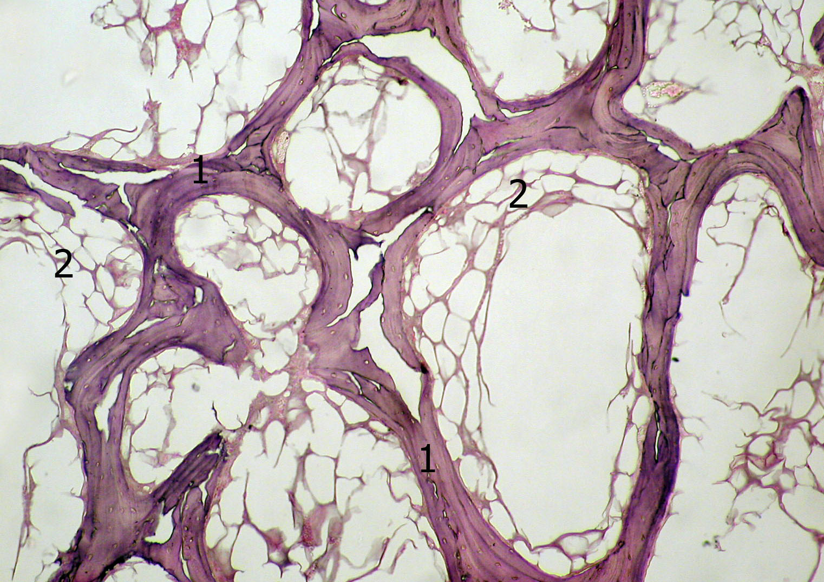
Pic. 1. The histological structure of the osteoma. × 100
1 – bony lamellas; 2 – lipocytes
The structure of the tumor as a whole resembles a cancellous bone. In bony lamellas with stronger magnification, a small amount of diffusely located in a mineralized amorphous substance of cellular elements can be identified. These cells have indistinct contours of a cytoplasm, round or oval nucleus and located as directly in an amorphous substance as in cavities that follow contours of a cell cytoplasm (pic. 2).
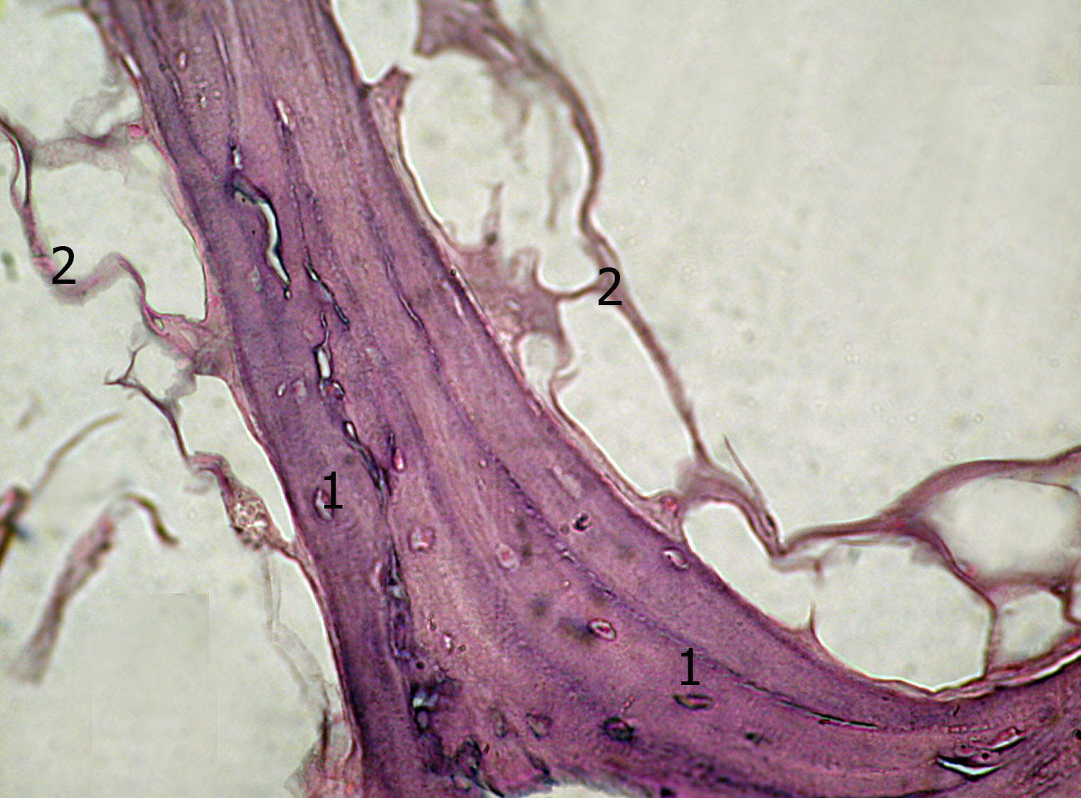
Pic. 2. The histostructure of the osteoma. × 200
1 – cellular elements of the osteoma; 2 – lipocytes
In studying of micropreparations of a metatarsal bone of sows with clinical signs of swelling of soft tissues and destruction of a bone basis the histological diagnosis – suppurative osteomyelitis was made. However, in most observations a large focus of a necrotic bone tissue that looks like structureless, homogeneous, moderately basophilic areas devoid of cellular elements is visualized. Very often these areas were subjected by resorption and replaced by a fibrous connective tissue, characterized by a moderate amount of cellular elements and fibroblastic series and a significant amount of fibrillar structures (pic. 3).
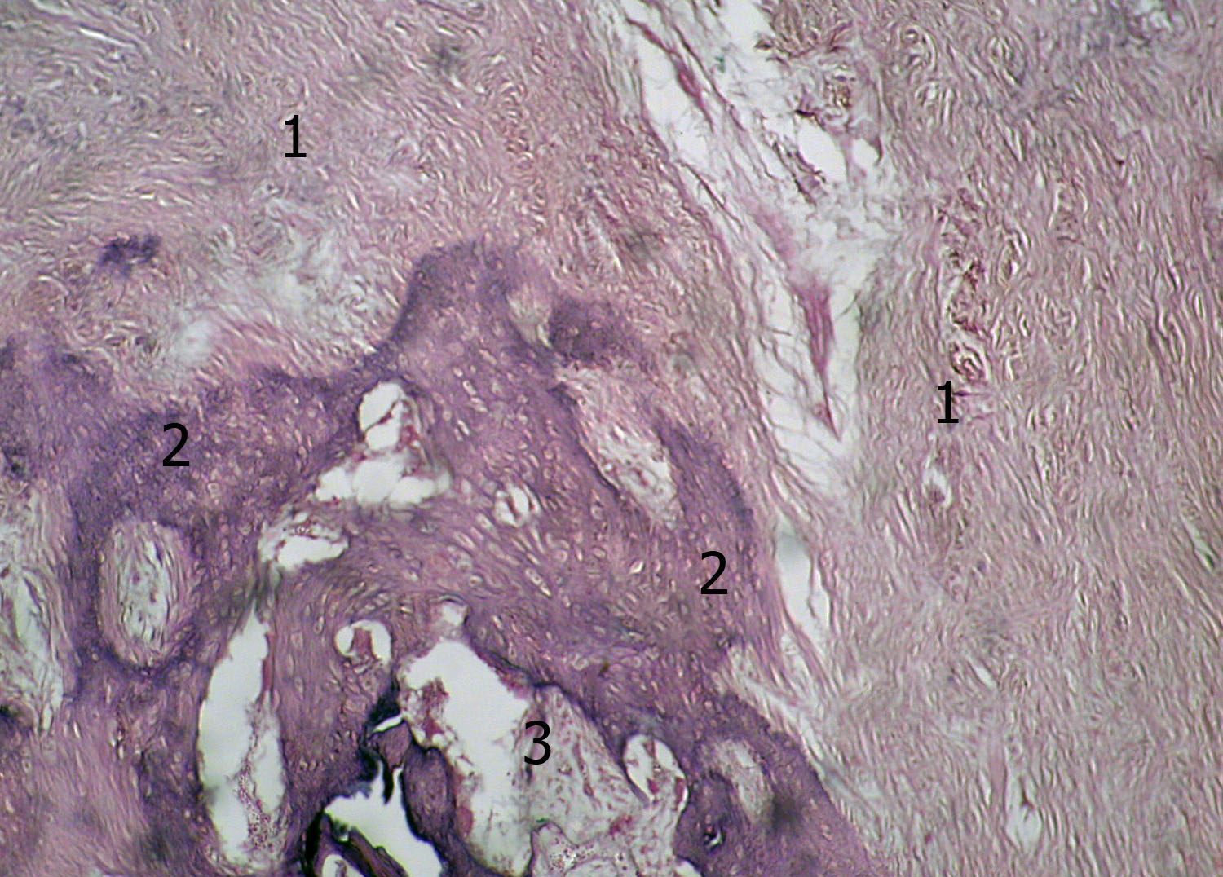
Pic. 3. The bone structure at chronic osteomyelitis. × 100
1 – areas of overgrowth of a fibrous connective tissue;
2 – the saved structure of a bone tissue; 3 – the bone marrow
A small focus of a granulation tissue with a significant number of thin-walled vessels and cellular elements of a haematogenous origin and low-specialized fibroblasts was detected rarely. Described areas without a clear boundary passed in a saved bone tissue to which typical structure of tubular bone was characteristic.
On the periphery of above described parts in a bone marrow fields filled with slough, unstructured detritus surrounded by a cellular infiltrate with a predominance of lymphocytes and neutrophils of a moderate amount were determined. In some cases individual parts of endosteal ossification in the form of primitive trabeculas of bones are found out. In a cortical substance Haversian canals were expanded, bumpy, trabeculas of bones were thinned.
In the microscopic examination of tissue complexes taken from ulcerous parts of distal limbs in swine the histological diagnosis – atonic ulcer was made.
In such case, the tissue specimen can discern several layers that have visible morphological differences. Thus, the fairly wide zone of necrosis was located in the most superficial parts of the bottom and edges of the ulcer. In the letter, except a homogeneous tissue detritis, mainly in the most superficial parts, fibrin filaments were detected, between which cellular elements, primarily segmented neutrophil granulocytes, were located in a significant number (pic. 4).
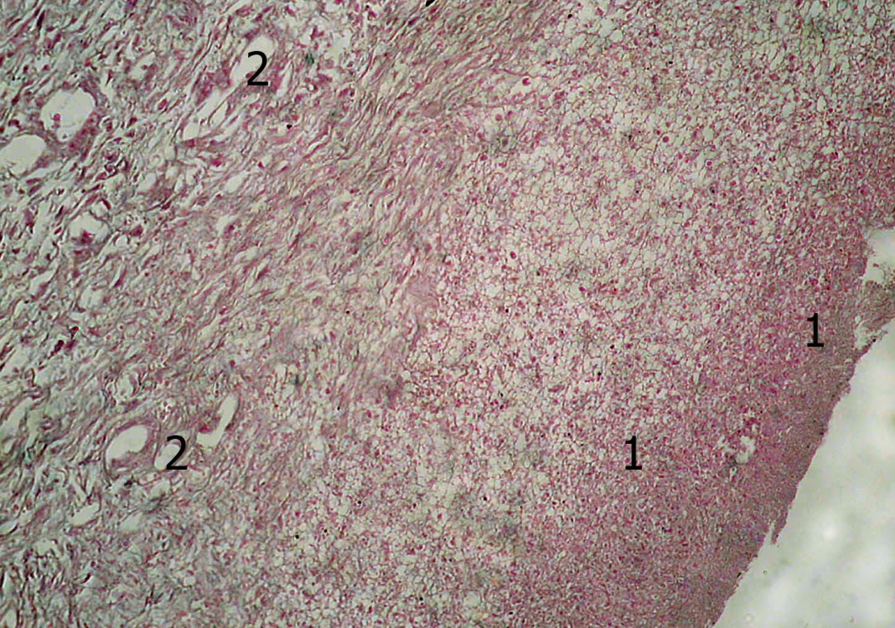
Pic. 4. The structure of wall ulcers. × 100
1 – the zone of necrosis; 2 – the hypervascularized fibrous connective tissue
A layer of a hypervascularized fibrous connective tissue is deeper than the described zone. Most of the blood vessels of this zone had thick walls and slightly narrowed lumen, in which a moderate amount of formed elements was visualized. The cells in the described zone of an ulcer defect are extremely rare and have been presented mostly by fibroblasts. Collagen fibers were detected in a large number, were characterized by degenerative changes and formed multidirectional fascicles.
On the periphery the layer of hypervascularized fibrous connective tissue was surrounded by a fairly wide layer of a connective tissue, which differed by significantly smaller number of blood vessels and more pronounced dystrophic changes that manifested by mucoid degeneration and fibrination swelling, hyalinosis phenomenon. This layer of the ulcer defect wall was densely adherent to a bone tissue, in which significant necrotic changes of trabeculas bones, diffuse inflammatory infiltration, represented preferably by lymphocytes and plasmatic cells were observed (pic. 5).
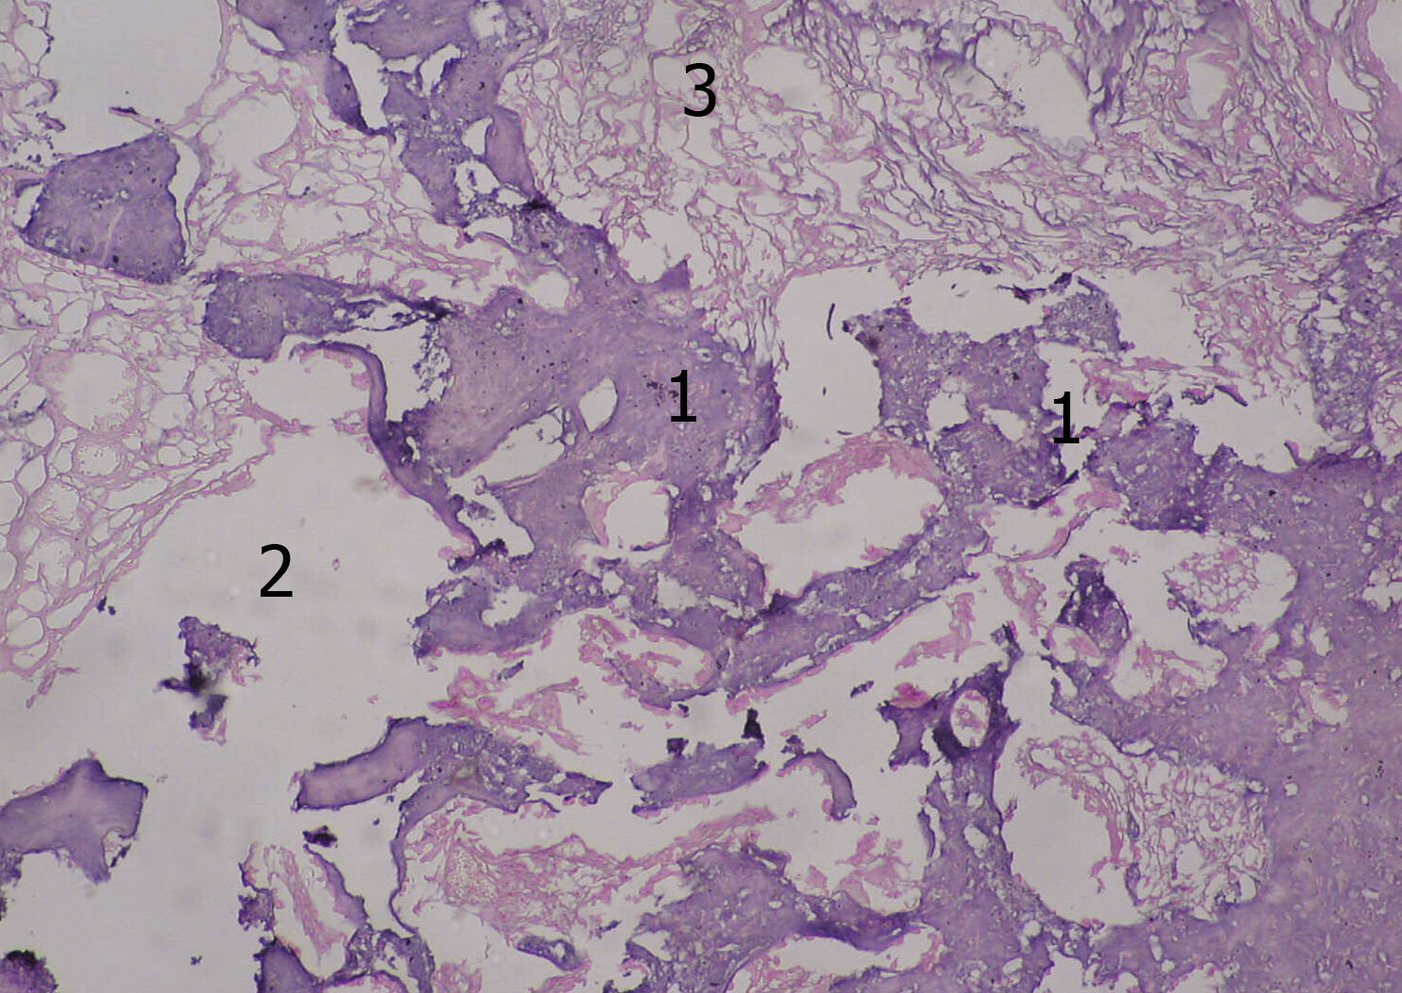
Pic. 5. Structure of deep layers of wall ulcers. × 100
1 – the trabeculas of bones with necrotic changes; 2 – the fibrous connective tissue
Studying of observation micropreparations from a pastern joint of sows with clinical signs of arthritis allowed to make the histological diagnosis – chronic suppurative arthritis. Significant changes have been found in all components of a joint tissue. So, first of all, attention is drawn to almost complete obliteration of joint space due to the proliferation of granulation articular cavity and mature fibrous tissue.
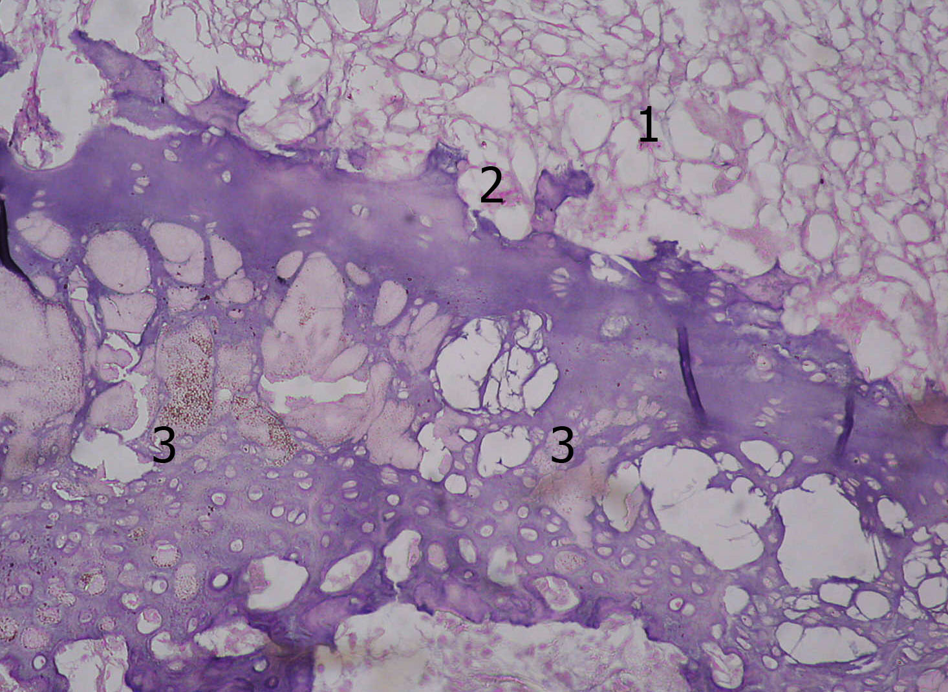
Pic. 6. The structure of the pastern joint at chronic suppurative arthritis. × 200
1 – the joint space filled with a cellular tissue;
2 – the articular surface; 3 – the articular cartilage
Articular surfaces presented by a hyaline cartilage had a rough, porous appearance due to alternation of pretty deep multiple defects with cartilage fragments protruding into the lumen of a joint space. The letter had signs of necrotic changes. Also, in surface parts of articular cartilages there was a noticeable decrease in number of chondrocytes. In deep parts of a cartilage rather large cavities were constantly detected which are formed probably in the process of making preparations in local depositions of calcium salts (pic. 6).
Conclusion. In a number of histologic examinations the typical pathognomic peculiarities have been found out that allowed to differentiate separate nosologic forms of distal limbs in swine: spongy osteoma, suppurative osteomyelities, atonic ulcer, chronic suppurative arthritis.
BIBLIOGRAPHY
- Бобриев Б. И. Применение коллагенового материала в комплексном лечении язвы Рустерхольца [текст] : автореф. дисc. ... к.вет.н. : 16.00.05 / Б. И. Бобриев. – М. : Моск. вет. академия, 1991. – 18 с.
- Бурденюк А. Ф. Трещины копытец у свиней как отдельное заболевание, их осложнения и профилактика [текст] : автореф. дисc. ... д.вет.н. / А. Ф. Бурденюк. – Х. : М-во высш. образования УССР, Харьк. вет. ин-т, 1955. – 16 с.
- Гутиеррез X. Клинические и морфологические изменения пальцевого мякиша у животных при некоторых воспалительных заболеваниях в условиях промышленного скотоводства [текст] /
X. Гутиеррез, А. Ангелов, Н. Бодуров // Ветер.-мед. науки. – 1987. – С. 80–90.
- Effect of reduced growth rate on the prevalence and severity of osteochondrosis in gilts [text] / [Carlson C. S., Hilley H. D., Meuten D. J., Hagan J. M., Moser R. L.] // American Journal of Veterinary Research. – 1988. – Vol. 49, №3. – P. 396–402.
- Dewey C. E. Clinical and postmortem examination of sows culled for lameness [text] / C. E. Dewey, R. M. Friendship, M. R. Wilson // Canadian Veterinary Journal-Revue Veterinaire Canadienne. – 1993. – №34. – Р. 555–556.
- Locomotive disorders associated with sow mortality in Danish pig herds [text] / [Kirk R. K., Svensmark B., Ellegaard L. P., Jensen H. E.] // Journal of Veterinary Medicine Series. A Physiology Pathology Clinical Medicine. – 2005. – Vol. 52, №8. – Р. 423–428 (doi:10.1111/j.1439-0442.2005.00747.x).
- Smith B. Lameness in pigs associated with foot and limb disorders [text] / B. Smith // In Practice. – 1988. – Vol. 10, №3. – P. 113–117 (doi: 10.1136/inpract.10.3.113).
- Whay H. R. Associations between locomotion, claw lesions and nociceptive threshold in dairy heifers during the peripartum period [text] / H. R. Whay, A. E. Waterman, A. J. F. Webster // Veterinary Journal. – 1997. – №154. – Р. 155–161 (doi:10.1016/S1090-0233(97)80053-6).
- Whay H. R. The influence of lesion type on the duration of hyperalgesia associated with hindlimb lameness in dairy cattle [text] / H. R. Whay, A. E. Waterman, A. J. F. Webster, J. K. O'Brien // Veterinary Journal. – 1998. – Vol. 156, №1. – P. 23–29.
- Ytrehus B. Etiology and pathogenesis of osteochondrosis [text] / B. Ytrehus, C. S. Carlson, S. Ekman // Veterinary Pathology. – 2007. – Vol. 44, №4. – Р. 429–448 (doi:10.1354/vp.44-4-429).

