© 2018
Garbar L. A., Ph.D. in Agricultural Sciences,
Yatsyshyna T. P., Master's Degree,
Samoliuk O. P., Master's Degree
National University of Life and Environmental Sciences of Ukraine
EFFECT OF FERTILIZER ON WINTERING OF WINTER RAPE
Reviewer – Candidate of Agricultural Sciences N. O. Yashchuk
The results of researches of influence on growth, development and over-wintering of plants of growing of rape crops of winter complexes of microfertilizers «Reakom chelat boru» and «Kwantum» in the phase of four to six true leaves on the background of the main fertilizer are given. The research was conducted during 2015–2017 in conditions of the Forest-Steppe of Ukraine on typical blackheads of low-humus. As a result of the conducted research, it was found that the use of foliar feeding on the background of the main fertilizer provides satisfactory growth and development of winter rape plants during autumn vegetation and allows obtaining high parameters of plant preservation during the period of the restoration of spring vegetation. Higher indexes of plant preservation were obtained on variants using the N₈₀P₆₀K₈₀ + «Quantum» in the phase of four to six true leaves.
Key words: winter rape, fertilization, hybrids, foliar nutrition, autumn vegetation, plant preservation.
Formulation of the problem. Winter crops in their biology are most adapted to the use of autumn-winter moisture and therefore provide high yields. The biological basis of the winter rape crop is laid in the fall and depends, first of all, on soil preparation to sowing, provision of nutrients, timing and methods of sowing, seed rates and weather conditions. In the specialist and reference literature, there are quite controversial data on the fertilizer system, the timing and methods of sowing and other elements of cultivation technology. In the production, this leads to a lack of yield, and, ultimately, a decrease in the value of rape as an industry in general [1, 7]. That is why scientists are faced with the task of developing recommendations for a scientifically sound technology of growing winter rape, which will ensure the development of optimal parameters of plants in the fall, and their successful hibernation.
Winter rape is considered to be extremely sensitive to low temperatures by culture. In the absence of snow cover combined with prolonged minus temperature there is a partial damage to the crops or even the complete destruction of plants. When choosing winter sown rape for sowing, it's worth remembering that the frost resistance of individual rape hybrids can be different.
The wintering of winter rape also depends on the technological conditions of cultivation in the autumn period. An extremely important stage in the development of the winter rape is the transition from winter to spring, when we can visually estimate the state of hibernation of plants and the degree of damage to winter rape crops. Sometimes the loss of winter rape crops reaches 100 %. They can be caused both by factors independent of the owner, and by mistakes in choosing a hybrid, remedies, irregular fertilization [3].
Analysis of recent research and publications. Winter rape is very demanding conditions for cultivating the culture, especially the conditions of winter hibernation. Climatic and soil conditions have a strong influence on the development of plants and their productivity [2, 4].
One of the main problems that lead to loss of crop during the cultivation of winter rape is the hibernation of plants. Previous research indicates that thickened crops and late sowing plants are freezing and dying. An important factor is also the morphological features of plants, which are determined by the timing of seeding, because for the formation of optimal parameters of plants before wintering must pass a certain amount of time with the appropriate temperature regime and moisture.
The main body of the winter rape is the root neck, whose diameter before entering the winter should be 8–10 mm. An important aspect is the size and number of leaves, which in winter will cover the root neck of freezing, which is also ensured by the optimal timing of sowing. Given current climate changes, especially in recent years, it is important to provide plants with affordable moisture during the formation of stairs.
Winter Rape needs a large amount of nutrients. Literary sources contain controversial data on fertilizer standards that must be used to fertilize this culture [5, 6, 8]. Therefore, optimization of mineral nutrition lies in the huge untapped reserve of increasing rape productivity and efficiency of farming.
The shortage of nutrients leads to slowing growth, lack of accumulation of necessary plastic substances (carbohydrates) for overeating. Failure of any element of technology leads to deterioration of winter resistance of plants and increases the risk of their freezing in winter.
The success of hibernation depends not only on favorable weather conditions, but also on the state of crops in the autumn period, that is, the development of plants. Important is the formation in the autumn of a powerful, but not overgrown plants.
The purpose of our research was to study the influence of various variants of fertilization of hybrids of winter rape on the formation of productivity of culture in the conditions of the Forest-Steppe of Ukraine on typical black earths of low-humus.
Materials and methods of research. The subject of research was the rape crop of winter hybrids, Excels and Dembo. The research was conducted in accordance with generally accepted methods during 2015–2017. Field experiments were laid out using the split plot method. The predecessor is winter wheat. The area of ​​the plot is 25 m². Repetition is four times. Scheme of the experiment envisaged the study of the following factors:
Factor A – Hybrids: Excels and Dembo.
Factor B – fertilizer: 1. N₈₀P₆₀K₈₀ (control); 2. N₈₀P₆₀K₈₀ + «Quantum» (4–6 true leaves); 3. N₈₀P₆₀K₈₀ + «Reakom chelat boru» (4–6 true leaves).
Results of researches. The results of the research showed that application in the nutrient complex of trace elements against the background of the main fertilizer had a positive effect on the growth and development of winter rape plants during autumn vegetation.
Dibo's hybrid have reached a height of 21.5–25.5 cm, depending on the outcome of the vans. The dormancy of the coriander system reached 10.1–13.4 cm. For this period, the sophomorphs of 6.2–7.4 leaves were removed from the bedding sheet of 9.2–10.2 cm. The diameters of the cornea neck stones were 8.1 to 10.3 mm (pic. 1).
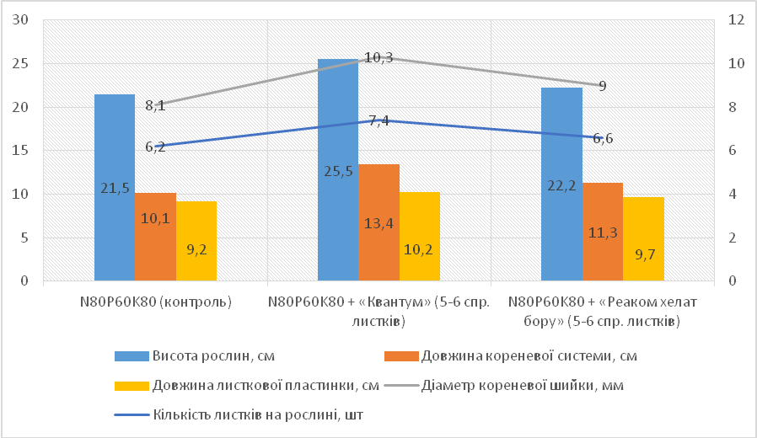
Pic. 1. The development of the dampening of the ozymogenous hybrid of the Dembo is due to the termination of the original vegetation, depending on the distribution of plants (average for 2015–2017)
After the introduction of «Quantum» and «Reakom chelat boru», an increase in all the indicators in the variants using the drug «Quantum» is observed. The growth of the grain yield of the ozymogenous hybrid of the Dembo at the time of the termination of the original vegetation (dependent on the growth of plants) was within the optimum parameters for the plants that enter the winter.
Similar results were also observed in respect to the performance of plants of the winter hybrid Excels. They reached the height of 22.8–25.9 cm, depending on the outcome of the vents. The dormancy of the coriander system reached 13.4–15.6 centimeters. The grain size was 7.3–7.9 cubic meters from the leaf of 10.5–1.07 centimeters. The diameter of the cervical stomata was 9–11.1 mm (pic. 2).
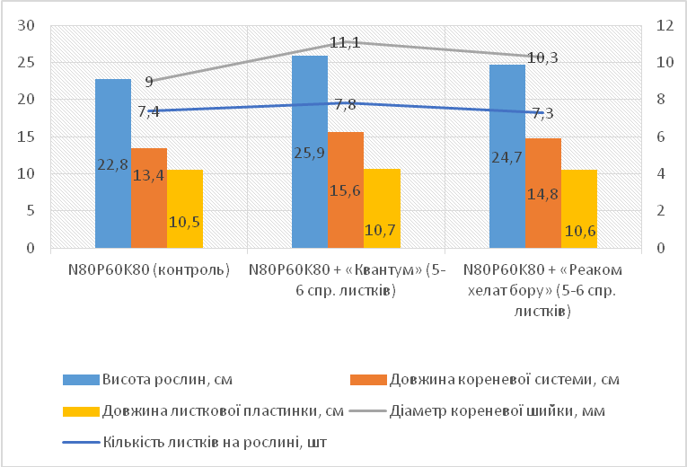
Pic. 2. The development of winter hybrid Excel for the termination of the original vegetation depending on the distribution of plants (average for 2015–2017)
In general, for comparison of the results obtained, it can be concluded that the introduction of the complex of trace elements «Quantum» provided better formation of plants in the autumn period.
By analyzing the discharged pocelin of the dictled gibbons (see table), it is possible to find out that the highest winterstanding is characterized by hybrid Excel. The output of the accumulated pocelin on the nonobtained variants in the hybrid is the lowest.
Improvement of the quality of education in the field of education owing to the substitution of micropayment, %
Hybrid | Date of receipt | 2016 | 2017 | Average  2016–2017
Excel | N₈₀P₆₀K₈₀ (control) | 65.7 | 64.7 | 65.2
Excel | N₈₀P₆₀K₈₀ + «Quantum» | 75.3 | 70.8 | 73.05
Excel | N₈₀P₆₀K₈₀ + «Reakom chelat boru» | 72.1 | 68.8 | 70.45
Dembo | N₈₀P₆₀K₈₀ (control) | 62.5 | 64.3 | 63.4
Dembo | N₈₀P₆₀K₈₀ + «Quantum» | 70.2 | 67.4 | 68.8
Dembo | N₈₀P₆₀K₈₀ + «Reakom chelat boru» | 67.1 | 66.2 | 66.65
The division of the hybrids of Dembo and Excel with the use of microscopic materials positively influenced their use. In the last year, the average net weight of 3–8 % is higher in the variant, on which the fertilization of microfertilizers is introduced, rather than on the nontilleged areas of control. The number of returned goods is higher than in the quotas of the «Quantum», as in the previous version of «Reakom chelat boru».
It is worth noting that the biggest percent of winterstanding during the second round of training was in the average of the year in Excel with a score of 73.05 %.
Conclusion. Analyzing the results of the research, it can be concluded that the application of foliar feeding on the background of the main fertilizer provides satisfactory growth and development of winter rape plants during autumn vegetation and allows obtaining high parameters of plant preservation during the period of the restoration of spring vegetation. Higher indexes of plant preservation were obtained on variants using the N₈₀P₆₀K₈₀ + «Quantum» in the phase of four to six true leaves.
BIBLIOGRAPHY
- Інтенсивна технологія вирощування озимого ріпаку в Україні / [Лазар Т. І., Лапа О. М., Чехов А. В., Свидинюк І. М. та ін.]. – 2006. – 102 с.
- Камінська Т. В. Вміст олії у насінні ріпака ярого залежно від технології вирощування /
Т. В. Камінська // Вісник ЖНАЕУ. – 2009. – №1. – С. 262–268.
- Ковальчук Д. Оцінка перезимівлі озимого ріпаку / Д. Ковальчук // Спецвипуск ж. Пропозиція. Озимий ріпак технології прибутковості. – 2016. – С. 32–34.
- Лагуш Н. Продуктивність озимого ріпаку на дерново-підзолистих ґрунтах Передкарпаття залежно від удобрення / Н. Лагуш, С. Гуринович, О. Гуринович // Вісник Львівського національного аграрного університету : агрономія. – 2009. – №13. – С. 13–17. 21.
- Марков І. Хвороби ріпак / І. Марков // Агробізнес сьогодні. – 2010. – №15/16. – С. 18–25 .
- Марчук І. Добрива – основа отримання стабільних врожаїв / I. Марчук // II Агроном. – 2003. – №11 – С. 11–13.
- Мельник І. І. Комплексна механізація виробництва озимого ріпаку / І. І. Мельник, В. Д. Гречкосій, В. В. Марченко // Пропозиція. – 2004. – №2. – С. 46–50.
- Санін Ю. В. Осіннє підживлення озимих культур: важливий агротехнічний захід підвищення стійкості культур до перезимівлі та дружного старту навесні! / Ю. В. Санін // Агроном. – 2010. – №3. – С. 26–27.

