© 2016
Slavgorods’ka Yu. V., Candidate of Agricultural Sciences
Institute of Agroecology and Environmental Management of National Academy of Agrarian Sciences of Ukraine
ORGANIC PRODUCTION IN UKRAINE: STATE AND PROSPECTS
Reviewer – Candidate of Agricultural Sciences P. V. Matsìboruk
The article reviews the current state of organic products in Ukraine. We analyzed the distribution of organic operators for areas of the country. As a result, we considered prospects of development of organic production and feasibility of increasing its scope for increasing demand. We discovered constraints of the development in production of organic products. The measures of stimulation of production of organic products are offered.
Keywords: organic production, organic product, organic operators, the development of the organic market.
Statement of the problem. Market for organic products is a promising segment of the agricultural markets of developed countries. According to date [16, 17] the production of ecologically clean agricultural products is developing in 153 countries, and market size is 50–60 bln $.
This is the impetus for the development of organic farming in Ukraine. Production of organic products is a practical realization of conception of sustainable agriculture development, which involves a combination of environmental, economic growth and social development as interdependent elements of strategic development.
Analysis of the main research and publications which initiated solving the problem. Study of organic production and prospects of its development in Ukraine is subject of many scientists, such as V. I. Artysh,
N. A. Berlach, N. H. Hrabak, O. T. Dudar, M. V. Kapshtyk, M. I. Kobets, O. M. Maslak, M. K. Shykula, A.V. Shubravs’ka etс. Despite of the importance of scientific papers, the scientific substantiation of the essence about practical steps to accelerate the development of organic agriculture is important.
The aim of the study is examination of the state of organic production and to determine the prospects of the market for organic products in Ukraine.
The main tasks are: to analyze the current state of organic products; to outline the prospects for the development of organic production; to identify constraints in the development of the production of organic products; to offer measures to stimulate the production of organic products.
Results of research. The world market of organic products began to develop at the end of last century. In Ukraine the organic production is in the period of formation. Significant positive development that will intensify the market of organic products is the Law of Ukraine № 425-VII «About the production and turnover of organic agricultural products and raw materials» adopted 03.09.2013 [5].
Ukraine has made some progress on the development of its own organic production. Thus, at the beginning of 2003 in Ukraine there were 31 certified organic farms, in 2014 – 182, the number of operators increased on 151 unit. The total area of certified organic farmland in 2003 was 164,449 thousand ha, in 2014 – 400,764 thousand ha, a positive trend is 23,632 thousand ha (pic. 1) [14].
Pic. 1. The evolution of organic production in Ukraine
The share of certified organic areas among the total amount of agricultural land in Ukraine is about 1 %. Country gains the lead in Eastern Europe among producers of organic products [14] and ranks 21 place in the world [6].
In Ukraine none of authorized bodies keeps official statistics at national level to organic producers. The information about certified company can be found in Organic business directory of Ukraine [13]. Most farms that produce organic products, are located in the south – Odessa, Kherson region, in western Ukraine – Zakarpattia, Lviv, Khmelnyts’kyi region, as well as in Kyiv, Vinnytsia and Kharkiv regions (pic. 2).
In Lugans’k region there are no organic operators, although the set of climatic, edaphic factors, prospects of organic production are quite significant. Number of organic operators in almost half of the regions in small ranges is fluctuating from 1 to 5. These are Ivano-Frankivs’k, Chernivtsi, Donets’k, Mykolaiv, Kirovograd, Poltava, Sumy region.
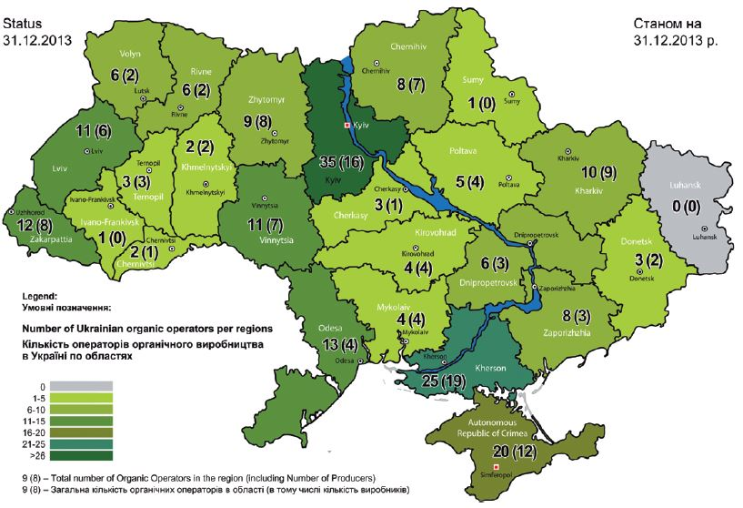
Organic Federation Research of Ukraine show that modern domestic consumer market for organic products in Ukraine began to develop since the early 2000s, reaching in 2007 – 500 thousand euros, in 2008 – 600 thousand €, in 2009 – 1,2 mln €, in 2010 – 2,4 mln €. In 2011 this figure has rosen to 5,1 million €, in 2012 – to 7,9 million €, in 2013 – up to 12,2 million €, and in 2014 – to 14,5 million € [14]. Today organics account for only 1 % of sales of food, although it tends to increase [1, 14].
Pic. 2. Organic map of Ukraine on 31.12.2013
It is known that organic farming of agricultural land must meet certain requirements regarding the level of pollution by harmful substances, pesticides, heavy metals, radionuclides etc. According to data [2], four small areas left in Ukraine, where cultivation of environmentally friendly products to global standards is possible: 1) North Poltava; 2) Vinnytsia-Carpathian; 3) South Podillia; 4) North-East Luhans’k.
According to M. I. Kobets [9] the transition from intensive technologies of agricultural production to organic agriculture (conversion period) is a time-intensive process (2 to 5 years). Problems of conversion period are divided into three groups [9, 12]: psycho-social, institutional, legal, financial and economic.
The main factors that hinder the production of organic products, according to P. S. Zorya, S. V. Mamalyga, L. V. Porodina, include the following [6, 10, 12]: underdeveloped domestic market, the dominance of imported organic products on the market; insufficient development of infrastructure trade of organic products; availability of unscrupulous manufacturers on the market; imperfect legal framework; not a sufficient number of registered certification centers; weak development of integration with international structures and limited access to markets for organic products; lack of government support; lack of public education.
The governments of many developed countries have developed a system of incentives and encourage organic producers. Thus, in Germany the amount of state support is 170–750 €/ha, in Switzerland – 162–970 €/ha, in France – 80–900 €/ha, in the Netherlands – 650 €/ha, in Poland – 66,6–394,5 €/ha, in Lithuania – up to 376 €/ha. In turn, Ukrainian producers of organic products don’t have state support [6], and substantial financial support for the development of the organic sector in Ukraine is provided by donors from Switzerland, the Netherlands, France, Germany and other countries [12].
It should be noted that Ukrainian scientists have developed economic mechanism of the incentives of organic products, which is based [10] on economic instruments, incentives and economic sanctions.
Ukraine has a great potential for the production of certified organic products. According to A. I. Shkuratova, V. A. Chudovsky, A. V. Vdovichenko, despite of the problems of formation [6, 15], the organic sector is promising thanks to the fertile black soil, favorable climatic conditions, low prices for the rental of land, growing demand for organic etc. Organic agricultural production has great potential to improve the economic, social and ecological situation in Ukraine [3].
For domestic organists the implementation of organic products abroad now is the best economically prospect. The main export market for Ukrainian organic products is the European Union, USA, Canada, Japan [6]. According to scientists [4, 12], organic products produced in Ukraine is capable to sustain compliance with international standards and be competitive on the world market.
Conclusion. In Ukraine global trend towards popularization of organic production are observed. Between 2003 and 2014 the number of organic farms has increased in 6 times and now totals 182 units; area occupied by organic production has increased in 2,4 times and makes 400,764 thousand ha, 1 % of the total area of agricultural land. Leaders among organic farms are Kyiv and Kherson regions. It should intensify the development of organic products in the areas of the country where their number is insignificant – Luhans’k, Sumy, Ivano-Frankivs’k, Chernivtsi regions.
Today Ukraine has significant potential for development of organic production. Production of organic origin is becoming more attractive both for European and for domestic consumers. Given that Ukraine has a strong potential of agriculture, the country could become one of the main exporters of these products to the EU market.
For the improvement and growth of organic production we need to improve the regulatory framework for organic production and its harmonization in accordance with European regulations, Regulations, Directives. The development of organic production in Ukraine is possible only with the state support. State incentives can be realized through financial support, tax relief, increasing payments to the purchase price, reduced prices for services and means of production, state insurance, popularization of organic production among producers and consumers, creating an extensive infrastructure of organic products. In this case the domestic agricultural producers will be able to provide a sufficient amount of the production of organic products. It will contribute, on the one hand, a better environment, on the other – the growth of domestic agriculture will become quite significant and integral improvement of the health of the nation.
BIBLIOGRAPHY
- Бєляєва Н. В. Сучасний стан виробництва органічної продукції в Україні та світі / Н. В. Бєляєва // Інноваційна економіка. – 2013. – №1. – С. 151–155.
- Відтворення родючості ґрунтів у ґрунтозахисному землеробстві / [під. ред. М. К. Шикули]. – К. : Оранта, 1998. – 680 с.
- Грабак Н. Х. Виробництво екологічно чистих продуктів харчування – найперспективніший напрям агропромислового комплексу України / Н. Х. Грабак // Наукові праці Чорноморського державного університету імені Петра Могили комплексу «Києво-Могилянська академія». Серія : Екологія. – 2012. – Т. 206, Вип. 194. – С. 126–131.
- Журавель С. В. Особливості органічного землеробства на Поліссі [Електронний ресурс] / С. В. Журавель, Б. В. Матвійчук, Н. Г. Матвійчук // Збірник наукових праць ННЦ «Інститут землеробства НААН». – 2011. – Вип. 1–2. – C. 86–94. – Режим доступу : http://agriculture.kiev.ua/wp-content/uploads/2011/04/13.pdf.
- Закон України «Про виробництво та обіг органічної сільськогосподарської продукції та сировини» від 03.09.2013, № 425-VII [Електронний ресурс] / Верховна Рада України. – Режим доступу : http://zakon5.rada.gov.ua/laws/show/425-18.
- Зоря П. С. Виробництво екологічно чистої продукції: проблеми та виклики сьогодення / П. С. Зоря // Економіка і управління. – 2014. – №3. – С. 45–50.
- Капштик М. В. Нормативно-правове забезпечення органічного виробництва в Україні: проблеми та перспективи / М. В. Капштик // Агроекологічний журнал. – 2012. – №1. – С. 25–31.
- Кисіль В. І. Біологічне землеробство в Україні: проблеми і перспективи / В. І. Кисіль. – Х. : вид-во «Штрих», 2000. – 161 с.
- Кобець М. І. Органічне землеробство в контексті сталого розвитку [Електронний ресурс] / М. І. Кобець // Проект «Аграрна політика для людського розвитку». – К., 2004. – 22 с. – Режим доступу : http://www.undp.org.ua/agro/pub/ua/P2004_01_051_04.pdf.
- Ковальчук С. Я. Виробництво органічної продукції – аграрна спеціалізація України на міжнародному ринку / С. Я. Ковальчук, Л. В. Муляр // Збірник наукових праць ВНАУ. – 2013. – №3 (80). – С. 104–110.
- Мамалига С. В. Розвиток ринку органічної продукції в Україні / С. В. Мамалига, О. П. Глубока // Збірник наукових праць Таврійського державного агротехнологічного університету. – 2012. – №2 (28). – Т. 1. – С. 270–279.
- Породіна Л. В. Сучасний стан регулювання ринку безпечного продовольства: світовий досвід /
Л. В. Породіна // Товарознавство та інновації. – 2013. – Вип. 5. – С. 188–197.
- Органік бізнес-довідник України [Електронний ресурс] / [за ред. Н. Прокопчук, Т. Зігг, Ю. Власюк]. – 2014. – Вип. 2. – 405 с. – Режим доступу : http://www.ukraine.fibl.org/fileadmin/documents-ukraine/UKRAINE_ORGANIC_BUSINESS_DIRECTORY_part2.pdf.
- Офіційний веб-сайт Федерації органічного руху України [Електронний ресурс]. – Режим доступу : http://www.organic.com.ua.
- Шкуратов О. І. Органічне сільське господарство: еколого-економічні імперативи розвитку : монографія / О. І. Шкуратов, В. А. Чудовська, А. В. Вдовиченко. – К. : ТОВ «Діа», 2015. – 248 с.
- International Federation of Organic Agriculture Movements [Електронний ресурс]. – Режим доступу : https://www.ifoam.bio/.
- Willer H. The World of Organic Agriculture. Statistics and Emerging Trends 2013 / H. Willer, J. Lernoud, L. Klicher. – Bonn : Research Institute of Organic Agriculture (FiBL), Frick and IFOAM – Organic International, 2013. – 340 p.

