© 2016
Syplyva N. A., PhD of Biological Sciences,
Gnenna M. A., Senior Research Officer,
Kolyadenko S. S., Senior Research Officer,
Pavlenko O. W., Research Officer
Ukrainian Institute of Plant Variety Examination
DECORATIVE HERBACEOUS PLANTS IN UKRAINE (PLACE OF CULTIVATION, STRUCTURE, ORNAMENTALITY)
We analyzed quantitative and qualitative composition of the decorative herbaceous plants listed in the State Register of plant varieties which are suitable for dissemination in Ukraine. We reviewed and generalized the results of the cultivation of decorative herbaceous plants of Botanical gardens of Ukraine. Taxonomic, geographical analyses of decorative herbaceous plants are conducted and the rate of assessment of their decorativeness is determined. The varieties of decorative herbaceous plants, which belong to the group of plants with high ornamentality are described.
Key words: arabatka, ornamental herbaceous plants, ornamentality, cultivation, botanical garden, mixborder, variety.
Statement of the problem. In our time more relevant are measures to improve environmental, landscaping, gardening of cities and settlements. In urbanization, the greening is an integral part of the whole complex of planning, development and improvement of settlements. Since ancient times people seek to decorate their home both outside and inside and in this key role belongs to floral plants. The constant change of aesthetic human needs requires updating and enrichment of assortment of ornamental herbaceous plants. It is only important to choose the right plants to design and create flower beds. It is only important to correctly choose the plants for the design and creation of flower beds. Furthermore, it will facilitate focused, productive activities at the preservation and enrichment of varietal diversity of herbaceous plants of the country.
Analysis of main researches and publications, which initiated solving the problem. Decorativeness of plants is determined by the combination of a number of external signs: structure and color of the leaves, size and colour of the flowers and duration of flowering. To achieve an ornamental effect, as a supplementary to the basic, we have used a variety of decorative varieties, which by their appearance is considerably different from the characteristic features of the species [5, 10].
Source of it is the collection funds of introduced plants and the creation on their basis of new highly ornamental varieties of local breeding, which are better suited for specific growing conditions. Actually, Botanic gardens are the main centers for the conservation and enrichment of biodiversity. In the result, we gathered significant collection funds of herbaceous plants, which were studied and included in breeding programs as donors of plant genetic resources [5, 10, 11].
The purpose of the research is to identify the species and varietal diversity of ornamental herbaceous plants (OHP) listed in the Register of plant varieties and generalization of places of cultivation in Ukraine. To determine the rate of assessment of their decorativeness.
The object of study – species and varieties of OHP listed in the Register of plant varieties.
The subject of the research is taxonomic, geographic structure of OHP, the indicator of the ornamentality.
According to the purpose of the research it is necessary to solve the following tasks:
- To make taxonomic, geographic structure of OHP.
- To determine the place of cultivation of OHP listed in the Register of plant varieties in the collections of Botanical gardens.
- To determine the assessment indicators of decorativeness of OHP for their wide use in gardening settlements.
The materials and methods of research. An inventory of herbaceous plants carried out by the method of laboratory research, by selection of species and varieties from the lists, catalogs, Internet resources and other published materials. To clarify the taxonomic names of plants we used scientific publications of S. K. Cherepanov (1981) [13], the latin names given by the identifications of plants «Indicator of higher plants of Ukraine» (1999) [9]. Geographical analysis was fulfilled by the system of phytogeographical division of the world of A. L. Takhtagyan (1978) [12]. To determine the indicator of the ornamentality we used recommendations of O. A. Porada (2007) [10], we take into account scientific works of G. V. Melnychuk (2012) [8]. These authors offer as a basis to take ornamental features, namely: plant height, diameter of the bush, the flower colour, doubleness of inflorescences, diameter of inflorescence, originality and overall condition of the plants. The calculation was conducted on a 9-point scale, therefore, the overall assessment of the ornamentality can be 54 points.
To determine the decorativeness we have used the following scale of distribution:
1 – weak ornamentality (assessment less than 14 points);
2 – medium ornamentality (assessment from 15 to 28 points);
3 – quite high ornamentality (assessment from 29 to 41 points);
4 – high ornamentality (assessment from 42 to 54 points).
Results of the research. According to the literary sources we found that in the State Register of plant varieties suitable for dissemination in Ukraine in 2016 there are 167 varieties of ornamental herbaceous plants, which are assigned to 11 species, 11 genera, 8 families, from one of the division Magnoliophyta. We found that a greater number of families consists of one genus – 6 families (Amaranthaceae, Cannaceae, Iridaceae, Paeoniaceae, Polemoniaceae, Saxifragaceae) (54,5 % of the total number of genera).
By results of researches it is established that the highest degree of varietal diversity was observed in four genera: Paeonia L. – 36 varieties (22,0 %), Chrysanthemum L. – 35 (21,0 %), Callistephus Cass. – 31 (18,5 %), Dahlia Cav. – 24 (14,3 %). From 10 to 20 varieties are found in genera Gladiolus L., Hemerocallis L., Phlox L. etc. The highest species diversity belongs to families: Asteraceae – three species (Dahlia Cav., Callistephus Cass., Chrysanthemum L.), Liliaceae – two (Hemerocallis L., Tulipa L.).
Geographical analysis showed that OHP listed in the Register come from two subkingdoms of Galarctic Kingdom: Ancient mediterranean, Boreal, which cover four floristic region, аnd Neotrope Kingdom which is in tropical South and Central America [12].
According to the results of the geographical analysis of OHP listed in the Register are represented mainly by species with different natural-geographical zones of the globe, which have successfully adapted to the new conditions of growth. Most species of the East Asian region – four. These are species that naturally grow in China, Japan (Callistephus chinensis (L.) Nees, Astilbe Buch.-Ham.ex. D. Don., Hemerocallis × hybridа hort., Paeonia L.). There are for two species from Atlantic-North American region (Dahlia × cultorum hort., Phlox paniculata L.) and Mediterranean region Chrysanthemum × hortorum Bailey).
As a result of the analysis of the place of cultivation of the species and varietal diversity of OHP listed in the Register we found that in the Botanical garden there are 133 varieties, 7 species, 7 genera, 5 families from one of the division Magnoliophyta, that is 79,6 % of the total number of varieties in Register [1, 2, 4–7].
Chrysanthemum × hortorum Bailey have the highest varietal diversity – 32 varieties (or 91,4 % of the total number of varieties in the Register), Paeonia L. – 35 (97,2 %). Based on the analysis of representativeness (the number of places of cultivation) it is possible to conclude about the composition of species and varietal diversity of the OHP listed in the Register in Botanical gardens of Ukraine.
As a result of the analysis we have made three levels of representativeness: the highest (6–7 species of the OHP listed in the Register), medium (4–5) and low (1–3). As it is shown in the table the National Botanical garden named after N. Gryshko National Academy of Sciences of Ukraine is characterized by the highest degree – 6 species, 122 varieties (91,7 % of the total number of varieties).
Among them, the highest varietal diversity is in Paeonia L. – 35 varieties (28,6 % of the total number of represented varieties): «Beregynya», «Chervona Vezha», «Chaklunka», «Cheburashka», «Antey» etc., Chrysanthemum × hortorum Bailey – 29 (23,7 %): «Zirnycya», «Oksamytka», «Smuglyava krasunya», «Osinnij Blyuz», «Perlynka» etc., Callistephus chinensis (L.) Nees – 23 (18,8 %): «Flamingo», «Angelina», «Anzhelika», «Malynovyj Blyesk», «Anyutochka» etc. From six to 18 varieties or 4,9–14,7% respectively accrued in Phlox paniculata L. – 6 varieties, Gladiolus × hybridus hort. – 11, Dahlia × cultorum hort. – 18.
The degree of representation varieties of the OHP from the Register in the collections of Botanical gardens
The name of species | The number of varieties in the Register, unites | The number of varieties in the collections of the BG, unites | The place of cultivation
Astilbe Buch.-Ham.ex. D. Don. | 4 | – | –
Callistephus chinensis (L.) Nees | 31 | 23 | 1–2, 9–10, 13
Canna indica L. | 1 | – | –
Chrysanthemum × hortorum Bailey | 35 | 32 | 1–3, 4, 7, 9–10, 11, 12, 13–14
Dahlia × cultorum hort. | 24 | 20 | 1–3, 4, 6–7
Gladiolus × hybridus hort. | 13 | 11 | 1, 5, 7, 8
Hemerocallis × hybridа hort. | 10 | 3 | 2
Paeonia L. | 36 | 35 | 1, 3, 10, 11
Phlox paniculata L. | 10 | 8 | 1, 4, 7, 10
Tulipa hybridа hort. | 2 | – | –
Сelosia cristata L. | 1 | – | –
In total: | 167 | 133
Notes: BG – Botanical garden, RL – research laboratory, TRC – teaching and research center, 1 – the National Botanical garden named after N. Gryshko of the National Academy of Sciences of Ukraine, 2 – Donetsk Botanical garden of the National Academy of Sciences of Ukraine, 3 – Kryvyi Rig Botanical garden of the National Academy of Sciences of Ukraine, 4 – BG of Dnipropetrovsk national University, 5 – BG «Volyn’» of Lesya Ukrainka State University of Volyn, 6 – BG of B. Khmelnytskyi National University of Cherkasy, 7 – BG of Yuriy Fed’kovych National University of Chernivtsi, 8 – BG of Podolsk State Agrarian-Technical University; 9 – BG of V. N. Karazin National University of Kharkiv, 10 – BG of Ivan Franko National University of Lviv, 11 – Zaporizhzhia city children Botanical garden, 12 – BG of I. Mechnikov National University of Odessa, 13 – RL «Botanical garden» TRC «Institute of biology» of Taras Shevchenko National University of Kyiv, 14 – BG of National Forestry University of Ukraine.
The medium degree of species and varietal diversity is characterized by Donetsk Botanical garden of the National Academy of Sciences of Ukraine – four species and 34 varieties (25,6 %). The greatest number of varieties is presented by Chrysanthemum х hortorum Bailey – 25 varieties (73,5 % of the total number of represented varieties): «Kassandra», «Belaya Romashka», «Barhan», «Khrustal’na», «Kolyskova» etc. Three varieties (8,8 %) has Callistephus chinensis (L.) Nees, Dahlia × cultorum hort., Hemerocallis × hybridа hort. There are four species and 25 varieties (18,7 %) in the collections of the Botanical garden of Yuriy Fed’kovych National University of Chernivtsi. Among them 12 varieties (48,0 %) of Chrysanthemum × hortorum Bailey: «Zvezdopad», «Leliya», «Knopa», «Umka», «Pryvitna» etc. From one to eight varieties presents Dahlia × cultorum hort. – one variety, Phlox paniculata L. – four, Gladiolus × hybridus hort. – eight.
In Botanical garden of Ivan Franko National University of Lviv is cultivated four species, 16 varieties (25,6 %). Chrysanthemum х hortorum Bailey has the greatest number of varieties – 8 varieties (50,0 %): «Kryzhynka», «Vrodlyva», «Pryvitna», «Pektoral», «Zolote Runo».
Kryvyi Rig Botanical garden of the National Academy of Sciences of Ukraine, Botanical garden of Dnipropetrovsk national University, Botanical garden «Volyn’» of Lesya Ukrainka State University of Volyn’, Botanical garden of B. Khmelnytskyi National University of Cherkasy, Botanical garden of Podolsk State Agrarian-Technical University, Botanical garden of V. N. Karazin National University of Kharkiv and others are characterized by a low degree of species representation of OHP (one–three species) and from 1 to 21 varieties, that is 0,6–12,5 % accordingly. Only one species (one or two varieties) of OHP is presented in Botanical garden of
I. Mechnikov National University of Odessa – Chrysanthemum × hortorum Bailey «Promenysta», «Sonechko», Botanical garden of B. Khmelnytskyi National University of Cherkasy – Dahlia × cultorum hort. «Vechnyj ogon», Botanical garden of Podolsk State Agrarian-Technical University – Gladiolus × hybridus hort. «Mirazh».
The creation of a harmonious system the combination of plant forms, varieties is the main purpose of landscaping. A wide range of the ornamental qualities of the types of OHP enables their skilful combination in the greening of urban areas. Therefore, one goal of our research was the determination of evaluation indicators of ornamentality of varieties of OHP. To determine the decorativeness we have selected new varieties species of OHP listed in the Register over the past three years. They are: Chrysanthemum × hortorum Bailey – eight varieties, Hemerocallis × hybridа hort. – six varieties, Callistephus chinensis (L.) Nees – four varieties.
As a result of the assessment of the ornamentality there are 14 varieties or 77,7 % of the total number of represented varieties which are assigned to the group with a quite high decorativeness (pic. 1). The amplitude of the assessment indicators is from 29 to 41 points. As shown by the results of our research to the group with a high decorative effect can be attributed four varieties of OHP. These are two varieties: Callistephus chinensis (L.) Nees – «Yantarna» – 46 points, «Anzhelika» – 48 points and one variety Chrysanthemum × hortorum Bailey – «Osinnij blyuz» – 48 points; Hemerocallis × hybridа hort. – «Slyvovyi Kokteil» – 42 points.
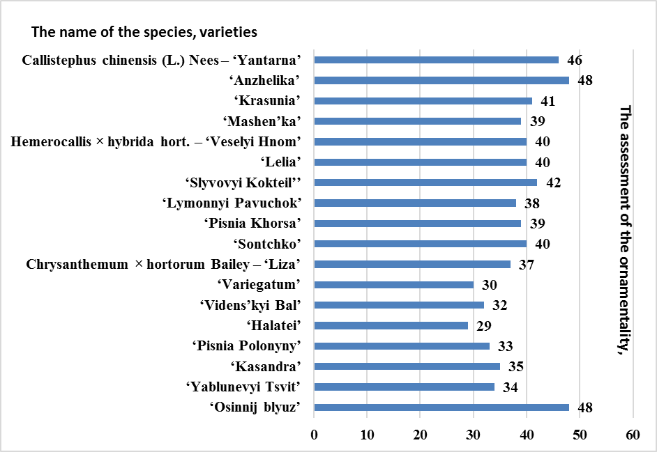
Pic. 1. The amplitude of the assessment indicators of ornamentality
of OHP in the Register
There are OHP with sufficient, medium and high ornamentality and suitable for use for cutting and gardening cities and farmlands. Assortment depends on what purpose garden object will have, which architectural and planning principles of these objects will be created: flowerbeds, rabatkas, mixborders, groups, solitaires. To create flowerbeds varieties of species Callistephus chinensis (L.) Nees, Chrysanthemum × hortorum Bailey, Tulipa hybridа hort., Сelosia cristata L. are suitable, rabatkas – Canna indica L., Gladiolus × hybridus hort., mixborders – Phlox paniculata L., Astilbe Buch.-Ham.ex. D. Don. Decorative tapeworms or groups can create using varieties of species Paeonia L., Chrysanthemum × hortorum Bailey, Hemerocallis × hybridа hort. etc.
Pic. 2, pic. 3, pic. 4, pic. 5 shows OHP, which in our opinion, belong to the high ornamentality group, the assessment indicators of ornamentality is from 42 to 48 points.
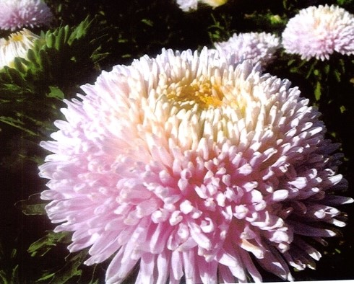 |  | 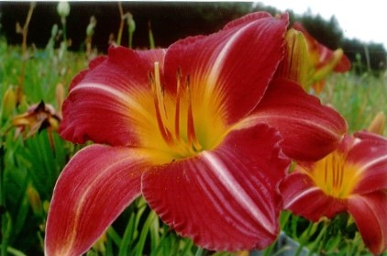
Pic. 2. Callistephus chinensis (L.) Nees  variety «Yantarna» |  | Pic. 3. Hemerocallis × hybridа hort.  variety «Slyvovyi Kokteil»
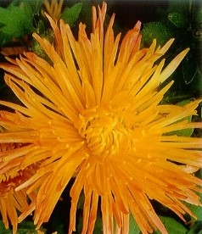 |  | 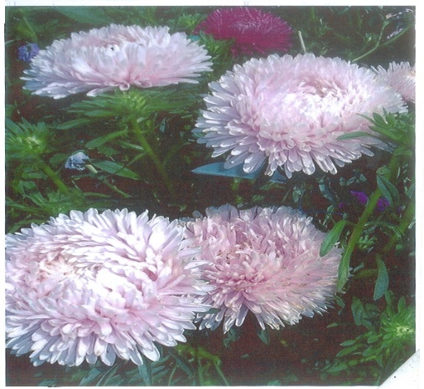
Pic. 4. Chrysanthemum × hortorum Bailey  variety «Osinnij blyuz» |  | Pic. 5. Callistephus chinensis (L.) Nees  variety «Anzhelika»
Conclusion. As a result of our researches it is established that there are 167 varieties of OHP in the Register. Analyses of representativeness of OHP listed in the Register showed that in the collections of Botanical gardens of Ukraine 133 varieties, 7 species, 7 genera, 5 families from one of the division Magnoliophyta are cultivated.
The highest and the medium degree of representativeness characteristic of the National Botanical garden named after N. Gryshko of the National Academy of Sciences of Ukraine – 122 varieties (91,7 %), Donetsk Botanical garden of National Academy of Sciences of Ukraine – 34 (25,6 %), Botanical garden of Yuriy Fed’kovych National University of Chernivtsi – 25 (18,7 %), Botanical garden of Ivan Franko National University of Lviv – 16 (12,0 %). As a result of the assessment of the ornamentality there are 14 varieties of OHP (or 77,7 %), which were the subject of research and belong to the group with a quite high decorativeness and to the group with a high decorative effect selected four varieties: Callistephus chinensis (L.) Nees – «Yantarna», «Anzhelika», Chrysanthemum × hortorum Bailey – «Osinnij blyuz», Hemerocallis × hybridа hort. – «Slyvovyj kokteil».
BIBLIOGRAPHY
1..Ботанічний сад Полтавського державного педагогічного університету ім. В. Г. Короленка : путівник / [уклад. : Оніпко В. В., Гриньова М. В., Дзюбаненко А. С., Гапон С. В.]. – Полтава : Полтавський держ. педагогічний ун-т ім. В. Г. Короленка, АСМІ, 2003. – 27 с.
2. Глухов О. З. Донецький ботанічний сад Національної академії наук України : путівник /
О. З. Глухов, О. М. Шевчук. – Донецьк : Дедра-Схід, 2002. – 128 с.
3. Державний реєстр сортів рослин, придатних для поширення в Україні у 2016 році. – [Чинний станом на 05.05.2016]. – [Електронний ресурс]. – Режим доступу : http://minagro.gov.ua/system/files/Реєстр сортів.pdf.
4. Каталог рослин Ботанічного саду Національного лісотехнічного університету України : довідник / [за ред. П. Р. Третяка]. – Львів : вид-во Нац. ун-ту «Львівська політехніка», 2006. – 60 с.
5. Каталог декоративних трав’янистих рослин ботанічних садів і дендропарків України : довідниковий посібник [Електронний ресурс] / за ред. С. П. Машковської. – К. : [б. в.], 2015. – 282 с. – Режим доступу : http://www.nbg.kiev.ua/upload/biblio/katalog.pdf.
6. Каталог растений Криворожского ботанического сада : справ. пособие / [Бойко Л. И., Василенко Е. В., Вечканова Л. В., Доровская И. А., Калинчук Л. Н.]. – К. : Фитосоциоцентр, НАН Украины, Криворож. ботан. сад, 2000. – 164 с.
7. Колекція рослин Ботанічного саду Дніпропетровського національного університету / [Опанасенко В. Ф., Зайцева О. І., Кабар А. М., Сироватко К. О., Мартинова Н. В.]. – Дніпропетровськ : Дніпропетр. нац. ун-т, РВВ ДНУ, 2008. – 224 с.
8. Котов М. И. Определитель высших растений Украины / М. И. Котов, Ю. Н. Прокудин,
А. И. Барбарич. – [2-е изд., стереот., с незнач. доп. и испр.]. – К. : Фитосоциоцентр, Акад. наук Украинской ССР, Ин-т ботаники им. Н. Г. Холодного, 1999. – 548 с.
9. Мельничук Р. В. Оцінка декоративності зразків колекції роду Calendula L. / Р. В. Мельничук // Вісті Біосферного заповідника «Асканія-Нова». – 2012. – Т. 14. – С. 516–518.
10. Порада О. А. Методика формування та ведення колекцій лікарських рослин / О. А. Порада. – Полтава : ПП ПДАА, 2007. – 50 с.
11. Рубцова О. Л. Підсумки інтродукції старовинних троянд у Національному ботанічному саду імені М. М. Гришка НАНУ / О. Л. Рубцова, В. І. Чижанькова // Сортовивчення та охорона прав на сорти рослин. – 2016. – №2. – С. 5–9.
12. Тахтаджян А. Л. Флористические области Земли / А. Л. Тахтаджян. – Л. : Наука, 1978. – 247 с.
13. Черепанов С. К. Сосудистые растения СССР / С. К. Черепанов. – Л. : Наука, 1981. – 510 с.

