© 2016
Kotchenko M. V., Candidate of Agricultural Science,
Kyrsanova G. V., Candidate of Agricultural Science,
Puhach A. M., Candidate of Agricultural Science,
Puhach A. V., postgraduate student
Dnipropetrovsk State University of Agriculture and Economics
PRODUCTIVITY OF MAIZE HYBRIDS WITH DIFFERENT MATURITY UNDER CONDITIONS OF THE NORTHERN STEPPE OF UKRAINE
Reviewer – Doctor of Agricultural Science, I. I. Yarchuk
We established that the highest productivity indexes (the leaf area, number of cobs per 100 plants, grain weight of one cob, weight of 1000 grains) form hybrid crops NC Lemoro. Agroclimatic potential of Steppe zone of Ukraine is in the best biological characteristics of this group of hybrids ripeness, ensuring the formation of grain yield at 8,67 tones/ha.
Key words: maize, hybrids, yield, moisture, grain, economical efficiency.
Statement of the problem. Different biotypes of modern maize hybrids are distinguished by the differences in morphological characteristics, qualities and demands for ecological factors. In connection with this, to detect the potential productivity of each hybrid it is necessary to create favourable conditions for growth and development of plants. In turn, these conditions are determined by agro-technical method and natural climate resources.
Analysis of the latest research and publications where the problem solving is started. The experimental data show that the maize yield depends less on hybrid productivity, but more on technology and growing conditions [1, 4, 5]. In order to get a high and stable crop it is necessary to provide the selection of the best hybrids, which are adaptive to conditions of soil-climatic zone, and to create agro-technical background according to their needs. The results of research, which are conducted in different soil-climatic conditions of Ukraine, and the advanced experience in cultivation of maize in agrosystems show the possibility to get high and stable crops of maize when the elements of technology are followed – 4,0–6,0 t/ha without irrigation and 10,0–12,0 t/ha with irrigation [2, 4]. There are intensive type forms among newly created biotypes of maize which are demanding for conditions of environment and level of agro-technology. There are also hybrids with a lower response to changes in growing method which is providing a noticeable economic effect from their production [3]. In connection with this, the research in identifying the most adaptive forms, which are suitable to grow under technological schemes in specific soil-climatic conditions, acquires considerable relevance.
The aim of our work was to study the process of growth, development and yield formation of maize hybrids NK Simba (medium early maturity, FAO 270), NK Lemoro (medium maturity, FAO 310) and Sisco (medium late maturity, FAO 400), which have been recorded in State Register for suitable breeds to propagate in Ukraine. Also to determine those ones, which are giving the highest economic effect from their production in conditions of northern Steppe of Ukraine.
The materials and methods of research. The researches were carried out during 2014–2015. The soils of the experimental plots were presented by ordinary low-humus fully-profiled black soil. The humus capacity in one layer of fully-profiled black soil is varied in interval of 3,1–3,7 %. The content of total nitrogen is 15–20 mg/kg (under Kjeldahl`s method), labile phosphorus content is 100–150 mg/kg, exchange potassium – 60–120 mg/kg of soil (under Chirikov`s method). Research area of plots was 50,4 m², experiments are replicated three times. Predecessor of maize is winter wheat. After harvesting the predecessor, a stubble peeling has been done with the use of a disc hoeing plough at a depth of 6–8 cm and was repeated after the weed germination, which facilitated the accumulation of soil moisture and the effective fight with weeds. The ploughing has been carried out in late September at a depth of 25–27 cm. The technology of maize cultivation, except tasks for research, was conventional for northern Steppe of Ukraine.
In research the following methods have been used: measure-counting – for biometrical analysis of plants; weighing – for grain moisture counting; visual – for establishing the stages of growth and development of plants; mathematical statistics – for the research planning and assessment of the reliability of the results; count comparison – for economic effectiveness of maize cultivation.
The results of research. According to the results of the research it has been found that the leaf area of hybrid crops under the study are the most at panicle ejection phase. For example, the leaf area of hybrid Sisco was the highest and showed 42,1 thou.m²/ha, from hybrid Lemoro – 35,7 thou.m²/ha, from hybrid Simba – 32,4 thou.m²/ha. The minimum of this indicator for all hybrids was noted at wax ripeness phase. The leaf area from hybrid NK Lemoro was 23,4 thou.m²/ha, from hybrid Sisco – 25,1 thou.m²/ha, from hybrid Simba – 21,8 thou.m²/ha (table 1).

1. The dynamics of leaf surface area of maize hybrids, (thou.m²),
average for 2014–2015
Hybrid | Phase of development
Hybrid | panicle ejection |  |  | wax ripeness
Hybrid | area | number of leaves per 1 plant | height, cm | area | number of leaves per 1 plant | height, cm
NK Simba | 32,8 | 12,4 | 234 | 21,8 | 11,3 | 233
NK Lemoro | 35,7 | 12,8 | 240 | 23,4 | 11,7 | 237
Sisco | 42,1 | 14,1 | 245 | 25,1 | 12,3 | 241
Depending on hydrothermal conditions of the year, biological features and conditions of cultivation the height of the experimental maize hybrids also have been changed.
For example, on average, over the years of research the biggest height of plants has been recorded for hybrid Sisco – 245 cm. NK Lemoro and NK Simba had slightly smaller indicators.
In the phase of wax ripeness, the height of plants, regardless of the hybrid, has been slightly descended and fluctuated in interval 233–241 cm, that can be explained by drying of plants and decreasing of vegetative mass.
It is known, that maximum yield crop of maize grain can be obtained under the optimal proportion of elements of the individual plant productivity.
The number of cobs per 100 plants, the grain mass of one cob and the mass of a thousand grains are the indicators, that form an individual productivity of maize plants.
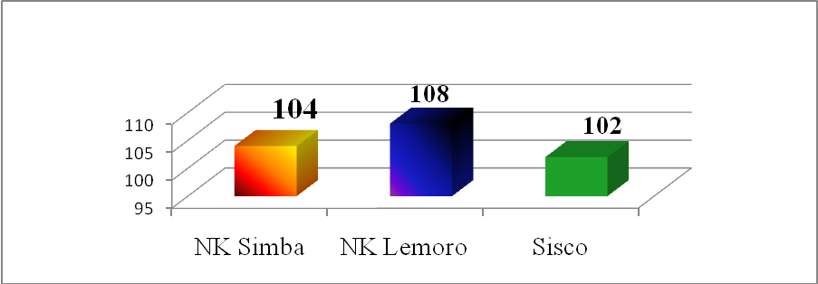
Pic. 1. The number of cobs per 100 plants
According to our research results the highest number of cobs per hectare were formed by medium maturity hybrid NK Lemoro (pic. 1). Medium early maturity hybrid NK Simba and medium late maturity hybrid Sisco have shown slightly lower indicators, by 3,8 % and 5,6 % accordingly.
The indicators of grain mass from one cob were affected by the research factors and hydrothermal regime (pic. 2). It was found that the heaviest cobs were formed by hybrid NK Lemoro – 184 g. The same indicator for hybrid NK Simba was less by 3,9 % and for Sisco – by 3,2 %.
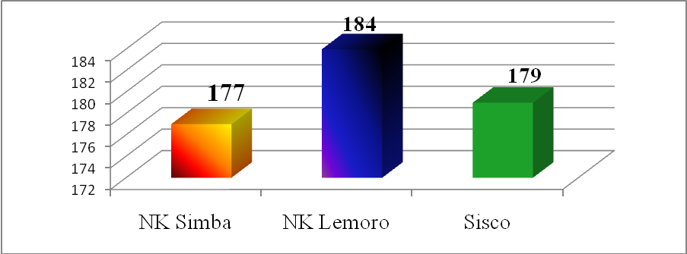
Pic. 2. Grain mass of one cob, g
Besides that, the mass of 1000 grains is important element of maize yield structure. The results of research have shown that its indicators were dependent on weather conditions during vegetation period and morphological characteristics of hybrids (pic. 3). Medium maturity hybrid NK Lemoro formed the highest mass of one thousand grains – 306 g. The mass of one thousand grains of medium late maturity hybrid Sisco was lighter by 4 g and of medium early maturity hybrid NK Simba – by 17 g.
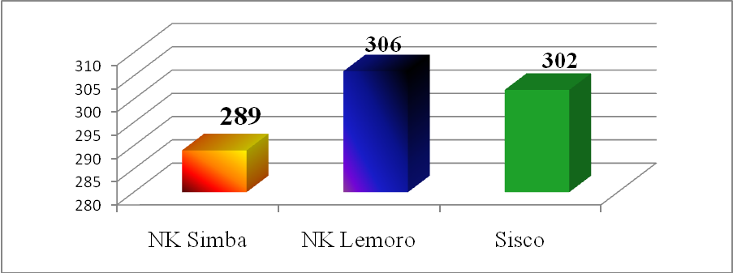
Pic. 3. The mass of 1000 grains, g
Carried out researches have shown that in 2014–2015 the grain yields of the different biotypes of maize were fully dependent on weather conditions of the vegetation period and the biological potential of hybrids. Early maturity hybrids have a crop yield smaller than hybrids with medium maturity and medium late maturity. But normally, early maturity hybrids are ripening early and don’t need drying after harvesting, as a result, these are reducing their production cost.
Thus, the optimal combination of the structural elements provides an opportunity to get the highest crop of maize grain. The most adapted for given growing conditions was the medium maturity hybrid NK Lemoro, which produced the crop 8,67 t/ha. Slightly lower crops were obtained from growing medium early maturity hybrid NK Simba – 8,03 t/ha and medium late maturity Sisco – 7,97 t/ha.
2. Crop yield, grain moisture and effectiveness of cultivation the maize hybrids
Hybrid | Crop yield, t/ha (with moisture 14 %) | Grain moisture, % | Production costs, hryvnia/ha |  | Cost of sold grain, hryvnia/t | Conditional net profit, hryvnia | Rate of return,  %
Hybrid | Crop yield, t/ha (with moisture 14 %) | Grain moisture, % | total | for drying | Cost of sold grain, hryvnia/t | Conditional net profit, hryvnia | Rate of return,  %
NK Simba | 8,03 | 16,4 | 11045 | 1687 | 1375 | 19272 | 174
NK Lemoro | 8,67 | 17,2 | 11368 | 1769 | 1311 | 20808 | 183
Sisco | 7,97 | 19,1 | 10986 | 1964 | 1378 | 19128 | 174
The obtained data have shown that the rate of return of grain production has been affected by the crop yield of these hybrids likewise, in full measure, by grain moisture (table 2). The highest production costs have been noted in the cultivation of hybrids with high pre collection moisture of grain. It required an increase in cost in order to achieve the standard level (moisture 14 %).
The results of research demonstrate that production costs were slightly higher in cultivation of medium maturity hybrid compared with early maturity and medium late maturity hybrids. This is due to a higher yield of maize grain and an increased cost of harvesting and further grain processing. But in result, indicators of production cost, net profit and rate of return of the hybrid NK Lemoro showed higher cost due to an increase of crop by 0,64 t/ha compared with hybrid NK Simba and by 0,70 t/ha – with hybrid Sisco.
Conclusion. To obtain the high economic indicators in practical farming it is recommended to grow the hybrid NK Lemoro.
BIBLIOGRAPHY
1. Циков В. С. Кукуруза: технология, гибриды, семена. – Днепропетровск : Зоря, 2003. – 296 с.
2. Циков B. C. Прогрессивная технология выращивания кукурузы. – К. : Урожай, 1984. – 192 с.
3. Ткаліч Ю. І. Оптимізація площі живлення – основа високих урожаїв кукурудзи // Хранение и переработка зерна. – Днепропетровск, 2002. – №3 (33). – С. 27–29.
4. Андрієнко А. Л. Основні заходи сортової агротехніки гібридів кукурудзи різних груп стиглості в північному Степу України : автореф. дис. … к. с.-г. н. – Дніпропетровськ, 2004. – 19 с.
5. Кирсанова Г. В. Формування фотосинтетичного потенціалу рослин різних гібридів кукурудзи залежно від умов вирощування / Г. В. Кирсанова, М. В. Котченко, Д. В. Ковальов // Materials of XI international research and practice conference «Scientific horizons – 2015». – Vol. 9. – P. 81–82.

