© 2017
Kovpak V. V., Ph.D of Veterinary. Sciences,
Kovpak O. S., post-graduate student
(research supervisor – Doctor of Veterinary Sciences A.Y. Mazurkevych)
National University of Biological Resources and Environmental Management of Ukraine
INFLUENCE OF CELL CULTURE TRANSPLANTATION ON ISLET CELL OF THE PANCREAS CONDITION AND ON BLOOD GLUCOSE LEVEL AT EXPERIMENTAL PANCREATIC DIABETES OF ANIMALS
Reviewer – Doctor of Veterinary Sciences, Professor M. O. Maliuk
The article describes the influence of various cell cultures (pancreas, bone marrow, adipose tissue) on the clinical course of experimental pancreatic diabetes of rats. It is found out that the optimal method of cell material injection is its transplantation under the pancreatic capsule. The study of islet cell condition under injecting various cell cultures in the setting of pancreatic diabetes showed that all of them produce a positive therapeutic effect in the treatment of the this pathology. The obtained data is testified by the growth of a general volume of islet tissue of recipient animals (compared to a control set); this in its turn results in the decrease of blood serum glucose level.
Key words: cell culture, pancreatic diabetes, bone marrow, adipose tissue, pancreas, Langerhans islets.
Statement of the problem. The basis of insulin-dependent diabetes development is the decrease of pancreatic β-cells, which leads to the decrease of blood insulin level. That is why the cytothesis of Langerhans islets presents an important issue in diabetes treatment. Cell culture transplantation is one of promising methods of pancreatic diabetes treatment, as it facilitates the cytothesis of the islet cells of the pancreas.
Analysis of basic research and publications which initiated the problem solution. Pancreatic diabetes is a group of metabolic diseases which are characterized by hyperglycemia caused by insulin secretion defects, insulin effect or by both factors. Insulin is the hormone developed by pancreas β-cells, which is necessary for the cells' use of glucose as a source of energy. Under type 1 diabetes, an organism fails to develop insulin, which results in its daily injecting [2–15]. However, a long-term substitutive therapy and the use of hypoglycemic agents can result in insulin resistance; besides it does not prevent the development of macro- and microvascular complications [7–18].
That is why, the attention of many researchers is focused on methods of pancreatic diabetes treatment by means of Langerhans islets cytothesis. Cell technologies are a promising area in pancreatic diabetes treatment which is aimed at regeneration of islet cells of the pancreas [1–16].
The purpose of the research lies in the study of the influence of cell culture transplantation of bone marrow, adipose tissue and pancreas on the islet cell of the pancreas condition and blood glucose level at experimental pancreatic diabetes of animals.
Research tasks are as follows: to obtain bone marrow, adipose tissue and pancreas culture cells; to form in rats experimental alloxan pancreas diabetes; to determine the optimal method of cell material infusion; to conduct a morphometric research of islet cell condition at cell culture transplantation in the setting of pancreatic diabetes; to analyze the obtained results.
Materials and methods/techniques. In experiments apparently healthy animals were used (30 non-pedigree male rats weighing 200–250 gr, aged 4–5 months; 9 non-pedigree baby rats aged 12 days). Experiments on animals were conducted under the requirements of the Law of Ukraine «On Animal Protection Against Cruel Treatment» (Art. 230 dated 2006) and the Provision on keeping and using test animals in the NAU animal facility and clinic, studied and approved by the Principal of HAU dated 20.05.2001.
In the research cell cultures of bone marrow, pancreas (obtained from the cortical bone marrow and pancreas of baby rats aged 12 days) and of adipose tissue (obtained from rats aged 4–5 months) were used. Cell cultivation was exercised under a standard technique in a СО₂-incubator [10].
The experimental model of pancreatic diabetes was recreated by means of a single transdermal delivery of alloxan monohydrate (Sigma, USA) in the dose of 150 mg/kg as a 5 % solution in citric buffer, рН 4.5 following a prior food deprivation (with a free access to water). To reduce animal deaths caused by a hypoglycemic shock after alloxan infusion, during 24 hours after diabetes induction the animals received a 5 % glucose solution instead of water [4].
To study the cell migration capacity, recipient animals with alloxan diabetes were transplanted 2 mln (50 microliters in volume) of bone marrow culture cells in two ways: intravenously and under the pancreatic capsule (for control, similar injections of PBS solution were made). The culture was previously conditioned with a vital nuclear stain Hoechst 33258 (Stigma, USA) according to a standard technique (after being marked, the cells fluoresce with bright-green colour) [14]. On the 8th day the animals were removed from the experiment and the pancreas samples were taken. Cell detection was conducted on cryosections made according to a standard technique [13, 9]. The samples were studied under the fluorescent microscope Leica DMR (Germany).
Tissue sampling for histological research was conducted on the 50th day of the experiment (the control group and the research group: the 30th day after cell transplantation). After sample selection, they were fixed in 10 % neutral formalin solution during 24 hours, and then the tissues were dehydrated and drowned into paraffin according to standard techniques [17]. Sections of 5 µm were made with the help of rotation microtome НМ 320 Е (MICROM, Germany) and the system of section transfer (STS, MICROM, Germany). For tissue microstructure study, the sections were stained with hematoxylin and eosin [12], after this the preparations underwent light microscopy. Preparations evaluation and analysis was exercised with the help of the microscope Leica DMR (Germany).
The state of the animals’ pancreas was studied in the setting of pancreatic diabetes (the 50th day of the experiment) and on the 30th day after the culture cells transplantation. The morphometric research of the islet cell condition was conducted on stained preparations. The total islet number on 10 mm² of the section was counted; complementally the number of cell nuclei in islets was estimated. The research was conducted on 3 non-serial sections made at a distance of 0.5 mm from each other (the distance bigger than one islet size).

Results of our own research. One of stem cells’ biological features if their migration capacity into a pathologic process area. It is known that in the process of MSC transplantation into an adult animal organism without experimental damage, up to 25 % of donor material is found in red bone marrow [20]. Of special interest is the migration of stem cells in the organism having a damage area. In the work of Wu with colleagues it is demonstrated that endogenic MSC migrate to the allograft rejection area [19]. It is considered that stem cells migration into a pathologic process area is determined by pro-inflammatory cytokines and chemokines.

At the same time, the migration mechanism into a damage area is not yet studied well enough; so one of our tasks was to study the migration capacity of bone marrow culture cells depending on the way of their infusion into a recipient animal organism.

Cell infusion was exercised in 2 ways: intravenously and under the pancreatic capsule. The results were evaluated by marked cells detection in pancreas cryosections (Pic. 1)
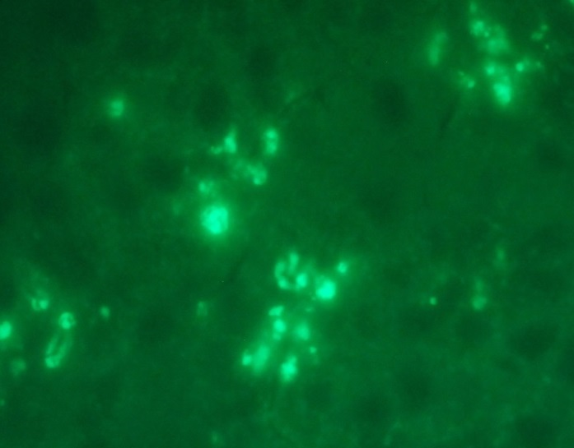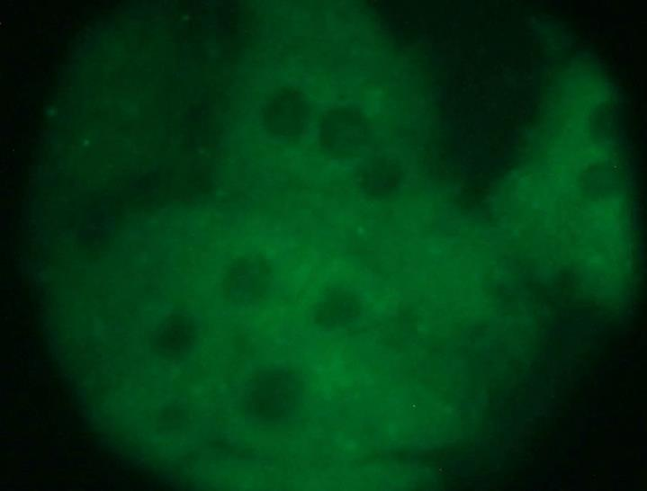
а)
б)
Pic. 1. Detection of Hoechst-marked cells in the pancreas: a) transplantation under the capsula;
b) control. Cryosections, fluorescence microscopy, ×1000.
At local infusion of pancreas culture cells to animals with experimentally formed pancreatic diabetes, on the 8th day their diffuse distribution in the pancreas tissue was observed (Pic. 1, a). The obtained data shows not only the cells’ survival after the infusion during a prolonged time, but their migration into the midst of the damaged organ. At intravenous Hoechst-market cells infusion, single signals were detected, which testifies to a limited number of cells to have reached the pancreas. That is why, in further research the culture cells transplantation under a pancreatic capsule was exercised.

The next step of the research was the morphometric data comparison of the rat pancreas at alloxan diabetes without treatment (a control group) and at the transplantation of various types of culture cells.

It is worth noting, that in the process of pancreas evaluation of intact, control and research groups, no difference was detected.

In the process of histological research of intact rats pancreas it was stated that the average islet number to 10 mm² of a section 5 µm thick equals 9.7±1.0, and the average cell number in a Langerhans islet is 100.0±14.9 (see table).

Islet cell of a pancreas changes at the culture cells transplantation at the setting of alloxan diabetes
Animal group | Average number of Langerhans islets | Average cell number in an islet
Intact animals | 9.7±1.0 | 100.0±14.9
Control group | 9.7±1.3 | 62.5±12.4
At BMCC infusion | 14.7±1.4* | 111.0±13.9*
At PCC infusion | 17.7±1,9* | 78.3±14.0
At ATCC infusion | 10.7±0,8 | 69.5±10.3

Note: *р<0.05; (indices of the alloxan diabetes 50th day were compared to intact animals’ indices; indices after transplantations of PCC, BMCC and ATCC at the setting of PD were compared to the 50th day indices (control).
While studying the pancreas tissue of control group rats (which were not under transplantation), no changes as to the islet number compared to intact animals were found; however, the average cell number in islets decreased 1.6 times.
Pic. 2. Glucose level in rats’ blood at pancreatic diabetes at the setting of culture cell infusion, n=5 (M±m)

Fig
However, while studying the blood glucose level on the 50th day of the experiment, we marked its slight accurate decline (Pic. 2). The obtained data testify to the fact that between the 20th and the 50th days of the experiment the animals can demonstrate cell composition restructuring in pancreas islets which remained after alloxan action, with the growth of β-cells specific volume due to islet cells proliferation with their differentiation in β-cells; but the islet tissue general volume remains unchanged and islet neo-genesis is not observed.
The histological study of pancreatic tissue of group animals which underwent the pancreatic culture cells transplantation allowed stating the growth of average number of islets per area unit, compared to control group animals. On the 50th day of the experiment the growth was 1.8 times (p<0.05). At that, their size varied greatly. The obtained results testify to the fact that after the pancreatic culture cells transplantation, considerable cell proliferation acceleration takes place in the islets which existed before the transplantation, which in its turn results in the growth of its area and the appearance of new small-sized islets (Pic. 3, arrow). The growth of existing islets and the appearance of new ones leads to tangible and accurate increase of islet tissue specific gravity.
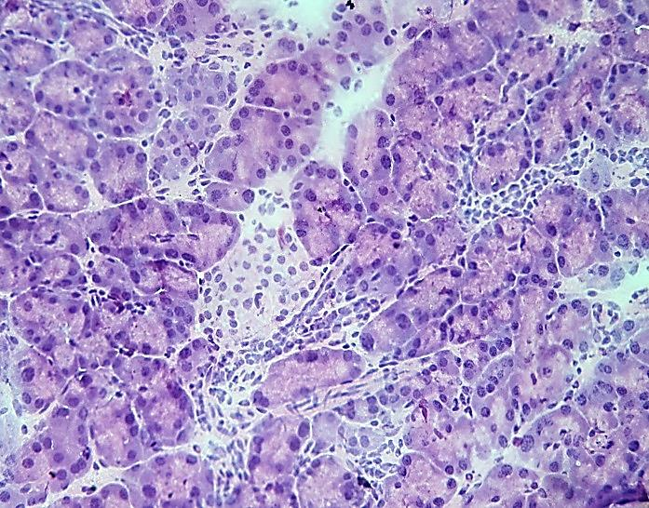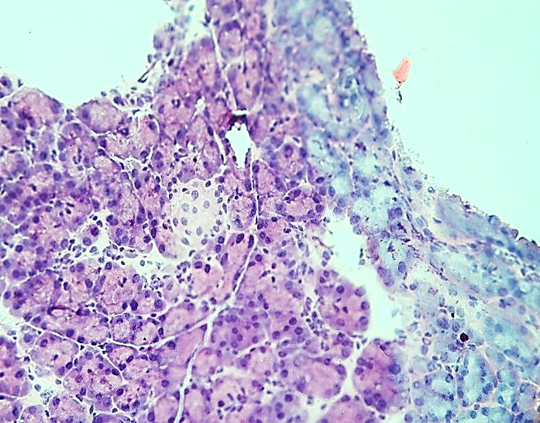
Pic. 3. Appearance of new Langerhans islets in the pancreas of rats with experimental pancreatic diabetes at allogenic transplantation of pancreatic culture cells

The histological research of pancreatic tissue of animal group which underwent the bone marrow culture cells transplantation detected both the increase of islet number per area unit, and the increase of their average size (the average islet number to 10 mm² of a section 5 µm thick grew 1.5 times). Both small and big islets were detected; on the 50th day of the experiment some of them included over 170 cells. The morphological research data shows that at the bone marrow culture cells transplantation, a more expressed acceleration of cell proliferation is observed; though the islet number as compared to the group which underwent the pancreatic culture cells transplantation was lower, however the sizes of some islets increased considerably. Hence, the specific gravity of islet tissue and the number of insulin-positive cells per area unit increases considerably.
The obtained data testifies to the fact that the infusion of adipose tissue culture cells also leads to neo-genesis enhancement of the islets, however these islets are of a small size (up to 50 cells). The specific gravity increase of islet tissue per area unit was the lowest among all applied transplantation techniques.
Conclusions and prospects for further research. The most effective transplantation technique of culture cells at pancreatic diabetes of animals is the infusion under the pancreatic capsule of recipient animals. After the pancreatic culture cells transplantation, the growth of islet tissue takes place, in the first place, by means of islet neo-genesis, as well as due to cell regeneration acceleration in a previously formed islet tissue. The bone marrow culture cells transplantation results in the growth of islet tissue mostly due to regeneration by means of proliferative proplasia of islet cells. The transplantation of adipose tissue culture cells stimulates the Langerhans islet neo-genesis in the pancreas.
The obtained data indicate a positive therapeutic effect of stem cells, which in will allow them to be used in clinical practice in the treatment of diabetes mellitus.
BIBLIOGRAPHY
- Алиев М. А. Трансплантация культур островковых клеток поджелудочной железы больным сахарным диабетом / [Алиев М. А., Исмагилов Р. З., Рысбеков М. М. и др.] // Трансплантологія. – 2000. – Т.1, №1. – С. 147–151.
- Дедов И. И. Болезни органов эндокринной системы / И. И. Дедов. – М. : Медицина, 2000. – С. 149–252.
- Дедов И. И. Сахарный диабет: ретинопатия, нефропатия / И. И. Дедов, М. В. Шестопалова,
Т. М. Миленькая. – М. : Медицина, 2001. – 176 с.
- Жилюк В. І. Аналіз морфометричних та ультраструктурних характеристик гемомікроциркуляторного русла гіпокампу щурів з алоксановим діабетом за умов введення цитиколіну /
В. І. Жилюк, В. Й. Мамчур, Н. С. Петрук, А. Е. Лєвих // Scientific Journal «ScienceRise». – 2015. – №7/4 (12). – С. 53–59.
- Зорин А. И. Сахарный диабет у собак и кошек / А. И. Зорин // РВЖ МДЖ. – 2005. – №2. – С. 44–47.
- Зорин А. И. Сахарный диабет у собак и кошек / А. И. Зорин // РВЖ МДЖ. – 2005. – №2. – С. 44–47.
- Ковальська І. О. Цукровий діабет та трансплантація / І. О. Ковальська // Трансплантологія. –2000. – Т.1, №1. – С. 140–142.
- Комісаренко І. В. Ендокринологія / [Комісаренко І. В., Боднар П. М., Комісаренко Ю. І. та ін.]. – К. : «Здоров'я», 2003. – 512 с.
- Луппа Х. Основы гистохимии / Х. Луппа ; [пер. с немецкого И. Б. Бухвалова, Е. Д. Вальтер]. – М. : Мир, 1980. – 343 с.
- Мазуркевич А. Й. Клітинні технології у ветеринарній медицині : навч. посібник для студ. вищ. навч. закладів / А. Й. Мазуркевич, В. В. Ковпак, В. Б. Данілов. – К. : КОМПРИНТ. – 2014. – 132 с.
- Марков В. О. Нові підходи у комплексному лікуванні цукрового діабету / В. О. Марков // Одеськ. мед. журнал. – 2002. – №2. – С. 60–63.
- Меркулов Г. А. Курс патологогистологической техники / Г. А. Меркулов. – Л. : Медицина, 1961. – 423 с.
- Морозова К. Н. Электронная микроскопия в цитологических исследованиях: методическое пособие / Новосибирск : Новосиб. гос. ун-т., 2013. – 85 с.
- Скибо Ю. В., Абрамова З. И. Методы исследования программируемой клеточной гибели : Учебно-методическое пособие для магистров по курсу «Теория апоптоза» / Ю. В. Скибо, З. И. Абрамова. – Казань : ФГАОУ ВПО КФУ, 2011. – 61 с.
- Шахбазиди Г. Сахарный диабет. Диагностика, классификация, критерии компенсации /
Г. Шахбазиди, Д. Д. Дунаева, Г. И. Гордеева // Крымский терапевтический журнал. – 2006. – №2. – С. 62–66.
- Hayek A. Cell replacement in type 1 diabetes mellitus / A. Hayek // J. Pediatr. Endocrinol. Metab. –2005. – Vol. 18, Suppl. 1. – P. 1157–1161.
- Jocelyn H. Histopathologic Techniques / H. Jocelyn, M. D. Bruce-Gregorios. – Philippines : Good Will Bookstore, 1974. – 257 p.
- The role of capsule composition and biologic responses in the function of transplanted microencapsulated islets of Langerhans / [King A., Andersson A., Berit L. S. et al.] // Transplantation. – 2003. – Vol.76, №2. –
P. 275–279.
- Wu G. D. Migration of mesenchymal stem cells to heart allografts during chronic rejection / [Wu G. D., Nolta G. A., Jin Y. S. et.al.] // Transplantation, 2003. – Mar. 15. – 75 (5). – Р. 679–685.
- Wynn R. F. А small proportion of mesenchymal stem cells strongly expresses functionally active CXCR4 receptor capable of promoting migration to bone marrow / R. F. Wynn, C. A. Hart, C. Corradi-Perini // Blood 2004 Nov.1. – 104 (9). – Р. 2643–2645.

