© 2017
Grytsyniak I. I., Doctor of Agricultural Sciences, Professor, Academician of NAAS,
Gurbyk V. V., Post-Graduate Student
(scientific advisor – Doctor of Agricultural Sciences, Professor I. I. Grytsyniak)
Institute of Fisheries of the National Academy of Agrarian Sciences
FISHERY ASSESSMENT OF COMMERCIAL THREE-YEAR-OLDS OF HALYCH CARP
Reviewer – Doctor of Agricultural Sciences V. V. Bekh
The basic fish-farming characteristics of three-year-old Halych carp, obtained in conditions of staple cultivation, are determined. The ecological conditions during growing trilogy of the Halych carp were within the fishery requirements. At the end of the growing season, the trunks were characterized by a high individual weight. The yield of fish feeding stood from 96 % to 98 %. The fish productivity index exceeded 2,000 kg/ha.
The intensive increase in the weight of the body of fish and plant material in 2015 was recorded during the second decade of July, during this period, their absolute weight gain exceeded that in 2016 by almost 200 g. The main peak of the weight increase of fish in 2016 was observed in early July. The smallest weights of growth during the experimental period are noted in May. In 2015, the downward trend is also observed in early July. According to the indicator of specific growth rate, the peak of its growth was set in the second decade of July. Minimum growth rates in 2015 are fixed at the beginning of June.
In order to characterize the economic quality of the Galician carp, an assessment of exterior characteristics during the growing season was conducted. Three-year-olds are characterized by high growth rates, have a small head and a fleshy structure.
The three-year-olds of Halych carp, obtained in the Precarpathian pond conditions, are characterized by high economic indicators both in terms of the individual weight of fish, and in the overall fish productivity. Halych carp is a highly productive and promising object for further restoration of the aboriginal composition of cultivated fish species in the Precarpathian fish farm.
Key words: growth rate, exterior, Galician carp, specific growth rate, mass accumulation.
Formulation of the problem. In recent years, there has been a tendency to increase the species composition of cultivated fish species. Importance is also given to the revival of valuable indigenous small carp species in Ukraine, in particular, the Galician carp. Therefore, the study and analysis of the productive characteristics of this carp in the conditions of modern industrial cultivation becomes of special urgency.
The Galician carp is worthy of attention, because the representatives of this massif remained only in several farms of Lviv region. Consequently, for the industrial reproduction and estimation of Galician carp as an object of industrial cultivation, it is necessary to study its productive capacities at different parts of the technological process.
Analysis of basic research and publications, which initiated a solution to the problem. Aquaculture is one of the specific areas of animal husbandry within the agro-industrial complex. Its development determines not only the efficient use of agricultural areas, but also an increase in the production of fish products and valuable species of hydrobionts [6, 7].
The territory of Lviv region has about 15.1 thousand hectares of inland waters, most of which have acquired a fishery significance. The transition to a market economy led to a general decline in production of fish products, which led to a decrease in the consumption of fish products by the population [3, 4].
At this time, the task to provide the population with high quality products of the fish industry is an important. The crucial criterion for the consumer is the availability and high level of economic value of fish. According to the latest trends in the market, the basis of consumer demand are low-scaly or naked body carps, which should have an increase in weight condition [8, 9].
One of the main criteria for choosing high-quality fish products is the average mass of a particular fish. You can increase that by means of a three-year cycle of carp growing. Achievement of improved indicators of fish products is carried out with the help of intensification measures aimed at improving the quality of grown fish [5].
One of the most important ways of intensification is to improve the productive qualities of growing objects, which is achieved through the creation of new or restored aboriginal highly productive fish species. Particular attention is needed to growing plants that are in high demand due to their gastronomic properties and fast growth rates. These criteria are fundamental in determining the competitiveness and quality of fish products [11].
The purpose of the research is to determine the main fish-farming characteristics of the three-year-old fish of Galician carp, obtained in conditions of growing in artificial ponds.
The task of the research is to analyze the dynamics of growth and the rate of mass accumulation during the growing season, to carry out the economic assessment of commercial three-year-old fish of Galician carps grown in the industrial conditions of the Carpathian region.
The method of research conducting. The cultivation of the three-year-old fish of Galician carp was carried out under conditions of monoculture in artificial ponds of the farm «Korop». The area of ​​the experimental artificial pond was 0.4 hectares. We used two-year-old fish of the Galician carp for settlement, the average weight of which was 1.5 kg. Prior to settlement of fish material, preventive and reclamation measures were carried out in the artificial ponds. The density of fish placement was 1250 specimens per ha.
During the growing season, the ecological state of fish keeping was studied on the hydrochemical parameters of the pond and the development of the forage base [1, 12].
The main fishery and biological indicators of the three-year-old fish of Galician carp were investigated during the control catches, spring inventory and autumn catches according to generally accepted methods in fish farming. In order to assess the economic quality of the Galician carp, an assessment of the exterior characteristics during the growing season was conducted [2, 12].
Characteristics of the growth of the three-year-old fish of Galician carp were made on the basis of increments during the growing season and the specific rate of fish growth according to I. I. Shmalgauzen [13].
Research results. The ecological conditions during growing were within the fishery requirements. During the growing season, the feeding of fish with grain of wheat was carried out, the daily ration was calculated according to the methodological recommendations [12].
During the growing season, the control catches of the cultivated three-year-old fish of Galician carp were carried out. The most intensive increase in the mass of fish was noted during both years of the study in early July and in the first decade of September. The results of control catches are presented in pic. 1.
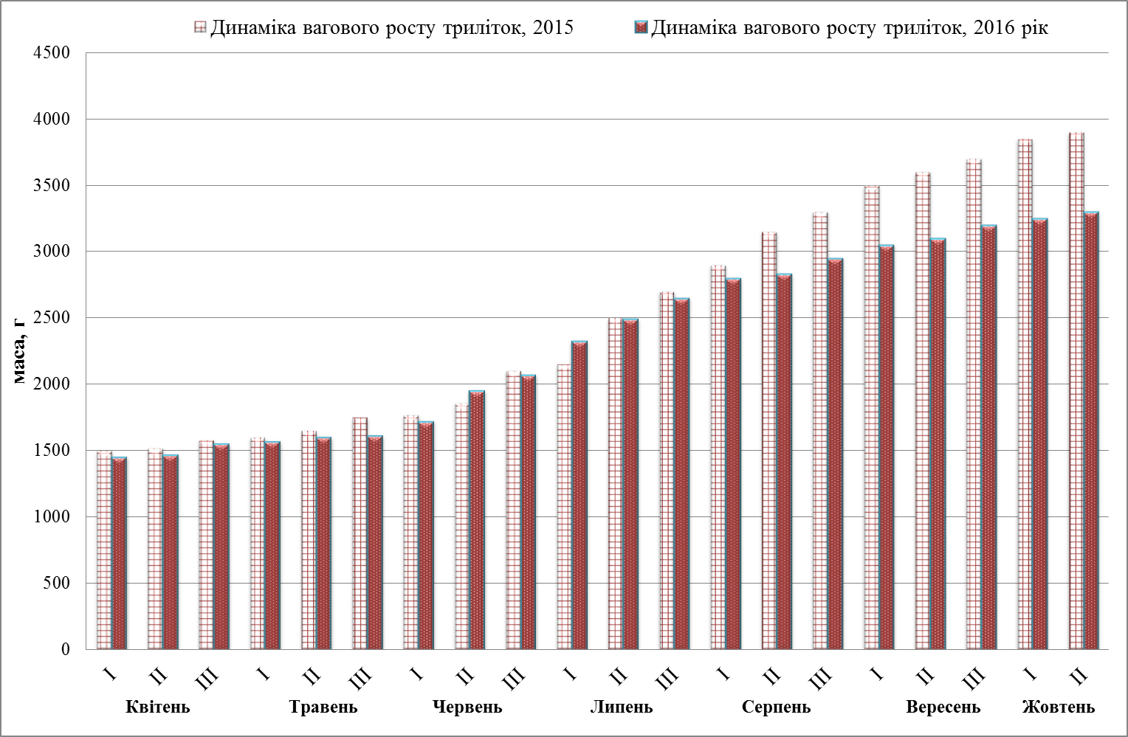
Pic. 1. Dynamics of the weight growth of the three-year-old fish of Galician carp in the farm «Korop»
The smallest indicators of weight growth during 2016 were in May. In this period, the growth of Galician carp did not exceed 20 grams on average. The lowest growth rate in absolute terms in 2015 was 10 grams. This tendency was followed in early May and July.
The largest indicator of relative growth in 2015 was observed at the level of 14 %, which was recorded in the second decade of July. It exceeded 2016 almost twice. The lowest relative growth rate in 2015 was noted at around 2 % in early May and in June.
In 2016, several peaks of relative growth were recorded. The highest values ​​of this indicator varied from 10 to 12 %. This tendency was followed in the second decade of June and in the first decade of July. The lowest value was about 1 %, it recorded in the third decade of May (pic. 2).

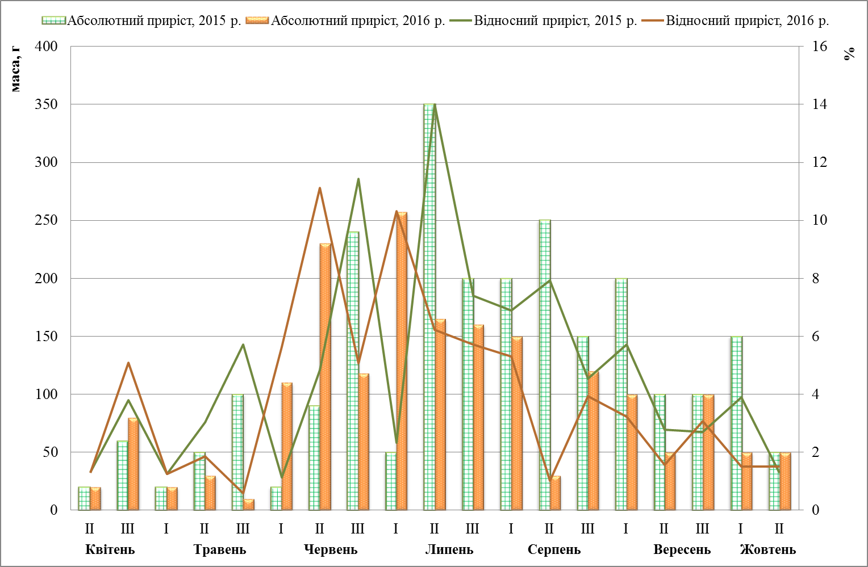
Pic. 2. Growth of the three-year-old fish of Galician carp in 2015–2016 in the farm «Korop»
An analysis of the growth of the weight conditions of the three-year-old fish of Galician carp was carried out using the indicator of specific growth rate. During 2016, several peaks of mass accumulation rate were recorded. The maximum growth this year was in the second decade of June and in the first decade of July. The lowest indicator of mass accumulation in 2016 was registered in the third decade of May and in the second decade of August.
In 2015, the specific growth rate (C) peaked in the second decade of July. However, high rates of mass accumulation are recorded also in the third decade of June and in the second decade of August. The lowest growth rate is observed in early June. Dynamics of specific growth rate is presented in pic. 3.
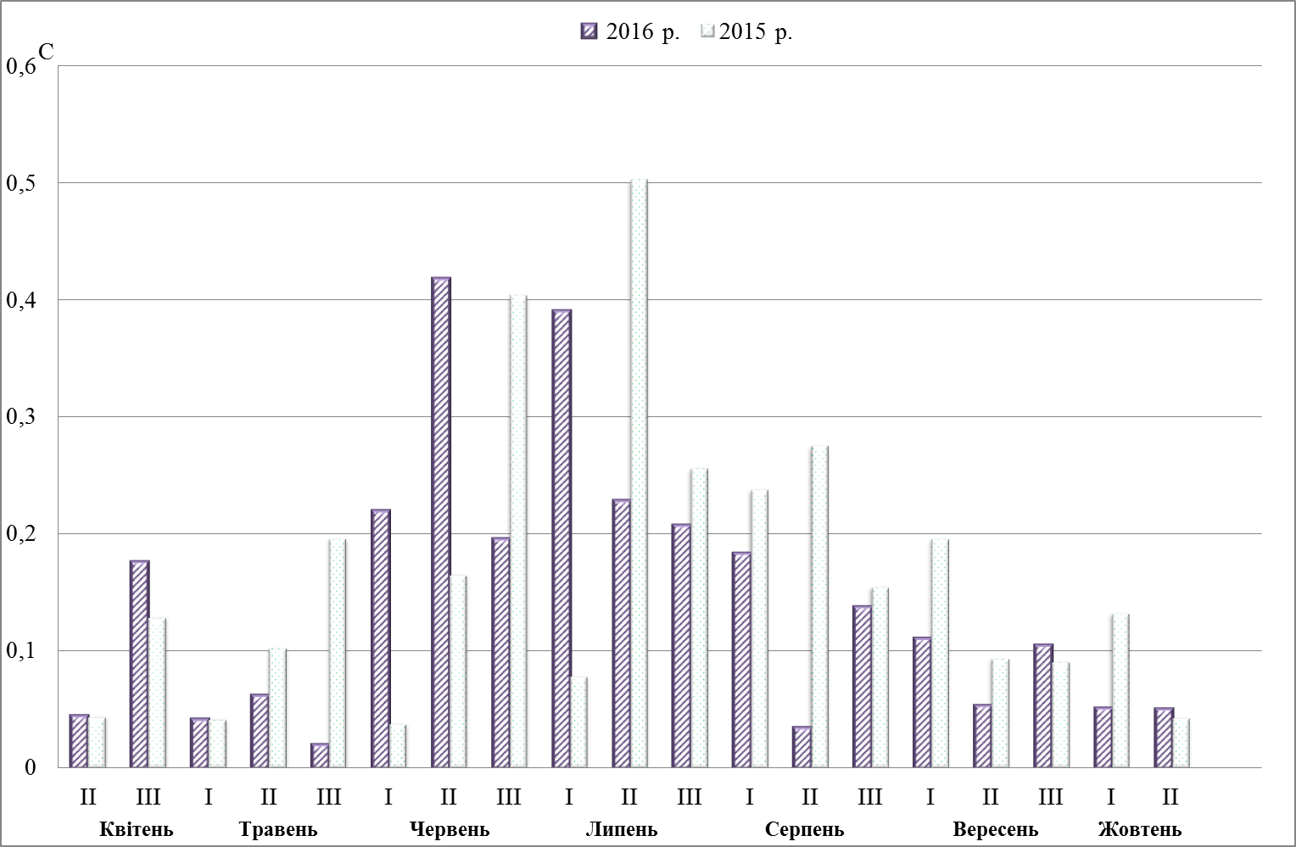
Pic. 3. Dynamics of the specific growth rate of the three-year-old fish of Galician carp in the farm «Korop»
After catches in the experimental pond, the average weight of the three-year-old fish of Galician carp during the experimental period exceeded 3 kg. Exit ranged from 96 % to 98 %. The indicators of the efficiency of cultivating the Galician carp in the farm «Korop» are given in table 1.

1. Efficiency of cultivation of Galician carp in the farm «Korop»
Indexes | Years
Indexes | 2015 | 2016
Square of the experimental artificial pond, ha | 0.4
The density of fish placement, specimens per ha | 1 250 | 1 250
Average weight of fish-material, kg | 1 500 | 1 450
Released three-year-old fish, specimens | 500 | 500
Caught three-year-old fish, specimens | 490 | 480
Fish products, kg/ha | 4 700 | 3 960
Total fish productivity, kg/ha | 2 940 | 2 220
Average weight of three-year-old fish, g | 3 900 | 3 300
Three-year output, % | 98 | 96
Feed costs per unit of mass increment of fish, units | 3.0 | 3.0
After wintering, the fattening factor of fish material was 3.0, at the end of the growing season, it increase on 13 % (table 2).
2. Extreme indices of the three-year-old fish of Galician carp (n = 10)
Date | Mass, g |  |  | Кvg | Indicators of Exteriors
Date | max | min | M±m | Кvg | l/H | l/O | l/C | L min./h min.
31.03.2016 | 1700 | 1100 | 1450±181 | 3.0 | 2.5 | 1.4 | 4.4 | 1.6
CV | - | - | 14.6 | 15.4 | 10.8 | 7.8 | 3.6 | 19.8
σ |  |  | 209 | 0.4 | 0.3 | 0.1 | 0.2 | 0.3
15.07.2016 | 2800 | 1800 | 2325±275 | 3.25 | 2.5 | 1.1 | 3.7 | 1.3
CV | - | - | 13.9 | 7.7 | 10.2 | 0.5 | 5.44 | 8.6
σ |  |  | 325.1 | 0.3 | 0.3 | 4.4 | 0.2 | 0.1
15.10.2016 | 3750 | 2900 | 3287±242 | 3.4 | 2.2 | 1.1 | 3.8 | 1.1
CV | - | - | 8.6 | 10.2 | 6.6 | 0.3 | 2.5 | 4.8
σ | - | - | 285.3 | 0.4 | 0.2 | 3.3 | 0.1 | 0.1
During the growing season, the head index decreased by 16 %, and the tail stem index – by 45 %. The three-year-old fish of Galician carp are characterized by a high-backed body structure, as evidenced by the high-backed index (2.2–2.5).
Conclusion. The three-year-old fish of Galician carp, obtained in the conditions of artificial pond in the Carpathian region, are characterized by high economic indicators both in terms of the individual weight of fish, and in the overall fish productivity. In addition to the high individual weight, they were characterized by relatively little head and high-backed body structure, which indicating the fleshy structure of the body.
Thus, Galician carp is a highly productive and promising object for the restoration of an aboriginal composition of cultivated fish species in the Carpathian region pond fishery.
BIBLIOGRAPHY
- Алекин О. А. Руководство по химическому анализу вод суши / О. А. Алекин, А. Д. Семенов,
Б. А. Скопинцев. – Львів : Гидрометеоиздат, 1973. – 262 с.
- Галасун П. Т. Рыбоводно-биологический контроль в прудовых хозяйствах / П. Т. Галасун. – М. : Пищевая промышленность, 1976. – 127 с.
- Гринжевський М. В., Пекарський А. В. Економічна ефективність вирощування товарної риби за трилітнього циклу / М. В. Гринжевський, А. В. Пекарський. – К. : Світ, 2000. – 164 с.
- Гринжевський М. В., Пекарський А. В. Економічна ефективність вирощування товарної риби за трилітнього циклу / М. В. Гринжевський, А. В. Пекарський. – К. : Світ, 2000. – 164 с.
- Гринжевський М. В. Ефективність інтенсифікації ставового рибництва в сучасних умовах /
М. В. Гринжевський, Й. Є. Янінович, Т. М. Швець // Рибогосподарська наука України. – 2007. – №2. –
С. 34–40.
- Грициняк І. І. Історичні аспекти, стан та перспективи розвитку рибогосподарської діяльності на внутрішніх водоймах України / І. І. Грициняк, О. М. Третяк, О. М. Колос // Вісник Сумського національного аграрного університету. Серія : Тваринництво. – 2014. – №2 (1). – С. 22–30.
- Грициняк І. І. Наукове забезпечення розвитку аквакультури та підвищення ефективності використання водних біоресурсів внутрішніх водойм України / І. І. Грициняк // Рибогосподарська наука України. – 2010. – №1. – С. 4–13.
- Гурбик В. В., Грициняк І. І. Оцінка товарних кондицій різновікових груп галицького коропа /
В. В. Гурбик, І. І. Грициняк // Науковий вісник ЛНУВМБТ імені С. З. Ґжицького. – 2017. – Т. 19, №74. –
С. 29–32.
- Поддубная А. В. Карп как продукт питания. Ориентиры для селекции / А. В. Поддубная // Генетика, селекция, племенное дело и воспроизводство рыб : междунар. конф. : мат. СПб., 2008. – С. 67–68.
- Методические рекомендации по сбору и обработке материалов при гидробиологических исследованиях на пресноводных водоемах. Зообентос и его продукция. – Львів, 1982. – 51 с.
- Олексієнко О. О. Антонінсько-зозуленецький тип – структурна ланка українських порід коропа /
О. О. Олексієнко // Таврійський науковий вісник. – 2004. – Вип. 32. – С. 157–163.
- Сяра Я. И. Методические указания по гидрохимическим исследованиям в прудовых рыбных хозяйствах / Я. И. Сяра. – Львов : Вільна Україна, 1978. – 17 с.
- Шмальгаузен И. И. Определение основных понятий и методика исследования роста /
И. И. Шмальгаузен // Рост животных. – М., 1935. – С. 8–60.

