© 2017
Myhailiutenko S. M., Candidate of Veterinary Sciences
Poltava State Agrarian Academy
THE SPREADING OF EOSTROGILLIDOSIS OF GOBIIDAE FAMILY IN KREMENCHUK RESERVOIR
Reviewer – Candidate of Veterinary Sciences S. O. Klymenko
Based on the results of the studies, a significant spread of eustrongylidosis of Gobiidae family bulls was established in the conditions of the Kremenchuk reservoir. The larvae of the nematode had a filiform shape, a red color (sometimes areas of light pink color turned into a cherry blossom), a length of 35–53 mm, a width of 0.4–0.6 mm. Parasites were located mainly in the body cavity on the surface of the liver and intestine. The larvae were unencapsulated. It was found out that the EI was 37,25 % at an invasiveness rate of 1–4 ex./fish.
Key words: eustrongylidosis, gobies, extensiveness and intensity of invasion.
Statement of the problem. Kremenchuk reservoir is one of six large reservoirs in the cascade on Dnipro river in Poltava, Kirovograd and Cherkasy regions of Ukraine. Its ecosystem is characterized by stable inter-populations. Helminths are one of the important components of aquatic biocenoses. Violation of the stability of the parasite – host relationship indicates serious changes in the biocenotic balance, the consequences of which can lead to irreversible phenomena [6].
The increase of invasiveness proportion of small fish, including short-cycle carps and gobies, in the reservoirs contributes to the increase of the extent of damage and expansion of the species composition of the parasitic fauna of predatory species of fish: pike, perch, pike perch, catfish, etc. [1].
Analysis of basic research and publications on this problem. Representatives of Gobiidae kind are the most mass species of fish in the coastal biocenoses of the North-Western part of the Black Sea and the estuaries of the Black Sea. The analysis of literature over the last century has shown that the gobies have greatly increased their area. They are objects of amateur fishing in most areas of Ukraine [6].
The gobies can be both definitive and intermediate masters of parasites, the adult stages of which infect industrial fish, as well as birds and mammals (including humans). According to scientists, the helminthofauna of the gobies of Odessa Gulf and the estuaries of North-Western Black Sea region is represented by the 24 species of parasites. The trematodes (9 species) are dominated among them. Nematodes (7 species) and cestodes (5 species) fauna is quite a rich. Acanthosephals are represented by only three species. Slightly fewer than half of the registered parasites (43.2 %) are common to gobies and other fish species, which in turn ensures their existence in the region [4, 5].
According to Moldovan and Ukrainian researchers, in the basin of lower Dniester, the following species are recorded in gobies: Eustrongylides tubifex (Nitzsch, 1819) and Eustrongylides excisus (Jägerskiöld, 1909) [6, 7].
Scientists note a sharp increase in the damage of freshwater fish by larvae of the nematodes Eustrongylides excisus. Thus, according to the analysis of the work carried out during 2008–2013, the population of parasite nematodes of the genus Eustrongylides in Zaporizhzhia reservoir has increased its size and indicators of fish invasion almost 10 times. Accordingly, the number of infected fish has increased. In 2008, Yesipova N. B. registered eustrogilidosis only in perch, in 2011 – in gobies. In 2012, there was an extension of the range of hosts of nematode larvae. The presence of Eustrongylides in pike perch (2012) and catfish (2013) has been registered. The extensiveness of invasion of the gobies was 75 % for the intensity of the invasion was 4–8 exemplars/fish, the invasiveness of the perch was 67 % [3].
There is no information on the expansion of the eustrogilidosis of gobies in Kremenchuk reservoir in the available literature.
The aim of the study is to analyze the current state of fish invasiveness by the nematodes Eustrongylides in Kremenchuk reservoir.
Research task is to analyze the infestation of fish by the Eustrongylides larvae.
Materials and methods of research. The research was conducted during 2015–2016 on the basis of the educational and scientific laboratory of the Department of Parasitology and Veterinary and Sanitary Expertise of the Faculty of Veterinary Medicine of Poltava State Agrarian Academy. The gobies Gobiidae kind was the object of the research. They were caught in Kremenchuk Reservoir. The research was carried out by the method of complete parasitological analysis of fish with subsequent identification of parasites [2].
Research results. Eustrongylides nematodes were found during the study of fish (pike, crucian carp, perch and gobies) caught in Kremenchuk reservoir.
The gobies had a larvae of filamentous shape, the front and rear ends were pointed, red (sometimes areas of light pink alternate with cherry-colored areas), 35–53 in length mm, thickness 0,4–0,6 mm. The surface of the body is transversely striated. Usually, the larvae are rolled up by one in a flat spiral, a wide ring or a coma shape (see picture).

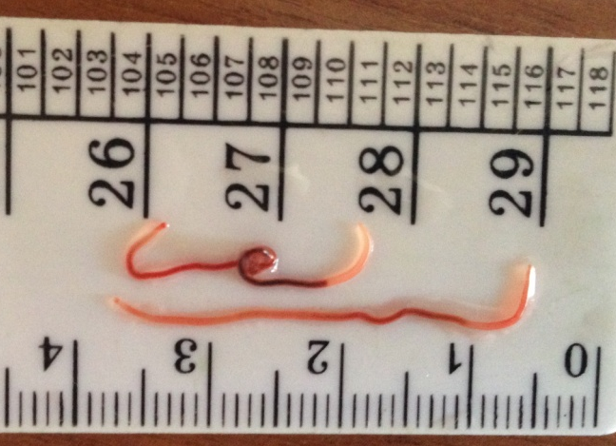
The general form of Eustrongylides larvae
Parasites were localized predominantly in the body cavity on the surface of the liver and intestines. The larvae were not encapsulated. The intensity of the invasion in 2015 was 37.25 % (intensity of invasion = 1–4 exemplars/fish). In 2016, the infectation of gobies increased to 48.3 %.
The invasiveness of pike, crucian carp, and perch varied within the range of 17.2–47.25 % with the intensity of invasion 1–9 exemplars/fish.
Parasite larvae were localized in the body cavity (76.32 %), in internal organs (7.89 %) and muscles (15.79 %). However, the larvae were in a free state, they were not found in the cysts.
Conclusions:
- We defined that the damage of gobies of the Gobiidae in the Kremenchuk reservoir by the Eustrongylides was 48.3 % with the intensity of the invasion of 1–4 exemplars/fish.
- The prospect of further research is the detection of physico-chemical parameters of meat of invasive gobies.
BIBLIOGRAPHY
- Анцышкина Л. М. Фауна паразитов рыб Запорожского водохранилища и ее особенности /
Л. М. Анцышкина // Биологические аспекты охраны и рационального использования окружающей среды. Сб. науч. тр. – Днепропетровск, 1977. – С. 59–69.
- Бауер О. Н. Определитель паразитов пресноводных рыб / О. Н. Бауер. – Л. : Наука, 1987. – Т. 3. – 583 с.
- Есипова Н. Б. Распространение паразитической нематоды Eustrongylides excisus у рыб Запорожского (Днепровского) водохранилища // Сучасні проблеми теоретичної та практичної іхтіології : тез. VI Міжнар. іхтіол. наук.-практ. конф., 9–11 жовтня 2013 р. – Тернопіль, 2013. – С. 86–88.
- Квач Ю. В. Гельмінти бичків (Gobiidae) та інших фонових риб Одеської затоки та лиманів Північно-Західного Причорномор’я (фауна, екологія) : автореф. дис. … к. б. н. : спец. 03.00.08 – зоологія / Ю. В. Квач. – НАН України. Ін-т зоології ім. І. І. Шмальгаузена. – К., 2005. – 22 с.
- Квач Ю. В. Угруповання багатоклітинних паразитів бичкових риб (Actinopterygii: Gobiidae) комплексу водойм нижньодніпровського басейну / Ю. В. Квач // Вісник Львів. ун-ту. Сер. біол. – 2010. – Вип. 54. – С. 208–215.
- Комплексные молдово-украинские исследования ихтиофауны водоемов басейна Нижнего Днестра) / Руководитель исследований (Республика Молдова) И. Д. Тромбицкий, руководитель исследований (Украина) С. Г. Бушуев // Отчет в рамках проекта ОБСЕ / ЕЭК ООН / ЮНЕП «Трансграничное сотрудничество и устойчивое управление в бассейне р. Днестр : Фаза III – реализация Программы действий» («Днестр-III»), 2011.
- Моргун О. А. Зараженность бычковых рыб (Gobiidae) нематодами Eustrongylides excisus (Nematoda, Dioctophymidae) в Бугском и Днепро-Бугском лиманах и низовье Южного Буга / О. А. Моргун // Морський екологічний журнал. – 2012. – №4. – Т. XI.– С. 64−66.

