© 2017
Goncharov S. L., PhD, Senior Lecturer
(scientific consultant – PhD, Professor N. M. Soroka)

Mykolaiiv National Agricultural University
AGE DYNAMICS OF PREDATORY FISH INFECTION WITH NEMATODES EUSTRONGYLIDES EXCISUS IN DNIPRO-BUG ESTUARY AND DELTA OF DNIPRO

Reviewer – Professor, PhD V. F. Galat
The dependence of infection with nematodes Eustrongylides excisus, Jägerskiöld, 1909 on the age of the predatory fish, such as pike-perch – Sander lucioperca (Linnaeus, 1758), European Perch – Perca fluvial (Linnaeus, 1758) and pike – Esox lucius (Linnaeus, 1758) that were caught in the waters of Dnipro-Bug estuary on the delta of Dnipro was studied. It was shown that with increasing age of the fish prevalence of infection and abundance were also rising. The most affected were fish from older age groups – from 7+–8+ to 9+.
Keywords: Eustrongylides excisus, nematodes, prevalence, the index of abundance.
Formulation of the problem. Recently, the tendency to sustained growth in the production of fish farming occurred. Protecting fish from diseases is a topical issue. It is known that fish, like other animals, can be infected with various diseases that occur in both natural and artificial reservoirs. One of the causes of infectious and parasitic diseases, including zoonosis is insufficient monitoring and surveillance. Significant progress has been made in the study of parasitic diseases: the biology of major pathogens has been studied and, in most cases, the development of effective control measures. But today it turned out that many pathogens of diseases that were considered previously safe, and therefore poorly-learned, in the current industrial and pond fish farming, become quite pathogenic and can bring significant economic losses. Hence, it is necessary to study this issue in greater details urgently [2].
An analysis of the latest research and publications that suggested the solution of the problem. Eustrongylides excisus, Jägerskiöld, 1909 – nematodes belonging to the family Dioctophymatidae and represent a potential threat to human health [11]. Type Egersheld was grounded in 1909 as a result of the study of nematodes found in the glandular stomach cormorants [4].
Predatory fish such as perch, pike and pikeperch can serve as part of the spread of the pathogen of piscivorous species of birds [8]. Eustrongylides spp. was recognized zoonotic parasite that is dangerous to humans. Infection occurs when consumption of insufficiently thermally processed fish and fish products [11].
This species is widespread in the world. On registration E. excise reported in Serbia, Rumania, Turkey, Brazil, USA, Italy, Iran, Azerbaijan, Czech Republic, Russia and Ukraine [7, 8, 10, 12, 13, 14].
The purpose of work was analyzing the degree of destruction depends parasitic nematodes E. excisus predatory fish species on their age.
Objective: to establish a possible correlation between Eustrongylides infection and age of predatory fish that were caught in the waters of Dnipro-Bug estuary in the delta of Dnipro.
Materials and methods of research. During 2014–2016 years were studied 346 specimens of three species of predatory fish, namely pike-perch – 155 fishes, perch – 74 fishes, and pike – 117. The selection of fish was carried out four times a year: spring, summer, autumn and winter, during routine monitoring catches, caught her bait and be purchasing fishermen catch in place. Catching of fish samples was conducted along the shoreline of Dnipro-Bug estuary and delta of Dnipro, administrative within the Mykolaiv region (near the village Dniprovske Ochakiv, Cape Adzhigol) and part of the area, which is located in the administrative Kherson region (near the villages Aleksandrovka Stanislav And Sofiyivka, Belozersky district; near Ribalche village and Heroiske, Hola Prystan area).
All species of predatory fish (perch, pike-perch and pike) were subjected to an ichthyopathological study. Clinical investigation was carried out by careful examination of the surface of the scales and skin. Separately examined the oral and gill cavity. They cut the abdominal cavity with a cut that started from the anus and directed to the head. Every organ was sprayed and separated. Separately separated and examined the intestine and its contents. To study muscle tissue, the skin was previously removed. Isolated and examined the brain and spinal cord, and the lens of the eye [1]. In the course of the autopsy, the nematodes were found, red in color, approximately the size of 30–55 mm. The parasites were fixed in 70 % ethyl alcohol. After fixation they were immersed in a solution of lactic acid for clarification. Nematode larvae were placed in a petri dish and examined under a microscope stereoscopic Micromed XS-6320. The morphological characteristics of the parasites were studied by the Key of Bauer (1987) [5].
Results of the research and their discussion. During post-mortem study showed nematodes, which are localized in the intercostal and abdominal muscles. Rarely parasites were detected in the muscle tissue of the back. The larvae were placed tight spiral or a wide ring directly on the inside of the abdominal wall of translucent capsules (Pic. 1).

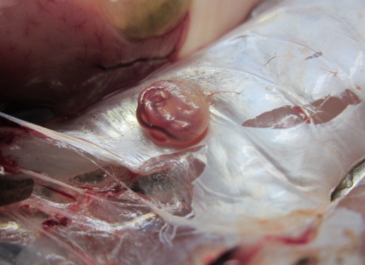
Pic. 1. Nematode E. excisus in a capsule on the inside of the abdominal wall of the perch
Larvae of nematodes were also found in tissues of hepatopancreas and gonads. Freely distributed nematodes that were on the surface of internal organs (Pic. 2).
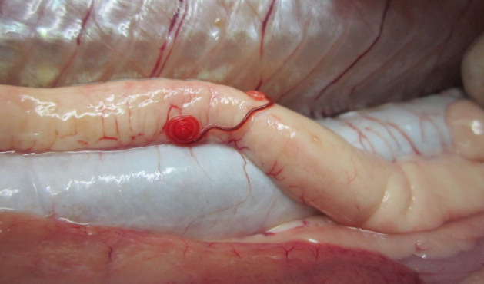
Pic. 2. Larva of E. excisus located on the internal organs of the pike-perch
Also, parasites were registered at the wall of the stomach, where they were placed in a capsule, which was formed from the tissues of the host.
The allocation of larvae of parasites showed signs of livelihoods and were up to 55 mm in length, 0.5 – 1.8 Mm Under the nerve ring, seven cervical glands were detected. The nerve ring was placed at a distance of 0.092 – 0.015 mm from the main end. The length of the esophagus varied from 2.44 to 4.6 mm. The body of worms dark red, covered with cuticle without thorns and buds. Head end was slightly blunt end, it had two circles are papillae with 6 papillae in each circle (Pic. 3).

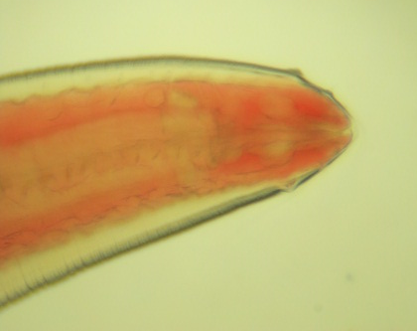
Pic. 3. The proximal end of nematode larva E. excisus of pike. Good pictures of two circles of papillae
In studying the distribution of Eustrongylides infection in perch of different ages revealed that the maximum level infection takes in younger age groups, namely 0+–2+. So the prevalence of in fection 2+ was – 48.8 % of all fish studied in this age group, and the abundance was – 1.71 copies. Age group 3+–4+ marked by lower prevalence 44.4 %, the abundance – 1.77 copies. The slight reduction in infection prevalence was characterized in fish aged 5+–6+ – 33.3 %. The abundance was 1.95 copies. In the perch aged 7+–8+ and 9+ the prevalence of infection reached the maximum level – 65.2 and 58.8 % respectively. And the abundance was 2.33 and 3.52 respectively (table 1).
1. Infection of perch with larvae nematodes Eustrongylides excise depending on the age
Age category | Prevalence, % | Abundance
0+ – 2+ | 48,8 | 1,71
3+ – 4+ | 44,4 | 1,77
5+ – 6+ | 33,3 | 1,95
7+ – 8+ | 65,2 | 2,33
9+ | 58,8 | 3,52
Age categories of pike 0+ – 2+ were characterised by prevalence of infection – 52.9 %, and the abundance – 1.05 copies. Prevalence of infection in pike age 3+ – 4+, compared with the previous age group, increased up to 56.7 %. The abundance also increased – 1.13 copies. Age 5+ – 6+ prevalence of infection slightly to 57.1 %, and the abundance was 1.71 copies. Prevalence of infection in at E.excisus age 7+ – 8+ tended a slight decrease to 54.5 %, but the abundance rather increased to 2.18 copies. The highest prevalence of infection in fish were in pike age 9+ – 85.7 %, the abundance – 3.42 copies (table 2).
2. Infection of pike with larvae nematodes Eustrongylides excisus depending on the age
Age category | Prevalence, % | Abundance
0+ – 2+ | 52,9 | 1,05
3+ – 4+ | 56,7 | 1,13
5+ – 6+ | 57,1 | 1,71
7+ – 8+ | 54,5 | 2,18
9+ | 85,7 | 3,42
Pike-perch at ages 0+–2+ showed prevalence of infection 47.8 %. Abundance was – 0.95 instances. The slight decrease of prevalence of infection was noted at age 3+–4+ – 43.7 % and the abundance increased compared to younger age groups and was 1.31 copies. Prevalence of infection in age groups 5+–6+ reached 66.6 %, while the index was abundance was 2 instances. Slightly lower prevalence of infection pike-perch age 7+–8 + – 60.0 %. Abundance also declined slightly compared with the previous age group, and was – 1.8 copies. Maximum prevalence of infection was in the age group 9+ – nearly 100 %. It should be noted that significantly increased level of abundance was also observed – 4 copies (table 3).
3. Infection of pike-perch with larvae nematodes Eustrongylides excisus depending on the age
Age category | Prevalence, % | Abundance
0+ – 2+ | 47,8 | 0,95
3+ – 4+ | 43,7 | 1,31
5+ – 6+ | 66,6 | 2
7+ – 8+ | 60,0 | 1,8
9+ | 100 | 4
Data on prevalence of infection shows that among predatory fish species most affected age group of perch was 7 +–8 + – 65.2 %. Lowest prevalence in perch was in age group 5+–6+ – 33.3 %. Pike was the most affected in the age 9+ – 85.7 %. In pike-perch of age 9+ prevalence of infection reached 100 %. This age category was characterized by the highest rates of infection (pic. 4).
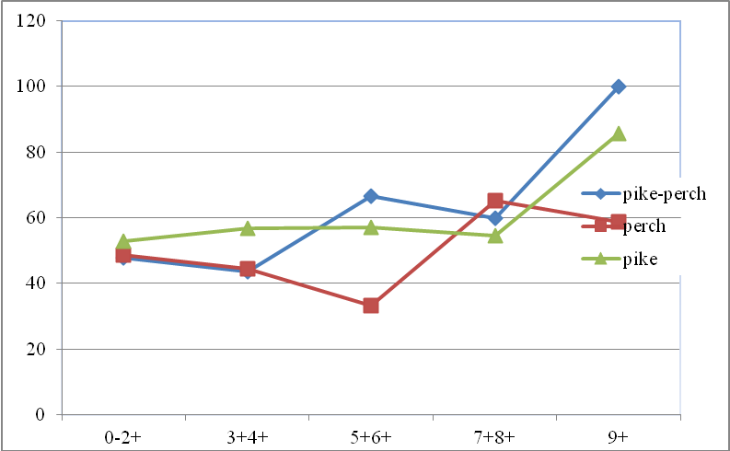
Pic. 4. Prevalence of infection with E. excisus in three fish species in different age groups
The index of abundance in the perch was maximal at the age of 9+ and amounted to 3.52, while the lowest was in the age group 0+–2+ – 1.71. Nematodes E.excisus in the pike, the standard abundance index gained the highest value in the age category 9+ – 3.42 samples. The lowest indicators were pike-age 0+–2+ and were 1.05. Parasites among pike perch, it was found that the maximum indexes of abundance were in the age group – 9+ – 4 samples, and the minimum values were recorded in fish age 0+–2+ – 0.95 specimens (pic. 5).
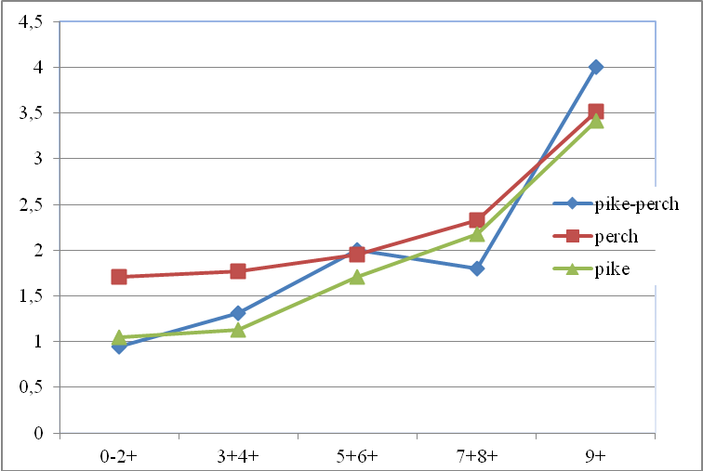
Pic. 5. Level of abundance in three fish species in different age groups
It should be noted that the analysis of infection indicators of predatory fish species found positive trend: with increasing age of fish – increasing the level of prevalence and abundance. Only in the perch of the river age group 9+ was characterized by a slight decrease in prevalence. The food range of the perch can include up to 40 species: branchy and oyster mussels, hamarids, larvae and pupae chironomid, oligochaetes, etc. Increased consumption of feed in the perch is observed at the end of summer, when the number of young bull and carp fish, which is readily accessible food, is increasing. Often victims of big perch is you do own youth [6].
Younger age groups of predatory fish can become infected because their diet consists of invertebrate organisms, including oligochaetes, which are known to be intermediate owners larval stage nematodes E. excisus. Next infected fish older age groups are in the majority, spontaneous and random as older fish is mostly predatory type of existence. It should be assumed that perches in older age groups is phased infection every year because the fish age 7 + - 8+ and 9+ indicators and abundance index were highest. So, Cole (2013) notes that the larval stage of nematodes can stay in the body and oligochaetes freshwater some species more than 1 year [9].
Conclusion. The distribution of parasitic nematodes is established E. excisus of predatory fish species Dnipro-Bug estuary and delta of Dnipro – perch, pike and pike-perch. It has been established that with the increase in the age of fish, the prevalence and abundance of infection also increase with most affected age groups 7+–8+ to 9+.
BIBLIOGRAPHY
- Быховская-Павловская И. Е. Паразиты рыб / И. Е. Быховская-Павловская // Руководство по изучению. – Л. : Наука, 1985. – 121 с.
- Давыдов О. Н. Болезни пресноводных рыб / О. Н. Давыдов, Ю. Д. Темниханов. – К. : Ветинформ, 2003. – 219 с.
- Есипова Н. Б. Патологические изменения в тканях и органах рыб под действием паразитических червей р. Eustrongylides / Н. Б. Есипова, В. С. Сидоренко // Проблемы патологии, иммунологии и охраны здоровья рыб и других гидробионтов : мат. IV конф., Борок, 24–27 сент. 2015 г. – Ярославль : Филигрань, 2015. – С. 297–304.
- Карманова Е. М. Диоктифимидеи животных и человека и вызываемые ими заболевания /
Е. М. Карманова. – М. : Из-во «Наука», 1968. – 261 с.
- Определитель паразитов пресноводных рыб / [под. ред. О. Н. Бауэра]. – М. : Наука, 1987. –
Т. 3. – 583 с.
- Попова О. А. Питание и пищевые взаимоотношения судака, окуня и ерша в водоёмах разных широт /
О. А. Попова // Изменчивость рыб пресноводных экосистем. – М. : Наука. – 1979. – С. 95–112.
- Федоров Н. М. Ветеринарно-санитарная экспертиза речного окуня при эустронгилидозе /
Н. М. Федоров, Н. Ф. Фирсов, Н. А. Соловьев // Ветеринарная патология. – №3–4. – 2014. – С. 68–73.
- Branciari R. Occurrence of parasites of the genus Eustrongylides spp. (Nematoda: Dioctophymatidae) in fish caught in Trasimeno lake, Italy / R. Branciari, D. Ranucci, D. Miraglia, A. Valiani // Italian Jour. of Food Safety. – 2016. – 5:6130. – Р. 206–209.
- Cole R. Eustrongyloidosis. In: Field Manual of Wildlife Diseases / R. Cole // General Field Procedures and Diseases of Birds. Chap. 29. – 2013. – Р. 223–228.
- Lichtenfels J. R. Eustrongylides sp. (Nematoda: Dioctophymatoidea): First Report of an Invertebrate Host (Oligochaeta: Tubificidae) in North America / J. R. Lichtenfels, C. F. Stroup // Proc. Helminthol. Soc. Wash. 52 (2). – 1985. – Р. 320–323.
- Narr L. L. Eustrongylidiasis – a parasitic infection acquired by eating live minnows / L. L. Narr,
J. G. O’Donnell, B. Libster, P. Alessi, D. Abraham // J. Am Ost Assoc. – 1996. – 96:400 – Р. 2.
- Novakov N. Eustrongylidosis of European Catfish (Siluris glanis) / N. Novakov, O. Bjelic-Cabrilo,
M. Circovic, D. Jubojevik // Bulg. J. Agric. Sci., Supplement 1. – 2013. – Р. 72–76.
- Pazooki J. Metazoan Parasites from Freshwater Fishes of Northwest Iran / J. Pazooki,
M. Masoumian, M. Yahyazadeh, J. Abbasi // J. Agric. Sci. Technol. – Vol. 9. – 2007. – Р. 25–33.
- Soylu E. Metazoan Parasites of Perch Perca fluviatilis L. From Lake Sığırcı, Ipsala, Turkey / E. Soylu // Pakistan J. Zool., – Vol. 45(1). – 2013. – Р. 47–52.

