© 2018
Tsekhmeistruk M. G., Candidate of Agricultural Sciences,
Sheliakiv V. O., researcher
Institute of Plant Science named after V. Ya. Yuriev of NAAS
Shevnikov M. Ya., Doctor of Agricultural Sciences,
Lytvynenko O. S., postgraduate student
Poltava State Agrarian Academy
THE INFLUENCE OF SOWING DATES ON THE YIELD CAPACITY OF SOYBEANS SORTS
Reviewer – Doctor of Agricultural Sciences, Professor P. V. Pysarenko
The results of the experiments confirm the possibility of obtaining stable yields by years due to the selection of the sowing date and the background of mineral nutrition. On average, in 2002–2005, the sort Romance marked a clear tendency to increase yields from early to late, regardless of backgrounds (from 1.73 t/ha to 2.08 t/ha on average for 4 years). In the sorts Mriia and Amethyst on the background of non-fertilizers, the same tendency appears, whereas in the background of the application of fertilizers the most optimal terms were earlier (the third decade of April and the first decade of May) than the late ones. The highest level of soybean productivity in 2006–2010 was obtained at the early (22.04) sowing date – 1.82 t/ha, and the worst indicators were obtained in late (21.05) sowing where the yield was 1.67 t/ha. In terms of sorts – the best results, for most of the time, except for late was obtained during the cultivation of the sort Romance, which provided 1.84–1.87 t/hectare of seeds. In late times, the third (06.05), the fourth (14.05) and the fifth (21.05) higher yields were obtained for the cultivation of the sort Annushka – 1.72–1.85 t/ha.
Key words: soybean, crop yield, weather conditions, sowing dates, backgrounds of nutrition.
Formulation of the problem. In connection with the spreading of new varieties of soybeans, there is a question arises of identifying elements of cultivation technology, which must ensure its high productivity. The special importance has the sowing dates of seeding soybeans. The soybean, as a light-loving crop, forms a high yield only for the optimum for a particular variety of feed area and plant density, providing with moisture and nutrients, but the main requirement is the best lighting of the leaf surface. As a light-loving crop, it provides a high yield only for the optimum for a particular variety of feed space and density of plants, as well as with the proper structure of sowing.
With the introduction to the production of adapted early-growing soybeans, there was a problem of ensuring the guaranteed annual formation of a qualitative seed yield until the adverse conditions of growing in autumn period. Further spread of soybeans in conditions of unstable wetting of the Left-Bank part of the Forest-Steppe is restrained by the lack of grounded zoning technology for its cultivation, especially in early sowing, where the heat is a limiting factor. It is necessary to study the processes of forming the yield and quality of soybean seeds for different seeding periods. In this regard, the rational use of heat resources in the early spring is of particular importance due to early seeding. These considerations are the basis for studying the terms of sowing in conditions of unstable wetting of the Left-Bank part of the Forest-Steppe of Ukraine.
The analysis of the latest research and publications that initiated the solution of the problem. Soybean is a widely distributed food and feed product with valuable protein, it includes oil with low cholesterol [1] and high content (56–60.3 %) of valuable linoleic fatty acid [2].
The realization of the biological potential of modern soybean varieties under the specific conditions of cultivation is possible only with full compliance of the technology of cultivation with the requirements of culture to the factors of life. Therefore, to the base of selection of varieties should be laid the ecological principle, which is characterized by the use of the law of the relationship of plant organisms with the environment [3, 4].
It should be noted that due to the rapid growth of soybean cropping area, the level of its yield remains almost unchanged and is on average in Ukraine from 0,10 to 1,40 t/ha. This indicator does not meet current requirements [5, 6].
The growth of abnormal weather phenomenon in recent years puts forward demands that are difficult to combine in one sort. In connection with this, one of the main tasks faced by breeders and technologists today is the breeding and introduction into production of varieties with high adaptive potential and productivity [7].
Most of the developments are aimed to increasing the upper limit of productivity of the variety under favorable conditions of cultivation and underestimates the role of limiting and aggregate interaction of agro-ecological factors to increase the lower limit of productivity with combined adverse environmental factors. To organize the stable production of soybean seeds in zones with limiting environmental factors, is required a system of different varieties, that can ensure the yield of stable crops, which is achieved due to their normal reaction of growing conditions under different weather conditions and on different backgrounds [8, 9].
The increase of soybean production in Ukraine in the near future is possible only if the productivity of this crop is increased on the basis of efficient allocation and rational use of varietal resources and the introduction into the production of competitive, high energy returns, adapted to the environment of technologies [10–12].
In mobilizing the productivity potential of new soybean varieties, it is important to apply specific breeding characteristics to them, taking into account biological needs. It should proceed from the need for resource conservation and the provision of plants by the factors of life [13, 14].
Different soy varieties react differently to the length of the day [15–20]. It has been established that among the early-growing varieties of soybeans there are significant differences in sensitivity to light period [19]. The authors believe that varieties with a slight response to the length of the day are neutral, but for the most of them, the favorable duration of the day is 13–15 hours. A. O. Babich, S. I. Kolesnik and others [20] believe that the zone of unstable wetting of Dnipropetrovsk, Donetsk, Zaporizhzhia, Kirovograd, Lugansk, Mykolaiv, Odessa, and Kharkiv regions for thermal and light resources is suitable for growing early and fast-growing soybeans. When choosing the term of soybean sowing, it should be taken into consideration the temperature level and the moisture content of the seed layer of the soil. The early sowing plants (the third decade of April) had a longer vegetation period than late plant sowing plants. In case of insufficient provision of the soil with moisture and elevated temperature, the growing season was shortened by 7–12 days [22, 23].
The purpose of our research was to study the processes of forming soybean yields at different sowing times under conditions of insufficient moisture of the Left-Bank Forest-Steppe of Ukraine.
The task of the research was to establish the economic and valuable characteristics of soybeans for different periods of sowing.
The methodology of the research. The main field researches were carried out in the period 2004–2013, in the laboratory of plant growing and variety study of the Institute of Plant Cultivation named after V. Ya. Yuriev of NAAS of Ukraine. The soil is deep, weakly agglomerated black earth with a granular structure. It is characterized by the following agrochemical indicators: the content of humus (by Tiurin) – 5,8 %; pH 5.8; hydrolytic acidity – 3.29 mg/eq. per 100 g of soil. Stocks of nutrients on the control without fertilizers: nitrogen – 132 mg/kg, phosphorus – 104 mg/kg, potassium – 128 mg/kg; on the background with the use of mineral fertilizers (N₃₀R₃₀K₃₀): nitrogen – 140 mg/kg, phosphorus – 177 mg/kg, potassium – 172 mg/kg of soil. In the conditions of the research area, the main limiting factors are the amount of precipitation and temperature regime during the growing season of agricultural crops, including oilseeds. During the years of research, the weather conditions during the vegetation period were quite contrasting, which made it possible to fully evaluate varieties and hybrids of oilseeds. On average, during the years of research, the variation in the average daily temperature is plus 1.3 °C. At the same time, there is a significant difference in months and years. Thus, there is a marked warming of the period August–November, at 0,9–3,1 °С, and also more cool, at 0,2 °С, April and June. March is warmer by 0,9 °C, and in May – by 0,5 °C. In addition to average daily temperatures, the amount of effective (over 10 °С) temperatures for certain periods is of great importance for the growth and development of plants. On average, during the research period, the sum of effective temperatures was 1496.8 °C, which is 290.8 °C, or 24.1 % above the average multi-yearly. The growth of this indicator was noted for all months from 5.9 to 101.1 °С. Thus, on average, in terms of experience during the years of research, the amount of precipitation in comparison with the long-term values ​​increased by 34.4 mm. There is a strong variety in their income, depending on the year and months. In addition to the calculations of deviations, linear regressions were calculated at average daily temperatures during the spring and summer vegetation period. Calculations show a constant and steady increase in average daily temperatures for all months. At the same time it is insignificant in April and sharply increases in the summer months, especially in August.
The results of the research. The study of the effect of sowing time on soybean yield was carried out in 2002–2005 on the varieties: Amethyst, Mriia and Romantyka, in 2006–2015 on varieties: Annushka, Romantyka and Skelia, and in 2016–2017 on varieties Biliavka, Sprytna and Malvina. The first period of sowing soybeans is on the third decade of April, the second term is the first decade of May, the third term is the second decade of May. According to the results of many years research, V. Ya. Yuriev, the National Academy of Sciences (NAAN), found that the sowing dates had a different effect on the yield of soybean varieties. Various reactions of soybean varieties have been marked on sowing dates. The results of experiments confirm the possibility of obtaining stable yields by years due to the selection of the sowing date and the background of mineral nutrition. They also indicate that the main factor determining the level of soybean yield is the weather conditions in the critical growth phases for a particular variety (see table).
The yields of soybean sorts depending on sowing dates, t/hа
Sorts | 1st period |  | 2nd period |  | 3rd period
Sorts | non-fertilizer | manure + N₆₀P₆₀K₆₀ | non-fertilizers | manure + N₆₀P₆₀K₆₀ | non-fertilizers | manure + N₆₀P₆₀K₆₀
Average during 2002–2005
Amethyst | 1,90 | 2,26 | 2,02 | 2,22 | 2,06 | 2,13
Mriia | 2,00 | 2,24 | 2,10 | 2,29 | 2,29 | 2,17
Romantyka | 1,73 | 1,95 | 1,88 | 2,09 | 2,06 | 2,08
Average | 1,88 | 2,15 | 2,00 | 2,20 | 2,14 | 2,13
Average during 2006–2010
Annushka | 1,55 | 1,75 | 1,65 | 1,91 | 1,65 | 1,93
Romantyka | 1,75 | 1,85 | 1,77 | 1,85 | 1,70 | 1,73
Skelia | 1,64 | 1,74 | 1,55 | 1,62 | 1,53 | 1,58
Average | 1,65 | 1,78 | 1,66 | 1,79 | 1,63 | 1,74
Thus, on average, in 2002–2005, the Romantyka variety showed a clear tendency to increase yields from early to late, regardless of the backgrounds (from 1.73 t/ha to 2.08 t/ha on average for 4 years). In the varieties Mriia and Amethyst on the background of non-fertilizers, the same tendency appears, whereas in the background of the application of fertilizers the most optimal terms were earlier (the third decade of April and the first decade of May) than the late ones.
In the period from 2006 to 2010, the effects of five sowing periods on the yield of varieties (Anna, Romantyka and Skelia) of various varieties of maturity groups were studied.
According to the results of the research, the highest level of productivity was obtained at the early (22.04) sowing date – 1.82 t/ha, and the worst indicators were obtained at the late (21.05) sowing where the yield was 1.67 t/ha. In terms of varieties – the best results, for most of the time, except for late was obtained during the cultivation of the Romantyka variety, which provided 1.84–1.87 t/hectare of seeds. In later times, the third (06.05), the fourth (14.05) and the fifth (21.05) higher levels of productivity were obtained when cultivating the variety Annushka – 1.72–1.85 t/ha.
There is a certain varietal reaction to the background of mineral nutrition, depending on the time of sowing. So, on the background of no fertilizers (control) in all terms of the sowing, in addition to the last higher yields, the Romantyka grew 1.70–1.77 t/ha, while for soybean cultivation it was 1.55 t/ha in the growing of Annushka.
A similar situation is observed with the application to the main fertilizer of 30 t/ha of manure and N₃₀P₃₀K₃₀ at the background of manure – for the first three terms, higher productivity produced the variety Romantyka from 1.82 to 1.91 t/ha on the first and from 1.94 to 2.01 t/ha on the second background. For the fourth and the fifth sowing times, with higher fertilizer productivity, the sort Annushka was 1.82 and 1.76 t/ha. On the background of manure + N₃₀P₃₀K₃₀ for the fourth time, the highest yield was obtained for the sort Annushka – 1.78 t/ha, and for the fifth – for the sort Skelia – 1.83 t/ha.
When cultivating soybeans on the background of N₆₀P₆₀K₆₀ and the background of plowing, higher yields on all crop rotations were obtained when growing the sort Annushka – from 1.79 to 1.93 t/ha. When using for soybean fertilizers in a dose of N₆₀P₆₀K₆₀ and numeral cultivation of soil, in the first term of sowing, higher yields were obtained when cultivating the varieties of soybeans Annushka and Romantyka – 1.87 and 1.88 tons/ha, for the other four-grade Annushka – the level of productivity from 1.72 to 1.93 t/ha.
Analyzing the results of the studies the effect of seedlings on the yield of soybean varieties by research years (2006–2010), it is necessary to note the following: on the background of no fertilizers in 2006 almost all the time the best results were obtained in the sort Romantyka – from 1.23 to 1, 48 t/ha, in addition, during the fourth and the fifth terms, quite high productivity formed the sorts Annushka and Skelia at 1.34 t/ha.
The sort Annushka provided better results in 2007 and 2010; the sort Romantyka – in 2006, 2008 and 2009, according to the sort Skelia, the results are close to the maximum obtained in 2009.
When applied to a culture of 30 t/hectare of manure, differentiation of varieties is observed by reaction for the term of sowing. Thus, for the first time, the sort «Annushka» provided the best results in 2006 and 2007, the sort Romantyka – from 2008 to 2010 for the second – 2007 and 2010, 2006 and 2008, and in 2009 – the sort Skelia. The situation is similar in the case of soybean cultivation in the background of manure with additional introduction of N₃₀P₃₀K₃₀ – in 2009, for all the time, the highest productivity was obtained from the sort Skelia – from 2.44 to 2.53 t/ha, the sort Annushka was undisputed leader in 2007, in 2006, depending on the time, the higher indicators provided sorts Annushka and Romantyka.
On the background of N₆₀P₆₀K₆₀ and plowing in most years of the research, better results were obtained when growing the sort Annushka, and the sort Romantyka only in 2009. When applied to soya chisel cultivation of the soil, the fairly good results provided the sort Skelia in 2007 for the fourth and the fifth terms of sowing, in 2008 – for 4, in 2009 – for all terms; the sort Romantyka – in 2006 for 3 terms, in 2008 and 2009 – for the first. For all other terms of sowing in all years of the research, higher results were obtained when growing the sort Annushka.
In the period of 2011–2013, the study of the sowing dates of soybeans to their level of productivity was continued. On the average, in terms of mineral nutrition, the highest yield was obtained by cultivating the sort Romantyka, which was 1.97 times; 2,15 and 2,14 t/ha, similar indicators provided (1,91; 2,04 and 2,14 t/ha) of the sort Skelia. A similar pattern is observed on the background of mineral nutrition (Pic. 1).
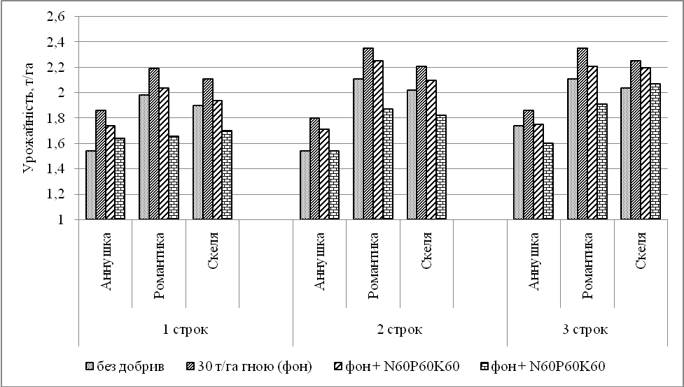
Pic. 1. The yields of soybean sorts depending on the terms of sowing averaged over 2011–2013, t/ha
The results of the experiments confirm the possibility of obtaining stable yields by years due to the selection of the sowing date and the background of mineral nutrition. They also indicate that the main factor determining the level of soybean yield is the weather conditions in the critical growth phases for a particular sort.
Thus, for the ultra early-growing sort Annushka, on the average for three years, was equivalent to early and late sowing periods, an average yield level of 1.70 t/ha and 1.74 t/ha. For the more late-growing sorts Romantyka and Skelia, the second and the third lines were the best ones.
In the application of mineral nutrient backgrounds (30 t/ha of manure and mineral fertilizers on its background), the yield level of sort Annushka for the first and the third sowing periods was the same. That is, when applying fertilizers, both organic and mineral, the effect of sowing time on the productivity of this sort is offset.
For the sorts Romantyka and Skelia, later planting dates were more effective. Thus, the average yield of the sort Romantyka for the second and the third terms was respectively 2.15 t/ha and 2.14 t/ha, compared with 1.97 t/ha in the early period. For the sort Skelia the values ​​of this indicator were respectively 2.04 t/ha and 2.14 t/ha against 1.91 t/ha respectively.
The results of the experiments of 2014–2015 confirm the data of previous years about the possibility of obtaining stable yields by years due to the selection of the term of sowing. They also indicate that the main factor determining the level of soybean yield is the weather conditions in the critical growth phases for a particular variety.
The application of the early dates of sowing in the conditions of 2014–2015 was the most effective. Thus, for the ultra early-growing sort Annushka had the best seeding time, average yields by the time of 2.14 t/ha, late sowing resulted in a decline in the yield of the sort, which was 1.89 t/ha and 1.56 t/ha respectively the date of sowing (Pic. 2).
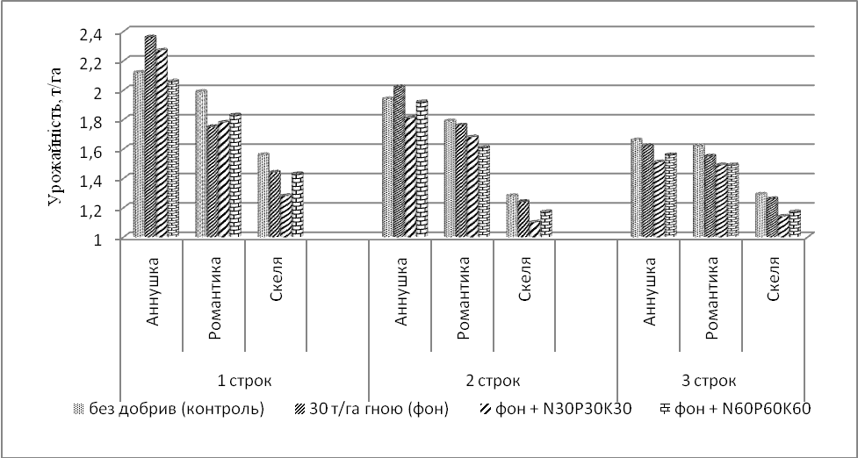
Pic. 2. The yields of soybean sorts depending on sowing dates on average for 2014–2015, t/ha
The lowest yield of this sort, both in backgrounds of mineral nutrition and on average received for sowing in the beginning of the third decade of May. For the sort Romantyka, a higher yield was obtained at an early stage of sowing with an average yield of 1.80 t/ha for other terms, it was 1.69 t/ha and 1.51 t/ha with fluctuations depending on the background of mineral nutrition from 1.41 t/ha to 1.99 t/ha. The transfer of the sowing significantly reduced the yield of the sort in all phases of nutrition.
A similar situation was observed in terms of the effect of the sowing period on yields depending on the sowing date, was 1.43 in the sort Skelia; 1.20 and 1.21 t/ha. To obtain a high level of yield, it is necessary to produce soybean seed at the end of April, which will allow to get high yields, depending on the sort, at 1.73–2.22 t/ha.
During the period 2016–2017 a sort feature was also noted in the formation of soybean yields, depending on the time of sowing and the background of mineral nutrition. Thus, in the sort Biliavka, in the control variant, higher yields were obtained at a late stage of sowing – 1.72 t/ha, the use of earlier sowing led to a decrease in this indicator, corresponding to 1.53 t/ha for the optimal and 1.24 t/ha in the early term (Pic. 3).
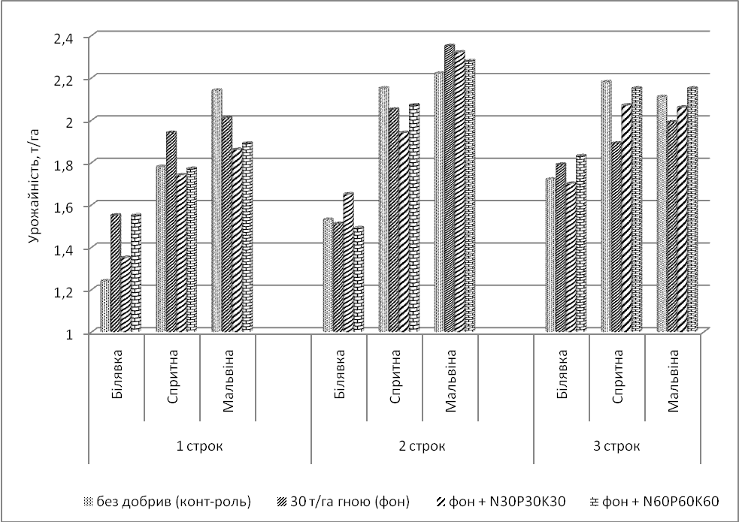
Pic. 3. The yields of soybean sorts depending on the terms of sowing in the average for 2016–2017, t/ha
A similar pattern is also for the sort Sprytna. In the cultivation of the sort Malvina, as a more recent, the highest productivity was formed for the optimal sowing time (2.22 t/ha), and the decrease for the others was 2.14 t/ha in the early period and 2.018 t/ha in the late period. The difference in the level of soybean sorts depending on the background of mineral nutrition was also noted. Thus, in the early period of sowing, the highest yield of the sort Biliavka was obtained on the background of 30 t/ha of manure and 30 t/ha of manure + N₆₀P₆₀K₆₀ – by 1.55 t/ha, for the optimal background + N₃₀P₃₀K₃₀ – 1.65 t/ha, and in the short term – against the background of 30 t/ha of manure + N₆₀P₆₀K₆₀ – 1.83 t/ha. In the cultivation of the sort Sprytna 30 t/ha of manure (2.14 t/ha), control (2.15 t/ha) and 2.18 t/ha, and the sort Malvina – control version (2.14 t/ha), 30 t/ha of manure (2.35 t/ha) and 30 t/ha of manure + N₆₀P₆₀K₆₀ (2.15 t/ha) according to the time of sowing.
Conclusion. On average, over the years of research, the variation in the average daily temperature is plus 1.3 °C. At the same time, there is a significant difference in months and years. March is warmer on 0,9 °C, and in May – on 0,5 °C. The sum of effective temperatures during the research period was 1496.8 °С, which is 290.8 °С, or 24.1 % above the average perennial index, and the amount of precipitation, in comparison with the long-term values ​​increased in 34.4 mm. The calculations of linear regressions indicate a constant and stable increase in average daily temperatures for all months. At the same time it is insignificant in April and sharply increases in the summer months, especially in August. Various reactions of soybean varieties have been marked on sowing dates. The results of experiments confirm the possibility of obtaining stable yields by years due to the selection of the sowing date and the background of mineral nutrition on the average in 2002–2005. The sort Romantyka has a clear tendency to increase the yield from the early to the late, regardless of the background of the feed (from 1.73 t/ha to 2.08 t/ha on average for 4 years). In the sorts Mriia and Amethyst on the background of non-fertilizers, the same tendency appears, whereas in the background of the application of fertilizers the most optimal terms were earlier (the third decade of April and the first decade of May) than the late ones. The highest level of soybean productivity in 2006–2010 was obtained at the early (22.04) sowing date – 1.82 t/ha, and the worst indicators were obtained in late (21.05) sowing where the yield was 1.67 t/ha. In terms of varieties – the best results, for most of the time, except for late was obtained during the cultivation of Romantyka variety, which provided 1.84–1.87 t/hectare of seeds. In later times, the third (06.05), the fourth (14.05) and the fifth (21.05) higher levels of productivity were obtained when cultivating the sort Annushka – 1.72–1.85 t/ha.
For the ultra-early-growing sort Annushka, on average, in 2011–2013, was equivalent to early and late sowing times, an average yield of 1.70 tons per hectare and 1.74 tons per hectare. For the more recent sorts Romantyka and Rock, the second and the third lines were the best ones.
The application for early sowing dates in the conditions of 2014–2015 was the most effective. Annushka's average yield level of 2.14 tons per hectare, late sowing resulted in a reduction in yields of 1.89 t/ha and 1.56 t/ha in line with the corresponding period of sowing. For Romantyka variety 1.80 t/ha, 1.69 t/ha and 1.51 t/ha, Rock type 1.43, 1.20 and 1.21 t/ha.
In 2016–2017 the highest yield of sort Biliavka, based on the control variant, was obtained at a short time of sowing – 1.72 t/ha, the use of earlier sowing led to a decrease of this indicator, corresponding to 1.53 t/ha for the optimal and 1,24 t/ha at an early date. A similar pattern is for the sort Sprytna. When cultivating the sort Malvina, as a more recent, the highest productivity was formed at the optimal time of sowing (2.22 t/ha), and the decrease in the others – 2.14 t/ha in the early and 2.018 t/ha in the late sowing period.
BIBLIOGRAPHY
1. Бабич А. О. Проблема білка і вирощування зернобобових на корм / А. О. Бабич. – 3-е вид. перероб. – К. : Урожай, 1993. – 192 с.
2. Макрушина Є. Утилізація ліпідів при проростанні насіння кукурудзи та сої залежно від його морфологічної будови / Є. Макрушина // Вісн. Львів. ДАУ. – Агрономія. – Львів, 2001. – №5. – 617 с.
3. Січкар В. І. Фізіологічна реакція сортів сої на посуху і підвищену температуру / В. І. Січкар, А. К. Ляшок, В. М. Мусич // Физиология и биохимия культурных растений. – 2001. – №6. – С. 497–503.
4. Терентьев Ю. В. Технологические основы комплексной механизации производства сои /
Ю. В. Терентьев. – Благовещенск : ВНИИ сои, 1988. – 97 с.
5. Бабич А. О. Соя для здоров'я і життя на планеті Земля = Soya for Healthand Life on Earth /
A. O. Babich. – К. : Аграрна наука, 1998. – 271 с.
6. Петриченко В. Ф. Особливості формування продуктивності сої залежно від гідротермічних ресурсів та впливу агротехнічних заходів / В. Ф. Петриченко, Л. М. Середа // Зб. Наук. праць Вінницького державного сільськогосподарського інституту. – Вінниця. – 2000. – Випуск 8, Т. 1.
7. Соя / [Прус А. В., Сичкарь В. И., Колот В. Н. и др.]. – К. : Урожай, 1982. – 78 с.
8. Селекция, семеноводство и технология возделывания сои : Сб. науч. тр. / Груз. НИИ земледелия им.
Ю. Н. Ломоури; [Редкол. : М. Б. Гвинджилия (гл. ред.) и др.]. – Тбилиси : НИИ земледелия, 1983. – 216 с.
9. Соя: аспекты устойчивости, методы оценки и отбора / [Шерепитко В. В., Жакотэ А. Г., Павлова Л. С. и др.] ; Отв. ред. Н. Н. Балашова ; АН ССР Молдова, Ин-т экол. генетики. – Кишинев : Штиинца, 1990. – 176 с.
10. Петриченко В. Ф. Наукові основи сталого соєсіяння в Україні / В. Ф. Петриченко // Корми і кормовиробництво. – 2011. – Вип. 69. – С. 3–10.
11. Бабич А. О. Селекція і розміщення виробництва сої в Україні : монографія / А. О. Бабич, А. А. Бабич-Побережна. – К. : ФОП Данилюк В. Г., 2008. – 216 с.
12. Камінський В. Ф. Значення зернових бобових культур та напрямки інтенсифікації їх виробництва / В. Ф. Камінський, П. С. Вишнівський, С. П. Дворецька, А. В. Голодна // Селекція і насінництво. – Х., 2005. – Вип. 90. – С. 14–22.
13. Баранов В. Ф. Реакция различных сортов сои на загущение // Научно-техн. бюллетень ВНИИМК. – Краснодар, 1989. – Вып. 4. – С. 8–12.
14. Поздняков В. Г., Посыпанов Г. С. Современное состояние, проблемы возделывания и использования сои // Соя: Научно-производственный справочник. – М. : ЦНСХБ, 1998. – С. 6–24.
15. Сичкарь В. И. Реакция различных сортов сои на длину дня / В. И. Сичкарь, А. И. Верещака,
В. В. Хангильдин // Научно-технический бюллетень Всесоюзного селекционно-генетического института. – Одесса, 1981. – №2 (40). – С. 41–43.
16. Блащук М. І. Технологічні аспекти підвищення продуктивності соєвого поля / М. І. Блащук, А. О. Бабич // Корми і кормовиробництво. – 2003. – Вип. 51. – С. 100–102.
17. Byth D. E. Comparative photoperiodic responses for several sojabean varieties of tropicaland temperate origin / D. E. Byth // Aust. J. Agr. Res. – 1968. – №19. – Р. 145–150.
18. Crisvell J. G. Variation insensitivity to photoperiod among early maturing soybeans trains /
J. G. Crisvell, D. J. Hume // CropSci. – 1972. – V. 12. – №5. – Р. 140–147.
19. Johnson H. W. Effects of photoperiod and time of planting on rates of development of the soybean in various stages of the lifecycle / H. W. Johnson, H.A. Borthwick, K. C. Leffel // Bot. Gaz. – 1960. – V. 122. – №2. –
Р. 270–278.
20. Polson D. E. Day-neytrality in soybeans / D. E. Polson // CropSci. – 1972. – V. 12. – №6. – Р. 223–229.
21. Бабич А. Розміщення посівів і технологія вирощування сої в Україні / А. Бабич, С. Колісник,
А. Побережна, А. Нємцов // Пропозиція. – 2002. – №5. – С. 38–40.
22. Шевніков М. Я. Застосування біологічних, хімічних та фізичних засобів у технологіях вирощування сої і кукурудзи / М. Я. Шевніков, О. О. Коблай. – Полтава, 2015. – 258 с.
23. Шевніков М. Я. Особливості розвитку сої залежно від строків сівби в умовах лівобережного Лісостепу України / М. Я. Шевніков, О. П. Галич, І. І. Лотиш // Вісник Полтавської державної аграрної академії. – 2015. – №4. – С. 15–17.

