© 2018
Kurylo V. L., Ph.D. in Agricultural Sciences, Professor
National Academy of Agrarian Sciences of Ukraine
Rakhmetov D. B., Doctor of Agricultural Sciences, Professor
National Botanic Garden named after M. M. Gryshko of the National Academy of Sciences of Ukraine
Kulyk M. I., Ph.D. in Agricultural Sciences
Poltava State Agrarian Academy
BIOLOGICAL FEATURES AND POTENTIAL OF YIELD OF ENERGY CROPS OF THE
THIN-SKINNED FAMILY IN THE CONDITIONS OF UKRAINE
Reviewer – Doctor of Agricultural Sciences, Professor M. Ya. Shevnikov
The necessity of comprehensive study and cultivation of energy crops on marginal lands in conditions of Ukraine for biofuel is substantiated. The biologo-morphological characteristic and illustrative material of energy cultures from the family of Poaceae are given. Understanding of morphological and biological features and the relation of energy crops to the environment will allow them to be rationally placed in certain climatic zones of Ukraine, to select the optimal elements of cultivation technology. It will ensure conditions close to those favorable for the growth and development of plants, and will allow you to receive a large, energy-intensive phytomass. It is determined that the largest yield of dry mass forms arundo cane and giant miskanthus, and the smaller – sorghum perennial and millet-like in the long-term cultivation cycle in soil-climatic conditions corresponding to their biological characteristics. It is expedient to harvest the phyto-raw materials of energy crops for the production of biofuels and the generation of energy.
Key words: energy cultures, botanical characteristic, biological characteristics, yield, energy productivity.
Formulation of the problem. Today, the main priorities of the new industry – bioenergy are the search for ways to reduce the cost of various types of biosources, the development of new technical and economic decisions, as well as the formation of the necessary infrastructure for more efficient use of plant energy resources and the processing of their phytomass for the production of liquid (bioethanol, bioobutanol), gaseous and solid biofuels (granules, briquettes, etc.).
In order to implement the bioenergy development program in Ukraine, all the necessary prerequisites are available, first of all – the soil-climatic conditions that contribute to the high yield of energy-intensive phytomass of energy crops. Secondly, the use of adaptive cultivating technologies on marginal lands of bioenergy crops, improvement of existing, appropriate processing of phytosterol and biofuel use in fuel and energy complex will provide an increase in the share of bioenergy in the overall energy structure of Ukraine and significantly reduce the energy dependence of our country. And as a result, reducing the use of non-renewable energy sources, against the backdrop of growing demand for alternative energy sources, which in the long run will contribute to the development of the national economy and the growth of the welfare of the population.
The Energy Strategy of Ukraine until 2030 [4] predicts a dynamic increase in the use of biomass energy in 2015 to 5 million tons of conventional fuel (tons of conditional fuel), which is 2.5 % of the total energy consumption, and in 2030 – up to 20 million tons of conditional fuel or up to 10 %.
In addition, the Law of Ukraine «On Alternative Energy Sources», as amended [8], defines the main principles of state policy in the field of alternative energy sources, among which are: increasing production volumes and consumption of energy produced from alternative sources for the purpose of economical spending of traditional fuels-energy resources and reducing Ukraine's dependence on their imports by restructuring production and rational energy consumption by increasing the share of energy from renewable sources.
In addition, in the biomass electricity sector, the situation changes with the introduction of a new order of calculation according to the «green» tariff for electricity produced from renewable energy sources. This calculation procedure is highlighted in the Law of Ukraine «On Amendments to the Law of Ukraine» on Electricity «regarding the promotion of the use of alternative energy sources» [7], and the Regulation «On Approval of the Procedure for Establishing, Revision and Termination of the Green Tariff for Subjects» economic activity» [20].
All this, in our opinion, determines the relevance of the chosen research direction.
Analysis of basic research and publications, which initiated a solution to the problem. A large number of scientific works have been devoted to the study of energy crops in our country: M. V. Roik,
V. L. Kurylo, M. Ya. Humentik [24], O. M. Ganzhenko [13], D. B. Rakhmetov [22], D. B. Rakhmetov and A. M. Vergun [23], G. G. Geletukha, T. A. Zhelezna, O. V. Tryboi [2], G. S. Goncharuk, S. M. Mandrovs’ka [25], M. I. Kulyk [30] and others.
Among the energy crops in Ukraine, the most widespread are: strawberry (switchgear), willow, miskanthus, poplar (their lifetime is 10–15, sometimes up to 30 years old), agro-measures for their cultivation do not require significant expenses, harvest in winter or spring, using conventional agricultural machinery [5, 14, 17, 21]. Along with these cultures, the scientific interest is as follows: Arundo reed [28–29], Sorghum sugar and perennial. But a detailed study of the morphological and biological characteristics of these crops, the potential of their yield and energy efficiency was not given due attention.
G. M. Kaletnik in his monograph [9] systematized the scientific and methodological and organizational and economic bases for the development of the biofuels market, the creation and development of a market for energy crops used as raw materials for the production of biofuels, technical and technological characteristics of the production of biofuels from raw materials of vegetable origin, and also provided an economic assessment of their use by the agro-industrial complex of Ukraine. The author's generalization of world trends in the development of the biofuels market from raw materials of plant origin, made possible by the author, allowed to develop an economic substantiation of the prospects for further development of the Ukrainian biofuel market.
The study of energy crops, with the exception of certain publications, mainly concerns the crop and energy potential, the possibility of obtaining biofuels from their biomass, without considering the botanical and biological characteristics of these crops, and the possibility of their zoning in the soil-climatic zones of Ukraine for the fuller realization of the potential of crops from purpose of obtaining the maximum yield of biofuels from biomass plants.
To solve this problem, based on the available information and the results of our own work, we give a generalized morphological and biological characteristics of plants, illustrative materials of energy cultures from the family of Poaceae. The estimation of potential of their productivity, energy and biofuel productivity and possibility of cultivation in different soil-climatic zones of Ukraine is conducted.
The purpose of the research is to characterize the species and varietal diversity, morphological features and the relation of energy cultures of the Poaceae family to the environment in order to realize the potential of plants in terms of their yield and energy productivity.
In accordance with the objective of the research, the solution to the successor tasks was envisaged:
1. To summarize the available information on the morphological characteristics of energy crops, their relation to the environment;
2. To determine the potential of crop yield of biomass of energy crops and energy productivity per unit area;
3. To consider the possibilities of distribution of energy crops under the soil-climatic conditions corresponding to their biological characteristics.
Materials and methods of research. In conducting research on this topic, commonly used methods of conducting research [3, 6], determinants, library catalogs, albums [10, 12, 19], atlases [1], reference books [11] and special methodological recommendations [15, 26]. The energy value of raw materials was determined on an ISO 200 calorimeter. The energy productivity of plants was determined on the basis of heat capacity and yield of phyto-raw materials, taking into account the methods [16, 18].
Research results. The energy cultures of the Poaceae family differ in their duration of the growing season, the intensity of growth and development, the shape, color of the edible organs and their structure, the relation to the environment, the technology of cultivation and the peculiarities of harvesting biomass. Illustrative materials (Pic. 1–5) and morphological and biological features of energetic plants are given.
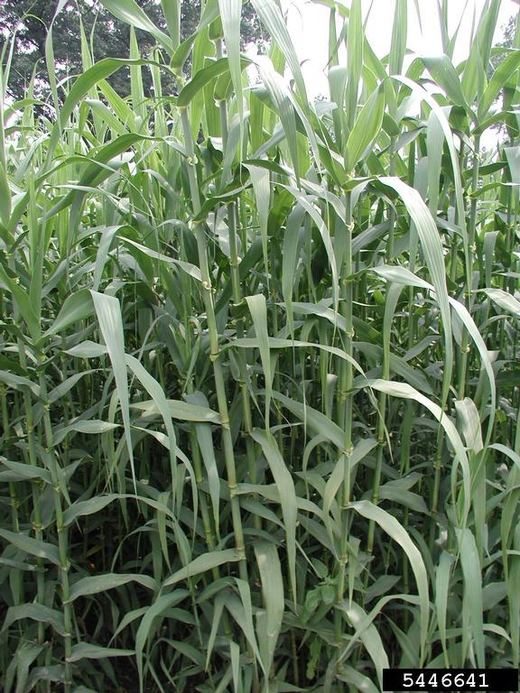  Pic. 1. Arundo reed (Arundo donax L.) | Arundo reed (Arundo donax L.), or a giant cane is a perennial plant from the family of Poaceae, with high (up to 8 m) straight stems, very stiff and woody, and inside hollow and tubular, up to 5 cm in diameter. The plant forms short, woody rhizomes.  Leaves are narrow, long, linear-lanceolate, not pubescent. The flowers are small, collected in a thick, fluffy vein, which consists of a multitude of small ears of 2–7 flowers, in which a non-viable seed is formed.  The temperature of the new spring shoots is  7 °C, optimal for plant growth is 30 °C.  The yield of phytomass is from 25 to 50 t/ha.  Energy efficiency of plants is up to 100  Gcal/hectare.
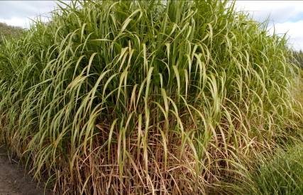
Pic. 2. Giant Miskanthus (Miscanthus giganteus)
Giant Miskantus (M.×giganteus) is a tetraploid hybrid of the Chinese miskanthus (M. sinensis Anderss.) and a mucantic mushroom (M. sacchariflorus (Maxim.) Benth. A perennial herb with a C₄-scheme of photosynthesis.
Plants reach a height of 220–310 (may reach 450–500) cm. The number of shoots in the bush is 10–15 (up to 70). The stem is straight, rounded. The diameter of the stem is 12–25 mm. The number of leaves on the stalk is 11–15 pieces, the width is 2.2–2.9 cm, and the length is 93–102 cm. The valve has a spindle-shaped, cone-shaped or elliptical shape and reaches a length of 30–33 cm. Plants have a rifle-type planting the number of rhizomes (rhizomes) in one plant is from 18 to 37 pcs., the length of which is 10–15 cm.
Spring branching begins in the second half of April, tillering – end of June, the exit from the tube – the end of August. The vegetation is completed in the phase of the appearance of volatility (most often in the phase of entering the tube) in the first half of October. The life cycle of plants lasts 15–20 years.
The yield of green phytomass is from 60 to 150 t/ha, dry weight is 10–15 (to 32) t/ha. The energy productivity of plants is 67–84 (up to 130) Gcal/ha.
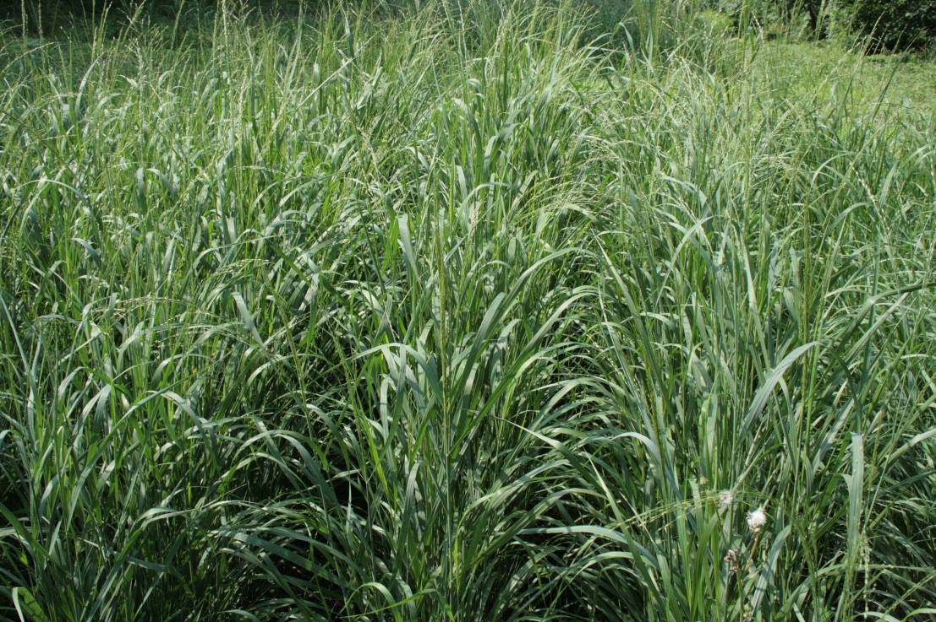
Pic. 3. Millet straw (Panicum virgatum L.)
Milling rod-shaped (Panicum virgatum L.) is a perennial herb (up to 10–15 years in one place).
Plants reach a height of 100–150 to 210–250 cm. The number of productive shoots per plant is from 12–14 to 30–35 pieces. Plants, depending on the shape, are straight and semi-delusional. The number of metamers per stem is from 3 to 7, and in individual forms – up to 9. The diameter of the stem base is 4–6 mm on average, but forms with thin and thick stems are found. The sheet plate reaches a length of 50–60 cm, in some forms can be much longer; width – on average 11–14 mm. In the form of drool is a loose, cheeky, oval, pyramidal, compressed. The length of the vent is 30–40 cm, the width – 20–30 cm. By weight of 1000 pcs. grains are divided into three groups: with a low weight – up to 1.5 g, with an average weight of 1.5–1.8 and a large weight – more than 1.8 g. Perennial rhizomes can be divided into 8–25 (vegetative reproduction) (up to 80) parts depending on the year of life and form of plants. Each landing unit has a length of 5–7 cm.
Unlike most perennials, perennial millet is a complete cycle of development (from seed to seed) during the first growing season. Completes intensive vegetation in the III decade of August – late October, depending on the genotype. After hibernation, early spring (second decade of April) begins intensive plant regeneration. The phase of entering the handset comes from the second decade of July. Flowering is from the third decade of July to the first decade of August. Achievement occurs from the end of September to the mid of October. Vegetation period is about 175–185 days.
Yield: overground phytomass of plants during the period of occurrence of draft is 42–64 t/ha, during the flowering period is 42.7–70.2 t/ha; dry weight is 10–15 t/ha; seeds is 500–600 (sometimes up to 1000) kg/ha. Energy productivity of plants is 40–60 (up to 80) Gcal/ha.
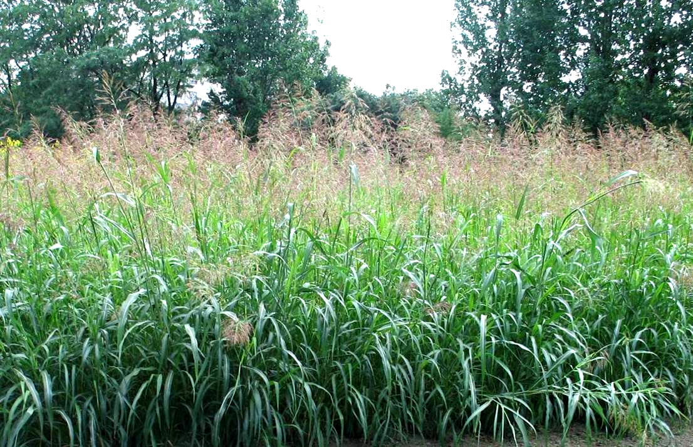
Pic. 4. Perennial sorghum (Sorghum almum Parodi.)
Sorghum perennial (Sorghum almum Parodi.) belongs to the family of Poaceae. The plant has a height of 230–300 cm. The main stem and all the side shoots on top end with volleyball. Leaves – long-lance, 60–80 cm long, 3–5 cm wide. The number of them per plant varies from 18 to 26 pcs. The leaves of the base cover the stem in half. Inflorescence is draws length 40–45 cm. Seeds are elongated, brownish-black. Weight 1000 pieces is 8.5–9.0 grams. The root system is well developed and penetrates into the soil to a depth of 2.0–2.5 m. During drought, it can develop secondary roots. The optimal seeding time is the 1st and 2nd decade of May, when the soil warms up to a depth of 10 cm to 12–14 °C. Field similarity of seeds is 75–80 %. Optimal temperature for development is plus 18–25 ⁰C.
The yield of the green mass at the beginning of the formation of the vole provides 30–35 t/ha, in the flowering period is 45–50 t/ha, and during the period of fruiting is 65–75 t/ha, the seed is 1.5–1.7 t/ha. The yield of dry phytosterol is 11–14 t/ha. The energy value is 3750–3810 kcal/kg.
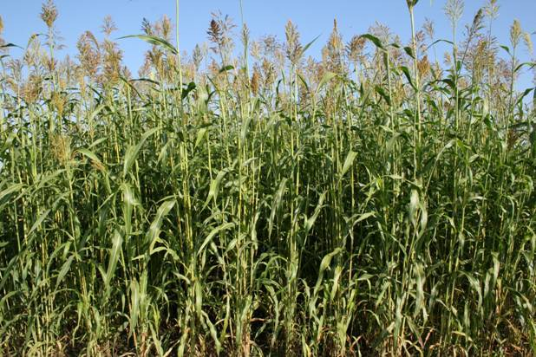
Pic. 5. Sorghum sugar (Sorghum saccharatum (L.) Moench.)
Sorghum sugar (Sorghum saccharatum (L.) Moench.) is an annual herb (grass form). Plants reach a height of 300 cm. The stalk is straight, the diameter at the base is 13–36 mm. The number of internodes on the stalk, depending on the height, varies from 5–9 to 25. The leaves are long-lanceate, large, 50–100 cm wide and 1–6 cm wide, in some forms – up to 10 cm or more. Inflorescence is panicle, length 15–60 cm in different forms (loose, compressed, coma, etc.). Sorghum grain is bare or filamentous, spherical, long-oval, ovoid, white, yellow, brown, black color. The weight of 1000 grains is 27–33 (up to 40). The root system is fibrous, strongly developed, deepens into the soil to 150–200 cm.
As a yearly sorghum, all stages of organogenesis take place in one year. Passes the following phases of development: stairs, planting, exit into the tube, throwing the vole, blooming, milk-wax ripe and reaching. Flowering takes place in July–August, reaching is from the second half of August to the end of September. Vegetation period is 145–155 days.
Yield: phytosteroids is 60–120 t/ha, seeds – 900–1800 kg/ha. Energy efficiency of plants is 35–70 (up to 100) Gcal/ha.
Based on many years of research it has been determined that the potential of crop yields along with their specific features, the response to soil-climatic conditions depends on the agrochemical properties of the soil, how it is cultivated, the application of fertilizers, biopreparations, the timing and methods of sowing/planting, care of plants, the specifics of harvesting, and other factors.
Characteristics of energy crops on the yield potential and the period of receipt of phytosanitary resources, depending on the temperature regime and rainfall in agroclimatic zones is given below (table, pic. 6).
Comparative characteristics of energy crops on the yield of green mass and the yield of dry matter depending on the conditions of cultivation
Energy culture | Temperature, °С | Rainfall, mm | Agro-climatic zone | Yield of green mass,  t/ha | Output of dry matter, t/ha
Arundo reed | 20–30 | >500 | P* | 50–150 | -
Gigantic miskanthus | 20–30 | >500 | P, F-S | 60–150 | 10–15
Rod-shaped millet | 20–30 | 400–500 | P, F-S, S | 43–70 | 10–15
Perennial sorgo | 20–30 | 400–500 | F-S, S | 65–75 | 11–14
Sugar sorghum | >30 | <400 | F-S, S | 60–120 | -
Note: P – Polissia, F-S – Forest-Steppe, S – Steppe.
The synthesis of the results of the studies made it possible to compare the period of the receipt of biomass energy crops (Pic. 6).
Culture | 2013 |  |  |  | 2014 |  |  |  |  | 2015 |  |  |  | 2016
Culture | в* | л | о | з | в | л | о | з |  | в | л | о | з | в | л | о | з
Arundo reed
Gigantic miskanthus
Rod-shaped millet
Perennial sorgo
Sugar sorghum
Marking:
 |  | – sowing/planting |  |  |  |  |  |  |  | – care for plants
 |  | – harvesting
Pic. 6. Logistic chain of cultivation, care of plants, harvesting of cereal crops, 2013–2016*
Note: в – spring period, л – summer period, о – autumn period, з – winter period.
The comparative characteristics of energy crops in the period of biomass supply make it possible to state that the proper crop management approach, the dry matter yield (raw material for biofuels: solid, liquid and gaseous) is from 10 to 15 t/ha, can be obtained stably for a long time is from August–September of the previous year to February–March next year.
In accordance with agro-climatic zoning in Ukraine, there are zonal features of selection and technology of cultivation of agricultural and energy crops. In connection with this, an attempt has been made to allocate places of cultivation of cereal energy crops on the territory of Ukraine, taking into account the biological characteristics of plants (see table).
Taking into account the morphological and biological features, the ratio of plants to the temperature regime and the amount of precipitation during the growing season, it is advisable to place the energy cultures of the Poaceae family in Ukraine as follows: Arundo reed, Giant and millet-like millet – Polissia zone, giant Miskanthus, millet-like, perennial sorghum and Sorghum sugar – Forest-Steppe, millet-barley, perennial sorghum and sugar sorghum – Steppe Ukraine. In addition, different cultures of the genus Miscanthus can also be grown in compliance with the relevant irrigation conditions in the Steppe zone.
Conclusion. According to the soil-climatic conditions of Ukraine, energy cultures vary widely. This is due to their origin, biological characteristics, adaptive reactions at the introduction of plants and agrotechnical requirements for cultivation.
In Polissia, the soil-climatic conditions most correspond to biological characteristics and are favorable for the cultivation of arundo cane and giant miscanthus. The conditions of the Forest-Steppe and the Steppe are more suitable for millet-like, perennial sorghum and sugar sorghum.
Among the cereal energy crops, the largest potential for dry weight yield is Arundo Reed, Giant Miskantus. Somewhat less productivity was noted – perennial sorghum and millet perennial for many years of cultivation in soil-climatic conditions that correspond to their biological characteristics.
BIBLIOGRAPHY
1. Атлас енергетичного потенціалу нетрадиційних та відновлюваних джерел енергії. – К., 2016. – 54 с.
2. Гелетуха Г. Г. Перспективи вирощування та використання енергетичних культур в Україні /
Г. Г. Гелетуха, Т. А. Железна, О. В. Трибой. – К., 2014. – 33 с.
3. Доспехов Б. А. Методика полевого опыта (с основами статистической обработки результатов исследований) / Б. А. Доспехов. − Изд. 5-е, перераб. и доп. − М. : Агропромиздат, 1985. − 351 с.
4. Енергетична стратегія України на період до 2030 року // Інформаційно-аналітичний бюлетень «Відомості Міністерства палива та енергетики України». Спеціальний випуск. – 2006. – 113 с.
5. Енергетичні культури для виробництва біопалива : довідник / В. Л. Курило, М. І. Кулик. – Полтава, 2017. – 74 с.
6. Єщенко В. О. Основи наукових досліджень в агрономії / [Єщенко В. О., Копитко П. Г., Опришко В. П. та ін.]. – К. : Дія, 2005. – 288 с.
7. Закон України від 20.11.2012 р. № 5485-VI. «Про внесення змін до Закону України «Про електроенергетику» щодо стимулювання виробництва електроенергії з альтернативних джерел енергії».
8. Закон України про внесення змін до Закону України «Про альтернативні джерела енергії» щодо віднесення теплових насосів до обладнання, яке використовує відновлювані джерела енергії / Відомості Верховної Ради, 2017. – №1, Ст.1.
9. Калетнік Г. М. Розвиток ринку біопалив в Україні : моногр. / Г. М. Калетнік ; рец. М. Й. Малік. – К. : Аграрна наука, 2008. – 464 с.
10. Котов М. И. Определитель высших растений Украины / М. И. Котов, Ю. Н. Прокудин,
А. И. Барбарич. – [2-е изд., стереот., с незнач. доп. и испр.]. – К. : Фитосоциоцентр, Акад. наук Украинской ССР, Ин-т ботаники им. Н. Г. Холодного, 1999. – 548 с.
11. Кулик М. І. Довідник: ботаніко-біологічна характеристика, особливості вирощування та використання енергетичних культур. Частина перша: світчграс / М. І. Кулик. – Полтава, 2014. – 130 с.
12. Кулик М. І. Енергетичні культури: альбом / М. І. Кулик. – Полтава, 2017. – 38 с.
13. Курило В. Л. Біоенергетика в Україні: стан та перспективи розвитку / В. Л. Курило, М. В. Роїк, О. М. Ганженко // Біоенергетика. – 2013. – Вип. № 1. – С. 5–10.
14. Курило В. Л. Міскантус – перспективна енергетична культура для виробництва біопалива /
В. Л. Курило, М. Я. Гументик, В. М. Квак // Агробіологія : зб. наук. праць Білоцерківського НАУ, 2010. – №4 (80). – С. 62–66.
15. Методи визначення якості. ДСТУ 4138–2002. Насіння сільськогосподарських культур [введ. з 01.01.2004 р.]. – К. : Держспоживстандарт України, 2003. – 173 с.
16. Методика узагальненої оцінки технічно-досяжного енергетичного потенціалу біомаси /
[В. О. Дубровін, Г. А. Голуб, С. В. Драгнєв та ін.]. – К. : ТОВ «Віолпринт», 2013. – 25 с.
17. Мороз О. В. Світчграс як нова фітоенергетична культура / [Мороз О. В., Смірних В. М., Курило В. Л. та ін.] // Цукрові буряки. – 2011. – №3. – С. 12–14.
18. Морозов Р. В. Оцінка біоенергетичного потенціалу рослинних відходів та енергетичних культур у сільському господарстві / Р. В. Морозов, Є. М. Федорчук // Науковий вісник Херсонського державного університету, 2015. – Випуск 10. – Частина 3. – С. 111–117.
19. Котов М. И. Определитель высших растений Украины / Акад. наук Украинской ССР ; Ин-т ботаники им. Н. Г. Холодного / М. И. Котов, Ю. Н. Прокудин, А. И. Барбарич. – 2-е изд., стереот., с незнач. доп. и испр. – К. : Фитосоциоцентр, 1999. – 548 с.
20. Постанова НКРЕ «Про затвердження Порядку встановлення, перегляду та припинення дії «зеленого» тарифу для суб’єктів господарської діяльності», від 02.11.2012. – № 1421.
21. Рахметов Д. Б. Міскантус в Україні: інтродукція, біологія, біоенергетика / Д. Б. Рахметов,
Т. О. Щербакова, С. Д. Рахметов. – К. : Фітосоціоцентр, 2015. – 158 с.
22. Рахметов Д. Б. Теоретичні та прикладні аспекти інтродукції рослин в Україні / Д. Б. Рахметов. – К. : Аграр Медіа Груп, 2011. – 398 с.
23. Рахметов Д. Б. Panicum virgatum L. – перспективний інтродуцент у Національному ботанічному саду ім. М. М. Гришка НААН України / Д. Б. Рахметов, О. М. Вергун, С. О. Рахметова // Інтродукція рослин. – Вип. 3(63), 2014. – С. 4–12.
24. Роїк М. В. Ефективність вирощування високопродуктивних енергетичних культур / [М. В. Роїк,
В. Л. Курило, М. Я. Гументик та ін.] // Вісник Львівського національного аграрного університету. – 2011. – №15(2). – С. 85–90.
25. Роик Н. В. Результаты интродукции проса прутьевидного в растениеводство Украины / Н. В. Роик, Г. С. Гончарук, С. Н. Мандровская // Сахарная свекла. – Вып. №7, 2016. – С. 42–45.
26. Кulyk М. Methods of calculation productivity phytomass switchgrass in Ukraine / М. Кulyk, W. Elbersen. – Poltava, 2012. – 10 p.
27. Rossa B., Tuаers A. V., Naidoo G., von Willert D. J. (1998). Arundo donax L. (Poaceae) – a C₃ species with unusually high photosynthetic capacity. Botanica Acta. 111 : 216–21.
28. Saltonstall K., Lambert A., Meyerson L. A. (2010). Genetics and reproduction of common (Phragmites australis) and giant reed (Arundo donax). Invasive Plant Sci. Manag. 3 : 495–505.
29. Spencer D. F., Ksander G. G. (2006). Estimate Arundo donax ramet recruitment using degree-day based equation. Aquat. Bot. 85 : 282–288.
30. Switchgrass Ukraine : overview of switchgrass research and guidelines / Elbersen H. W., Kulyk M., Poppens at all. Wageningen : Wageningen UR – Food & Biobased Research. – 26 p.

