© 2014
Frolov D. O., PhD student
(Supervisor is PhD, аssociate A. P. Korzh)
Zaporizhzhya national university

EСONOMIC PROBLEMS OF HUNTING PHEASANT BREEDING IN UKRAINE
Reviewer - P. C. Pisarenko, doctor of agricultural Sciences
Economic efficiency of the farm depends on maintaining the technology of birds breeding. During the optimization process of the hunting pheasant breeding content in the farm "Skiff" for 3 years we managed to increase the number of chicks from one female 185 %. In the case of maintenance of the hunting pheasant breeding technology on all farms in Ukraine, the number of young chickens increases by 113103. In the recalculation to the cash index, the economic effect for Ukraine as a whole will be more than 13,3 million UAH.
Keywords: hunting pheasant, artificial breeding game, the technology of growing birds.

Problem statement. In the territory of Ukraine the hunting pheasant became the mass object of hunting only after an application of funds of its artificial cultivation and regular releases in grounds. I.E. Litus [11], analyzing the state of populations of this species in Ukraine, considered that for 20 years (1951 to 1971) the implementation of release in the amount of more than 370 thousand birds is enough for resettlement in the whole country. However, even today the available number does not provide full needs of hunters.
At the time of Soviet Union was developed the technology industry of growing the hunting pheasant [3] and regulatory requirements of the daily youngsters and incubation eggs [12]. At that time the USSR was one of the most promising republics for breeding hunting pheasant.
Economic crisis in our country, which began after the collapse of the Soviet Union, led to the fact that artificial breeding pheasant hunting has undergone significant decline. In one turn, that has led to a significant reduction in the volume of growing pheasant hunting in Ukraine.
Only since the 2000s it is observed an increase in the farm’s number of breeding pheasant in the country. Already in 2009 their number reached 27, in which 19.8 thousand of main livestock in general were kept. In the same year it was introduced 15,45 thousands heads of pheasant hunting [14]. In 2013 the farm’s number of breeding pheasant has reached 45, while only 15.185 thousand of main livestock’s heads were kept and 10.56 thousands were introduced. That is, during the increasing number of farms, their effectiveness and indicators of the last five years are reduced.
The number of pheasant hunting in the wild varied all the time at a fairly low level. Moreover, in recent years the number of these birds in the lands was reduced by 13.79 % from 406,000 (1995) to 347 thousand nowadays. In Ukraine hunters got about 35 thousand pheasants. For comparison, in France, which area of land smaller than in our country, annually produced 12-15 million birds, and is made about 5 million [16]. Based on the material above, it is important to define pheasant husbandry’s problems.
Analysis of basic research and publications, which solves the problem. In Ukraine, the evaluation of the economic efficiency of growing hunting pheasant in ex-situ conditions was not practically made. Existing works are devoted to the history of pheasant’s husbandry [1, 2], or some morphological aspects of natural populations [4, 8-11], or just the influence of individual factors on productive indicators of hunting pheasant in ex-situ conditions [5-7]. Unfortunately, there is no work, based on complex assessment of economic indicators growing hunting pheasant in ex-situ conditions.
The purpose of the research. The aim of the work was to determine the economic problems of artificial breeding hunting pheasant in Ukraine. For aim’s realization were set the following tasks: improvement of pheasant’s farm during three seasons and analysis of the economic success of breeding hunting pheasant in Ukraine.
Material and methods of the research. We have analyzed the main indicators of the work of pheasants farm "Skif" during 2010 - 2012 years. Observance of the most important elements of the production process has been analyzed. According to your recommendations in 2010 to optimize cultivation on the experimental farm was corrected gender and age structure of the parent livestock 1:5 to 1:9. In addition, it was taken away some animals, that did not correspond the requirements of the exterior indicators, and the time of family’s formation was also corrected (formation’s term of families deferred from the end of March to the second week of February).
We have reworked feed rations of parent’s livestock, such as the amount of protein was increased from 16 % to 20 %. Also during the reproductive period it was added shredded seashells in unlimited quantities to the cages.
Selection work was carried out for morphometric indicators of eggs and defects. The conditions of egg’s storage was also corrected (the temperature in egg’s repository was reduced from + 26 °C to + 20 °C). The incubation mode also changed: the temperature in the incubator was changed from + 380 °C to + 37,8 °C , and the humidity was increased from 70 % to 74 – 76 %.
By holding young animals feeding was also changed, the content of crude protein was increased to 26 %. Because of using PC-5 as a basic feed for broiler chickens with a sufficiently large fraction of granules, in the first week of growing pheasants were fed with additionally crushed granules, which were reduced to 2-3 mm. Also the temperature was raised to 35 °C in burdensome room under heating lamps.
In addition, we have used data from the State Statistics Committee of Ukraine [13], in particular the number of main and sold livestock of hunting pheasant.
Results. In 2010, the hunting farm "Skif" received from one female 31.36 eggs on average per season, and only 3.85 adult birds. It noted that the results were in 1.8 times higher than the average in Ukraine.
Changes in technology process at farm "Skif" allowed increasing its effectiveness in 3 years (Table. 1). It turned out to increase egg production of females per season on average by 8,19 %. Processes of increasing nesting are accompanied with slight increase of middle weight of eggs for investigated period by 3,5 % and decrease the number of defects in shell and share eggs with blue and white color. Due to this, there is an increasing suitability of eggs for incubation to an average of 32,2 %.
Significantly increased the percentage of chick’s output, that in 2012 was 36 % higher compared to 2010. Processes related to the improvement quality of eggs also effect on weight of chicks for the investigated period, this figure rises to 3,12 %.

Table. Calculation of economic benefits in introducing management systems of metapopulation on the example of "Skif’" economy.
№ | Indicator | Year of research |  | Economic effect
№ | Indicator | 2010 | 2012 | Economic effect
1 | The number of eggs per female per season 1 (pcs.) | 31,36 | 33,93 | 2,57
2 | The average egg’s weight (g) | 29,36 | 30,39 | 1,03
3 | Egg’s suitability for incubation (%) | 69,5 | 85 | 15
4 | The number of eggs, suitable for incubation for 1 female per season (pcs.) | 21,8 | 28,84 | 7,04
5 | Brood of eggs (%) | 31 | 67 | 36
6 | The percentage of chicks fit for further for growing (%) | 32 | 33 | 1
7 | The number of chicks fit for growing (pcs.) | 4,52 | 12,94 | 8,42
8 | Survival of chicks while growing (%) | 85 | 85 | 0
9 | The number of adult birds received from one female per season (pcs.) | 3,85 | 11,00 | 7,15

According to the State Statistics Committee of Ukraine, the natural population of hunting pheasant hovers around 325,000 (pic. 1). With the cost of a license for hunting pheasant’s obtaining on average 75 USD and the pursuit of about 45 thousand, the sum received by hunting a pheasant, is 3,375,000. UAH. Thus, the cost of artificial breeding hunting pheasant reached 787.2 thousand UAH in 2013, which made 23% percent of revenues from hunting. It should be noted that the costs in 2009 were higher and reached 1275.6 thousand UAH without inflation. According to investigated period, the number of pheasant farm increased from 8 to 45, that is higher in 9 times.
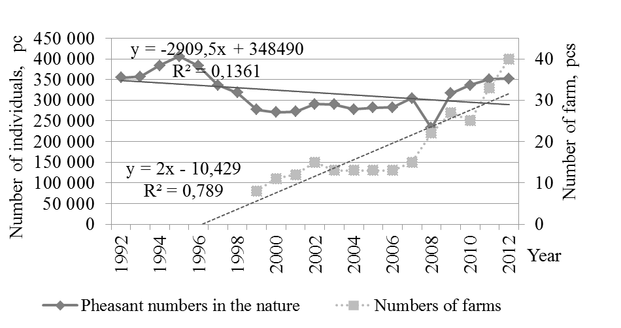
Picture. 1. Dynamics of natural numbers and the number pheasant farm in Ukraine
With such dynamics of increasing farmers of growing hunting pheasant proportionally would have to grow and the number of marketable young animals, but this indicator for the investigated period increased only 2.5-fold (Pic. 2). In addition it should be noted, that it got 2 times more pheasants than introduction. Statistical data for 2013 indicate that the number of main livestock pheasants in pheasant farm reached 15189 individuals, and business output of young animals was 25395. Thus, in one season it is received from one female an average of only 2.01 pheasants. For comparison, in European countries this index is 20 - 25 individuals per female per season [15].
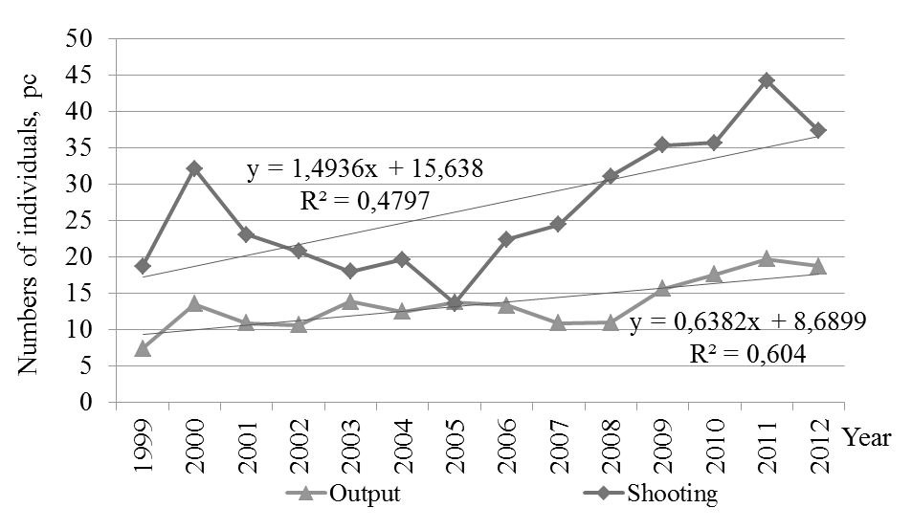
Picture. 2. The dynamics of the natural number obtained and resettlement pheasants in Ukraine

In case compliance by all farms in Ukraine a technology growing hunting pheasant, the economic effect was more than 113 thousand business young individuals. On conversion to monetary indicators, the economic impact in Ukraine as a whole will be about 13.3 mln. UAH., that almost three times more than the profit hunting farms for provision of services for the hunting of this species.

Conclusions:
- Economic efficiency on pheasant farm depends on the technology compliance of growing birds. During optimization the process of keeping a hunting pheasant on the farm "Skif" for 3 years, managed to increase 185 % obtaining chick from one female. Thus, the economic impact to the economy was 270 thousand UAH.
- In the investigated period, the number of pheasant farm increased from 8 to 45, that is in 9 times. The number of marketable young animals increased only by 2.5 times. The cost of artificial breeding hunting pheasant in 2013 reached 787.2 thousand UAH, which amounted 23 % percent of the hunt’s profits.
- In case compliance by all farms in Ukraine the technology of growing hunting pheasant, the economic impact would represent more than 113 thousand business young individuals. On conversion to monetary indicators, for Ukraine it will reach about 13.3 mln UAH.

BIBLIOGRAPHY
1. Васильєва О. О. Історія та перспективи розвитку фазанівництва в галузі птахівництва України / О. О. Васильєва // Вісник Полтавської державної аграрної академії, 2009. – №2. – С 58–62.
2. Васильєва О. О. Розведення фазанів – перспективний напрям сучасного птахівництва України / О. О. Васильєва : збірка матеріалів Міжнародної науково-практичної конференції [Промислове і декоративне птахівництво : проблеми та перспективи проведеної у рамках фестивалю «Пташиний двір» ] (Кам’янець-Подільський, 12–13 жовтня 2011 р.) / Міністерство аграрної політики і продовольства України. – Кам’янець-Подільський, 2011. – С. 10–11.
3. Габузов О. С. Искусственное дичеразведение / О. С. Габузов. – Иркутск, 1984. – 51 с.
4. Дзизюк О. Фазан звичайний phasianus colchicus L. у різних мисливських угіддях /
О. Дзизюк // Вісник Львівського університету. Серія біологічна, 2005. – Вип. 39. – С. 135–
140.
5. Корж А. П. Управление состоянием метапопуляции охотничьего фазана в условиях ex-
situ / А. П. Корж // Вісник Дніпропетровського державного аграрного університету. –
Дніпропетровськ, 2006. – С. 134–138.
6. Корж О. П. Зоокультура як наукова основа збереження рідкісних та зникаючих видів / О. П.
Корж, Д. О. Фролов // Питання біоіндикації та екології. – 2008. – Випуск 13. – № 2. –
С. 151–157.
7. Корж О. П. Теоретичні засади зоотехнічного розділу фазанівництва / О. П. Корж //
Наукові доповіді НУБіП. – 2012. – №2 (31) http://www. nbuv.gov.ua/e-
journals/Nd/2012_2/12kop.pdf
8. Курочкин С. Л. Аклиматизация фазана на юге Украины и Молдавии / С. Л. Курочкин //
Разведение и создание новых популяций редких и ценных видов животных. – Ашхабад,
1982. – С. 131–136.
9. Курочкин С. Л. Создание популяции фазана в Причерноморье путем интродукции
искусственно выращенных птиц / С. Л. Курочкин // Зоокультура ценных и редких видов
птиц и зверей. – М., 1989. – С. 172–181.
10. Курочкин С. Л. Особенности постэмбрионального развития обыкновенного фазана в
северо-западном Причерноморье / С. Л. Курочкин // Дичеразведение в охотничьем
хозяйстве. – М. : Изд-во ЦНИЛ Главохоты РСФСР, 1985. – С. 85–101.
11. Литус И. Е. Акклиматизация фазанов на Украине / И. Е. Литус : автореф. дис. на
здобуття кандидата биол. наук. – К., 1973. – 24 с.
12. Габузов О. С. Нормативные требования на инкубационные яйца и суточный молодняк
охотничьего (гибридного) фазана / О. С. Габузов, В. П. Юрченко, В. С. Иванова и др.
[утверждено нач. Главного управления охот. хоз. и заповедников при Совете Менистров
В. И Фертиковым]. – М. : Изд-во Упрполиграфиздата Мособлисполкома, 1987. – 4 с.
13. Сайт Державної служби статистики України [Електронний ресурс]. – Режим доступу :
http://www.ukrstat.gov.ua/druk/publicat/kat_u/2014/bl/04/bl_misl_13.zip
14. Статистичний збірник «Довкілля України» за 2004 рік / Державний комітет
статистики України / за ред. Ю. М. Остапчука. – К. : 2005. – 260 с.
15. Estienne H. L’élévage du faisant / H. Estienne // La Revve de la chasse, 1970. – № 271. –
P. 26–29.
16. Melin J.-M. Selection sur la couvaison naturelle darts une souehe de faisans (Phasianus
colchicus) elevée en captivité / J.-M. Melin, J.-P. Damange // Z. Jagdwiss. – 2002. – № 48. –
Р. 327 – 339.

