© 2014
Prasolov E. Ja., Candidate of Engineering Sciences
Lapenko T. H., Candidate of Engineering Sciences,
Bondarenko O. Ju., student
Poltava state agrarian academy

Enhancing the stability of engine wear PARTS AGAINST AGRICULTURAL MACHINERY
Reviewer is Dmytrykov V. P., Doctor of Engineering Sciences, Professor
Increasing of the resistance against wear of parts of agricultural machinery is grounded on necessity of coating the surfaces of the mating parts with inorganic non-metallic phosphate films. Manufacturing process conditions for the preparation of starting materials and the composition of the working solution at a predetermined temperature based.
During the research has been established such relationship: the temperature of the working solution concentration; the linear velocity at the control points on the wear surface of the samples. The recommendations for the implementation of the technology antifriction coatings in production have been recommended. Technological process of putting coating with the saturation of nanomaterial tested for the manufacture of friction components of agricultural machinery and engines has enough commercial appeal.
Keywords: durability, phosphating, adjustment, conversion coating, nanomaterials, antifriction

Problem statement. Domestic and some imported agricultural machinery engines are operated under conditions not very high quality, they are maintenances and repaired due to inadequate supply or production equipment service centers in extreme working environments. One of the sources to increase longevity and technological readiness of engines is a proper maintenance and service. For increasing the durability and reliability of engines are required the application of the latest scientific achievements into the technology of repair.
Increasing the wear resistance of parts is one of the important directions in matters for improving engine’s life in general. This is achieved by strengthening the coupling and software environments, which reduces the coefficient of friction and the provision of reconstructing the surface details of special properties of reduced fuel consumption and increases the durability of the engine.
Details of cylinder-piston engine resource limit the resources of the engine and determining to improve the reliability and service life of a thermal barrier is coating, of non-stick and antifriction films. The experience of foreign countries in recent years shows the appropriateness of this treatment, increases the life of the cylinder group almost doubled. Extend the life of machinery and equipment equivalent to the introduction of significant new capacity.
Design, manufacture and operation of the engine is constantly accompanied by the search for ways to enhance efficiency, reduce costs, the use of available and cheap materials, facilitate, accelerate and increase the flexibility of repair.
Currently used methods are coating the surface of the parts: the deposition of thin films, polymer films, electroplating layers of composite films. Of the known methods of applying nonmetallic inorganic coating is of special interest phosphating. Based on the terms of the least cost of a process of coating properties to reduce the coefficient of friction, it is advisable to conduct research in the direction of using the application method and the impregnation of phosphate coatings deposited with various solutions.
Analysis of recent research and publications. With increasing operating speeds, pressures, temperatures, corrosive environment, stringent conditions that are characteristic of the modern production, and increases the wear rate, the corrosion of a metal surface details are in conjunction with each other.
Operational properties of engine parts are determined by the state of the surface layer. The problem of the electrochemical state of the surface layer of steels for mechanical action remains relevant because it affects the quality of the surface is formed. In [1 - 5] highlights the influence of the anion composition of the medium on the passivation of iron at the mating surfaces of parts. Phosphate coatings are known as corrosion inhibitors secondary actions [1 - 2], that is, they are used as corrosion inhibitors [3 - 6]. At a minimum concentration of phosphates to create optimal protection of metal should be attributed to the advantages over other inhibitors [6 - 8]. Phosphate film on the surface of the mating parts alters the kinetics of electrochemical reactions. The disadvantage of this phosphating is difficulty coating process complex shape parts.
The purpose and objectives of research. Purpose is to increase the longevity (life) engine components by determining the influence of the composition and concentration of the solution on the properties of phosphate antifriction surfaces.
Task is to select materials for phosphating surfaces of the parts. Experimental studies on application of phosphate coatings of different concentrations. Conduct a study on the application of phosphate coatings impregnation and comparative tests the durability of surfaces mating parts.
Materials and methods of research. Production of samples and conducting the experiments conducted with workers in laboratories NSC "have general."
Choosing the material for the application of phosphate coatings on the basis of the conditions for the least cost and to achieve the required performance on adhesion, friction coefficient.
For phosphate films used acidic, alkaline and salt solutions. The quality phosphate films affect the total acidity of the solution and arbitrary, its composition and operating temperature. Process duration is also affected by the thickness and porosity of the spray. The working solution was prepared by dissolving weighed amounts of dry substance, followed by heating to reflux. After precipitation and cooling to 60 ... 70 °C, the solution was adjusted to a temperature of 96 ... 98 °C and the solution is ready for use.
Perfect protective film prepared from a solution "Mazhef" concentration of 30 ... 35 g/l, at a temperature of 96 ... 98 °C for 80 ... 90 min. Increasing concentration of the solution to 100 ... 200 g/l can reduce the friction coefficient. From the solutions of salts "Mazhef" obtained film 7 ... 50 mm, have sufficient strength and adhesion to steel quality microporous structure which absorbs varnishes, paints and lubricants.
For studies selected salt concentrate FC-16. Modes coating and material consumption and time to confirm the advantage of covering concentrate FC-16. The solution contains a larger amount of manganese, which provides a surface more resistant to wear. Preparation of solutions of specified concentration held plumb desired amount and dissolving the concentrate in the calculated amount of water. Studies were made for samples of steel Art. 3 with a rectangular cross section. Samples labeled external surface polished was degreased in an organic solvent and the coating layers are applied at a temperature of 95 + 50C for 45 minutes. Samples were washed in tap water, dried at t = 100 °C for 30 min.
The research results. Test specimens of steel St.3 uncoated layered and oiled M10G2K M10G 2K and with the addition of anti-additives. Performing studies used instruments that have passed metrological verification. Samples were coated with a phosphate layer. Six out of ten samples to obtain uniformly thick layers of dark color on the seventh and eighth surface samples were not of good quality, and the ninth and tenth samples deposited on the surface layers were washed with water when flushing. The surfaces of the samples were studied under a microscope (× 400). The bulk of the phosphate layer is formed in the first minutes of the process. For samples labeled 7, 8, 9, 10 experimentally established rational modes of application of phosphate layer.
Graphic dependence of temperature on the concentration of the working solution is shown in pic. 1. Samples were coated with a phosphate coating subjected to abrasion under a load of 0,04 MP for duration of 5 minutes and a frequency of 10 s-1 of rotation of the opposing member as the drive. Abrasion estimated path length from 4525 m to 5285 m with a change rate of abrasion of 2,4 to 2,8 m/s.
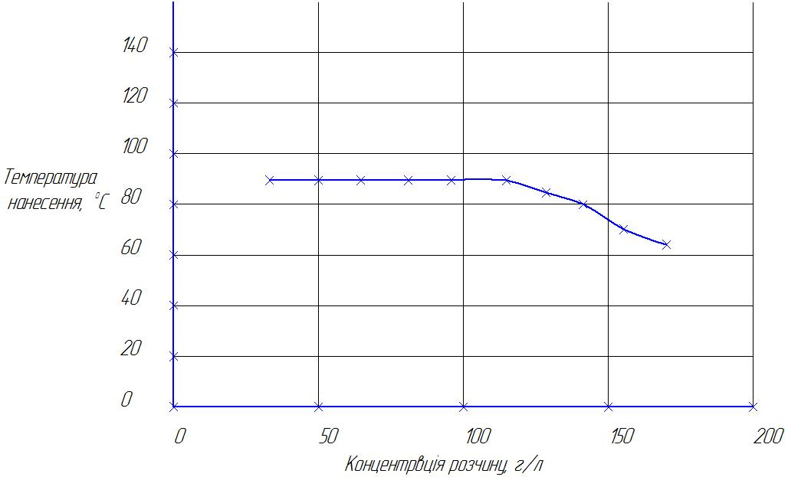
Picture.1. Dependence of the temperature of the working solution concentration

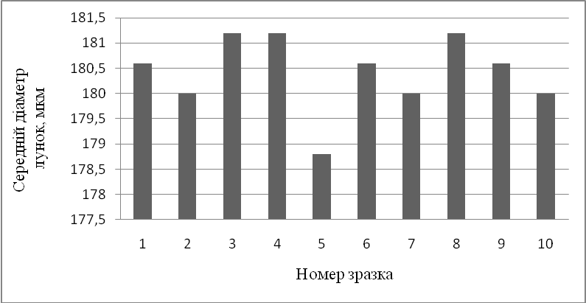
Picture 2. Mean diameter of the first to fifth hole, depending on the sample number

Examination of the traces and the wear amount of the sample surface indicates improved antifriction properties towards increasing the concentration of the working solution to 125 g/l inclusive. The surface properties ranging from 140 g/l deteriorate. The surface quality is worse in the first sample and the best in the seventh. The dependence of the wear surfaces of the samples are shown in the histogram in pic. 3.
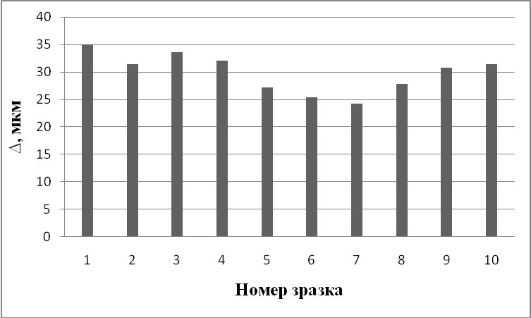
Picture 3. Histogram surface wear, depending on the number of sample

The dependence of the linear velocity at the control points of the wear surfaces of the samples are shown in pic. 4.
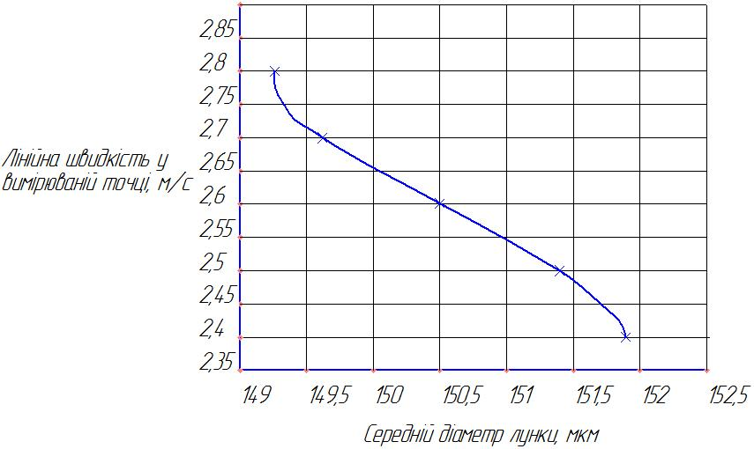
Picture. 4. The dependence of the linear velocity at the control points of the wear surface of the samples

From the graph (pic. 4) that corresponds to a greater wear large wear rate. The results of the studies, the optimal modes of coating: the concentration of the working solution - 125 g/l, temperature 85 °C, the time of application - 45 min. When these modes have the highest wear resistance of the specimen. Subsequent studies durability phosphate coating impregnated with antifriction solutions were made at a load of 0,04 MP, a rotation speed of rider is disk 10 s-1 and experiment duration of 60, 120, 180 minutes. The research results are presented as histograms. The histograms in pic. 5, pic. 6, pic. 7 shows the results of changes in the diameter of the wells, respectively, after 60 min, 120 min and 180 min.

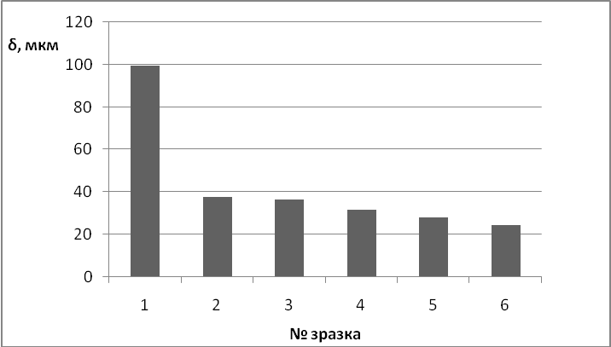
Picture 5. Histogram diameter changes wells after 60 min. friction
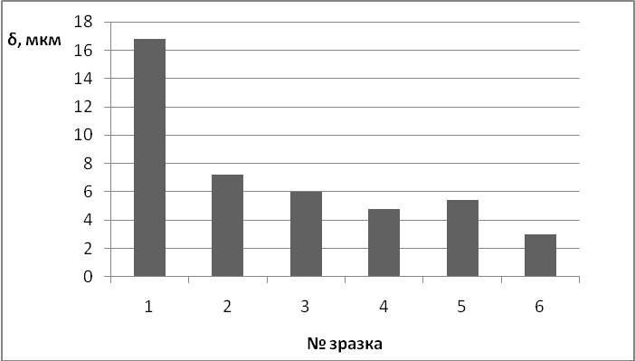
Picture 6. The histogram change diameter holes after 120 min. friction
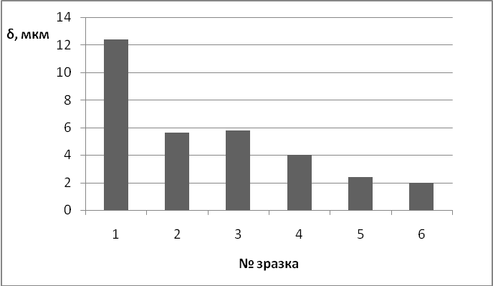
Picture 7. Histogram hole diameter changes after 180 min. friction.
During the first hours of the test additive positive effect on the running process that can be seen on the sixth sample. Changing the average diameter of the five points of the samples were approximately 24 microns. As compared to the first sample, this without a phosphate coating, the difference of wear was 75 microns.
Over the next hour wear test of the first sample was approximately 17 microns and impregnated with antifriction material samples ranged 3≈7 microns.
Over three hours of testing the fifth and sixth samples have less wear.
Picture 8 shows the dependence of the wear surfaces of the samples with respect to time.

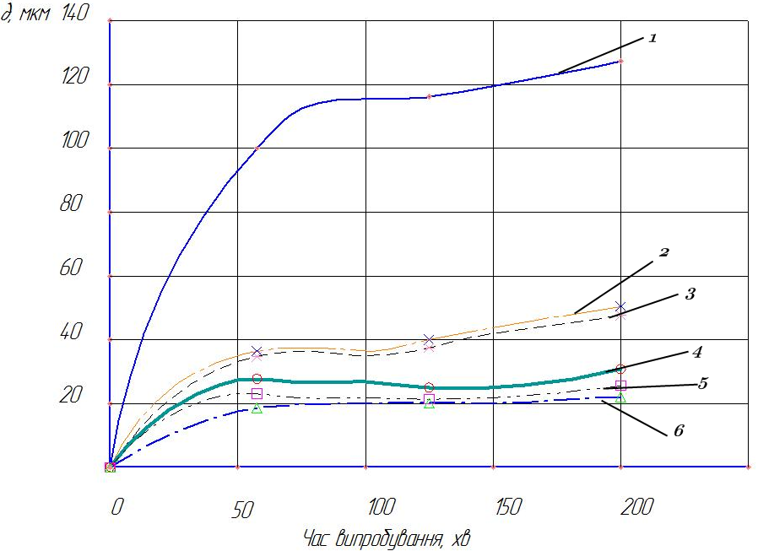
Picture 8. Dependence of the wear surfaces of the samples with the time of research
Analysis of the nature of the surface wear curves of the samples showed that the addition of gel Revitalizing "Hondo" gave stable effect after the running-in period of the sample surface. Al2O3 additives also increase antifriction. When comparing the results of studies shows that the samples impregnated with paraffin technical and pure oil appreciable amount of wear is observed. The nature of the curves shows that the running surface and deterioration in the following 2:00 has lowest values 3 and 2 microns respectively.
In general, the additive is added to the impregnating solution is positively influenced the frictional properties of phosphorus coating.

Conclusions:
1. It was found that increasing the wear resistance of surfaces mating parts in engines of agricultural machinery is achieved by coating the phosphor film.
2. Individuals have reasonably process, conditions of preparation of the starting materials and the composition of the working solution at a specific temperature.
3. Establishment of the study according to the temperature of the working solution concentration, the linear velocity at the control points of the wear surface of the samples.
4. The laboratory results were confirmed in a production environment for the manufacture of friction of the mating parts of agricultural machinery and engines have commercial appeal.
In the future we plan to conduct research on the development and improvement of methods for the preparation of surface films with nanophase structures consist of compositions of metals, alloys, non-metallic materials, and organic compounds.

BIBLIOGRAPHY

1. Гаркунов Д. М. Триботехника / Д. М. Гаркунов. – М. : Машиностроение, 1985. – 424 с.
2. Журавльова Л. О., Колодяжна Л. Г., Покінтелиця М. Я. Фосфатування поверхні вуглецевих сплавів в процесі вібраційної механохімічної обробки / Л. О. Журавльова, Л. Г. Колодяжна, М. Я. Покінтелиця // Вісник Вінницького політехнічного інституту машинобудування і тракторів. – 2008. – № 4. – С. 89–91.
3. Износостойкость сплавов, восстановление и упрочнение деталей машин [учебное пособие / под общей ред. В. С. Попова]. – Запорожье : ОАО «Мотор Сич», 2006. – 420 с.
4. Коновалова В. С. Оптимизация процесса химического фосфатирования стали [текст] /
В. С. Коновалова, К. Е. Румянцева, В. Е. Румянцева // Сборник тезисов докладов 9-й международной конференции [«Покрытия и обработка поверхности»]. – М., 2012. – С. 64–65.
5. Розенфельд И. Л. Коррозия и защита методов / И. Л. Розенфельд. – М., 1970. – 448 с.
6. Томашов А. Д. Лабораторные работы по коррозии и защите металлов [текст] / [Н. Д. Томашов, Н. П. Жрук, В. А. Титов, М. А. Веденеева]. – М. : Металлургия, 1971. – 140 с.
7. Adams A. A., Foby R. T. Corrosion / A. A. Adams, R. T. Foby. – 1975 – V. 31. – 84 р.
8. Ratzer – Sehibe N. I. Werkst. Anol Korros / N. I.Ratzer – Sehibe. – 1975. – V. 26. – P. 2–10.

