© 2014
P. I. Lokes, Doctor of Veterinary Sciences, Professor
S. A. Kravchenko, Candidate of Veterinary Science
T. P. Lokes-Krupka, Master of Veterinary Medicine
T. L. Burda, Master of Veterinary Medicine
Poltava State Agrarian Academy
MORPHOLOGICAL CHANGES OF A LIVER BY HEPATITIS IN DOGS AND CATS
Reviewer – Skrupka M. V., Professor, Doctor of Veterinary Science
Investigations found that by the development of hepatitis in dogs and domestic cats in liver an inflammatory process occurs in two forms - serous and hemorrhagic. Macroscopically, the liver is enlarged and swollen, its edges - blunted, capsule is strained, registered stagnation effects. Sectional picture erased. Changes in the vessels for both pathologies are similar. Inflammatory edema more expressed for serous form of hepatitis in cats. In both cases there is hypertrophy and hyperplasia of Kupffer cells and granular degeneration of hepatocytes.
Keywords: dogs, cats, morphology, liver, hepatitis.
Statement of the problem. Liver inflammatory disorders in dogs and domestic cats constitute a significant part of internal non-contagious pathologies of these animal [1-4]. Essence of the problem is that inflammatory liver diseases often passed more subclinical, which complicates diagnosis and choice of treatment type. Clinical symptoms in the following cases provide enough information for analysis, so it is necessary to use additional methods of research, such as ultrasound, laboratory studies of biological substrates. However, for scientific researches it is important to combine the results of clinical and laboratory studies and analysis of the structural changes in the liver.
Thus, the study of morphological changes of the liver for the hepatitis in dogs and cats is an important question.
Analysis of basic studies and publications which discuss the problem. Hepatitis is one of the most common disease among people and domestic animals, including dogs and cats. Exactly in these species of animals often observed acute hepatitis for whom there is a diffuse inflammation of the liver, accompanied by exudative, proliferative and alternative processes in stroma of the organ, hyperemia, cellular infiltration, degenerative and necrotic changes of hepatocytes and other structural elements and pronounced liver impairment [5-7].However, the morphology of the liver by hepatitis in dogs and domestic cats is still poorly studied, so scientific researches in this direction are essential.
The purpose and objectives of the research.
Purpose of research - study morphological changes of the liver in dogs and cats by hepatitis.
The main objective was to study the microscopic changes in liver cells for the indicated disease.
Materials and methods. Studies were conducted under conditions of the therapy department of Poltava State Agrarian Academy. In cases of death of dogs and cats diagnosed with "hepatitis" were studied for pathological changes and carried out the selection of material (liver function tests) for further histological studies.
Histological researches of the liver carried out at the Department of pathological anatomy and of infectious pathology of Poltava State Agrarian Academy (for consultative assistance of Doctor of Veterinary Sciences, Professor M. Skrupka).
Pieces of the liver of investigated animals with the next size - 1 × 1 × 1 cm were fixed with 10 % neutral formalin solution for one - two days, then dehydrate through increasing alcohol concentration (from 50 degrees to absolute). Received samples after fixation and dehydration filled in paraffin according to the classical method [8]. From the received blocks with the help of the microtome were made serial slices with thickness of 7.5 mm and stained with hematoxylin-eosin and stabilized in polystyrene. Typical histopathological changes in the histological preparations were photographed on microscope MBI-3 with micro photo attachment MFN-12.
The material for the research served as dogs and cats that died due to hepatitis diagnosed on the basis of clinical and biochemical studies.
During the implementation of work we used material taken from the corpses of four dogs and fourdomestic cats. Histologically was investigated sectional material from six animals (three dogs and three cats).
Results. Animals that died as a result of hepatitis, noted that their liver was enlarged and swollen, its edges - dull, with strained capsule. Some places areas were bluish color with stagnation. The cut surface was erased and dull, from it stand out dark red liquid. Distinct morphological changes in the liver and kidneys were found in all animals. On the surface of the liver were found areas of light gray and gray-brown in various sizes and shapes.
Hepatitis morphologically manifested with serous and hemorrhagic inflammation of the liver parenchyma.
During the histological investigations was registered expand and overflow blood vessels of the liver, especially vascular triads. Such changes were accompanied by stagnation of blood in the arteries and veins, which in many cases morphologically manifested coagulation and increasing concentration of proteins which diffusely or as a grid painted with eosin (Pic. 1).In the interlobular connective tissue of organ and inside particles was noted serous fluid accumulation (Pic. 1; Pic. 2).
.
Picture. 1. Microscopic structure of the liver (cat, age 3 years):
1 - plethora of hepatic venous vessels;
2 - accumulation of serous fluid in the interlobular connective tissue;
3 - granular degeneration of hepatocytes.
Coloring with hematoxylinKaratsu and eosin. Zoom × 200.

High content of proteins in fluid also painted with eosin and especially manifested in liver lobules. At this time, there is a significant increase of the distance between the plates of hepatocytes (Pic. 2). All hepatocytes are in a state of granular dystrophy. They were irregularly enlarged, their cytoplasm - swollen, muddy, unevenly colored; with small grains of acidophilic protein. Limits of cells and their nucleusdifferentiated hard or were completely invisible.Also we registered hyperplasia and hypertrophy of Kupffer cells.
By hemorrhagic hepatitis (in two cases) liver had expressed deep red color.In conducting research histological changes in vessels (arteries and veins) of the liver were similar to that of a serous hepatitis (Pic. 3).Inflammatory swelling registered in both interlobular connective tissue and inside lobules, but it was not so expressive. At the same time, as for serous hepatitis, hypertrophy and hyperplasia of Kupffer cells were noted and of hepatocytes granular dystrophy.

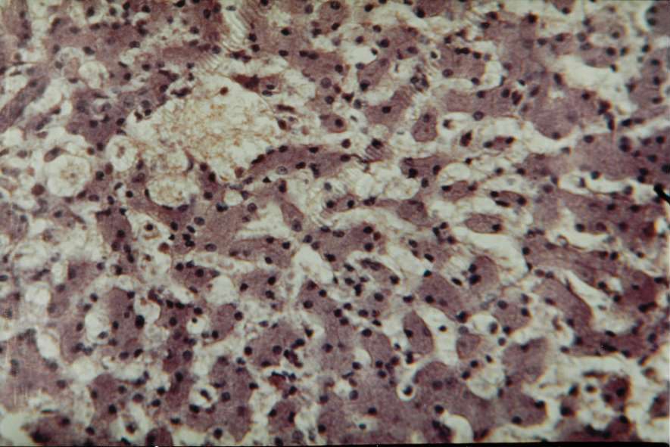
1
2
2
1
3
3

Picture. 2. Microscopic structure of the liver (dog, age 5 years):
1 - granular degeneration of hepatocytes;
2 - accumulation of serous fluid between the beams of hepatocytes;
3 - Kupffer cells.
Coloring with hematoxylinKaratsu and eosin. Zoom × 200.
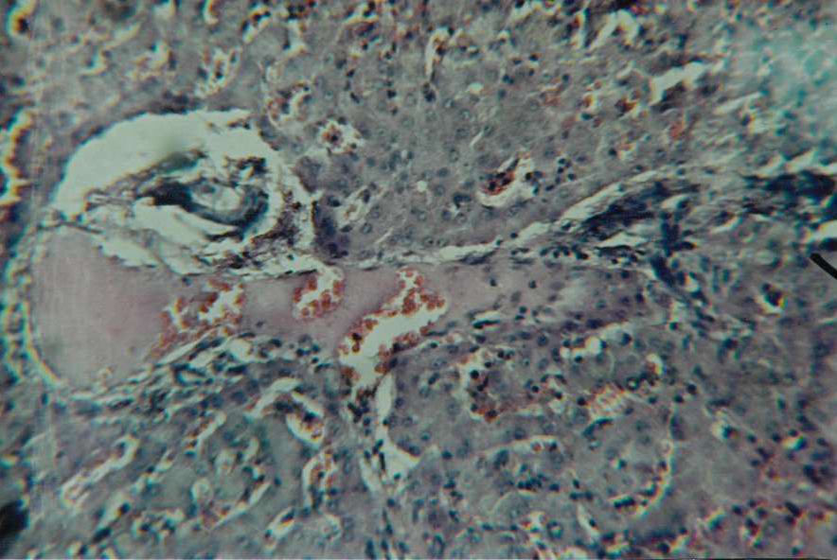

Picture. 3. Microscopic structure of the liver (cat, age 5 years):
1 - granular degeneration of hepatocytes;
2 - perivascular swelling of liver triad;
3 - partial hemolysis of erythrocytes of triadartery;
4 - increased blood filling of sinusoidal capillaries.
Coloring with hematoxylinKaratsu and eosin. Zoom × 200.

Obtained histological data show that in dogs and cats which were the objects of morphological researches, hepatitis ran in two forms - serous and hemorrhagic. Changes in vessels under both forms of pathology were similar. However, the inflammatory swelling was more pronounced for serous form of hepatitis in dogs.
In both cases observed hypertrophy and hyperplasia of Kupffer cells and granular dystrophy of hepatocytes.
Conclusions. So, results of researches of dogs and cats suffering from acute parenchymal hepatitis indicate that there are two forms of the course of inflammatory process - serous and hemorrhagic. The phenomena of inflammatory edema is more pronounced for serous form of hepatitis in dogs. Consequently, hepatitis in cats have more severe course than in dogs.

BIBLIOGRAPHY
1. Болезни собак и кошек. Комплексная диагностика и терапия болезней собак и кошек : учеб. пособие / [Т. К. Донская Г. Г. Щербаков, Г. В. Полушин] ; под ред. С. В. Старченкова. – СПб. : Спец. литература, 2006. – 655 с.
2. Чандлер Е. А. Болезни кошек / Е. А. Чандлер, К. Дж. Гаскелл, Р. М. Гаскел : пер. с англ. – М. : Аквариум, 2002. – 696 с.
3. Болезни печени и желчевыводящих путей: Руководство для врачей : [под ред. В. Т. Ивашкина]. – М. : ООО «Издатдом М-Вести», 2002. – 416 с.
4. Уша Б. В. Болезни печени собак / Б. В. Уша,
И. П. Беляков. – М. : ПАЛЬМАпресс, 2002. – 36 с.
5. Ниманд Х. Г. Болезни собак / Х. Г. Ниманд, П. Б. Сутер : пер. с англ. – М. : Аквариум ЛТД, 2001. – С. 604–608.
6. Внутрішні хвороби тварин / [В. І. Левченко, І. П. Кондрахін, В. В. Влізло та ін.] ; за ред. В. І. Левченка. – Біла Церква, 2012. – Ч. 1. – 528 с.
7. Кондрахин И. П. Диагностика и терапия внутренних болезней животных / И. П. Кондрахин, В. И. Левченко. – М. : Аквариум-Принт, 2005. – 830 с.
8. Меркулов А. Б. Курс патогистологической техники / А. Б. Меркулов. – Л. : Медицина, 1969. – 237 с.

