© 2015
Makedon H. M., postgraduate student
(scientific supervisor – Doctor of Economics Sciences, Professor M. P. Talavyria)
National University of Bioresource and Environmental Sciences of Ukraine
CONSUMER SENTIMENT OF RURAL POPULATION: ANALYSIS OF SOCIAL FACTORS
Reviewer – Candidate of Economics Sciences, Lecturer Z. D. Ovcharyk
The focus of attention is on the impact of the population’s behavior on the state's economy. Method of calculating the Index of Consumer Sentiment (ICS) was researched. ICS dynamics of rural population in Ukraine over the last year was analyzed. Rural households are less sensitive to political changes and escalating conflict in eastern Ukraine because their ICS is higher than in urban citizens. National indicators is compared with similar in foreign countries. We established that consumer confidence is the highest in Asia. We recommended to learn the experience of these countries to increase consumer sentiment of population in Ukraine .
Keywords: Index of Consumer Sentiment, consumer market, psychological factors, social factors, social welfare, rural population, age category.
Statement of the problem. The population of the state is one of the most important subjects of the market economy, as both consumer and producer of serving the public good. In their turn, rural households account for about a third part of the population of Ukraine, so their impact is quite significant at the macro level. In addition, the development of villagers’ consumer behavior has several differences caused by economic, social and cultural characteristics of rural areas.
Analysis of research and publications, which initiated resolution of problems. John Katona, G. Tard, D. Kahneman, A. Tversky are believed as a founders of analysis of the impact of psychology on the economy of the state population. Wodern scientists, in particular A. Kostomarova [3], D. Tyupa [6], T. Bulakh [1], I. Dementieva [2] and others are occupied in issues of economic behavior of households, social conditions of the population, including rural one.
Ahmed Shahriar Ferdous, Batul Towfique [8], Sarah Gelper, Aurelie Lemmens, Christophe Croux [10] are occupied in research of consumer sentiment of households in market conditions. And the issue of consumer behavior is the rural population and its impact on the domestic economy needs more detailed study.
The purpose of the research – to research the dynamics of consumer sentiment of rural population in Ukraine and to compare it with data of countries with developed economies.
The main objectives of the research is analyze the main factors which determine consumer behavior of rural households.
Materials and methods of the research. Materials are scientific works of foreign and local scholars, results of social surveys and statistical information.
General scientific and special methods of learning, including generalization and systematization, economic analysis, method comparison and statistical methods are used in the research.
Results of the research. Consumer behavior of the population depends on many factors, so it’s studying requires integrated approach. In economic theory, since the twentieth century, scientists are beginning to pay attention to psychological factors. The first who came up with this idea was G. Tard. But the ancestor of psychological economics believe John Katona.
According to John Katona, the relationship between human psychology and economics was the fact that most economic processes that were considered objective were largely influenced by subjective “population’s view of the economy”. In general, the state of some uncertainty is a feature of the economic system, because no one can quite accurately predict the direction of economic processes. At the same time, people should always take specific decisions about their consumption and savings. Conclusion of J. Katona was the fact that expectations and public opinion significantly have affect on the economic processes. Thus, if a large group of people simultaneously change their behavior, thinking to save money or spend it, psychological factors may return current business cycle, thus affecting macroeconomic processes. An important achievement of the scientist was developed in the 1950's. University of Michigan group of researchers under his leadership instrument of measuring psychological variables – Consumer Sentiment Index (CSI) or Index of Consumer Sentiment (ICS). This development brought an end to the perception of psychological factors as elements of disorder in economic models. [2]
Consumer Sentiment Index (CSI) is the main indicator of trends in the consumer market, which is used worldwide. This figure is forecasted indicator of potential changes of demand in these periods.
In Ukraine, the CSI is engaged in research GFK Ukraine (Society for Consumer Research) – Ukrainian research company, part of the GFK Group Network [11].
To define the CSI, respondents are asked the following questions:
1. How has the financial standing of your family changed for the last six months?
2. What do you think will your family's financial situation change in the next six months?
3. Speaking of the economic situation in the country as a whole, do you think the next twelve months will be good or bad for economy?
4. Looking at the next five years – will they be good or bad for the economy?
5. Do you think generally now is a good or bad time to make major household purchases? [11]
The index ranges from 0 to 200. The value equals 200 when all respondents positively assess the economic situation. It totals 100 when the shares of positive and negative assessments are equal. A value less than 100 indicate the prevalence of negative assessments [11].
If we look at the CSI by age, in Ukraine traditionally the most optimistic in youngest (16–30 years), the worst consumer sentiment in the oldest group (60 and older). And in the age structure the rural population is dominated by this age group. Because of the expansion of the age limit of the respondents (including with June 2014 subjects aged older than 60 years) the average index values were slightly lower. [11]
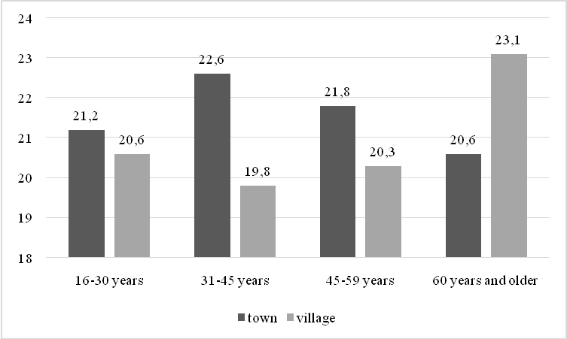
Picture 1. The age structure of the population
* Formed by the State Statistics Committee [5]
Beginning in January 2014 due to political instability and insecurity index fell sharply among the population of Ukraine, including among villagers. Although, traditionally, farmers are less sensitive to the political adversity and the situation in Ukraine has moved beyond political and it is a social disaster.
The turning point in the CSI was January–February 2014. Among country folk it even increased, compared to January on 3 position and fell on 19 position and reached a record of low value after the economic crisis of 2009. And if in July we see it sharply jumps up, in August the CSI has suffered a decline of 10 points with the aggravation of hostilities in the Donbas, destruction of industrial infrastructure in the region and the devaluation of the hryvnia (pic. 2).
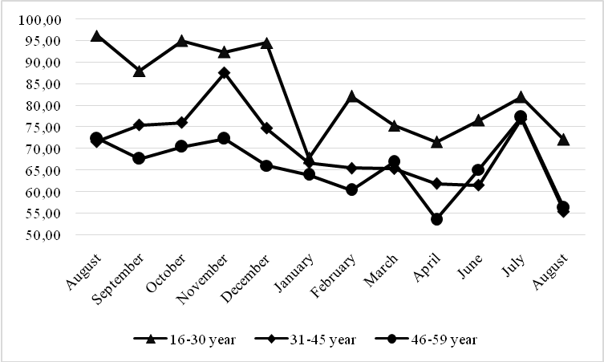
Picture 2. Consumer Sentiment Index of rural population 2013–2014.
* Information provided by GFK Ukraine [7]
Over the last six months, consumer sentiment of urban residents are more pessimistic than country folk. Change of power in Ukraine as a result of violent confrontation led to the expected decline in consumer sentiment. It has particularly strong impact on the demand for durable goods. However, many citizens of this change gave a hope for a better future after this difficult period and particularly in rural areas it was improving.
The strongest decline in this period was observed in the population under the age of 30 years. If CSI indicators in 2013 in this group were the highest, in the early period of the protests in the capital (January 2014), they fell by a record number of points (27) to 67 and change the power in a military confrontation led to increased consumer sentiment again most among young people [9].
The least consumer sentiment was deteriorated in citizens with low-income. A total income of rural households on average is only 86 % of the city. In wealthier citizens, as well as in big cities negative trend was more pronounced significantly.
That is to aggravation of socio-political processes in the country, CSI rural population has traditionally been lower in rural populations. But since February 2014 index of the interviewed farmers was higher. In other words, farmers are less sensitive to all economic and political disaster. CSI value in August for the urban population had fallen to 47, i.e. 40 positions from October 2013, and 19 for agriculture.
Rural households are not only consumers of goods and services, but also powerful agricultural producers in Ukraine [5].
In particular, in 2013 in the structure of crop farms were leaders in the production of potatoes (97,0 %), vegetables (88,3 %), fruits and berries (80,6 %). A benefit livestock farms owned only growing poultry (57,4 %) and it is equal in pig performance (49,0 %) [5]. That is because of the households of farmers have greater confidence at least in their food security, that they will be able to feed his family.
The predominance of elemental savings makes them be less vulnerable to currency fluctuations and any changes in financial markets. Rural households are less psychologically and economically dependent on financial income (share of cash income in total of farmers is 85,5 %, while for urban households – 94 %). In addition, during March-August is a period of agricultural activity, that’s why psychologically daily farmers’ attention riveted to their farms primarily [3].
In addition, despite the speed of informatization of ukrainian society for villagers information is less available: a low percentage of internet users, the absence satellite and cable TV of most of them, even a weak signal of mobile operators. Farmer understands all the negative situation in the country. But he knows that his well-being depends primarily on how he will work in the period of March-September.
In the village entertainment and trading chain is significantly worse developed. This includes all rural areas of our country. During 1995–2011 years was significant reduction of retail facilities. Number of retail stores in rural areas decreased from 1990 to 2011 in 3,7 times, semi stationary trade – 1,2 times. More than half of the villages do not have shops, some of which are served by a visiting mobile store, and others – whose population is forced to buy in neighboring villages. Although it is believed that the availability of commercial establishments must be by pedestrian accessibility of 2-3 km in rural locality, radius of availability stores an average of 3,5 km. The worst situation in Mykolayiv (4,85 km), Sumy (4,48 km) and Chernihiv (4,57 km) areas [1].
Consider the dynamics of CSI in countries with developed market economies. We take the state of the various rural particles: China – 47 %, Poland – 39 %, Ukraine – 31 %, USA – 17 %, Israel and Japan – 8 % [13].
Index of Consumer Sentiment
 | USA | Ukraine | China | Poland | Israel | Japan
October 2013 | 77,5 | 84,0 | 102,9 | 75,7 | 75,57 | 95,4
November 2013 | 73,2 | 85,5 | 98,9 | 77,3 | 71,38 | 91,2
December 2013 | 75,1 | 80,3 | 102,3 | 77 | 71,55 | 92,5
January 2014 | 82,5 | 72,5 | 101,1 | 79,8 | 70,74 | 91,3
February 2014 | 81,2 | 64,6 | 103,1 | 79,9 | 73,52 | 90,5
March 2014 | 81,6 | 67,8 | 107,9 | 79 | 73,82 | 88,3
April 2014 | 80 | 60,7 | 104,8 | 81,9 | 78,43 | 87,5
May 2014 | 84,1 |  | 102,3 | 83 | 77,54 | 87
June 2014 | 81,9 | 66,1 | 104,7 | 84,6 | 75,55 | 89,3
July 2014 | 82,5 | 65,1 | 104,4 | 82,9 | 73,26 | 91,1
* Formed by the author according to the site Economics and Trade [12]
Speaking of the world average, the best consumer sentiment is inherented in Asian countries (India, Indonesia, the Philippines, China). That’s why social and political stability of these states directly reflects in the confidence of their population in their purchasing power in the future. While much of Europe CSI is probably half lower (Portugal, Italy, Greece, Hungary). That is, we can see that the negative assessment of the state of the economy (CSI less than 100) are typical from most of the world [12]. And Ukraine in this rating the past six months alone occupies the lowest position. And given the lack of confidence in the future it does not begin to strengthen it. If the CSI rises, it does not fix its growth.
Conclusion. Thus, consumer behavior affect on the population growth of the economy. The influence of the rural population are important at the macro level, as it is a third of the state. The main difference between rural households is the presence of farms with which help they turn into powerful farmers. In addition, lower cash income, savings and availability of natural weak rural infrastructure – all these factors have caused smaller decrease in consumer sentiment compared with the city. That is, the rural population has been less sensitive to the political and economic crisis in Ukraine. And any way, the Ukrainian authorities for improvement public confidence in the state should take into account the experience of Asian countries, where the CSI is the highest.
BIBLIOGRAPHY
- Булах Т. М. Сфера торгівлі й ресторанного господарства у сільській місцевості України: стан, проблеми та перспективи розвитку / Т. М. Булах // Економіка розвитку. – 2013. – №1 (65). – С. 38–42.
- Дементьева И. Н. Потребительские настроения населения в условиях политических перемен / И. Н. Дементьева // Проблемы развития территории. – 2013. – №.1 (63). – С. 85–97.
- Костомарова А. В. Сбережения населения как потенциальный источник финансирования модернизации в России / А. В. Костомарова // Вестник МГИМО. – 2011. – №1 (16). – С. 12–18.
- Ксьонжик І. В. Економічна активність сільського населення України / І. В. Ксьонжик // Актуальні проблеми економіки. – 2013. – №12(150). – С. 153–159.
- Сільське господарство України. Статистичний збірник. – К., 2014. – 390 с.
- Тюпа Д. И. Экономические теории финансового поведения домохозяйств и экономический кризис в Украине / Д. И. Тюпа // Бизнес Информ. – 2011. – №1. – С. 4–7.
- Україна у цифрах 2013. Статистичний збірник. – К., 2014. – 239 с.
- Ahmed Shahriar Ferdous, Batul Towfique Consumer sentiment towards marketing in Bangladesh. The relationship between attitudes to marketing, satisfaction and regulation // Marketing Intelligence & Planning. – 2008. – Vol.26 Iss.5. – P. 481–495.
- Katona G. Psychological Analysis of Economic Behavior / G. Katona. – NY. : McGrow-Hill. – 1951. – 360 p.
- Gelper Sarah, Lemmens Aurelie, Croux Christophe Consumer sentiment and consumer spending decomposing the Granger causal relationship in the time domain / Sarah Gelper, Aurelie Lemmens, Christophe Croux // Applied Economics. – 2007. – Vol.39, Iss.1, P. 1–11. – [Електронний ресурс]. – Режим доступу : http://www.tandfonline.com/doi/full/10.1080/00036840500427791.
- http://www.gfk.com
- http://www.tradingeconomics.com
- http://www.worldbank.org

