© 2017
Dovhal’ H. P., post graduate student of the third year
(scientific supervisor – Doctor of Biological Sciences, Professor N. O. Voloshyna)
National Pedagogical University named after M. P. Drahomanov
THE EVALUATION OF WINTER WHEAT DEPENDING ON THE INFLUENCE OF METEOROLOGICAL FACTORS IN THE CONDITIONS OF FOREST-STEPPE ZONE
Reviewer – Candidate of Biological Sciences V. M. Lavrinenko
In the article the complex analysis of climatic factors and productivity of agro-ecosystems was made by the example of typical Forest-Steppe zones of agricultural enterprises. The studies found the correlation dependence of crop capacity of winter wheat yield of some climatic factors for the 20-year period (1997–2016). By certain mathematical models the graphics features that enable us to predict the level of productivity of various crops by the impact of climate factors were built. It is found that the most significant meteorological factors for winter wheat are rainfalls in May and June, and productive moisture reserves in the soil layer 20 cm in April and May.
Keywords: climatic factors, productivity, winter wheat, correlation and regression analysis.
Statement of the problem. Among the complex group of factors, climatic ones take a special place as they directly determine all processes in the ecosystem, conditions and limits of living organisms, their distribution, activity and reproduction. Mild winter and moderately humid and warm summer for climate of Forest-Steppe zone are quite favorable for obtaining high and stable yields of winter crops [6, 7].
Ambient temperature affects all vital processes of agricultural crops: the intensity of photosynthesis and respiration, absorption of water and minerals, transpiration, and consequently affects the crop formation. So, precipitations are important climatic resources and as consequence, soil water storage is formed and affects plant growth. That is why the reserves of soil moisture, which can be used by the plant during the growing season (available moisture) is an important factor and a factor in increasing crop capacity [1, 2]. Despite the fact that winter wheat, even with sufficient nutrients and following all the agronomic requirements of its growing is very demands the soil moisture reserves. This is due to the fact that the timing of the winter wheat sowing coincides with the driest period of the year. Moisture reserves in the soil determine the timeliness of germination, plant development and affect mainly the level of the future harvest [4].
The analysis of recent research and publications. The influence of climatic factors on crop yield was considered by V. L. Dmitrenko [2], L. M. Popytchenko [4], Yu. O. Tarariko [1] and others. In particular, the researchers note that the work has been carried out to assess the response of crops to climate change and the conditions of cultivation of agricultural crops in Ukraine in recent years [4]. This is a significant fact to ensure the stable development of agricultural production and the determining factor is the ability to predict the performance of individual cultures. The optimum of the values of the climatic parameters varies widely for similar soil and climatic conditions. The problem of the dependence of the biological productivity of agro-ecosystems of complex influence of meteorological factors in the moment is very relevant and requires further study.
The aim of the work is to identify the dependence of winter wheat from the influence of meteorological factors in the conditions of Forest-Steppe zone.
In particular, the main task is to establish a correlation interdependence yield of winter wheat from the influence of the average monthly air temperature, precipitation, and productive soil moisture reserves.
The materials and methods of the research. The indices of the dependence of winter wheat of meteorological parameters such as the average monthly air temperature readings, rainfall and soil moisture reserves productivity was examined by using correlation and regression analysis. The data on crop yields were collected based on the annual accounting reports of district administrations of the city Lubny. The observation sites were based on the research of agricultural economy Lubny weather station KFH «Roksolana». Meteorological data were obtained from the archives of Lubny Meteorological Station (the nearest to the farm) for the period from 1997 to 2016.
Results of research. To determine the productivity of the independence of crops from weather conditions statistical series of winter wheat in Lubny in Poltava region for the period from 1997 to 2016 years (Pic. 1), the average monthly rainfall, temperature, and moisture reserves were examined during this period.
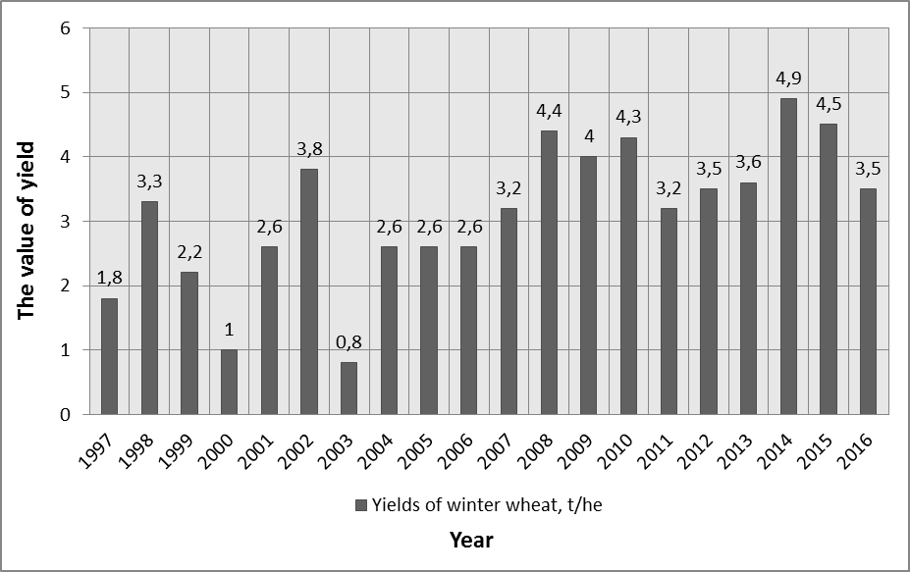
Pic. 1. Yields of winter wheat for the period from 1997 to 2016 years
During the period of analysis of the change of winter wheat it was noted that its figures ranged from 0,8 t/he to 4,9 t/he. To identify patterns of this change was calculated the value of winter wheat yield correlation coefficient for meteorological parameters over a 20-year period. It was found that the precipitates have a significant impact on the productivity of cereal than the temperature. For the study of culture is the amount of precipitation in May and June.
The value of the correlation coefficient – 0,8 indicates a direct correlation. Parameters of the individual functions of the mathematical model on the factor equations are shown in table 1.
1. Mathematical and statistical model of winter wheat yield depending on rainfall
Factor | Equation of  pair regression | The correlation of coefficient pair
Rainfall in May | у=0,02х+1,89 | 0,8
Rainfall in June | у=0,03х+0,88 | 0,8
These needs for moisture primarily are related to its uneven absorption of winter wheat during the growing season [3]. The greatest need is related to the phase of the shoot stage, when the plant is in a state of intense growth (formation of flowers and ears of wheat) and the period from earing to full ripeness (May–June). The lack of moisture at this time is extremely unfavorable for culture and leads to a decrease of yield. In particular, there is a direct correlation that indicates that the rainfall in May and June is the most important factor of the influence on the yield of winter wheat. The graphics functions (Pic. 2) were built according to certain mathematical models of the correlation of crop yield from meteorological data.
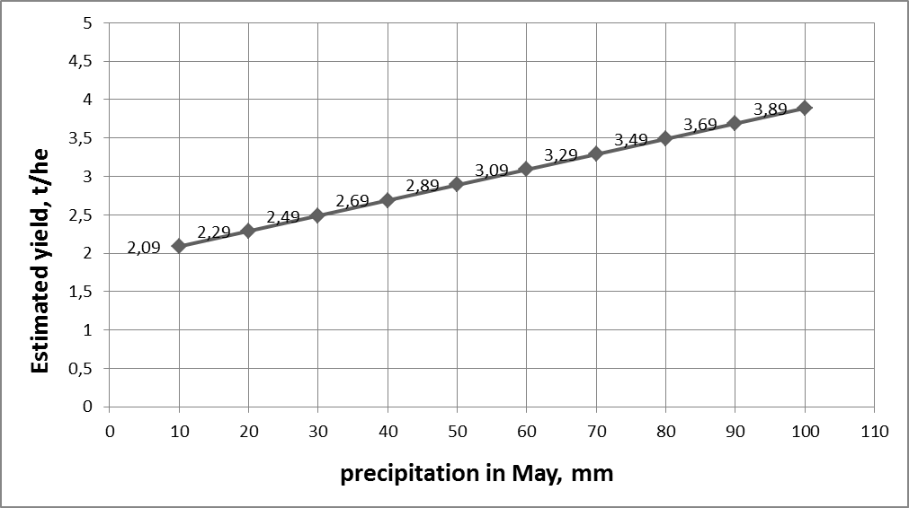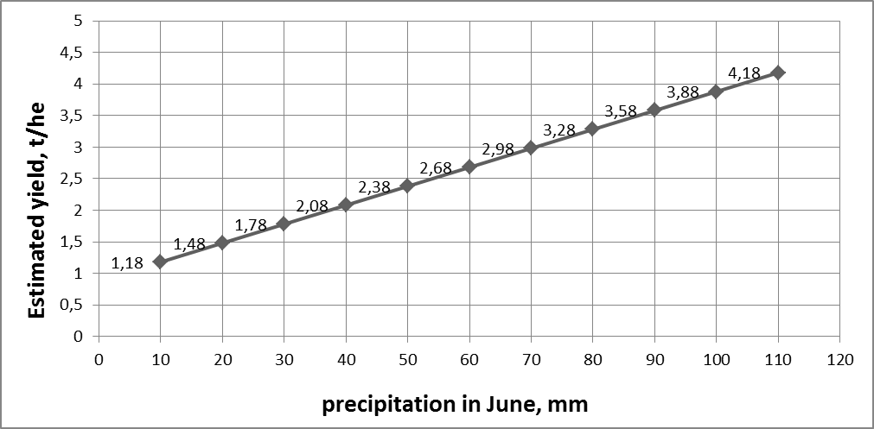
А Б
Pic. 2. The functional dependence of winter wheat on the amount of precipitation in May (A)
and June (B)
According to the diagram (Pic. 2), there is a direct correlation between the increases of winter wheat in accordance with the number of precipitation in May. The maximum value of the coefficient of crop capacity in May and June (3,89 t/he and 4,18 t/he) is predicted rainfall of 100 mm and 110 mm, respectively.
By analyzing data on winter wheat yield of Lubny area and our own research during 2016, it is determined that the amount of rainfall above the average for the Forest-Steppe zone of the climate over the years of research (53 mm) provides an increase in this indicator. The relatively high yield (3,8 t/he) was fixed in 2002, when the amount of precipitation in May, June was 58,7 mm and 78,0 mm; 4,4 t/he in 2008 when 57,5 mm and 78,6 mm; and in 2014 – 4,9 t/he at 66,1 and 76,2 mm of rainfall.
One of the main conditions for obtaining a high yield of crops is the degree of productive moisture, which is absorbed by the soil as a result of the soil supply [5]. That is why this option (reserves of productive moisture) is an important factor in increasing crop yields.
During the period from sowing to tillering phase the state of crops is determined by moisture of the upper layer of soil (0–20 cm). Mathematical statistics methods were used for an analytical study of character effects of certain factors on the vegetation process of winter wheat. As a result, studies has been established the availability of a direct correlation dependence of winter wheat from the stocks of productive moisture in a 20-centimeter layer of soil in some months over the 20-year period. At the same time, the greatest impact on crop yield are April and May deposits of productive moisture, as evidenced by the value of the correlation coefficient – 0,8 and 0,9 respectively. The parameters of function equations of the mathematical model for factors which influence the yield of winter wheat are given in table 2.
2. Mathematical and statistical model of winter wheat yield depending on reserves of productive moisture
Factor | Equation of  pair regression | The correlation of coefficient pair
The reserves of productive moisture in April | у=0,15х-1,73 | 0,8
The reserves of productive moisture in May | у=0,21х-1,73 | 0,9
This pattern is related to the biological needs of the highest sensitivity of winter wheat during the period from the beginning of the spring growing season till earing. At the optimum moisture content of plants, especially in the period from the shoot stage to earing, there is the probability of obtaining a high yield.
The graphic functions were made according to mathematical models of correlated dependence of crop yields from productive deposits of moisture (Pic. 3).
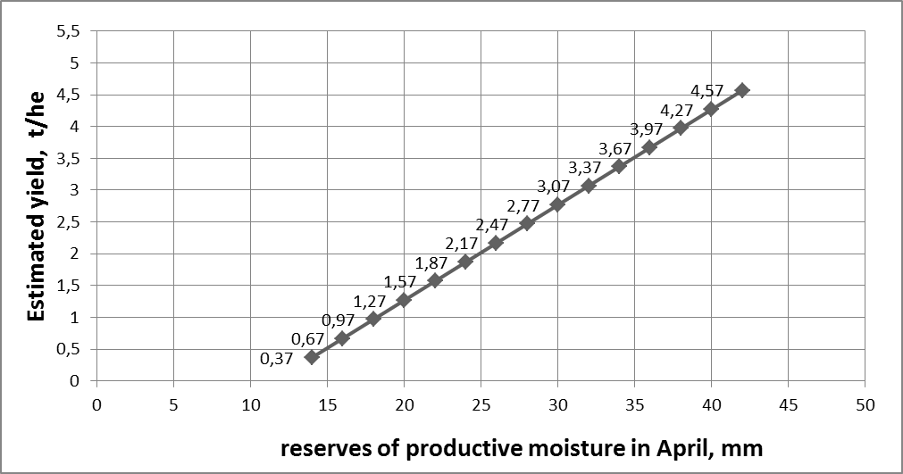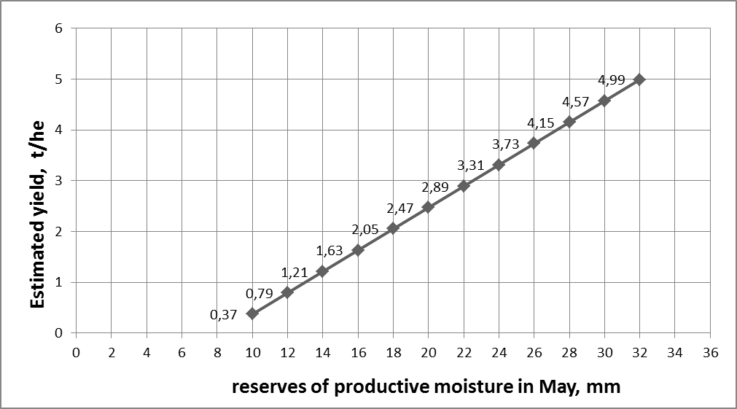
А Б
Pic. 3. Graphs of the functional dependence of winter wheat from the deposits of productive moisture in April (A), May (B)
According to the graph (Pic. 3), an increase of deposits of productive moisture in April and May shows the growth index of winter wheat. Its maximum value (about 4,57 t/he) respectively, it is predicted by the deposits of productive moisture 42 mm in April, and about 5 t/he at 32 mm in May.
Conclusion. In the course of our full analysis of the productivity dependence of the agro-ecosystem on the effects of climatic factors it was found that the yield of winter wheat mainly affects rainfall in May and June (there is a close correlation in which the correlation coefficient is 0,8), as well as the stocks of productive moisture in April and May (correlation coefficient of 0,8 and 0,9 respectively). By the construction of mathematical and statistical models, the estimated maximum yield of wheat in May and June (4 t/he and 4,24 t/he) is predicted according to the amount of rainfall of 100 mm and 110 mm, respectively. Whereas the deposits of productive moisture in April (44 mm) and May (32 mm) showed maximum crop yield about 4,6 t/he and 5 t/he, respectively. The calculated equations enable us to determine the productivity of the agro-ecosystem in accordance with the specific meteorological parameters, which, in turn, allows predicting the level of crop yield by the different effects of climate factors.
BIBLIOGRAPHY
1. Вплив агротехнологічних і агрометеорологічних факторів на продуктивність агроекосистем / [Тараріко Ю. О., Чернокозинський А. В., Сайдак Р. В., Глущенко Л. Д., Величко В. А., Єрьоміна Т. А.] // Вісн. аграр. науки. – 2008. – № 5. – С. 64–67.
2. Дмитренко В. П. Погода, клімат і урожай польових культур : [монографія] / В. П. Дмитренко // НАН України, Укр. наук.-дослід. гідрометеоролог. ін-т. – К. : Ніка-Центр, 2010. – 620 с.
3. Зінченко О. І. Рослинництво : [підручник] / О. І. Зінченко, В. Н. Салатенко, М. А. Білоножко. – К. : Аграрна освіта, 2001. – 591 с.
4. Попитченко Л. М. Погодно-кліматичні умови вегетації озимої пшениці в Луганській області /
Л. М. Попитченко // Збірник наукових праць Луганського національного аграрного університету. Серія «Сільськогосподарські науки». – Луганськ : «Елтон-2», 2009. – №100. – С. 121–124.
5. Фурдичко О. І. Агроекологія : [монографія] / О. І. Фурдичко // Нац. акад. аграр. наук України, Ін-т агроекології і природокористування. – К. : Аграрна наука, 2014. – 399 с.
6. Lonsdale K. G. (Eds). Climate Change. Climate, Variability and Agriculture in Europe. Environmental Change Unit / K. G. Lonsdale. – University of Oxford, UK. – 2008. – P. 367–390.
7. Parmesan C. Ecological and evolutionary responses to recent climate change / C. Parmesan // Annual Rev. Ecol. Evol. Sys. – 2006. – P. 37.

