© 2015

Kulibaba M. Yu., Postgraduate Student
(scientific supervisor – Doctor of Agricultural Sciences, Professor N. Ya. Shevnikov)
Poltava State Agrarian Academy
GROWTH AND DEVELOPMENT OF SOYBEAN DEPENDING ON SOWING TIME AND MICROBIOREACTOR
Reviewer – Doctor of Agricultural Sciences P. V. Pysarenko
The duration of the vegetation period of the plants of soybean depends on sowing time: the longest it at early period, and under optimal and late it decreases. The duration of the interphase periods during the growing season was also distributing differently depending on sowing time. The degree of development of plants during the growing season depends on pre-treatment of seeds of microbiological preparations: plants which at the sowing day were treated by drug «Rizogumin» develop better at all three rows of planting. However, yield and it’s quality depends on the processing of biological preparations and sowing dates. The highest rates were observed in plots treated with «Rizogumin» which were sown in early term.
Key words: sowing dates, attrac microorganisms, nitrogen fixation, Rhizobium, biological products, inoculation, «Rizogumin».

Statement of the problem. Increasing the productivity of soybean is one of the most pressing problems of our time. Soybean is an important food, feed and industrial crop. The content of essential aminoacids soy protein close to protein of animal meats but exceeds it in 1,5–2 times. The quality of soybean oil is highly appreciated. The soy flour using in the production.
Soybean productivity is reduced damage caused by weeds, disease, pests and also largely depends on the amount of moisture for the year and its distribution during weeting period. Therefore the main methods of productivity formation is the choice of optimum sowing terms, application of fertilizers, pesticides, and biologics.
Analysis of major studies and publications which discuss the problem. The most important feature of organic agriculture is to enhance the natural nitrogen-fixing systems, ensuring food crops mainly by biological nitrogen [8, 10].
Therefore, the symbiotic nitrogen fixation has a leading role in ensuring agriculture by biological nitrogen. The extension of its scope will improve soil fertility, reduce eneration costs in agriculture and to reduce the technogenic load on the environment [5, 7].
Soybeans (as legumes) are capable of symbiosis with nodule bacteria. Because of this a huge amount of atmospheric nitrogen is injected in biological cycle. Biologically bound nitrogen can be up to 60–70 % of the total nitrogen yield, in addition, a significant amount remains in the soil that making soy a valuable precursor for subsequent crops [11]. To successfully achieve this goal it is necessary to use of bacterial fertilizers which are used during the processing of seeds on the day of planting soybeans. The use of bacterial fertilizers is an important additional factor in increasing the yield of this crop [1, 3, 6].
Inoculation (or «vaccination» of bean seeds by bacterial drugs – inoculum) allows to distribute the optimal number of bacteria on each seed [2].
However, the legume bacteria are water-loving microorganisms, their activity begins at a humidity of 50 %, and more arid conditions lead to suspension and even the death of microorganisms. Unfortunately drought often coincides with such important stages of organogenesis as the «budding – flowering» when there is a critical period in the consumption of plant food elements [4]. Therefore it is extremely important that the choice of sowing dates. During choosing the sowing time expect full use of plants weeting period, fertility of soil, the characteristics of moisture areas, and the main criterion of a choice of time of sowing is warming sustainable seed layer of soil up to +12–14 ºC.
The aim of the study was to develop resource-saving technology of cultivation of soybean which will provide higher yields, improved crop quality and enhancing nitrogen-fixing ability.
The objective of the research was to study the effect of sowing dates and sowing seed treatment biological product «Rizogumin» and on this basis to develop resource-saving technology of cultivation of soybean.
Materials and methods of research. The experiment was conducted in 2012–214 in the experimental field of the Poltava M. I. Vavilov Institute. Agro-techniques for soybean production is typical of Left-bank Forest&Steppe zone, in addition to the elements of technology that have been studied. The area of experimental plot was 60 m², accounting – 30 m², repeated variants – three, the options are placed systematically. The object of the research was the variety Bilоsnizhka. Sowing was performed untreated seeds and namalowane drug «Rizogumin», in three periods (early – soil temperature at a depth is 10–12 °C, optimum is 12–14 °C, late is 14–16 ºC). Processing was carried out on the day of sowing.
The main methods of research were: a field (study of the interaction of the subject of research with agronomic factors), weight (setting of indicators of yield structure elements and definitions for seed yield), laboratory (determination of biometric parameters and productivity of plants), mathematical variance and correlation (determination of reliability of the data).
The research results. As a result of phenological studies have found that the longest vegetation period (100 days) was observed for early sowing, and under optimum and late it had fallen on 4–7 days (Table 1). However, the duration of the interphase periods was different. The period from full germination till flowering of early and late sowing was 37 days, with an optimum it was 35 days. Periods from germination till the formation of beans in the middle tier to the ripening of beans were longer by a few days under optimum and late sowing, while early it was 50 and 65 days.
1. The duration of the interphase periods of soybean depending on sowing time, days
(average over 2012–2014)
Sowing | The duration from the phase of full shoots till:
Sowing | Flowering | Beans in  the middle tier | Pouring beans  in the middle tier | Full ripeness
Early | 37 | 50 | 65 | 100
Optimal | 35 | 51 | 66 | 96
Late | 37 | 52 | 66 | 93

In addition, the experiment aimed at defining the influence of the studied factors on the growth and development of soybean plants in the middle tier. The counts were conducted in three terms in periods July 2–5, 12–15, 21–25, included measurement of plant height, number of leaves per plant and number of nodules with ten plants (see picture). As you can see from the charts, on July 21–25 (third record) plant height was greater in treatments inoculated «Rizogumin» during planting for optimum time of sowing, not treated with biologics for early and late, it was 72 and 71,3 cm respectively. The lowest embodiments were late sowing time plants. Their height was 69,8 cm (early is 70,5 cm). At the same time, in treatments without inoculation the lowest (69,8 cm) plants were some sown at optimum time.
Best leaf development was in treatments which was before sowing treated «Rizogumin». The greatest number of leaves of the plants had been planted at the optimum time. On July 21–25 their number was 17,8 pieces (at early and late sowing it was 15,9 pieces and 15,2 pieces respectively). At nonprocessed by the biological product options the highest number of leaves per plant during the third consideration was at the early time of sowing (14,6 pieces). For optimum and late sowing the number of leaves per plant was 13,6 and 13,3 pieces respectively).
A larger number and a better development was in embodiments with «Rizogumin», especially on the optimum time of sowing. The number of nodules with ten plants in the third account amounted 223 units on plots treated with biologics, and 187 units on plots without inoculation.
As we can see from Table 2, the greater mass has the seeds from the inoculated with «Rizogumin» plots, and the highest weight of 1000 grain was at the early time of sowing, and an average of 236 grams.
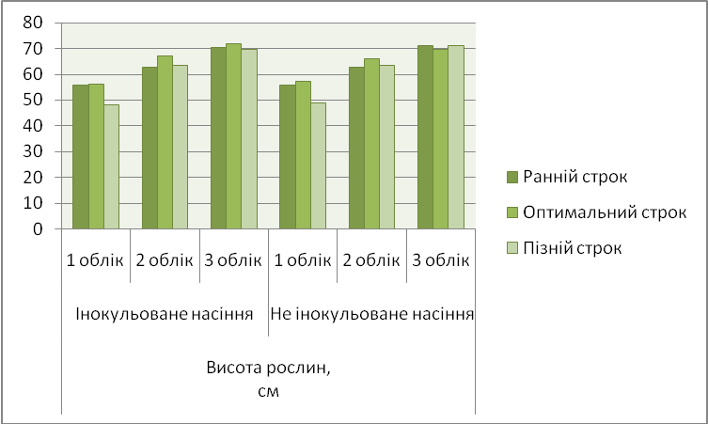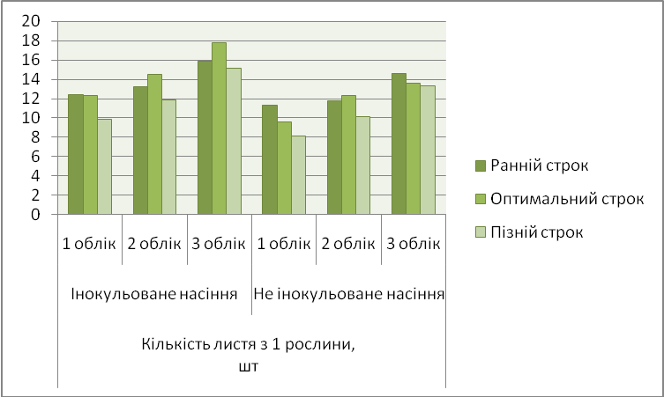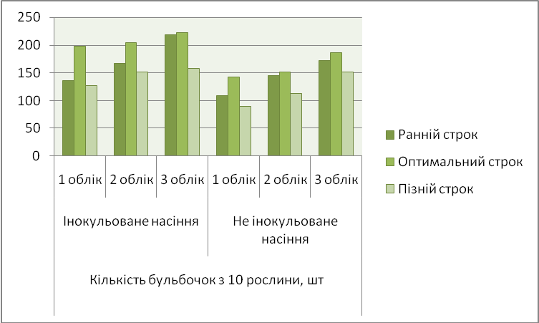

Picture. The dynamics of the plant depending on sowing time and processing
by biopreparation «Rizogumin» (average over 2012–2014)
2. 1000 grain weight of soybean depending on the elements of technology of cultivation
(average over 2012–2014), g
 | Early sowing time | Optimal  sowing time | Late sowing time
Inoculated seeds | 236 | 184 | 185,6
Untreated seed | 176,7 | 174,2 | 146,8
3. Structural indicators of soybean depending on the inoculation of seeds and sowing time,
2012–2014
Sowing | Number of beans per 1 plant, units | Number of grains per 1 plant, units
Sowing inoculated seeds
Early | 33,3 | 72,7
Optimal | 32,6 | 59
Late | 34,9 | 62,6
Sowing untreated seed
Early | 41,7 | 59,2
Optimal | 28,8 | 54,3
Late | 32,2 | 56,7

The lowest weight of 1000 seeds was on nontreated with the «Rizogumin» options, especially in case of late sowing time (146,8 g). The greatest number of beans was on nontreated with the «Rizogumin» variant for early sowing time, however, the number of grains on it was 59,2 pieces from 1 plant, whereas in treated with biopreparation variant for early sowing time (number of beans are 33,3 units) number of grains amounted to 72,7 pieces.
Conclusions:
1. Duration of the vegetation period depends on sowing time. It is the longest for the early sowing period (100 days), and in further for optimum and late sowing period it reduced by 4–7 days.
2. The best development of plants were in plots sown with treated seeds. 1000 grain weight and structural yields on plots sown with treated seeds were higher than in plots sown pure seeds for all three sowing dates.
3. Yield and quality of soybean crop depends on the sowing date and treatment of seeds before planting. On average over three years, structural indicators of yield and 1000 grain weight were higher in plots treated «Rizogumin» and sown in the early stages.

BIBLIOGRAPHY
1. Бабич А. О. Розміщення посівів і технології вирощування сої в Україні / А. О. Бабич, С. П. Колісник, А. А. Побережна // Пропозиція. – 2000. – №5. – С. 3–11.
2. Гордійчук Н. Інокулянти для сої: екологічно безпечна та економічно вигідна технологія підвищення врожайності // Агроном. – 2011. – №1. – 150 с.
3. Камінський В. Ф. Продуктивність сої залежно від удобрення, способів сівби та норм висіву в умовах південного Лісостепу України / В. Ф. Камінський, Г. М. Заболотний : матеріали міжнар. наук.-практ. конф. [«Землеробство ХХІ століття проблеми та шляхи вирішення»]. – К., 1999. – С. 111–112.
4. Козін К. Удосконалення технології вирощування сої // Агроном. – 2011. – № 1. –138 с.
5. Комок М. С. Ефективність симбіозу бульбочкових бактерій з рослинами сої в залежності від виду біопрепарату / М. С. Комок, В. В. Волкогон, Л. В. Косенко // Мікробіологічний журнал. – 2010. – Вип. 1. – С. 7–19.
6. Москалець В. В., Шинкаренко В. К., Москалець В. І. Вплив мікробних препаратів на інтенсивність фіксації атмосферного азоту / В. В. Москалець, В. К. Шинкаренко, В. І. Москалець // Агроекологічний журнал. – 2006. – №3. – С. 32–36.
7. Нагорний В. І. Агротехнічне значення та роль сої в екологізації сільськогосподарського виробництва / В. І. Нагорний., Ю. А. Романько // Вісник Сумського НАУ. – 2009. – Вип. 11 (18). – С. 79–83.
8. Патика В. П., Токмакова Л. М. Пошук мікроорганізмів для поліпшення фосфорного живлення рослин // Бюл. ін-ту с.-г. мікробіол. – Чернігів, 2000. – №6. – С. 56–57.
9. Шевніков М. Я. Наукові основи вирощування сої в умовах лівобережного лісостепу України. – Полтава, 2007. – 208 с.
10. Аксенов С. М., Туев H. A. Принципы построения биологических систем земледелия : тез. докл. респ. конф. [«Интенсивное земледелие и охрана окружающей среды»]. – Волгоград, 1989. – С. 8–11.
11. Самошкин В. И. Эффективность гамма-ризоторфина на посевах сои в Крыму /
В. И. Самошкин, Н. З. Толкачев // Бюл. ВНИИСХ микробиологии. – 1981. – №34. – С. 34–36.

