© 2015
Beseda A. A., Candidate of Engineering Science

Taras Shevchenko Luhansk National University
STUDY OF RESISTANCE DURING COVERING OF SOWING CROPS INTO THE SEED FERTILIZER PIPE
Reviewer – Doctor of Engineering Science A. V. Chesnokov
The work is devoted to the study of the movement of seed under the action of gravity in sowing system, namely «sowing system – seed fertilizer pipe – guiding device – undertenon space of dovetail ploughshare – switchgear». The impact of resistance during the flow of seed on the example of winter wheat was theoretically described, which is considered with regard to the form of profile of its convenient shape by flow in sow automate, provided mechanical feeder that is able to asume and theoretically describe the general scheme of seed movement in sowing system.
Keywords: frontal resistance, streamlined thing, strength, seed tube, seed, object shape, pneumatic conveying.

Statement of the problem. To investigate the resistance during the flow of seed flow in seed fertilizer pipe of seeding machines.
One of the factors that affect the seed flow during moving in seed tube and its structural elements distribution – is power resistance at the flow of seed by flow.
Analysis of recent researches and publications, which are based on the solution of this problem. Similar problems regarding agricultural mechanics was solved by academician Р. M. Zaika [1], рrofessor I. V. Morozov [2] and other.
A number of authors have investigated the influence of the guide elements on the seed material in the seed coulter, the quality of seed crops [3–4], but they consider planting material as a round body or material point, not taking into account the structural form of the profile of the grain.
Aim of the research. To investigate the resistance to the flow of seed in seed fertilizer pipe of seeding machines.
Task of the research – to consider the movement of seed material, taking into account the streamlined body in the system: «sowing system – seed fertilizer pipe – guiding device – undertenon space of dovetail ploughshare – switchgear».
Objects and methods of the research. During the movement of seed in the system «sowing system – seed fertilizer pipe – guiding device – undertenon space of dovetail ploughshare – switchgear» in terms of mechanical submission considers the following variable values: the speed of the air flow generates a pressure fed into seed tube; the shape and size of the sender and of the distributor, the lengths of seed tube and the radius of curvature of seed fertilizer pipe; rotation turnings of seed fertilizer pipe, consumption of seed (grain) per unit of time, and the resistance of the material.
Results of the research. At the initial stage of the modeling process seed distribution we take cereals (winter wheat) having average dimensions: length d_{х}=6,3 mm, width d_{у}=2,8 mm, thickness d_{z}=2,6 mm and mass m=0,045 gramme.
During this seed is moving in the air stream (picture 1) under the action of gravity, periodically testing the collision with the walls of seed tubed, distributor and arch arched feet.
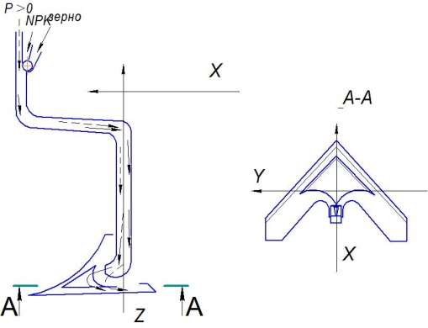
Picture 1. Is a diagram of the movement of seed in seed tube.

We have made the assumption that the seed material should be considered as sufficiently elastic body with the shape of the surface in the form of ellipsoids of rotation, taking into account, however, the high strength properties until the primary cracks [4].
The impedance areas of seed fertilizer pipe and its structural elements, which contained the body, streamlined flow derived from the resistance of its own land ζ_{ar} (for direct area – this frictional resistance) and resistance of the body ζ:
$ζ≡\frac{Δρ}{ρ⋅w_{0}^{2}2}=ζ_{\text{ar}}+ζ$. (1)
The power required to overcome the resistance forces of the body, the streamlined flow in seed tube and structural elements, is expressed through the power of frontal resistance Р_{f} this body,
$ΔN=P_{f}⋅w_{l}$. (2)
This power can be expressed through the coefficient of local hydraulic resistance of the pipe section, in which the body is placed:
$ΔN=ρ⋅w_{0}^{2}2w_{0}F$.
The force of frontal resistance
$P_{л}={c_{x}⋅S_{м}⋅ρ⋅w_{0}^{2}}/2$, (3)
where
$w_{l}=w\left(1−τ⋅S_{м}⋅F_{0}\right)$; (4)
$c_{x}$ – the frontal resistance’s coefficient of the body depending on the body shape, Reynold’s number $R_{e}^{'}=w_{0}⋅d_{м}/ν$ and other parameters;$S_{м}$, $d_{м}$ – accordingly middle area (m²) and the diameter or longest side (m) fuselage mid-section of the body; – the local flow velocity (in the live section $\left(F_{0}−S_{м}\right)$), id estthe velocity in the pipe section, m/s; $w$– the velocity at a given point in the section in front of the body, m/s; $τ$ – correction factor taking into account the influence of the shape of the body and narrowing of the cross-section of the pipe; for streamlined bodies $τ≤1,0$; for other bodies $τ≥1,0⋅\left(3\right)$ [3].
The joint solution of equations (1-3) shows the relationship between the coefficient of local resistance $ζ$and the frontal resistance’s coefficient $c_{x}$ of body:
$ζ=c_{x}⋅S_{м}F_{0}⋅{\left(w_{l}/w_{0}\right)}^{3}$. (5)
An important factor affecting the frontal resistance’s coefficient of the body is the shape of its profile. The more streamlined shape a body has, the less flow separation and vortex formation, and therefore less frontal resistance. Therefore, where it is possible, you should use the streamlined body shape. Convenient profile shape of the body is characterized by a smoothly rounded front part and a longer wedge-shaped rear part (Pic. 2).
Of these forms are elliptical cylinders and circular cylinders, equipped with rear fairings. For such bodies, the frontal resistance’s coefficient is obtained higher than for bodies, shaped according to table 10-2 [3]. However, due to the simplicity of construction of such bodies are often used in practice.
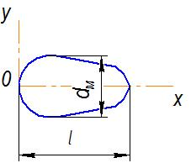
Picture 2. Profile adobeimage body.
Conclusion.
Considered the connection and dependence of the resistance for the flow in the stream allows us to represent the general flow pattern of the flight of seed in the system «sowing system – seed fertilizer pipe – guiding device – undertenon space of dovetail ploughshare – switchgear – seed bed», during the mechanical condition of their submission, after colliding with each other, with the walls of seed tube and the structural elements of the dovetail ploughshare.
In the general case, the speed in the pipe is unequally distributed over the cross section; therefore, the resistance of the body depends on the location of its cross section.

BIBLIOGRAPHY :
- Заика П. М. Избранные задачи земледельческой механики / П. М. Заика. – К. : изд-во УСХА, 1992.
- Морозов І. В. До обґрунтування параметрів спрямовуючих елементів для насіння в робочих органах сівалок / І. В. Морозов, В. Г. Власенко, М. Г. Доценко // Вісник Харківського національного технічного університету сільського господарства імені Петра Василенка («Механізація сільськогосподарського виробництва»). – 2008. – Вип.75, Том 1. – С. 83–89
- Идельчик И. Е. Справочник по гидравлическим сопротивлениям / И. Е. Идельчик; под ред. М. О. Штейнберга. – [3-е изд., перераб. и доп.]. – М. : Машиностроение, 1992. – 672 с.
- Беседа А. А. Повышение эффективности технологического процесса подпочвенно-разбросного посева зерновых культур распределительно-заделывающими устройствами : дис. на соиск. уч. степени к. т. н. : 05.05.11 / А. А. Беседа. – Луганск, 2012. – 161 с.

