© 2015
Dryuchko A. G., Сandidate of Chemical Sciences,
Storozhenko D. A., Candidate of Chemical Sciences,
Bunyakina N. V., Candidate of Chemical Sciences,
Ivanitskaya I. A., Candidate of Chemical Sciences,
Golub’atnikov D. V., student
Poltava National Technical University named after Yuriy Kondratyuk
THERMO-ANALYTICAL COMPLEX FOR SUBSTANCES IDENTIFICATION BY THE METHOD OF DIFFERENTIAL THERMAL ANALYSIS
Reviewer – Candidate of Physical and Mathematical Sciences A. T. Loburets
The designed thermo-analytical complex in functioning and technical realization of a number of existing prototypes differs from all developed and patented method of formulating the linear law of temperature change of a heater and the use of the combined differential-thermal method of investigating the model and indifferent substance. It uses a precision system for the phase control of average thermal energy supply into the heating zone by program assignment of the proportional, in the course of time, the „development” law of the reference voltage value of the setting device in accordance to temperature characteristics of the chromel-alumel converter with a simultaneous continuous tracking the voltage misbalances Ch-A of thermocouple in the chain of its negative feedback. The complex is simple, with high sensitivity and a good diagnostiсs ability.
The keywords: thermo-analytical complex, identification of substances, differential thermal analysis.
Statement of the problem. To solve a number of scientific and industrial problems on creation of a new one and improvement of existing production procedures of modern production, to obtain the perfect materials for various purposes with a given homogeneity, complex functionality and a set of stable reproducible characteristics, an urgent need arises to use effective multi thermo analytic complexes to identify and characterize the purity of substances by rapid methods.
Analysis of recent studies and publications which discuss the solution of problem. The known analogical solutions of similar tasks were implemented in modern thermo-analytic complexes of MOM firm – derivatographs Q – 1500 D [3]; the company SETARAM – thermo analyzers [5, 6], thermal differential quantitative analyzers Model „2000 K”, Model „1500K” [8, 6], differential programmable calorimeters DSK111, 101 [6, 6]; the company Bahr-Geratebau GmbH – complexes for samples study by differential thermal analysis (DTA) and simultaneously using methods of differential thermal analysis and thermo gravimetric analysis (STA) [2], partly on a special laboratory equipment [4] with a linear power static output characteristics, designed for high-precision regulation and stabilization of thermal processes and others.
In addition to the complexity and high cost, their disadvantage is that they cannot be universal for solving complex problems due to existence of a wide diversity and complexity of the studied objects. Constructions of power blocks of heating systems, the use of the available peripheral equipment supplies do not provide easy access to the research object and visual observation of the transformation process, that is important for the comprehensive study of nature and temperature limits of a number of imposed thermal processes: dehydration, decomposition, phase transformations (especially high-intensity, with gas emission, and so on); the functional dependence of physical properties of substances in conditions and modes not covered by the operating instructions of the complexes exploitation; the study of samples in small quantities. This leads to an inevitability of research results, increases the probability of error interpretation of nature and mechanisms of transformations, and in some cases, it even makes impossible the implementation of the task.
The development objective of the complex is the creation by simple technical means of a multipurpose laboratory device for identification of substances by heats of phase transformations (melting, boiling, crystallization, polymorphic transitions), thermal decomposition; the study of nature and temperature limits of a number of thermal effects: step-like, close by temperature values and such that overlap (due to a change in the spatial modification, dehydration, decomposition, etc.); functional dependencies of physical properties of substances; qualitative and, in some cases, quantitative analysis of mechanical mixtures of substances; measuring the temperatures of phase transitions of individual substances and systems, building the state diagrams on their basis.
The task of creating such device has generated extensive research and implementation of creative choice of the most optimal variant of its technical implementation, that combines the efficiency and benefits of the principles which are the base of modern control systems designing in the control unit by programming the temperature in derivatograph [3], and increased stability and reliability of precision control systems for thermal processes organized by using linear elements in the main circuit of the negative feedback [1, 5, 8–13]. It is possible to use other combined options (for example, with a discrete electronic setting the reference voltage), which are particularly effective in automation of the experiment.
The results of the development. The complex functioning is based on the use of the combined differential-thermal method of sample and indifferent matter study. The complex consists of easy dismountable electric furnaces with special holders and cartridges for samples and standards, a device for forming the linear law of the heater temperature (DFLLT) with a phase control, tablet double coordinate compensation potentiometer for recording thermo grams of the studied samples in the coordinates ∆T–T.
Its working temperature range is determined by the values area of using the chromel-alumel (Ch-A) converters, up to 1300 ^{о}C. High metrological characteristics of the complex are provided by the use of thermocouples Ch-A in a negative feedback device of temperature control and a number of scheme and design solutions for its implementation.
The domestic industry does not produce such complexes. Its method of operation is patented [7]. Depending on purposes of assigned tasks, the device may be used independently in the local systems or complex tools during thermo-analytic research.
The functioning of the complex is clearly explained below by the structural diagram (Pic. 1).
The work of programming temperature controller (DFLLT) is based on the phase control method of the power supplied to the electric resistance heaters. It consists of a temperature setter, primary transducer (temperature sensor – chromel-alumel thermocouple, TChA), node of subtracting (NS) on the basis of the differential and operational amplifier, a threshold device (Schmitt trigger, ST), generator with a linear law of voltage change (GWVL) for synchronization of the device operation with the frequency of voltage supply, the blocking generator (BG), power block, the indication scheme of operating modes of the device, the indication scheme of circuit break of the thermo transformer, the parametric stabilizer of bipolar voltage supply.
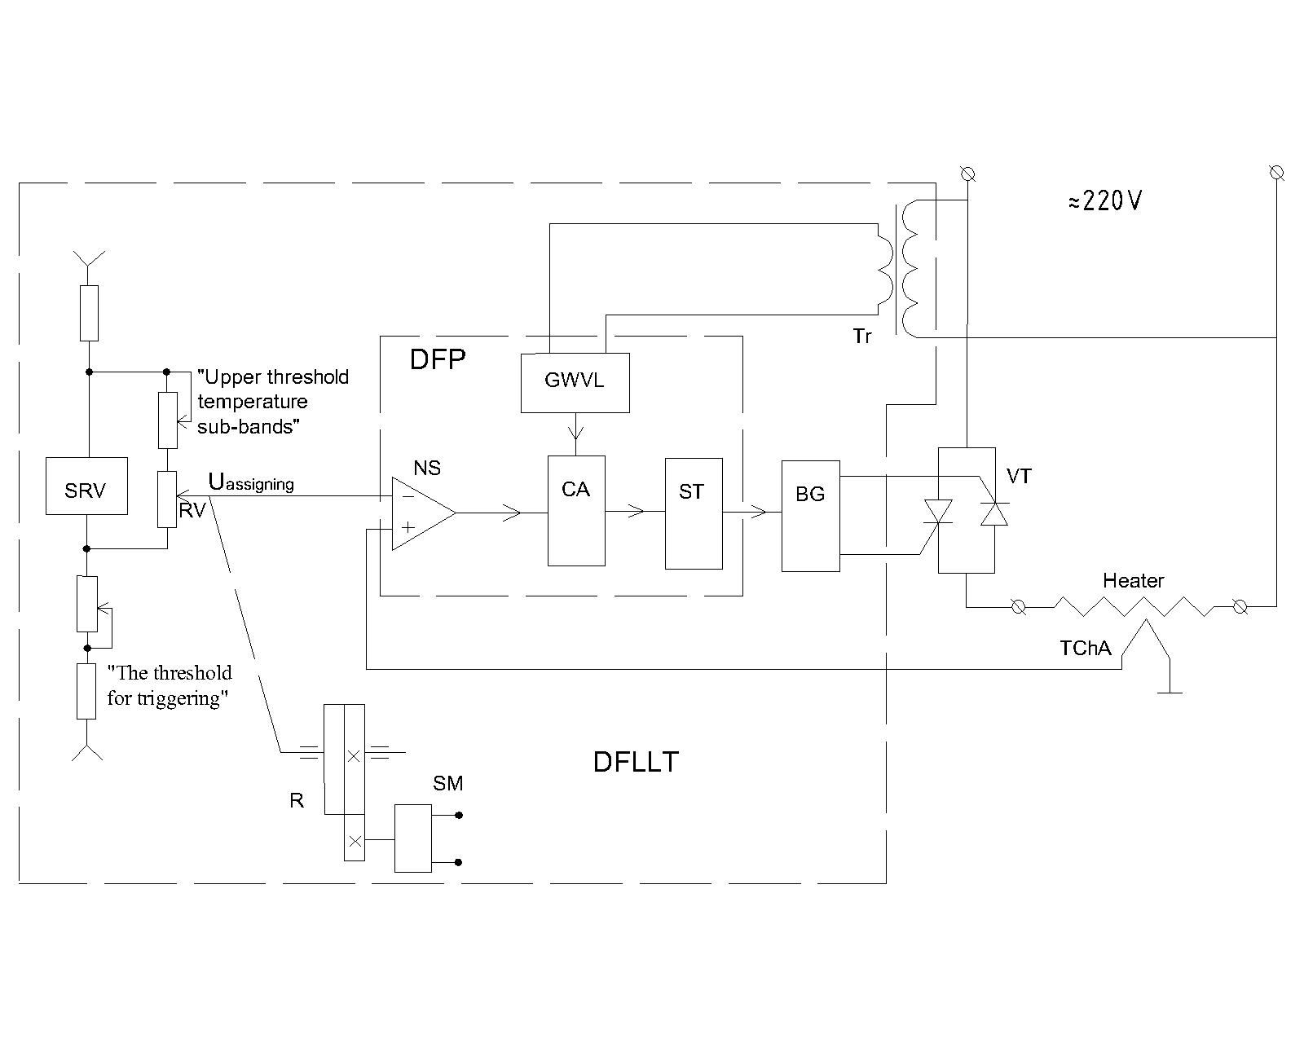
Picture 1. The structural scheme of the device forming the linear law of temperature change of the heater
In the node of the voltage generator it was used the serial changeable potentiometer RV with a linear dependence of resistance on the turn angle (characteristic A) after a simple removal of the final position fixer, on the shaft of which a gear is mounted. Reducer (R) with dual gears and a ratchet allows the easy change of the slider position of the potentiometer in the course of the experiment and also to set it in its original position. For easy operation the potentiometer, gear, synchronous motor (SM) are rigidly mounted on a general remote platform.
The experiment is preceded by a preparatory stage: a) the slider of the potentiometer knob with a ratchet mechanism is set at the initial position; b) the potentiometer of «threshold» activation correction is switched to the position that corresponds to the moment of activation of the control system; c) the t_{initial} of the research object is determined; d) depending on the purpose of the task and the programming mode of temperature rise, the gear ratio of the drive mechanism of a temporary "sweep" of the reference voltage generator is chosen and installed in accordance with the table of Appendix 2 of [11] U resistant top, that fits the upper limit value of the investigated temperature subdivision. After completing all preparatory operations on the command "start" the operation of the complex in the automatic mode starts.
Voltage of temperature setter from a precision reference source (SRV) is supplied to the inverting input node of subtraction (NS). To its non-inverting input the chromel-aluminel thermocouple is connected and is introduced into the chain of main circuit of negative feedback of the regulation system, and the choice of its type is determined by almost natural linear dependence of the EMF on temperature, which is characteristic for electrodes of chromel-alumel alloys. Hot junction of the thermocouple is located near the heater and insulated with a thin layer of heat-resistant dielectric. The voltage difference between the setter and the thermocouple is a signal of error. At the input of the agreement cascade (CA) a signal of an error is summed with the voltage of the formator of linearly alternating voltage (GWVL). In condition:
on the output of Schmitt trigger the rectangular impulses are formed. The back front of them is fixed and coincides with the end of the working voltage supply half period in a network, and the leading front "shifts" during the change of an error of a signal in the tracking system of the temperature controlling device. Rectangular impulses generated by the Schmitt trigger direct the work of the blocking generator, on the output of which a series of impulses with a total width corresponding to the duration of rectangular pulses appear. The blocking generator is used for electrical decoupling the control circuit with the power part of the regulating device using an impulse transformer. The impulses from the secondary winding of the transformer of the blocking generator control the opening phase of power thyristor valve (VT), thus conducting proportional control of average power of the heater. The supply of energy to the object is carried out until the temperature reaches the set value. The voltage at the output of the differential amplifier approaches zero, and the power valve closes. The system slowly passes through the number of successive quasi close states, reproducing linear temperature regularity in the heating zone with time.
A device with such additional linear chain «N. F. B.» shows a weak dependence on the instability of hardware components and at a large depth of the negative feedback, according to the power, not only provides high linearity of transmission coefficient, but also a weak dependence of the output power on voltage supply fluctuations.
The advantage of this method in its technical implementation is into the control system of a heater with a temperature deviation of the parameter during the problem solution is the use in the system of parameter setter and linear negative feedback of natural linear dependence of thermo power ЕMF chromel-alumel alloys, from the temperature difference of their hot and cold junctions, that currently is not used in any similar analytical tools. It is of interest due to schematic and design forms of problem solution of law formation of regulating the temperature of an object and is simple, with high sensitivity and a good distinctive character. It is being implemented in modern completing serially manufactured elements and can be offered for the use in the solution of many similar tasks.
Conclusion. This development can be used for fundamental scientific research, at laboratories for performing express analysis of phase composition of input materials and final products, testing, reliability assessment and determination of development resource, certification, establishing functional relationships of the studied objects, etc.

BIBLIOGRAPHY
1. Дериватограф Q-1500 D. Руководство по эксплуатации. МОМ, Завод оптических приборов. – Будапешт, 1990. – 102 с.
2. Заметин В. И. Линейный тиристорный усилитель для регуляторов температуры / В. И. Заметин // Приборы и техника эксперимента. – 1976. – №2. – С.113.
3. Иващенко Н. Н. Автоматическое регулирование / Н. Н. Иващенко. – М.: Машиностроение, 1973. – 430 с.

4. Каталог промышленного контроля компании CETAPAM. Научно-исследовательские инструменты и приборы. Калюир.. Термоанализаторы. – 1991. – С. 5.

Дифференциальный программированный калориметр ДСК 111, 101;

БИО ДСК «БАТЧ ФЛОУ». – С. 6 .

Калориметр Кальве – С. 7, С. 80.

Термические дифференциальные количественные анализаторы Модель «2000 К», Модель «1500 К». – С. 8.

5. Пат. 43549 Україна, МПК G 05 D 23/00. Спосіб програмного формування лінійного закону зміни температури нагрівника / О. Г. Дрючко, Д. О. Стороженко, Н. В. Бунякіна, І. О. Іваницька. – № 2009 01783 ; заявл. 02.03.2009 ; опубл. 25.08.2009, Бюл. №16. – 10 с.
6. Певзнер В. В. Приборы и системы управления / В. В. Певзнер, В. П. Ткачев. – 1973. – №6. –
С. 32.
7. Попов Е. П. Приближенные методы исследования нелинейных автоматических систем /
Е. П. Попов, И. П. Пальтов. – М.: Энергия, Наука, 1974. – 292 с.
8. Попович М. Г. Теорія автоматичного керування / М. Г. Попович, О. В. Ковальчук. – К. : Либідь, 2007. – 656 с.
9. Приборы автоматические следящего уравновешивания КС 2. Техническое описание и инструкция по эксплуатации ТО-994. – С. 68.
10. Тиристоры. Технический справочник / [авт. текста Лабунцов В. А.]. – М. : Энергия, 1971. –
76 с.
11. Шукшунов В. Е. Корректирующие звенья в устройствах измерения нестационарных температур / В. Е. Шукшунов. – М. : Энергия, 1970. – Вып. 383. – 80 с.

12. Atkinson P., Gee A. E. The Radio and Electronic Engenearing – 1969. – Vol.38. – №1. – Р. 23.

13. Bahr Geratebau GmbH. Systeme zur Thermoanalyse. Hullhorst. 1991. – S. 7.

