© 2013
Kuzmenko O. B., Doctor of Economics
BlackSea State University Named After Petro Mohyla
ORGANIC FARMING AS A FACTOR OF EUROPEAN INTEGRATION OF UKRAINE
Reviewer - Doctor of Economics V. G. Vyun
The necessity of the development of organic farming in Ukraine, as a condition of growth of exports of agricultural products to the European Union was grounded. That at the same time ensures the preservation and reproduction of the qualitative characteristics of land resources. It is proved that the trend of demand for organic products in the European Union and the available high-quality and environmentally friendly land resources in Ukraine create the preconditions for enhancing organic production and corresponding exports. The problems hindering the implementation of the farming system and proposals for their solution were defined.
Keywords: organic farming, export, production, European Union, land resources.

Statement of the problem. Ukrainian agricultural sector demonstrates stable trends of growth (agricultural production index increased by 17.5% in 2011) in a volatile world economic situation. Industry’s export potential actively develops in these circumstances. In 2012 share of exports in total foreign trade in agricultural products sector was 69.8% and reached 18.2 billion dollars USA [13].
A Ukrainian export of agricultural products to the European Union is growing: 2010 – 2.12 billion dollars (29% of total exports); 2012 – 5.08 (27.9%) and it takes the second place in regional structure [13]. However, the commodity structure of exports is dominated by seeds and oleaginous fruits – 33.16% (this is mainly sunflower and rapeseed), fats and oils of animal or vegetable – 29.75% (this is the same oil crops), crops – 7.44% [4], which is provided by corresponding production increase.
However, high yields of grain and oil crops (2011 – 37.0 kg / ha of grain and leguminous crops, 18.4 kg / ha – sunflower, 17.3 kg / ha – rape) are achieved by potential natural soil fertility and favorable climatic conditions in recent years [12].
It was brought 68 kg of active ingredient per hectare fertilizer and 0.5 t / ha of organic fertilizer at harvest of 2011 in the average per hectare crop, which does not provide non-deficit balance of humus (-0.37 t / ha) and nutrients (-117.7 kg / ha) [10].
The growth of export-oriented crops, primarily sunflower and rapeseed, is conducted by expanding acreage of these crops which gives evidence-based rotation. For example sunflower is 26-31% in the crop areas of Mykolayiv region in recent years, which means that the culture returns to the same field in 3-4 years. And this culture always ends a crop rotation in science-based crop rotations and after it a required field remained under black couples, and the term of its return is at least seven years. Sunflower increases the intensity of water erosion as cultivated crops: loss of humus in chernozems under its crops reach 1.3 - 1.4 t / ha per year on the slopes of 1 to 3 degrees [2].
The problem of agricultural export sector structure improvement in the EU considering European aspirations of Ukraine based on such farming system that ensured a steady demand for the rational use and land resources protection. One of such systems is organic farming.
Analysis of major studies and publications which discuss the problem. Japanese philosopher Mokishi Okada (1882 - 1955 years) is considered to be the organic farming concept founder. German scientist Rudolf Steiner (1924 biodynamic farming), French scientist Lemaire Boucher (1964 Biological farming), Ukrainian scientists John Ovsinskyy, Alex Podolinskyy contributed to its development. World-known scientists T.S. Maltsev, F.T. Morhun, M.K. Shykula and others worked on this problem. In 2011 organic farming land area in Ukraine constitute 0.65% of the total area of farmland despite active involvement of scientists. Underdeveloped market, especially exports, is one of reasons for that.
The purpose of the research is to substantiate the theoretical principles of organic farming and to provide practical recommendations for its development.
Achieving this goal necessitated the following tasks:
- to analyze the nature of organic farming;
- to justify the farming systems development need for the agriculture export potential of Ukraine intensification;
- to outline the organic farming prospects in Ukraine;
- to establish the positive technology impact on the organic soil condition quality;
- to identify the development of organic farming constraining factors and to suggest ways to overcome them.
Studies. Agriculture as one of the first activities of mankind has long been directed only to increase food production and to obtain raw materials for industry. This resulted a constant increase of costs of energy and resources per unit of output as well as in natural capacity of soil depletion and environmental pollution. Alternative farming systems (biological, organic and biological, biodynamic, ecological, organic) were established to prevent these processes.
The main elements of these farming systems are:
- ban or significantly restriction of the use of fertilizers and pesticides;
- soil fertility maintenance through organic fertilizers application (manure, green manure, plant residues, other organic matter);
- minimum soil-tillage, preventing its degradation;
- compliance with science-based crop rotations;
- biological methods of pest control;
- ban to use genetically modified organisms.
In essence, the combination of these elements is the definition of organic farming given by U.S. Department of Agriculture in 1980 [17].
By definition of the International Federation of Organic Agriculture (IFOAM) Organic agriculture combines all agricultural systems that support environmentally, socially and economically appropriate to agricultural production. Locally-specific soil fertility use as a key element of successful production underlies such systems. These systems use the natural capacity of plants, animals and landscapes and are aimed at the agricultural practices and the environment. Organic farming significantly reduces the use of external inputs (resources) by limiting the use of chemically synthesized fertilizers, pesticides and pharmaceuticals. Instead, other agro technical and various natural factors are used to improve yields and plant protection. Organic farming respects the principles which are caused by local socio-economic, climatic, historical and cultural features [16].
It should be noted that the conservation and improvement of soil fertility is one of the main components in the organic farming system where basic technological methods and measures are focused.
Organic farming technology rapidly distributes in the European Union (Table 1).
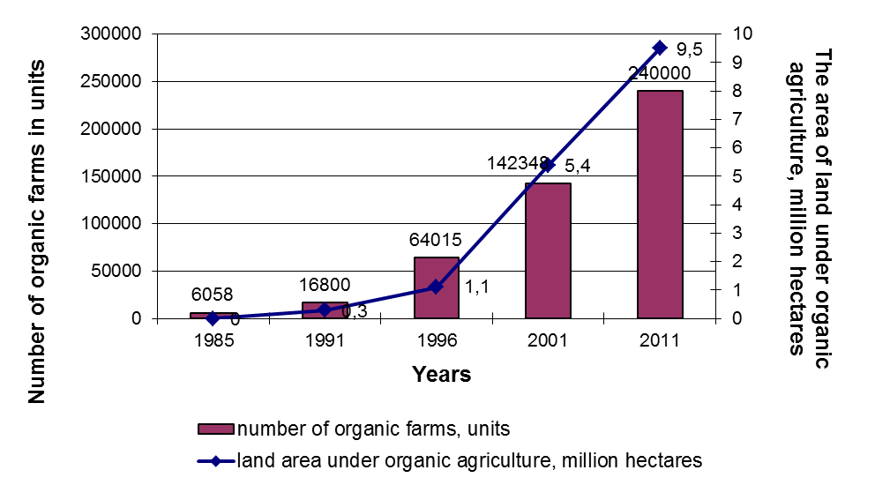
Table 1. Organic farms and land area under organic farming dynamics in the European Union. (constructed according to [15, 14])

So, the number of organic farms in the EU increased from 6058 to more than 240,000 and a land area of organic farming from 172 thousand hectares to 9.5 million hectares representing 5.4% of agricultural land, for the period from 1985 to 2011.
The European Union organic products market increases rapidly (Table 2) [14]. It increased 1.97 times, reached 19.7 billion euros and has a tendency to further increase during 2004-2011 years.
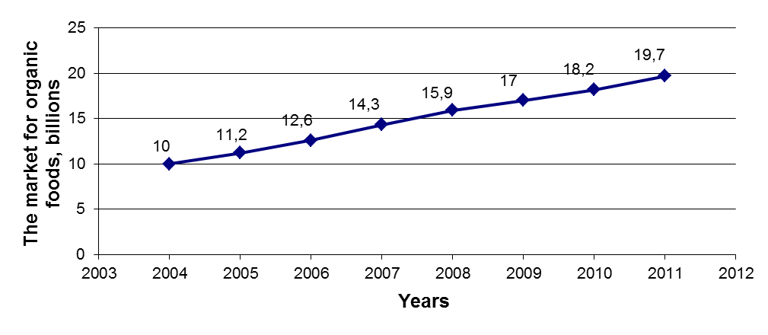
Table 2. The European Union organic products market dynamics (source [14])

Organic products markets of the following countries have the largest volume: Germany – 6.6 billion euros, France – 3.76 billion euros, United Kingdom – 1.9 billion euros. Such countries differ in the largest consumption of organic products per capita: Switzerland – 177.4 euros, Denmark – 161.9 euros, Luxembourg – 134.3 euros.
The main reasons for consumption of organic products are:
- ecological food safety, high quality and fresh products;
- superior taste of organic products;
- environment preservation in production process;
- absence of genetically modified organisms.
However, despite organic production active development the European Union has limited capacity in production development. Main reasons for that are: low quality soils characteristics, wide use of intensive technologies in agriculture. These areas "surround" organic farm lands constraining their development.
Considering this situation and trends Ukraine has prospects to take its segment of European Union organic products market. Considering European aspirations of Ukraine, especially in free trade area creation, organic farming may be one of the factors strengthening economic ties with the European Union while introducing resource-saving technologies.
The EU supports stable demand for organic grains, legumes, fruits, vegetables and their products. At the same time, they occupy a small proportion in Ukrainian exports to the European Union: crops – 7.44%, edible fruits and nuts – 3.53%, vegetables and roots – 1.1% [2]. The presence of fertile, clean land and relatively low labor costs offer significant potential for intensification of export activity.
According to Shykuly M.K. [1] there are about eight million hectares of organic black soil land in Ukraine. Kisil V.I. identifies areas suitable for cultivation of ecologically pure products [13], where about 50% of Nikolaev and 80% of Kherson regions are suitable for organic farming. But according to IFOAM only 270,320 ha in 155 certified farms were occupied under organic farming in Ukraine in 2011 [14].
Organic farming improves the environmental and economic efficiency. Accelerated recovery of soil nutrients, organic matter, trace element composition of the soil, cleaning of soil from heavy metals are set by organic technology of non-tradable production crops with concomitant treatment of microbiological agents use on a typical soil of Nikolaev region [6, 7, 8, 5]. This allows to save the use of fertilizers, and to receive additional products [9].
However, despite the prospects of export potential and the preservation and restoration of soil quality characteristics, constraints of organic agriculture in Ukraine are:
- Lack of legal framework in the form of the Law of Ukraine “On the production and turnover of organic agricultural products and raw materials” adopted by the Verkhovna Rada of Ukraine in 18.09.2012, and which is under construction on the proposals of the President of Ukraine.
- The transition to organic farming varies from 2 to 5 years, during which the person incurs losses from reduced yields and weed and pest control.
- Fee for certification in the EU is 250-750 euro area average of 30-50 hectares. In Ukraine, the average area of certified farms is ​​2200 hectares which increases costs but one have to pay for transportation and hotel inspector. [11]
- Low levels of awareness, ecological culture, education and innovation activities of agricultural producers.
Thus a legislative framework should be developed in Ukraine to enhance the export potential and to solve the environmental problems of agriculture, to provide a government support for farms in transition and during the certification for compliance with organic production, to create an infrastructure market of organic products.
Conclusions. Ukraine Exports of agricultural products in the EU demonstrates stable growth in the last period. However, its commodity structure differs in a large proportion of crops and their products. Such unilateral exports promote disruption of crop rotation and land resources degradation. Organic farming in the European Union has a growth trend in the number of farms, land area and the volume of products consumed. Ukraine has prospects for export potential development, strengthening of economic ties with the EU while using soil quality characteristics preservation and restoration technologies, considering large areas of fertile and clean soil existence in a growing demand for organic products in the EU. To do this, the Law of Ukraine “On the production and circulation of organic agricultural products and raw materials” must be completed, public households assistance should be provided during organic technology transition and certification, information and consultancy work for the organic farming implementation should be intensified.
REFERENCES
- Відтворення родючості ґрунтів у ґрунтозахисному землеробстві / Під. ред. М.К. Шикули – К.: Оранта,1998. − 680 с.
- Зубець М. Наші чорноземи – неоціненне надбання природи / М. Зубець, С. Балюк, Б. Носко // Голос України. – 2009. − №59(4559). − 2 квітня. – С.18-19.
- Кисиль В.І. Біологічне землеробство в Україні: проблеми і перспективи / В.І. Кисиль. – Харків: Вид-во «Штрих», 2000. – 161 с.
- Клименко І.В. Спільна аграрна політика Європейського Союзу: можливості та виклики для України (аналітична доповідь)/ І.В. Клименко, Н.Г. Бугрій, І.В. Ус.− К.: НІСД, 2011. − 19с.
- Кузьменко О.Б. Вплив мікробіологічних препаратів серії ЕМ на вміст важких металів в ґрунті при внесенні рослинних поверхневих решток зернових культур/ О.Б.Кузьменко // Вісник Харківського національного університету ім. В.В. Докучаєва: Харків: вид-во ХНАУ,2010. – №5. − С. 202 – 206.
- Кузьменко О.Б. Вплив мікробіологічних препаратів серії ЕМ на розкладання нетоварної частини урожаю зернових культур для повернення поживних речовин в ґрунт / О.Б.Кузьменко //Таврійський науковий вісник: [науковий журнал]. – вип.. 71. – Херсон:..2010. – С. 123 – 129.
- Кузьменко О.Б. Вплив мікробіологічних препаратів серії ЕМ на розкладання нетоварної частини урожаю зернових культур для відновлення поживних речовин ґрунту / О.Б.Кузьменко // Вісник аграрної науки Причорномор’я : Науково-теоретичний фаховий журнал Миколаївського державного аграрного університету. – вип.2(53). – Миколаїв: вид-во МДАУ,2010. – С. 198 – 205.
- Кузьменко О.Б. Вплив мікробіологічних препаратів серії ЕМ на розкладання нетоварної частини урожаю зернових культур для відновлення мікроелементного складу ґрунту / О.Б.Кузьменко // Вісник Полтавської державної аграрної академії: – №3 – Полтава: вид-во ПДЛА,2010. – С. 44 - 49.
- Кузьменко О.Б. Розвиток органічного землеробства в умовах ринку землі в Україні / О.Б.Кузьменко // Економіст: 2013. – №3 − С. 38 – 39.
- Національна доповідь про стан навколишнього природного середовища в Україні у 2011 році. – К.: Міністерство екології та природних ресурсів України, LAT&К. – 2012. – 258 с.
- Правила для виробників сертифікованої органічної продукції. [Електронний ресурс] – Режим доступу: www.organic.com.ua
- Сільське господарство України за 2011 рік/ [ред. Н.С.Власенко]. – Державна служба статистики України. − ДП «Інформаційно-аналітичне агенство». − Київ. – 2012. – 376 с.
- Стан зовнішньоекономічних відносин в системі агропромислового комплексу України за 2012 рік. [Електронний ресурс]: за даними митних органів. − Режим доступу: minagro.gov.ua/system/files/
- FIBL and IFOAM. The World of Organic Agriculture Statistics and Emerging Trends 2013. [Електронний ресурс]. – Режим доступу: orgprints.org/22349/7/fibl-ifoam-2013-regions-2011.pdf.
- M. Yussefi and H. Willer. The World of Organic Agriculture 2003: Statistics and Future Prospects. [Електронний ресурс]. − Режим доступу: www.ifoam.org
- Organic Agriculture and Food Security (IFOAM Dossier 1, 2002) [Електронний ресурс]. – Режим доступу: www.ifoam.org
- Report and Recommendations on Organic Farming (Washington DC: USDA, 1980), p. xii. NAL Call # aS605.5U52

