© 2013
Tishyn O. L., Candidate of Veterinary Sciences, Senior Researcher
State Scientific Research Control Institute of Veterinary Preparations and feed additives, Lviv, Ukraine
Kotsiumbas H. I., Candidate of Veterinary Sciences, Professor

Lviv National University of Veterinary Medicine and Biotechnologies named after S. Z. Gzhytsky

HISTOSTRUCTURAL CHARACTERISTICS OF WHITE RAT’S LIVER AT ADMINISTRATION OF E-SELEN TOGETHER WITH CLOSAVERM-A

Reviewer - Doctor of Veterinary Science, deputy director of scientific standardization, certification and state control in veterinary medicine of the State Scientific-Research Control Institute of Veterinary Preparations and Fodder Additives V. O. Velychko.
The article shows the influence of E-selenium on condition of white rats’ liver at daily introduction of Closaverm-A in therapeutic dose during 14 days. On the 7th day we observed the development of dystrophic changes together with beam structure impairment in peripheral part of particles, and on the 14th day – activation of regeneration processes, and full recovery of beam structure was observed on the 21st day after last introduction of Closaverm-A.
Key words: Closaverm-A, E-selen, rats, liver, toxicological and pathomorphological tests.

The statement of the problem. The perspective direction of creation of new peculiarities and the improvement of therapeutic ones of antihelminthic drugs is the development of multi componential medicinal products, the composition of which consists of few active substances that amplify each other and can show high efficacy either against adult or larvae parasites. Such requirements are satisfied by antiparasitic medicinal product of wide range of action, the efficacy of which is based on the peculiarities of two active substances – closantel and aversectine developed by “Ukrzooverprompostach” under the name of Closaverm-A [5]. Antihelminthic drugs negatively influence the parasites and simultaneously have unfavourable effect on the animal organism exposed to worming. That is why for elimination of negative influence the medicinal products are used to allow to achieve not only high efficacy during treatment but also to grade the negative effect of antihelminthic medicinal product. One of such medicinal product is E-selen that contains vitamin E and selenium. Selenium – important microelement for organism that provides functional state of cell membranes and strengthens antioxidant effect. Vitamin E is a strong antioxidant and protects cell membranes, controls reproductive function, participates in protein synthesis, stimulates ferment synthesis, some hormones, activates blood formation and is necessary for renewal of other fat-soluble vitamins [2].
Analysis of major studies and publications which discuss the problem. The important stage in development of new medicinal product are toxicological tests. Pathomorphological tests are the final and very important stage of work in assessment of toxicological effect of medicinal product since they give an opportunity to determine the primary changes, adaptive processes of different organs. In the process of studying of medicinal product effect the determination of morphofunctional liver condition is very important [1]. Occupying the central place in control of metabolism, elimination of toxic products, liver actively reacts on the effect of unfavourable factors [4]. We highlighted the liver pathomorphology at continued administration of Closaverm-A to white rats in different doses [6, 7]. However, structural state of liver of white rats at administration of E-selen in complex with Closaverm-A is not defined as yet.
Aim and tasks of research – to determine histostructural changes of liver at administration of E-selen in complex with Closaverm-A in therapeutic dose during 14 days.
Materials and methods. For studying of dynamics of pathomorphological changes of liver at administration of medicinal products 48 white rats at the age of 2-3 months with body weight of 170-185 g were used. 2 analogous groups with 24 animals in each were formed. The first group was control one. The solution of distilled water and propylene glycol was administered to animals during 14 days. Closaverm-A in therapeutic dose (0,05 ml/kg) daily during 14 days and E-selen in dose of 0,02 ml/kg at the beginning of experiment and on the 8th day of Closaverm-A administration were administered to animals of the 2nd group. The medicinal products were administered subcutaneously. On the 7th and the 14th day after administration of Closaverm-A and on the 21st and the 28th day of recovery period the animals decapitated. The postmortem examination was carried out, liver was weighted, the weight coefficients were determined and collected liver parts and fixed in 10 % formalin solution. Dehydration of material and embedding in paraffin were conducted by well-known method. Histocuts were stained with hematoxyline and eosine according to van Hizon method [3].
Test results. At histological test of liver of the 1st control group it was determined that lamellar structure was distinctly expressed. Hepatocytes of polygonal form with big round nuclei were observed. Chromatine of nuclei was localized near karyolemma. Cell membranes were outlined. Cytoplasma was homogeneously stained, basophilic. We observed hepatocytes with two nuclei. Kupffer cells in centrolobular area were of prolonged form and on periportal areas they were rounded (fig. 1).
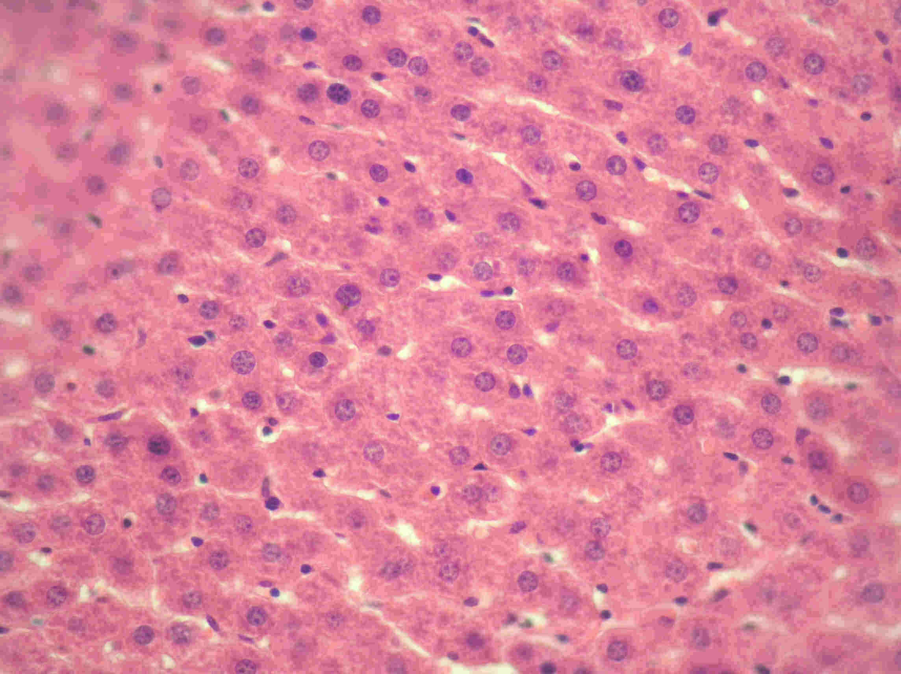
Fig. 1. Liver of rats of the 1st group. Radial lamellar straucture. Hematoxyline and eosine stain.
About 10, v. 40
At histological test of rat liver of the 2nd group on the 7th day of administration of Closaverm-A with E-selen we observed expressed discomplexation of gulches. In central part of particles radial structure of gulches was expressed, boundary between cells is observed, cytoplasm of hepatocytes is stained, nuclei of round form with chromatine location under karyolemma. On the periphery of particles most of hepatocytes were swollen, their cytoplasm is heterogeneously stained, granular, outlines between cells are degraded, not clear (fig. 2).
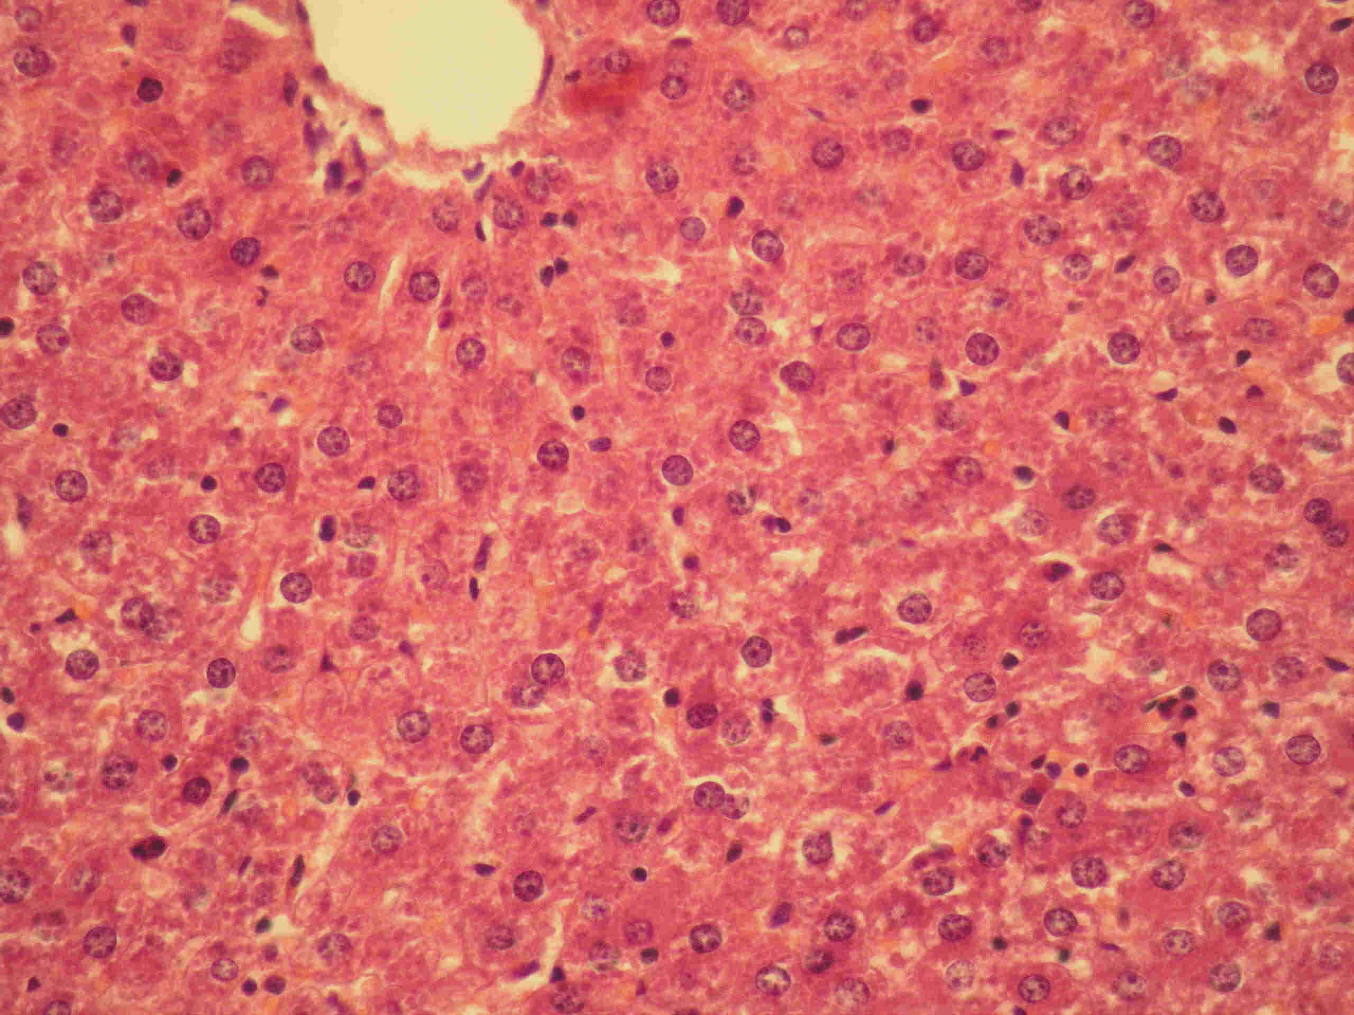  Fig. 2. Liver of rats of the 2nd group on  the 7th day of administration. Discomplexation of gulches on the periphery of particles. Hematoxyline and eosine stain.  About 10, v. 20 | 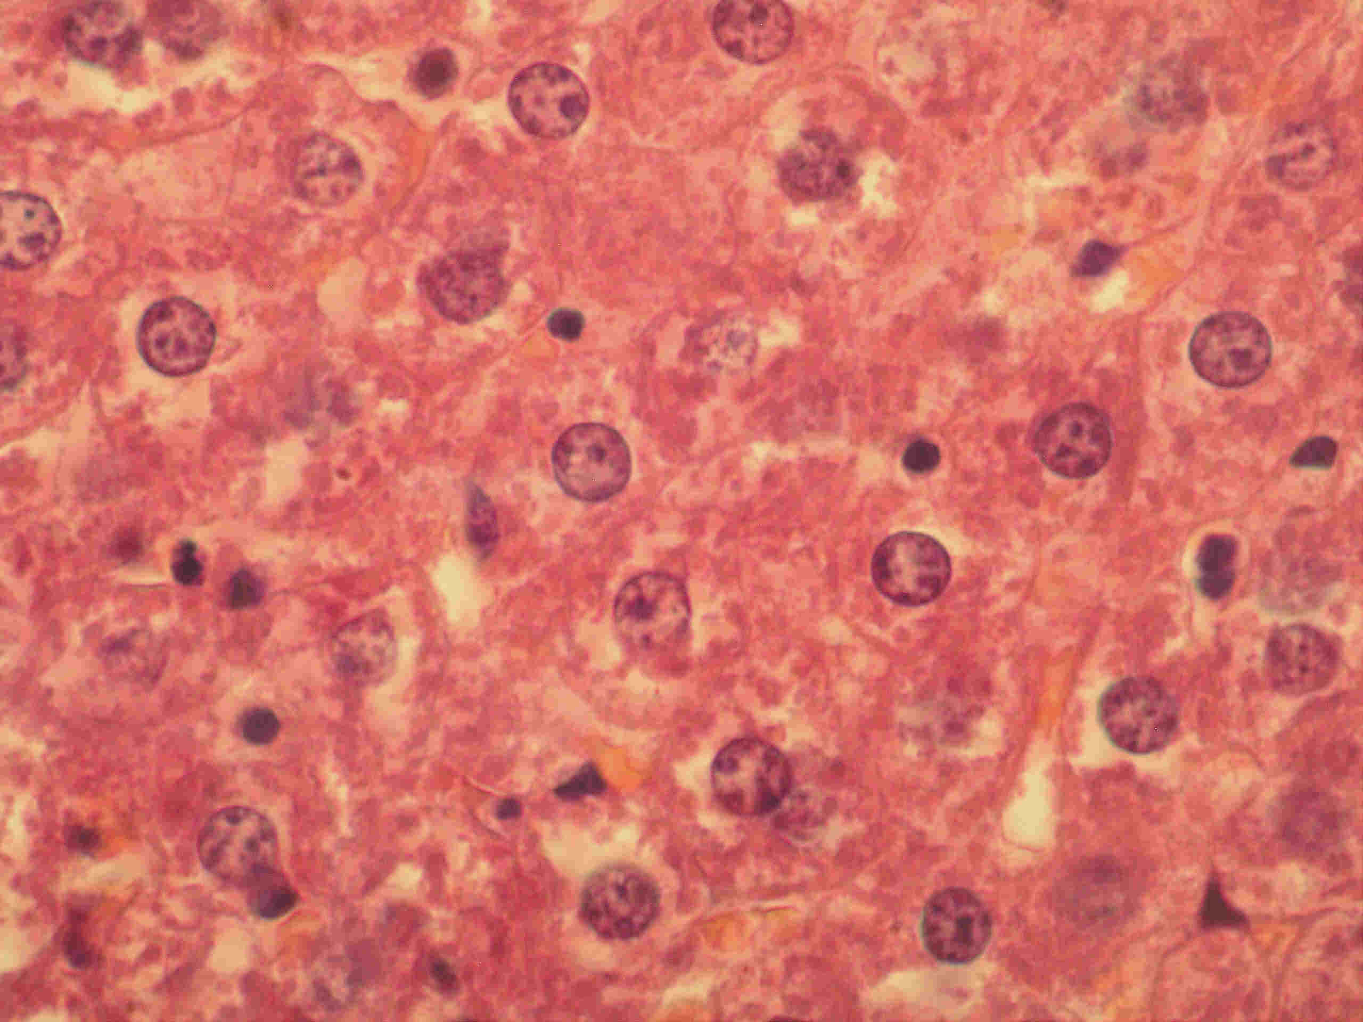  Fig. 3. Liver of rats of the 2nd group on  the 7th day of administration. Granular dystrophy of hepatocytes. Hematoxyline and eosine stain. About 10, v. 100

Nuclei of most cells are of round form with chromatine on all karyoplasm. Hepatocytes with liso nuclei were observed among such cells (fig. 3). Cells were becoming round and went out into capillaries. Detected changes caused stenosis of capillaries in peripheral area of particles and resulted in development of dystrophic changes in liver.

On the 14th day in rat liver we observed strengthening of hepatocyte renewal in peripheral area of particles that caused significant increasing of cell content with polyploidy nuclei. New regenerated hepatocytes with intensively stained, basophilic cytoplasm and 2–3 nuclei were observed. Intensively stained nuclei were the result of chromatine content. Among swollen light pink hepatocytes in the condition of granular dystrophy, outlined hepatocytes with dark pink cytoplasm and dark blue nuclei were observed (fig. 4). It is known that cell polyploidization causes cell division and renewal of functional activity of organ. Moderate round cell infiltration was observed (fig. 5).

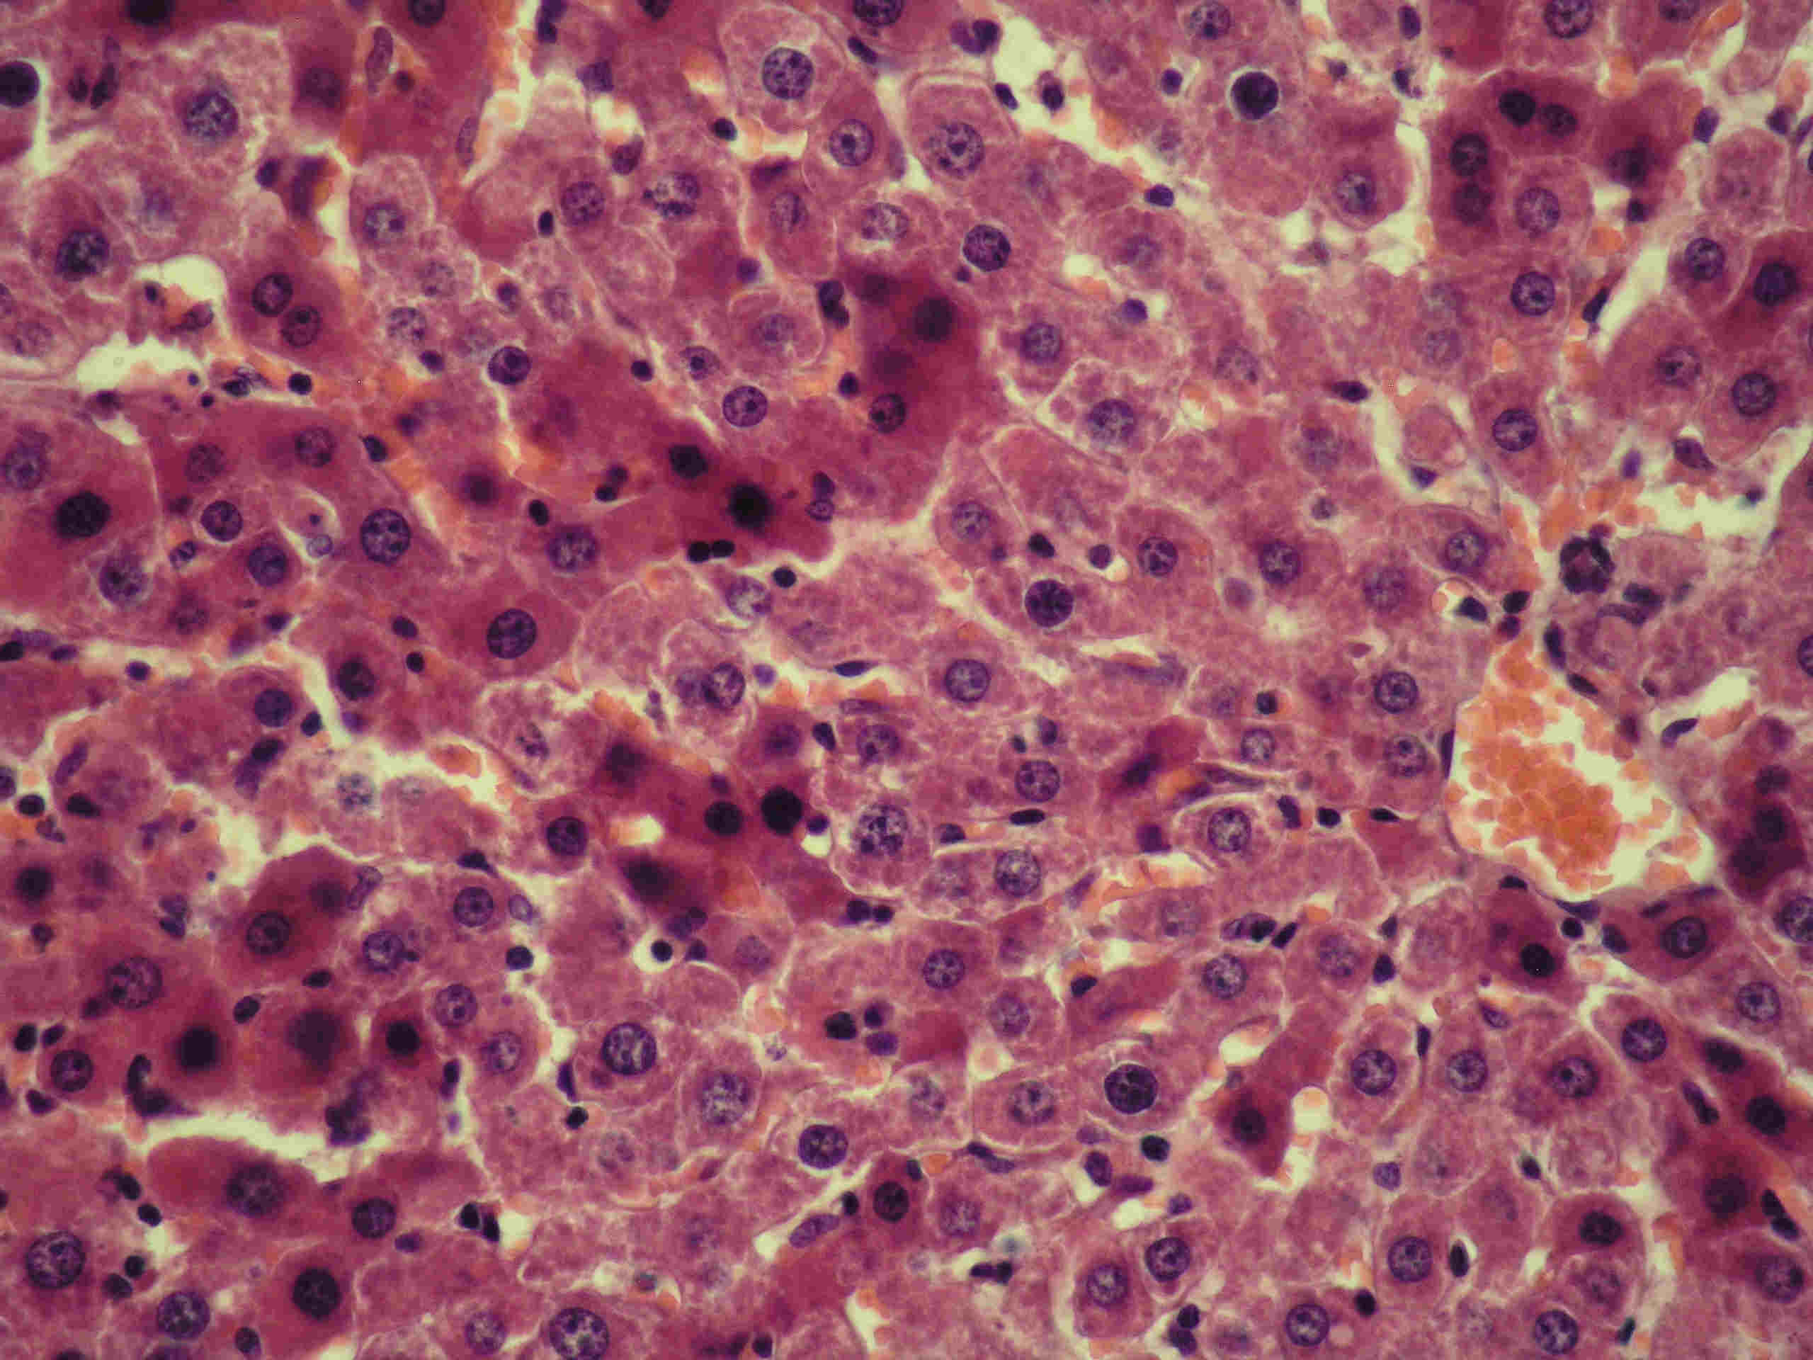  Fig. 4. Liver of rats of the 2nd group on  the 14th day of administration. Strengthening of regenerative processes. Hematoxyline and eosine stain. About 10, v. 40 | 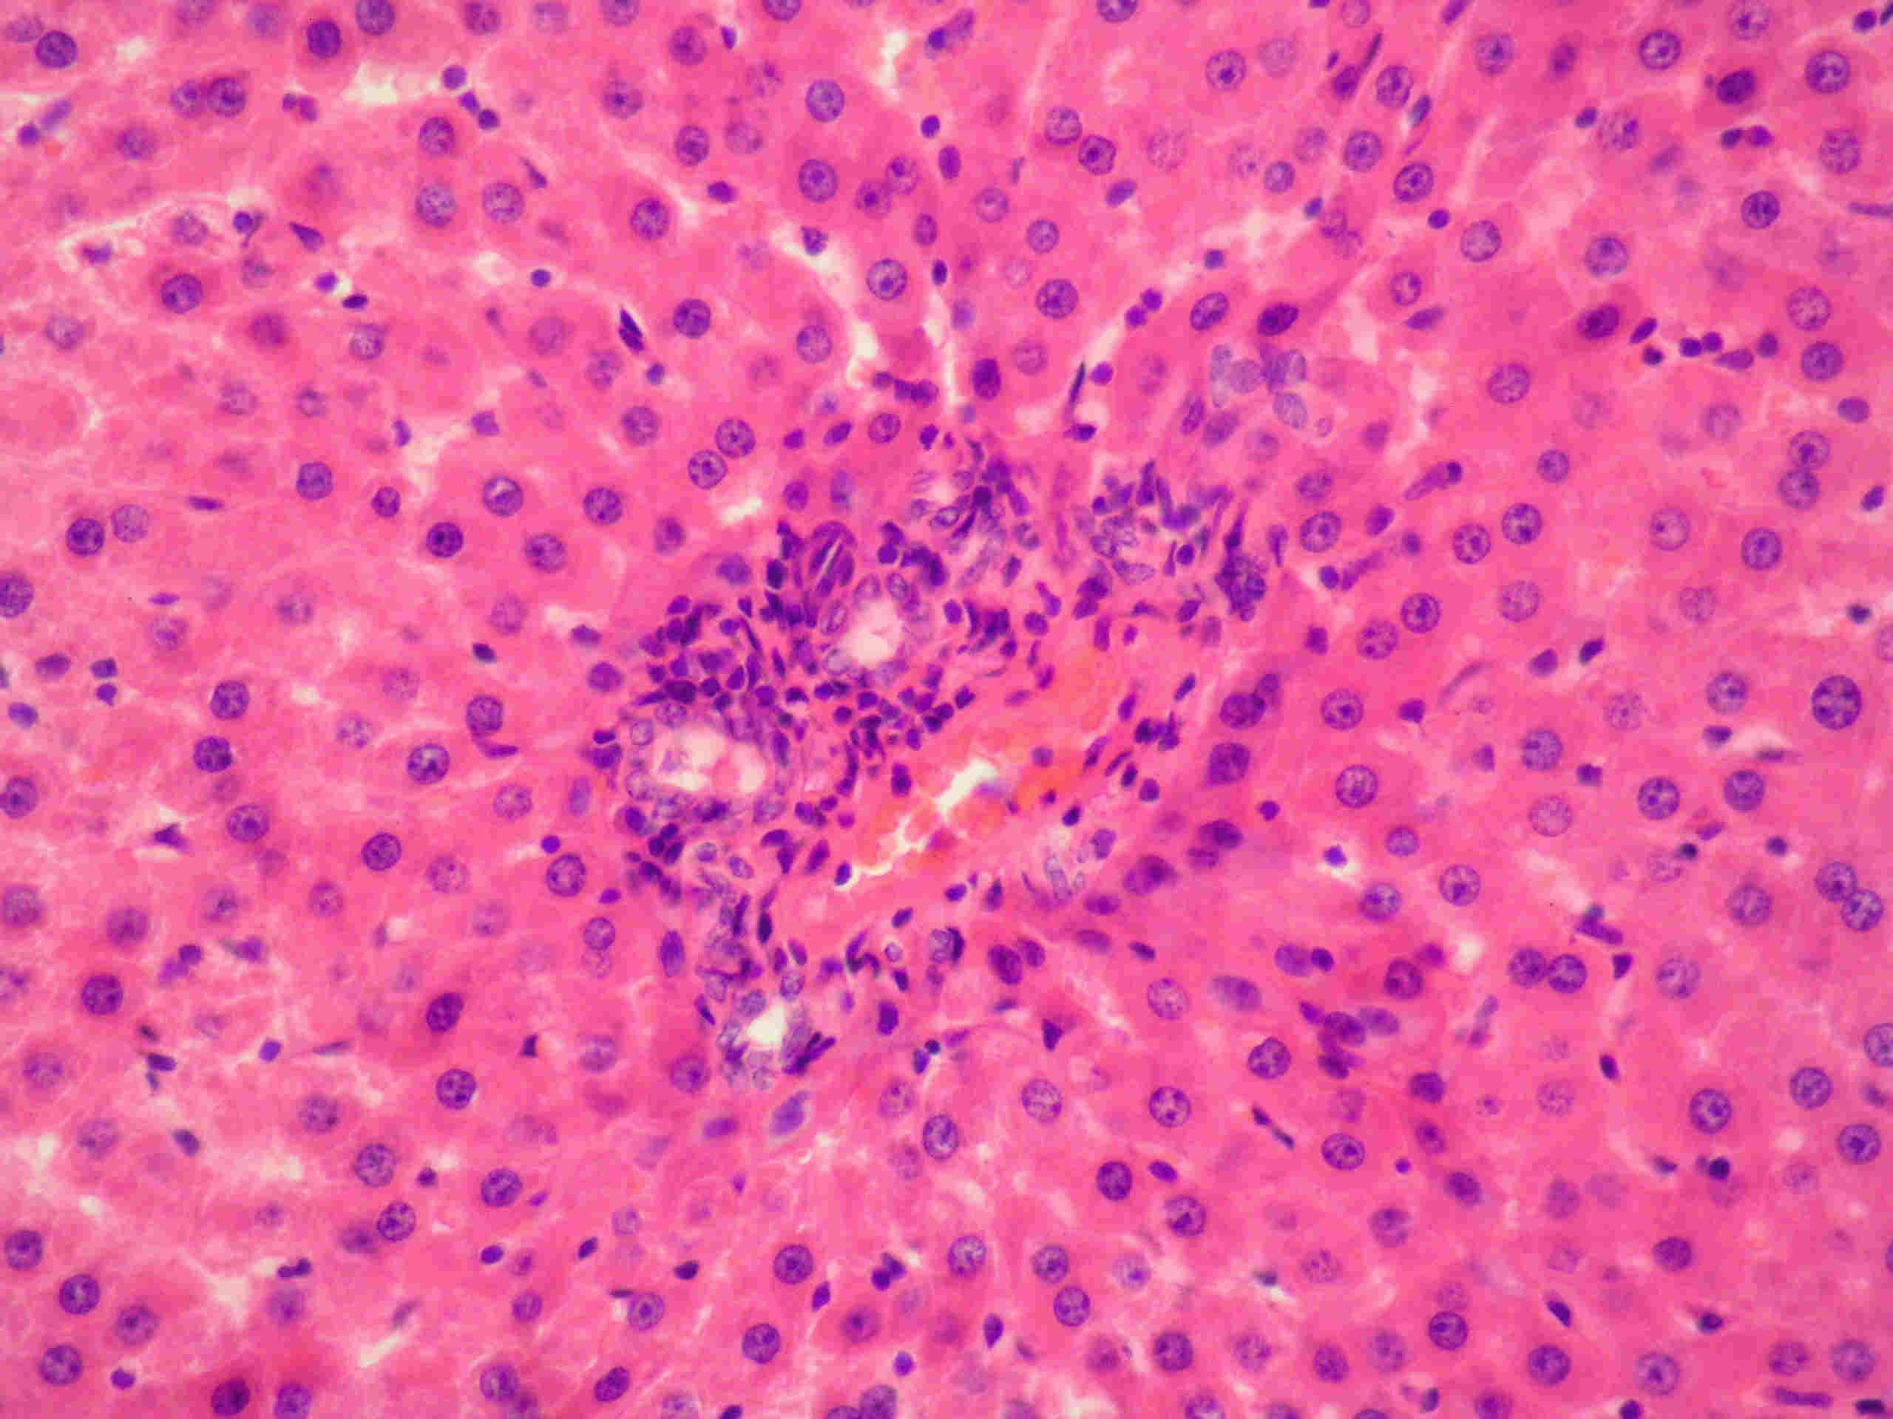  Fig. 5. Liver of rats of the 2nd group on  the 14th day of administration. Round cell infiltrates. Hematoxyline and eosine stain. About 10, v. 40

After stopping of administration on the 21st day renewal of histostructure of hepatocytes and lamellar liver structure were observed. Reparative processes were expressed in whole particle. Hepatocytes with intensively stained cytoplasm and large hyperchrome nuclei predominated (fig. 6).
On the 28th day of renewal period after last administration of Closaverm-A well-structured lamellar structure of particles was observed. Outlines of cells are expressed, cytoplasm has intensive basophilic saturation, nuclei are rich, of round form with high content of chromatine. However, moderate round cell infiltration is preserved (fig. 7).
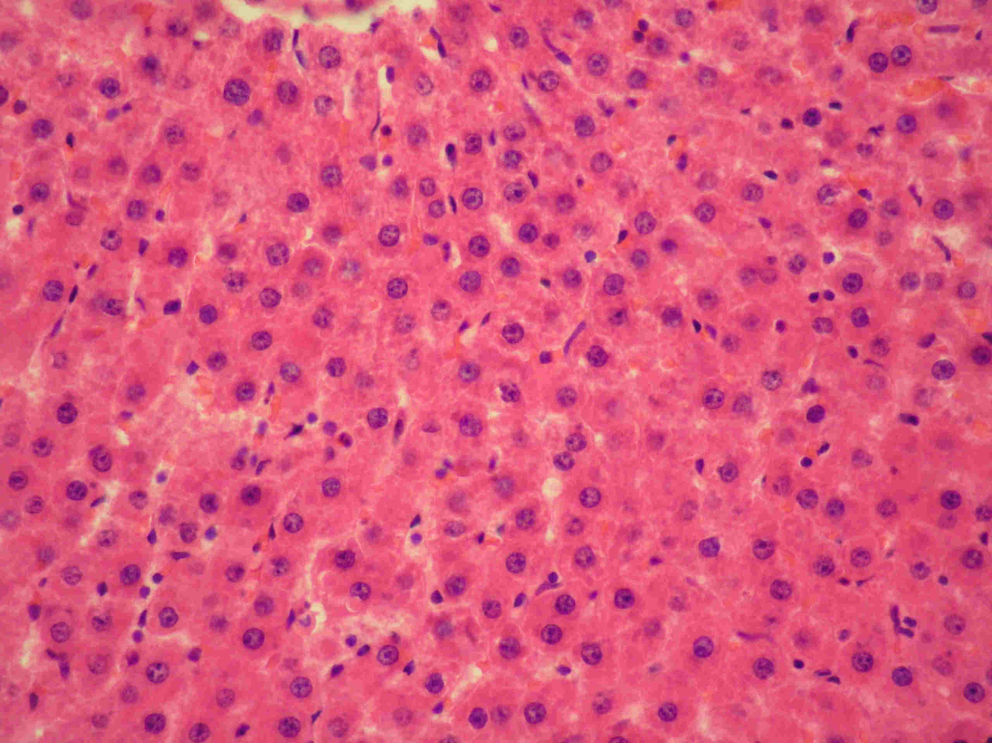  Fig. 6. Liver of rats of the 2nd group on  the 21st day of renewal. Renewal of lamellar structure of particles. Hematoxyline and eosine stain. About 10, v. 40 | 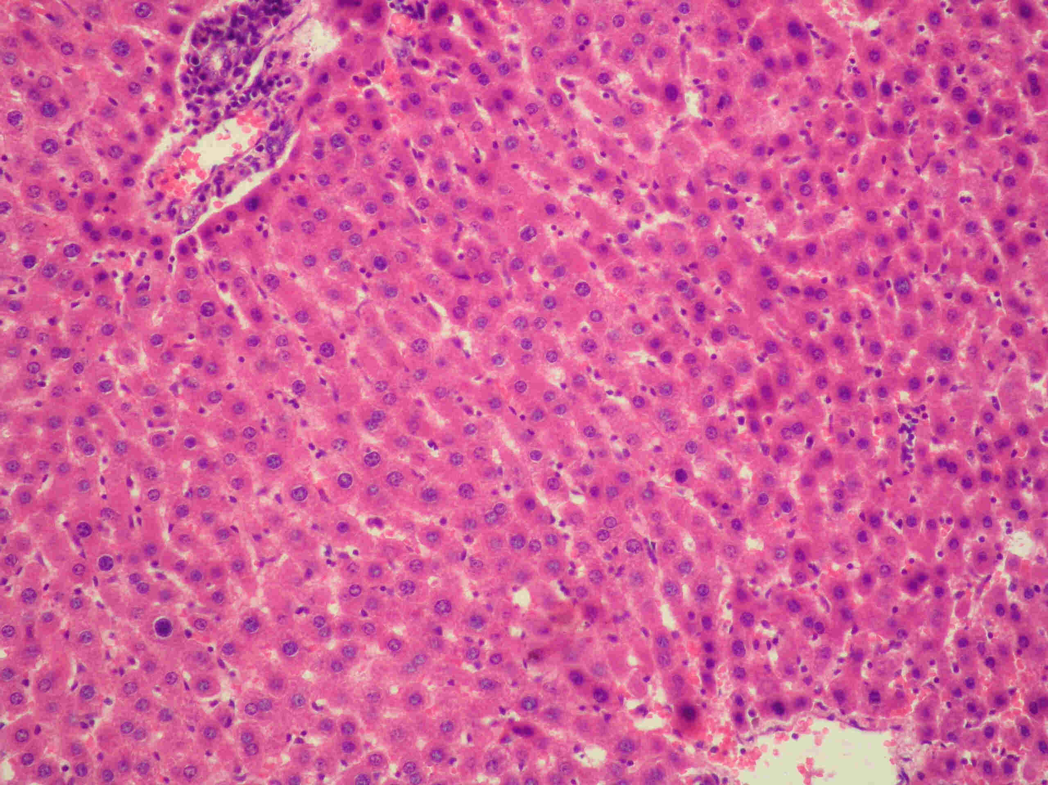  Fig. 7. Liver of rats of the 2nd group on  the 28th day of renewal. Renewed gulch structure and hepatocytes. Round cell infiltration. Hematoxyline and eosine stain.  About 10, v. 20

It should be noted that body weight coefficients of liver in the 2nd group in comparison with control group on the 7th day of administration of Closaverm-A were decreasing and on the 14th day – were increasing. On the 21st day of renewal, body weight coefficient in the 2nd group was decreasing by 10,3 % (p < 0,05), and on the 28th day of renewal we observed insignificant tendency to decreasing (tabl.).
Weight coefficients of liver at administration of Closaverm-A and E-selen and without it
(M ± m, n = 6)
Groups of animals | Weight coefficients of liver at:
Groups of animals | Administration of Closaverm-A |  | Renewal period
Groups of animals | the 7th day | the 14th day | the 21st day | the 28th day
І | 34,97±0,983 | 37,07±0,565 | 35,12±0,410 | 36,67±1,622
ІІ | 33,63±0,868 | 37,65±1,160 | 31,50±0,923* | 33,64±1,012
Remark: authenticity degree to animals of control group * – р < 0,05

So, according to results of conducted histological tests of white rat liver using Closaverm-A in therapeutic dose in complex with E-selen, it was determined that on the 7th day of administration we observed the development of dystrophic changes with lamellar structure disorder in peripheral area of particles, on the 14th day of administration – activation of regeneration processes in peripheral area and full renewal of particle structure was observed on the 21st day.
Conclusions:
1. Daily administration of Closaverm-A during 7 days in therapeutic dose together with single injection of E-selen resulted the development of dystrophic changes with lamellar structure disorder in peripheral area.
2. Twofold injection of E-selen on the background of 14-day administration of Closaverm-A in therapeutic dose activated the processes of reparative regeneration, lamellar structure renewal in peripheral area of particles together with round-cell infiltration.
3. At administration of Closaverm-A on the background of twofold injection of E-selen full renewal of particle structure was observed on the 21st day.
Perspectives of future findings. For determination of E-selen influence on the background of continued administration of Closaverm-A on organism it is reasonable to conduct histological tests of heart, kidneys, immune organs of white rats.
REFERENCES:
1. Доклінічні дослідження ветеринарних лікарських засобів / І. Я. Коцюмбас, О. Г. Малик, І. П. Патерега та ін.; за ред. І. Я. Коцюмбаса. – Львів: Тріада плюс, 2006. – 360 с.
2. Клінічна ветеринарна фармакологія: Навчальний посібник / О. І. Канюка, В. Р. Файтельберг-Бланк, Ю. П. Лизогуб та ін.; за ред. О. І. Канюки. – Одеса: Астропринт, 2006. – 296 с.
3. Меркулов Г. А. Курс патогистологической техники / Г. А. Меркулов. – Л.: Медицина, 1969. – 423 с.
4. Стефанов А. В. Руководство по клиническим испытаниям лекарственных средств / А. В. Стефанов, В. И. Мальцев, Т. К. Ефимцев. – К.: Авиценна, 2001, – 425 с.
5. Сучасні підходи до створення та застосування протипаразитарних препаратів / І. Я. Коцюмбас, О. І. Сергієнко, Л. М. Ковальчик та ін. // Ветеринарна медицина України. – 2010. – № 11. – С. 14–17.
6. Тішин О. Л. Динаміка морфологічних змін печінки білих щурів за вивчення токсичної дії препарату клозаверм-А / О. Л. Тішин. // Вісник Сумського національного аграрного університету: Серія “Ветеринарна медицина”. – 2009. – № 6 (25) – С. 125-131.
7. Тішин О. Л. Морфофункціональний стан печінки білих щурів за дії різних доз клозаверму-А / О. Л. Тішин, Г. І. Коцюмбас, К. О. Висоцька, Т. М. Висоцька // Науковий вісник Львівського національного університету ветеринарної медицини та біотехнологій імені С. З. Гжицького. – 2009. – Т. 11, № 2 (41), ч. 2. – С. 287-295.

