© 2013
Shevnikov M. Ya., Doctor of Agricultural Sciences, Professor
Kulibaba M. Yu, postgraduate
Poltava State Agrarian Academy
YIELD AND QUALITY OF SOYBEAN SEEDS DEPENDING ON THE TIMING OF SOWING AND THE USE OF BIOLOGICAL PRODUCTS
Reviewer – Doctor of Agricultural Sciences, Professor M. A. Bobro
Yield and quality of soybean seeds depended on the timing of sowing, and on the pre-sowing treatment. Soy seed treatment with biological product Ryzogumin had positive effect for nitrogen fixation and, due to this, increased crop yield quality. In areas where the plants were treated at sowing with biological product of all three sowing dates, structural performance and weight of 1000 grains were higher. Since that the mass of 1000 seeds differed by an average of 6,4–8,6 g. Different sowing terms significantly influenced the vegetation period. The most extended was for early sowing terms and subsequently was reduced by 6–9 days.
Keywords: timing of sowing, nitrogen-fixing bacteria, nitrogen fixation, Rhizobium, biological preparations, inoculation, Ryzogumin.

Statement of the problem. Insufficient production of vegetable protein is one of the most important problems of modern agriculture. Soybean as food, fodder and industrial crop is very important for solving this problem. Therefore, increasing soybean productivity is one of the actual topics nowadays.
Intensification of cultivation technology is the main way of solving this problem in the area of low moisture left-bank forest-steppe since soybean productivity is greatly reduced because of weeds, diseases and pests damage and is largely dependent on rainfall per year.
Analysis of major studies and publications which discuss the problem. The main methods of forming productivity is choosing optimal timing of sowing [3], fertilizers, pesticides and biological preparations usage [5]. Using biological nitrogen that is not harmful to other living organisms [4] is particularly important in the process of transition to alternative farming system [6]. That is why soybean as nitrogen-fixing plant has one more important role. Nitrogen fixation takes place in special formations – nodules that are formed due to symbiosis of plant with nitrogen-fixing microorganisms. Nodules are small bulges on the roots, populated by colonies of genus Rhizobium bacteria [2]. During the growth of plants to roots mainly those nitrogen-fixing microorganisms which in the process of evolution have adapted to living together with appropriate plant species tighten. They are accumulated in the young tissues of the main and the lateral roots, where rapidly reproduce by division, forming so-called infectious threads. Root cells spread into spherical nodules under bacteria influence [7]. The purpose of seed treatment with biological preparations such as Ryzogumin is increasing symbiosis efficiency, as derived strains of nodule bacteria have better productive properties. Besides, there are indigenous populations of peas, beans, vetch, vetchling, lentils (Rhizobium leguminosarum bv. Vicea), clover (Rhizobium trifolii), alfalfa, melilot (Sinorhizobium meliloti) and lotus (Mesorhizobium loti) which can provide the inoculation of corresponding legumes in the soils of south, center and east of Ukraine. The number of bacteria in the soil layer of 0-10 cm is 10³ nudleforming units in 1g of soil. Indigenous nodule bacteria of soybean (Bradyrhizobium japonicum), beans (Rhizobium phaseoli), chickpeas (Mesorhizobium ciceri), lupine (Rhizobium lupini), galéga orientalis (Rhizobium galegae) are found only in the places where these plants previously grew [1, 8].
The aim and tasks of the research. The aim of the research is to develop a resource-saving technology of growing soybeans that will improve productivity, grain quality and nitrogen-fixing ability activation. The tasks of the research are to study the influence of timing of sowing and pre-sowing seed treatment with biological preparation Ryzogumin and to develop a resource-saving technology of growing soybeans on this basis.
Research materials and methods. The research was conducted on the experimental field of Poltava Agricultural Production Institute named after M.I. Vavilov in 2012. Agrotechnology of soybean growing is typical for the left-bank forest-steppe area except the technology elements that were studied. The area of research plot is 60 m², accounting plot is 30 m², three-time repetition of the options and the options are systematically located. The object of the study was Snow White variety, sowing was carried by untreated seeds and seeds inoculated with Ryzogumin in three periods (April 27, May 4, May 13). Seeds were treated on the day of sowing. Winter wheat was predecessor.
Research results. Plant development monitoring was done in the experiment (Table 1). Shoots appeared on the eighth day during early sowing, during optimal and late sowing shoots appeared on the 9th and the 18th days respectively; germination period increased to 10-days. According to duration the phenological phases of the first sowing were the longest, duration of the second and the third terms reduced to 3-6 days.
In general, the longest growing season (100 days) was during early sowing, and subsequently (in lack of productive moisture) it reduced to 6-9 days.
1. Phenological observations of soybean plant development during different sowing terms, 2012
Sowing  terms | Shoots | Blossoming | Bean formation in the middle layer | Bean growth  in the middle layer | Complete ripeness | Vegetative  period,  days
Early | 05.05 | 14.06 | 26.06 | 13.07 | 13.08 | 100
Optimal | 14.05 | 18.06 | 5.07 | 20.07 | 16.08 | 94
Late | 23.05 | 29.06 | 13.07 | 23.07 | 20.08 | 91

Because of time difference for the phenological phases and highly extreme weather conditions, moistening of soybean plants during different sowing terms was also different. Adequate rainfall after germination positively influenced on intensive growth and development during early sowing, but later the phase of bean formation and growth were in the conditions of insufficient moisture, significantly reducing the generative development processes. During the second sowing term bean formation and growth were also held with minimal moisture and high temperatures and moisture was adequate only in the period of shooting and blossoming. During late sowing insufficient productive moisture was observed in the period of blossoming – bean formation, which adversely affected their number.
The experiment involved the determination of the studied factors effect on the growth and development of soybeans plants in the phase of been growth in the middle layer. Calculations were performed on the 2nd, 12th and 23rd of July and included measurement of plant height, determination of leaf number on the plants and the number of nodules per plant (Table 1). As we can see in these diagrams, plant height was higher on the variants of optimal sowing, inoculated with Ryzogumin on the second of July and was 59.2 cm while the plant height of early and late periods was 55.2 cm and 44.8 cm respectively, on July 12 height was 69.1 cm (height of early period was 59.4 cm and height of late periods was 62.5 cm), on July 23 height was 72.5 cm (early and late periods – 65.8 cm and 65.2 cm ). However, it was observed during calculations on the twenty third of July that during late sowing by not inoculated seeds plant height was higher than during optimal and early term without inoculation with biological preparation (late period – 70.8 cm).

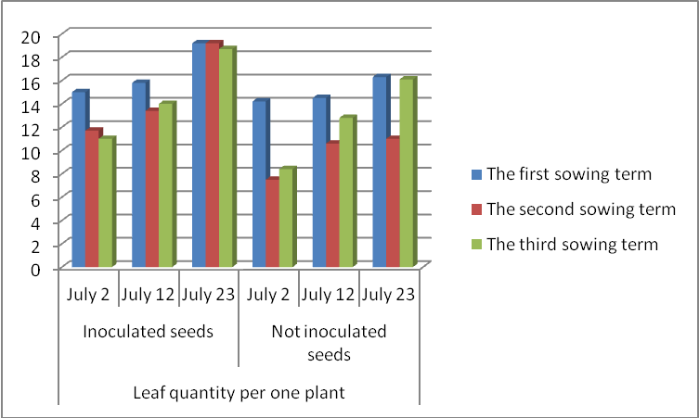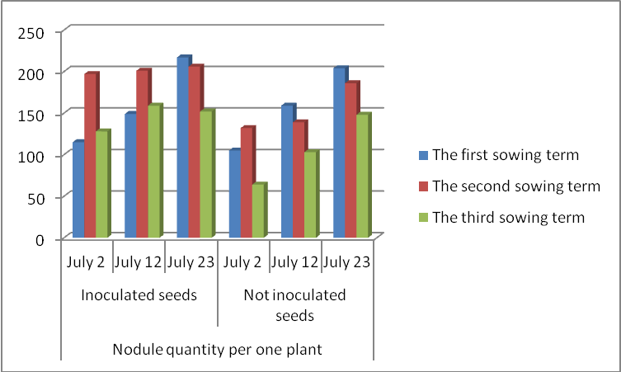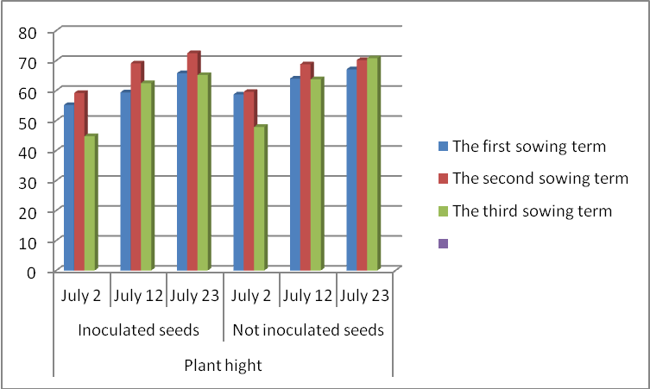
Table 1. The dynamics of plant growth and development depending on the technology elements, 2012

There was better development of leaf apparatus both on variants treated with Ryzogumin and not inoculated ones during early sowing. However, comparing these variants the leafiest plants were on variants treated with biological preparation. The best growth of leaf apparatus was during early and optimal sowing by inoculated seed and the number of leaves per one plant was on average 19.2 items on the twenty third of July while during the later period the number was 18.7 items. The least leafy plants were on the variants not inoculated with Ryzogumin during the second sowing term (11 items). There was better development and more quantity of nodules on all three variants inoculated with Ryzogumin.
In general plants development is better on variants inoculated with biological preparation that influence on yield quality indices, including the mass of 1000 seeds during all three sowing terms (Table 2).
Table 2. Mass of 1000 soybean seeds dependently on sowing terms in 2012

 | The first  sowing term | The second sowing term | The third  sowing term
Inoculated seeds | 137,5 | 134,2 | 134,0
Not inoculated seeds | 128,9 | 127,8 | 127,5

As we can see in the table, seeds from the first sowing plants treated with Ryzogumin got the largest mass (137.5 g) and the lowest mass is observed on the variant not treated with biological preparation and sown during the late terms (127.5 g). The highest number of beans and seed quantity per plant in extreme weather in 2012 is also observed during the first sowing by inoculated seeds (Table 3). The quantity of beans was 39.8 items and quantity of grains was 64.7 items.
Table 3. Structural indicators of soybean seeds dependently on seed inoculation and sowing terms, 2012
Experiment variations | Bean quantity on one plant,  items. | Seed quantity on one plant,  items.
Sowing by inoculated seeds
The first sowing  term | 39,8 | 64,7
The second sowing  term | 31,1 | 58,0
The third sowing  term of | 25,2 | 41,8
Sowing by not inoculated seeds
The first sowing  term | 39,1 | 55,6
The second sowing  term | 23,5 | 44,6
The third sowing  term of | 21,0 | 35,6

Conclusions:
1. Soybean yield depends on sowing terms and pre-sowing treatment of seeds with microbiological preparation. Structural yield indicators and mass of 1000 seeds were higher than during all timings of sowing on plots of land where plants were treated with Ryzogumin during sowing. Better development and more quantity of nodules were observed indicating intensive nitrogen fixation.
2. During different sowing terms and different availability of productive moisture for 6-9 days, growing period duration was different. The longest growing period was during the early sowing term (100 days) and subsequently during optimal and late sowing the period reduced to the 94th and 91st day respectively.
REFERENCES
1. Ефективність симбіотичної азотфіксації в агроценозах України / С. В. Дідович, М. З. Толкачов, О. Ю. Бутвіна // Сільськогосподарська мікробіологія: Міжвід. темат. наук. зб. – Чернігів, 2008. – Вип. 8. – С. 117–125.
2. http://www.agroscience.com.ua/plant/64-sivba-soi
3. http://agrocart.com/33/biologicheskij-azot-v-zemledelii
4. http://agroua.net/plant/catalog/cg-3/c-74/info/cag-225/
5. http://www.agrobox.com.ua/?PAGE=articles&id=164&aid=2
6. http://stud24.ru/botany/azotfksujuch-bakter/469488-1782940-page1.html
7. http://archive.nbuv.gov.ua/portal/chem_biol/sgmb/2008_8/2008a/SM8_11.pdf
8. R. Casey, D. R. Davies. Peas: Genetics, Molecular Biology and Biotechnology. – UK, 1993 – С. 237.

