© 2013
Zhemela G. P., Doctor of Agricultural Sciences, Professor,
PShevnikov D. M., postgraduate*
Poltava State Agrarian Academy
PRODUCTIVITY OF CROPS OF SPRING DURUM WHEAT DEPENDING ON FERTILIZERS AND BIOLOGICAL PRODUCTS
Reviewer – Doctor of Agricultural Sciences, Professor S.M. Kalenska
The use of fertilizers and inoculation of spring durum wheat seeds by biological products positively affected on the photosynthetic efficiency of plants. Formation of wheat leaf surface depends both on the background of mineral nutrition and the use of biologocals. In areas without fertilizing seed treatment by biological products contributed to the increase of leaf area by 20.3% using polimiksobakteryn, 20.5% – diazofit, 23.9% – a mixture of these two drugs. These measures create favorable conditions for nutrition; form the optimal nutrition area of leaf apparatus and efficient photosynthetic productivity.
Keywords: hard spring wheat, fertilizers, polimiksobakteryn, diazofit, leaf area, photosynthesis.
*Supervisor – Doctor of Agricultural Sciences, Professor – Zhemela G.P.
Statement of the Problem. With the appearance of new sorts of spring wheat there was a necessity to establish how rates of photosynthetic activity in crops depending on the mineral nutrition change, as between these quantities ​​and yield of plants there is a close and direct inverse correlation. In the left bank forest-steppe this issue isn’t sufficiently studied.
For optimal photosynthesis passage the sowing must have a leaf area. However, one must distinguish between leaf surface as a mean of accumulation of plastic materials for forming the yield of grain, roots, tubers, various fruits and leaf mass of crops that is grown to produce feed (green, hay, silage, etc.). In the first case (the formation of grain yield) the excess leaf surface does not contribute to high yield of the culture because part of the leaves will be shaded by its top tier. In addition, these shadowed part of the leaves not only give a productive feedback, but is in fact unnecessary, since its formation uses a lot of nutrients.
Analysis of major studies and publications which discuss the problem. Yields of plants is determined primarily by size and capacity of the photosynthetic apparatus, which must achieve the optimal size as soon as possible in the process of plant growth and development. One of the factors governing the assimilation of surface area is a rich treatment of plants. Therefore, during the growing season we must create favorable conditions for the nutrition so that plants will form the optimum area of leaf apparatus for efficient photosynthetic activity. A number of works is devoted to the study of this issue on the crops of spring wheat [2-3].
The biological significance of the size of leaf surface is that they determine the degree of absorption of crops of photosynthetic active radiation (PAR). To characterize the capacity of assimilation system the notion photosynthetic potential (PP) – parameter that characterizes the ability of crops to use for photosynthesis PAR was taken. It is believed that the highly productive crops have PP at least 2,2-3,0 million m ² per day counting upon 100 days of actual vegetation [1].
The Purpose and objectives of the study. The aim of our research was to study the peculiarities of photosynthetic surface of hard spring wheat plants depending on growing conditions, to set the norms of introduction of fertilizers on the assumption of the use of biologics that promote optimal development of overground and underground parts of the plant and provide a stable formation of large grain yields regardless of the weather.
Research Objectives – to explore the features of the photosynthetic efficiency of plants for the use of pre-treatment of seeds of various biological preparations depending on the level of mineral nutrition and to establish their optimal ratio for the formation of a stable grain yield of spring wheat with high quality features.
Materials and methods. The main experiments were carried out on the experimental field of Poltava Institute APV named after N.I. Vavilov in 2010-2012. The influence of pre-sowing seed treatment by microbiological preparations depending on the calculated microbiological balance method the background of mineral nutrition of plants on the yield of 3 t / ha of grain was studied. The study was conducted on six backgrounds of mineral nutrition: no fertilizer - control; N₄₅; P₄₅K₃₀ ; N₄₅P₄₅K_{30;} N₂₃P₂₃K₁₅; stubble of thepredecessor + N₁₀ per tonne of by-products. Experiments was done in trice, the accounting of yields had been conducted with the land area of ​​25 m².
The Results. Our research has shown that dry weather conditions in 2010, especially the second half of the growing season, contributed to a significant reduction of tillering plants. Plant density did not depend on the action of fertilizers and biological products. These means had a significant influence on the amount of leaf surface (Table 1).
1. Leaf area of hard spring wheat depending on the effect of mineral fertilizers and biological products, thousands m²/ha
Variants of fertilization | Year | Inoculation of grain micro biological products
Variants of fertilization | Year | without inoculation | polimiksobakteryn | diazofit | mixture of polimiksobakteryn  and diazofit
Without fertilizer | 2010  2011  2012 | 25,9  25,5  24,0 | 31,7  30,7  28,3 | 30,5  31,4  29,1 | 31,6  32,9  28,9
Without fertilizer | Average | 25,1 | 30,2 | 30,3 | 31,1
N₄₅Р₄₅К₃₀ | 2010  2011  2012 | 29,4  36,1  30.2 | 38,0  38,9  37,1 | 34,3  38,3  36,4 | 37,7  42,8  38,4
N₄₅Р₄₅К₃₀ | Average | 31,9 | 38,0 | 36,3 | 39,6
Straw N₁₀ per tonne of by-products | 2010  2011  2012 | 23,6  33,7  30,4 | 32,3  37,4  31,9 | 30,7  37,7  30,4 | 35,4  43,8  30,2
Straw N₁₀ per tonne of by-products | Average | 29,2 | 33,9 | 32,9 | 36,4
N₂₃Р₂₃К₁₅ | 2010  2011  2012 | 25,9  33,2  26,3 | 28,2  37,8  29,4 | 31,9  35,8  30,6 | 33,3  38,5  30,9
N₂₃Р₂₃К₁₅ | Average | 28,4 | 31,8 | 32,8 | 34,2
N₄₅ | 2010  2011  2012 | 25,4  32,7  26,0 | 27,3  34,2  27,5 | 34,6  34,0  28,8 | 34,1  35,0  33,5
N₄₅ | Average | 28,4 | 31,8 | 32,8 | 34,2
Р₄₅К₃₀ | 2010  2011  2012 | 25,7  31,0  26,0 | 30,1  32,9  29.8 | 33,7  34,1  32.7 | 32,5  33,8  32,0
Р₄₅К₃₀ | Average | 27,6 | 30,9 | 33,5 | 32,8

In the phase of earing leaf area was 30,5-31,7 for the use of biologics without inoculation – 25.9 thousand m²/ha. Using the biological preparations this index increased to 34,3-38,0 on the background of fertilizers N₄₅Р₄₅К₃₀, without inoculation – to 29.4 thousand m ² / ha. Other variants of fertilization were also quite efficient: diazofit was the best on the background of nitrogen fertilizers for growing the leaf surface, polimiksobakteryn – on the background of phosphorus-potassium fertilizers.
Research conducted in 2011 showed that fertilization contributed to an increase of leaf area of ​​ hard wheat on 13,7-57,4% compared with areas without their use. On average during the growing season the plants on the areas with the introduction of the maximum amount of fertilizers (N₄₅Р₄₅К₃₀) – from 36.1 to 42.8 thousand m²/ha depending on the use of biologics formed the most powerful leaf device. ​​The plants in areas characterized by no fertilizer and no inoculation (25,5-25,9 thousand m²/ha) was characterized by the smallest leaf area. By introduction of half dose of fertilizer (N₂₃Р₂₃К₁₅) the leaf area was average (33,2-38,5 thousand m²/ha). Quite a large area of ​​the leaf surface was on the variant stubble predecessor + N₁₀ per tonne of by-products – 33,7-43,8 thousand m²/ ha. By introducing nitrogen fertilizer N₄₅, or phosphorus-potassium Р₄₅К₃₀ – there was no increase in this indicator – accordingly 32,7-35,0 and 31,0-33,8 thousand m²/ha. Inoculation of seeds by polimiksobakterynand diazofit helped to increase leaf area of plants, especially in the use of fertilizers.
In 2012, weather conditions were very dry, with little rain, which negatively influenced the formation of leaf surface of plants. In variants without the use of fertilizers the positive biological effect by the influence of diazofit – leaf area was 29.1, without inoculation – 24.0 thousand m²/ ha. By entering N₄₅Р₄₅К₃₀ the largest leaf surface was observed by combined use of azotofit and polimiksobakteryn – 38.4, slightly lower - by seed treatment preparations, separately, 36.4 and 37.1 without inoculation - 30.2 thousand m²/ ha. In other variants of fertilizing the leaf under the influence of biological preparations increased on 0-4,9% (straw + N₁₀ per tonne of by-products), 11,7-17,2% (N₂₃Р₂₃К₁₅), 5,8-32,0% (N₄₅), 14,6-23% ( Р₄₅К₃₀).
Leaf area of hard spring wheat depending on the effect of mineral fertilizers and biological preparations on average of three years of research is shown in Table 1. Formation of leaf surface depended both on the background of mineral nutrition and the use of microbial preparations. In areas without fertilizing the seed treatment by biological preparations contributed to the increase of leaf area m²/ ha to 30.2 thousand (20.3%) for the use of polimiksobakteryn, 30.3 thousand m²/ ha (20.5%) – diazofit and 31.1 thousand m²/ ha (23.9%) – a mixture of these two drugs. By entering dose of fertilizers N₄₅Р₄₅К₃₀ leaf area was 31.9 m²/ ha thousand, the using of polimiksobakteryn provided an increase on 19.1%, diazofit – 13.8, a mixture of these drugs – 24.1%. By entering half a dose of fertilizers N₂₃Р₂₃К₁₅ leaf area decreased to 29.2 thousand m²/ ha, and the use of biologicals to the previous dose of fertilizers reduced this index on 12.0, 10.3, 8.8%, respectively.
By introducing a nitrogen fertilizer N₄₅ leaf area was 28.0 m²/ ha thousand for the use of biologicals: polimiksobakteryn – 29.7 thousand m²/ ha, diazofit – 32.5, a mixture of drugs – 34.2 thousand m²/ hectares. Leaf area by the use of manure phosphorus-potassium fertilizers Р₄₅К₃₀ was, respectively, 27.6, 30.9, 33.5, 32.8 thousand m²/ ha. Very effective background was fertilized background straw + N₁₀ per tonne of by-products, insofar as the size of leaf area in the areas of experiment was quite high (29.2 thousand m²/ ha), and the use of biologicals, respectively, 33.9, 32.9, 36 4 thousand m²/ ha.
To determine the influence of technological measures a specific portion of biologicals and background of fertilization on leaf area of hard spring wheat was defined (Table 2 and 3). Mathematical analysis carried out for all variants of the experiment, made ​​it possible to establish that the area of leaves without inoculation of biological products was 28.3 thousand m²/ ha. Inoculation of seeds by polimiksobakteryn helped to increase this index to 32.8, diazofit – up to 33.1, a mixture of drugs – to 34.7 thousand m²/ ha. As for the background of mineral nutrition, the leaf area had the following values: no fertilizer – 29.2 thousand m²/ ha; N₄₅Р₄₅К₃₀ 36,5 thousand m²/ ha or increased on 25.0%; straw + N₁₀ per tonne of side products – 33,1 thousand m²/ ha or increased on 13.4%; N₂₃Р₂₃К₁₅ – 31.8 thousand m²/ ha or increased on 8,9%; N₄₅ – 31,8 thousand m²/ ha or increased on 8.9%; Р₄₅К₃₀ – 31.2 thousand m²/ ha or increased on 3.5%.
Conclusions.
1. Formation of leaf surface of hard spring wheat depended both on the background of mineral nutrition and the use of microbial preparations. In areas without fertilizing the seed treatment by biologicals contributed to a higher leaf area by 20.3% for the use of polimiksobakteryn, on 20.5% – diazofit and on 23.9% – a mixture of these two drugs.
2. By fertilizing of N₄₅R₄₅K₃₀ the leaf surface was 31.9 thousand m²/ ha, the use of polimiksobakteryn led to its increase on 19.1%, diazofit – 13.8, a mixture of the drugs – on 24.1%. By entering only nitrogen fertilizer N₄₅ leaf area was 28.0 m²/ ha thousand, for the use of biologicals of polimiksobakteryn – 29.7 thousand m²/ ha, diazofit – 32.5, a mixture of drugs – 34.2 thousand m²/ ha.
3. The background straw + N₁₀ was fertilized effectively per tonne of by-products, because the size of leaf area in the areas of the experience was very impressive 29.2 thousand m²/ ha, and the use of biologicals, respectively, 33.9, 32.9, 36.4 thousand m²/ ha.
4. The most important factors governing the amount of assimilative surface is a rich mode of soil, which greatly improves preplant inoculation of hard spring wheat seeds by biological products of polimiksobakteryn and diazofit. These measures create favorable conditions for the formation of the optimal square of leaf apparatus and efficient photosynthetic activity.
REFERENCES
1. Антал Т. В. Вплив добрив на урожайність сортів пшениці ярої твердої в умовах північної частини Лісостепу / Т. В. Антал // Тези доповідей Міжнародної науково-практичної конференції м. Біла Церква, 26–28 лютого. – 2008. – С. 3.
2. Барановский П. М., Копытцова B. C., Даниличев С. Н. Фотосинтез и урожай яровой пшеницы // Зерновое хозяйство. –1980. –№ 12. – С. 30.
3. Кумаков В. А. Биологические основы возделывания яровой пшеницы по интенсивной технологии. – М. : Росагропромиздат, 1988. – 104 с.
4. Ничипорович A. A. Фотосинтез и теория получения высоких урожаев. – М. : Изд-во АН СССР, 1956. –330 с.
5. Шатилов И. С., Чаповская Г. В., Замараев А. Г. Фотосинтетический потенциал и урожай зерновых культур. – Изв. ТСХА, Вып. 3, 1979. – С. 18–30.
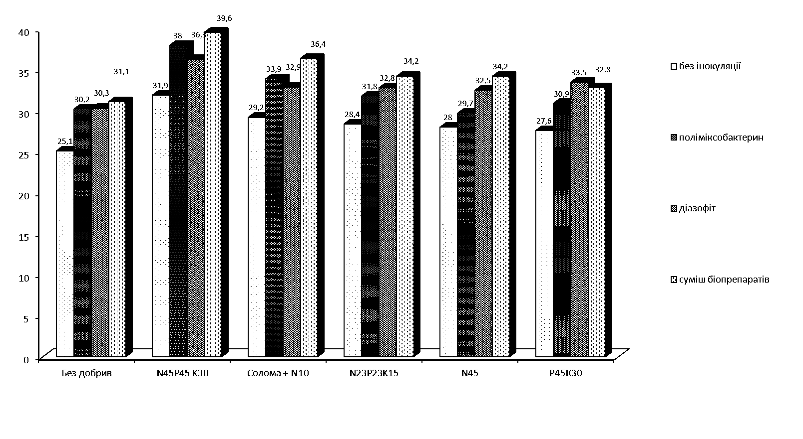
без добрив N₄₅Р₄₅К₃₀ N₂₃Р₂₃К₁₅ N₄₅ Р₄₅К₃₀
Солома+N₁₀ на тонну побічної продукції

Рис. 1.
Leaf area of hard spring wheat depending on the effect of mineral fertilizers
and biologicals, thousand m²/ ha (average for 2010-2012)

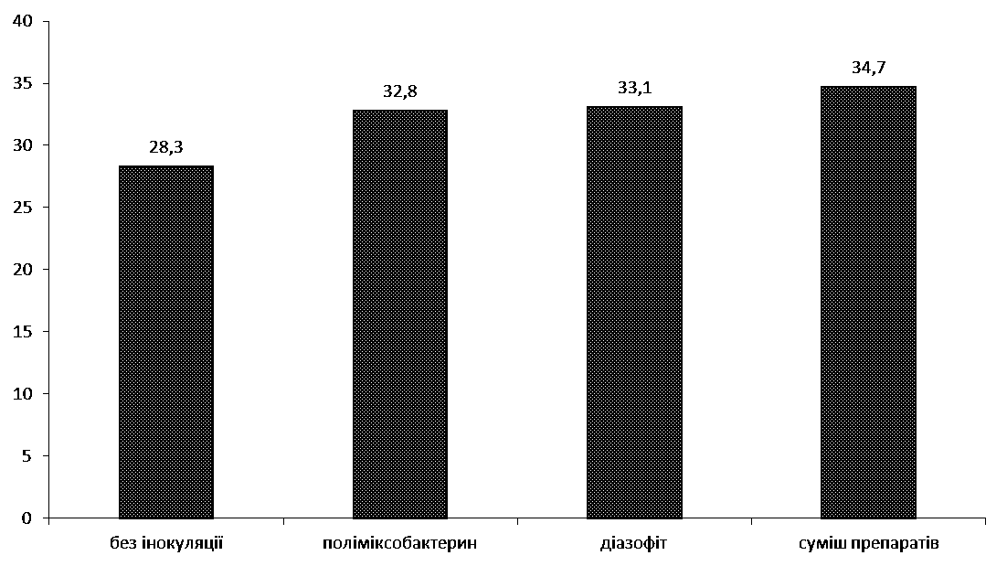
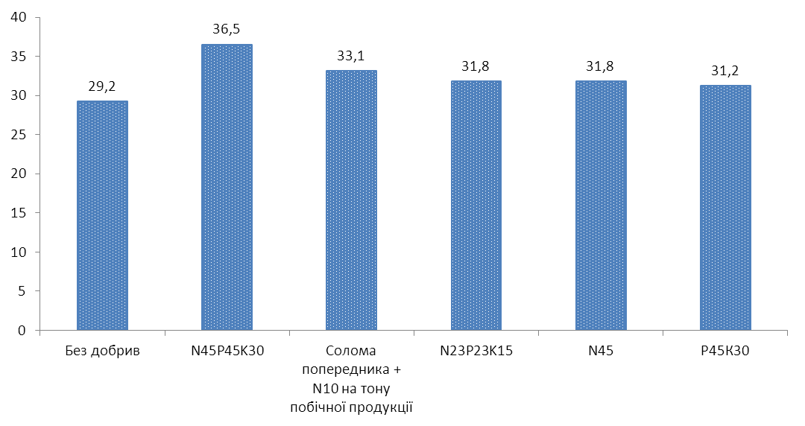
2. Leaf area of hard spring wheat depending on influence of grain inoculation by biologicals, thousand m²/ ha (2010-2012)
без добрив N₄₅Р₄₅К₃₀ N₂₃Р₂₃К₁₅ N₄₅ Р₄₅К₃₀
Солома+N₁₀ на
тонну побічної
продукції

3. Leaf area of hard spring wheat depending on influence of different fertilizer backgrounds, thousand m²/ ha (2010-2012)

