© 2013

Rozhkov А. O., Candidate of Agricultural Sciences
Puzik V. K., Doctor of Agricultural Sciences
Kharkiv National Agrarian University named after V. V. Dokuchayev
dynamics of formation of pigment substances in leaves of durum spring wheat depending on the different coenosis voltage between plants in the crops
The results of the three-year study (2008–2010) to determine the dynamics of the formation of photosynthetic pigments in plants of durum spring wheat varieties Kharkiv 41, depending on the different ways of planting and seeding rate are given in the article. A significant effect of the studied elements of the technology on the content of chlorophyll and carotenoids in the leaves of plants was found. The content of photosynthetic pigments was changed to a large extent at the impact factor of the seeding rate. The general regularity was to reduce the content of chlorophyll and carotenoids in the leaves of plants at effective seeding rate and optimization of the distribution of plants over the area of ​​nutrition. The studies identified a direct correlation between the content of pigments and grain productivity of the ear of the main shoot of the plant.
Keywords: spring wheat, planting methods, seeding rate, chlorophyll a and b, carotenoids, phenophases, ontogenesis.

Statement of the problem. The determination of dynamics of the pigments accumulation in the plants’ leaves is of great importance because their content affects the intensity of photosynthesis and other physiological processes. The researches are aimed to explore the dynamics of accumulation and metabolism of photosynthesis pigments, the peculiarities of the formation of the pigment apparatus of the leaf in the ontogenesis is of great importance in the assessment of the influence of components of technological elements on plant productivity.
Analysis of major studies and publications which discuss the problem. The creation of intensive sorts with high yield potential requires an in-depth study of all the elements of photosynthetic activity at different levels of organization of assimilation system – from cenosis to cells, chloroplasts [1–3].
The harmonious connection of photosynthesis with other plants physiological functions, primarily with functions of plants’ growth and development, requires the formation of general theory of the plant productivity [4, 5]. Determining such a theory it is necessary to pay attention to the phytometric principle of plant shoot structure organization [6, 7]. In wheat ontogenesis under the influence of the complex of endogenous factors the constant adjustment of inter-metameric connections takes place that is implemented in the functions of growth and development of phytomer elements and provides the ‘desired’ biological productivity at the end.
Organic compounds are formed in the process of photosynthesis. In order to pass the photosynthesis some pigments must be present in the plants cells – chlorophylls and carotenoids [8,9]. The pigments concentration in the structure of the photosynthetic apparatus of plants affects the productivity and intensity of photosynthesis, and thus the yield.
The compulsory component of the photosynthetic apparatus is carotenoids that present the derivative of isoprene which consist of 40 carbon atoms. All functions of yellow pigments have not been established yet but there is no doubt that they are able to transfer energy of absorbed quanta by other pigments, changing the spectrum of the photosynthetic apparatus action as well as to protect chlorophyll from photo destruction [10].
Pigment complex of plant organism is very sensitive to changes in environmental conditions [11 – 13], so it should be referred to a number of criteria that determine the degree of plants adaptation to natural and anthropogenic environmental factors. The discovery of regularity of changes in durum spring wheat leaves will allow controlling processes of crop development, the formation of organic matter by plants and their grain productivity.
The purpose of the researches was to establish the impact of different variants of sowing methods and seed sowing rates of durum spring wheat sort Kharkivska 41 on the change of contents of photosynthesis pigments in the plants leaves, since their content affects the intensity of physiological processes, especially the nature of the processes of photosynthesis passing and the formation of the crops grain productivity.
Methods of the research. The experiment was carried out in 2008 - 2010 in the experimental field of KhNAU named after V.V. Dokuchayev using the conventional method. [14]. Two-factor research was founded by split-plot method. Block plots in the research formed seed sowing rate: 450 seeds/m²; 500, 550 and 600 seeds/m². The subplots in the experiment were the following sowing methods: 1 – drill sowing method which was held with seed drill machine СЗ – 3,6; 2 – striped-sowing method which was held with sowing machine APP – 6 VAT “Fregat”. Sowing machine APP – 6 provided strip seed distribution of 15 cm wide. Inter-striped area was on average 15cm. The researches were carried out thrice repeated, the sown area – 120m², accounting – 80 m². All the elements of the growing technology (except the studied element) were generally accepted for this area of researches – Eastern Forest-Steppe of Ukraine.
The soil of the experimental field is typical black soil (chernozem) heavy loamy on carbonate loess. The arable soil layer contains 4,4 – 4,7% of humus, 13,8mg of mobile phosphorus and 10,3mg of potassium per 100g of soil.
The place of the researches has a character of unstable moistening. The amount of precipitations during the growing season of durum spring wheat (March – July) in 2008-2010 was 314,1mm; 243,9mm and 218,7mm at the average long-term index – 241,0 mm. The most favourable growing year was 2008 according to the amount of precipitations and their distribution.
The temperature conditions during the growing periods of the research differed considerably from the average long-term indices. The established excess temperatures brought significant correctives in the growth and development of plants, their grain productivity formation. At the same time a significant divergence at the main meteorological parameters during the years of research has allowed determining the impact of researched factors on the photosynthesis pigments content in the plants’ leaves of the studied spring wheat sort.
The results of the research. The analysis of the researched agrotechnical factors showed that the index of pigments content in plants leaves changed largely under the different seed sowing rates. This regularity was marked in all phases of development when the determination took place. Thus, in the flowering phase the concentration of chlorophyll a on average over the three years of research under the action of factor A (seed sowing rate) ranged from 10,61 to 11,03mg/g (range of changes – 4,0%), but under the action of factor B (sowing method) – only from 10,75 to 10,98mg/g (range of changes – 2,1%). In this phase the concentration of chlorophyll b under the various sowing rates ranged from 6,5% in different ways within just 4,5% – from 3,25 to 3,47 mg/g and from 3,30 to 3,45 mg/g appropriately (Table 1).

Photosynthesis pigments content in the leaves of durum spring wheat depending upon the use of different planting methods and sowing rates on the phases of development, mg/g
(average for 2008 – 2010)

Factor А – sowing rate, seeds/m² | Factor В – sowing method | Chlorophyll а |  |  |  | Chlorophyll b |  |  |  | Carotenoids
Factor А – sowing rate, seeds/m² | Factor В – sowing method | Plants development and growth phases
Factor А – sowing rate, seeds/m² | Factor В – sowing method | tillering | leaf-tube formation | earing | flowering | tillering | leaf-tube formation | earing | flowering | tillering | leaf-tube formation | earing | flowering
450 | 1 | 8,96 | 10,76 | 10,79 | 11,00 | 3,12 | 3,46 | 3,48 | 3,44 | 2,82 | 3,29 | 3,38 | 3,33
450 | 2 | 9,08 | 10,80 | 10,92 | 11,06 | 3,13 | 3,45 | 3,51 | 3,49 | 2,82 | 3,30 | 3,46 | 3,38
500 | 1 | 8,85 | 10,67 | 10,69 | 10,88 | 3,08 | 3,37 | 3,41 | 3,36 | 2,80 | 3,26 | 3,37 | 3,31
500 | 2 | 9,01 | 10,82 | 10,91 | 11,06 | 3,13 | 3,44 | 3,56 | 3,50 | 2,82 | 3,33 | 3,42 | 3,36
550 | 1 | 8,82 | 10,46 | 10,55 | 10,71 | 3,03 | 3,33 | 3,31 | 3,24 | 2,72 | 3,19 | 3,23 | 3,16
550 | 2 | 8,98 | 10,71 | 10,84 | 11,00 | 3,11 | 3,42 | 3,53 | 3,47 | 2,78 | 3,24 | 3,39 | 3,31
600 | 1 | 8,63 | 10,25 | 10,33 | 10,39 | 2,96 | 3,22 | 3,26 | 3,16 | 2,68 | 3,08 | 3,11 | 3,04
600 | 2 | 8,86 | 10,58 | 10,71 | 10,82 | 3,06 | 3,34 | 3,46 | 3,35 | 2,78 | 3,20 | 3,26 | 3,21
Average according factor А – seed sowing rate | 450 | 9,02 | 10,78 | 10,86 | 11,03 | 3,13 | 3,46 | 3,50 | 3,47 | 2,82 | 3,30 | 3,42 | 3,36
Average according factor А – seed sowing rate | 500 | 8,93 | 10,75 | 10,80 | 10,97 | 3,11 | 3,41 | 3,48 | 3,43 | 2,81 | 3,30 | 3,40 | 3,33
Average according factor А – seed sowing rate | 550 | 8,90 | 10,59 | 10,70 | 10,86 | 3,07 | 3,37 | 3,42 | 3,35 | 2,75 | 3,22 | 3,31 | 3,24
Average according factor А – seed sowing rate | 600 | 8,75 | 10,42 | 10,52 | 10,61 | 3,01 | 3,28 | 3,36 | 3,25 | 2,73 | 3,14 | 3,19 | 3,13
Average according factor В – sowing method | 1 | 8,82 | 10,54 | 10,59 | 10,75 | 3,05 | 3,35 | 3,36 | 3,30 | 2,75 | 3,21 | 3,28 | 3,21
Average according factor В – sowing method | 2 | 8,98 | 10,73 | 10,84 | 10,98 | 3,11 | 3,41 | 3,52 | 3,45 | 2,80 | 3,27 | 3,38 | 3,32
Average on the researches |  | 8,90 | 10,63 | 10,72 | 10,87 | 3,08 | 3,38 | 3,44 | 3,38 | 2,78 | 3,24 | 3,33 | 3,26
LSD₀₅ of the main effect А |  | 0,08 | 0,17 | 0,15 | 0,12 | 0,03 | 0,08 | 0,06 | 0,06 | 0,10 | 0,03 | 0,09 | 0,06
SLD₀₅ of the main effect В |  | 0,10 | 0,08 | 0,13 | 0,14 | 0,04 | 0,03 | 0,08 | 0,07 | 0,03 | 0,03 | 0,06 | 0,06
LSD₀₅ of partial comparison А |  | 0,12 | 0,23 | 0,21 | 0,17 | 0,04 | 0,11 | 0,09 | 0,09 | 0,15 | 0,04 | 0,13 | 0,09
LSD₀₅ of partial comparison В |  | 0,19 | 0,15 | 0,26 | 0,29 | 0,07 | 0,06 | 0,16 | 0,14 | 0,06 | 0,07 | 0,11 | 0,12
*Sowing methods: 1 – drill sowing method; 2 – striped sowing method.

The similar regularity of a greater importance of sowing rate factor for chlorophyll a and b concentration in all phases of development was marked in all the years of research.
The analysis of the interaction of the studied technology elements showed that the effect of optimization of plants allocation in the nutrition area on the variability of chlorophylls content indices in leaves of durum spring wheat is largely explained by the choice of normal seed sowing rate. For lower seed sowing rate the effect of optimization of seeds distribution in the nutrition area was significantly lower. For example, if the contents of chlorophyll a on average for the years of research in the phase of leaf-tube formation when applying striped sowing method in variants with seed sowing rate of 450 seeds/m² increased by 0,04 mg/g, but in variants with seed sowing rate of 600 seeds/m² increased by 0,33 mg/g at LSD₀₅0,26 mg/g (Picture 1). In the flowering phase the usage of striped-sowing method provided an increase of content of chlorophyll a as compared with the drill sowing method by 0,06 mg/g – in the variant of the seed sowing rate of 450 seeds/m² and by 0,43mg/g – in the variants with maximum researched sowing rate of 600 seeds/m² at LSD₀₅ of partial comparisons factor B 0,19 mg/g.
The content of chlorophyll b under the action of the factor B also had greater changes in the variants with the highest seed sowing rate of 600seeds/m². This dependence became more apparent in the later phases of growth – earing and flowering ( Picture 1).
In general, the highest content of chlorophyll a and b in all phases of growth was in the variants with the lowest seed sowing rate of 450 seeds/m². The increase of seed sowing rate caused a significant decrease of content of chlorophylls in the variants of drill sowing method in all phases of growth. At the same time while using the striped sowing method the increase of seed sowing rate from 450 to 550 seeds/m² did not provide a significant decrease of chlorophylls content in all phases of determination, thus provided the normal passing of photosynthesis physiological processes without a significant reduction of their intensity.
Durum spring wheat compared with other cereals is characterized by a higher content of carotenoids both in leaf mass and in the grain, besides the researched sort Kharkivska 41 is characterized by a higher content of carotenoids among spring wheat.

Chlorophyll а
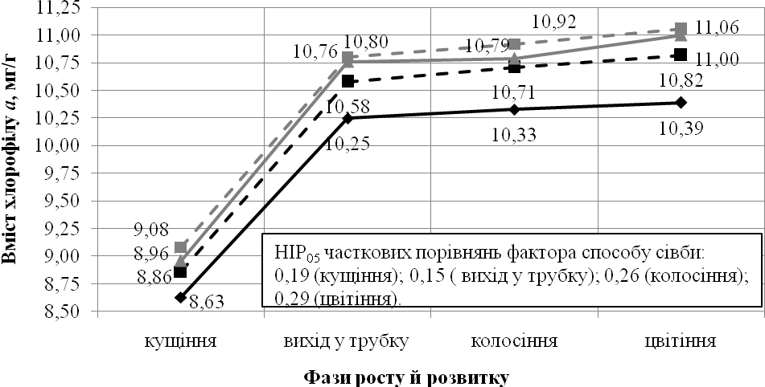

Chlorophyll b
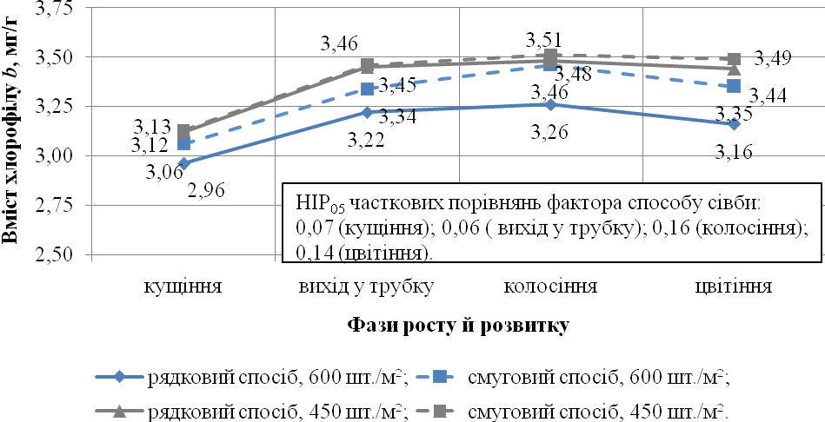
Picture 1. Dynamics of chlorophylls content in leaves of durum spring wheat according to the phases of development depending upon the use of different variants of sowing methods and sowing rates (average for 2008 – 2010)

The maximum content of carotenoids on average over the three years of research in the leaf mass of wheat plants was observed in the phase of earing. On average during the research the content of carotenoids in the phase of tillering was 2,78mg/g of dry substance; in the phase of leaf-tube formation – 3,24 mg/g; in the phase of earing – 3,33 mg/g; in the phase of flowering – 3,26 mg/g (see table 1).
The effect of the researched elements of technology on the content of carotenoids in the leaves of durum spring wheat was the highest in the later phases of growth and development. Thus, the divergence of carotenoids content indices depending upon the seed sowing rate in the tillering phase on average over the three years of researches was about 3,0%, in the phase of leaf-tube formation – 5,0%; in the phase of earing – 7,0% and in the phase of flowering – almost 7,5 %. The effect of sowing method on variability of the content of carotenoids was also the highest in the phase of earing and flowering.
The advantage of the striped sowing method concerning the influence on the concentration of carotenoids comparatively with the drill sowing method increased gradually with the increasing of seed sowing rate (Table 1). Thus, in the phase of earing the content of carotenoids if applied striped sowing method increased as compared with the variants where the drill sowing method was applied by 0,08 mg/g (2,4%) in the variants with seed sowing rate of 450 seeds/m² and by 0,15 mg/g (4,8%) – in variants with the highest seed sowing rate – 600 seeds/m² at LSD₀₅ of partial comparisons of the factor B effect – 0,12 mg/g. So, the striped sowing method makes it possible to apply the seed sowing rate in a wider range without a significant decrease in the concentration of photosynthesis pigments.
The effect of increasing of seed sowing rate on the reduction of content of carotenoids was significantly higher in the variants of using of drill sowing method. For example, in the phase of earing with the increasing of seed sowing rate from 450 to 600 seeds/m² the content of carotenoids on average over the three years of research decreased from 3,38 to 3,11 mg/g (or at about 9,0%) using the drill sowing method and only from 3,46 to 3,26 mg/g (or at 6,0%) in the striped-sowing method.
The correlation between total content of chlorophylls and carotenoids on average during the research in the phase of tillering, tube-leaf formation, earing and flowering was 4,3:1,0; 4,3:1,0; 4,2:1,0 and 4,4:1,0 appropriately.
In the conducted research the close reverse linear regression y = 19,93122 – 2,24670x – while using drill sowing method and y = 16,33853 – 0,66354x – while using striped-sowing method was observed between total chlorophylls content and the leaf surface of the studied variants of seed sowing rates. The correlation between total chlorophylls content and leaf surface index was – 0,917 while using drill sowing method and – 0,794 while using striped-sowing method.
According to the calculated regression equations, the increase of the leaf surface index by 0,1 which takes place on condition of the increasing of seed sowing rate decreased the total chlorophylls content by 0,25 mg/g in the variants of the drill sowing method and only by 0,07 mg/g – while using striped-sowing method.
During the conducted experiments it was established a similar regularity of the effect of the researched elements of growing technology both on the grain productivity of an individual plant and the chlorophyll a and b contents. The highest spike grain weight of durum spring wheat on average over the three years of research was in variants with the lowest coenotic tension in crops (Picture 2).
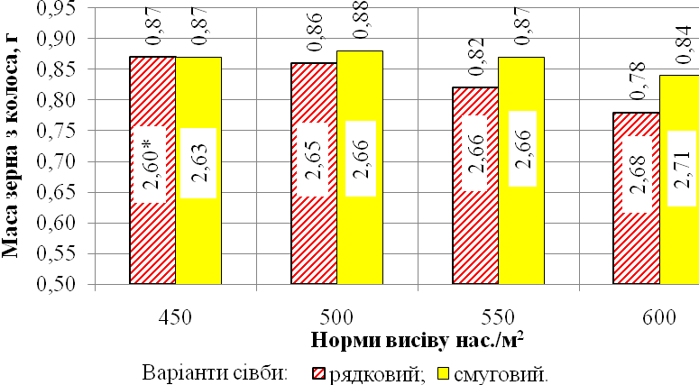
* - In the middle of columns - index of leaf area of relevant options of the research.

Picture 2. Weight of the main spike grain and leaf surface index of durum spring wheat during the action of different seed sowing rates and sowing methods (average for 2008 - 2010)

The total chlorophylls a and b content had the strong direct correlation with spike grain weight of durum spring wheat (r = 0,987). The correlation between spike grain weight of durum spring wheat and total content of chlorophylls a and b was approximated by the following linear regression equation: y = – 0,516576 + 0,095871x which acts within the researched variants in 97,4% of cases (r² = 0.974).
Conclusions. The content of photosynthesis pigments in the leaves of durum spring wheat undergoes significant changes depending upon the nature of the plants distribution over the nutrition area and sowing density. The striped-sowing method enables to carry out sowing in a wider range of seed sowing rates without a significant reduction of photosynthesis pigments in the plants leaves. The impact of seed sowing rates and sowing methods on the change of correlation between the content of chlorophyll and carotenoids actually was not observed. The research has shown the close correlation between the total chlorophyll a and b content and the grain productivity of the main spike shoot (r = 0,987).

REFERENCES
1. Доспехов Б. А. Методика полевого опыта / Б. А. Доспехов. – М. : Агропромиздат, 1985. – 351с.
2. Ермаков А. И. Методыбиохимическихисследованийрастений / А. И. Ермаков, В. В. Арасимович, Н. П. Ярош. – Л. :Агропромиздат, 1987. – 430 с.
3. Жученко А. А. Адаптивное растениеводство (эколого-генетические основы) / А. А. Жученко. – Кишинев : Штиинца, 1990. – 432 с.
4. Макроносов А. Т. Онтогенетический аспект фотосинтеза. – М. : Наука, 1981. – 195 с.
5. Мусієнко М. М. Спектрометричніметоди в практиціфізіології, біохімії та екологіїрослин / М. М. Мусієнко, Т. В. Паришкова, П. С. Славний. – К. : Фітоцентр, 2001. – 199 с.
6. Ничипорович А. А. Физиология фотосинтеза и продуктивность растений / А. А. Ничипорович // Физиология фотосинтеза. – М. : Наука, 1982. – С. 7–33.
7. Степанов С. А. Проблема целостности растения на современном этапе развития биологии / С. А. Степанов // Изв. СГУ. Серия «Химия, биология, экология». – Вып. 2. – Саратов, 2008. – Т. 8. – С. 50–57.
8. Тарчевский И. А. Основы фотосинтеза [учеб. пособие для биол.спец. вузов] / И.А. Тарачевский. – М.: Высш. шк., 1977. – 253 с.
9. Удовенко Г. В. Методы оценки устойчивости растений к неблагоприятным условиям среды / Г. В. Удовенко. – Л.: Колос, 1976. – 318 с.
10. Шафронова Л. М. Растение как жизненная форма (к вопросу о содержании понятия «растение») / Л. М. Шафранова // Журн. общей биол. – М., 1990. – Т. 51. – №1. – С. 72–88.
11. Kreuz K. Old enzynes for a new job / K. Kreuz. R. Tommasins. E. Martinoa // Plant Physiol. – 1996. – III. – P. 349–353.
12. Robertson E. I. Significant Changes in Cell and Chloroplast Development in Young Wheat leawes (Triticumaestivum w Hereward) Grown in Elevated CO2 / E.I. Robertson, M. Rachel, R. M. Leech // Plant Physiol., 1995. – Vol. 107. – P. 63–71.
13. Sims D. A. Relationships between leaf pigment content and spectral reflectance across a wide range of species. Leaf structures and developmental stages / D. A. Sims, I. A. Gramon // Remote Sinsing of Environment, 2002. – Vol. 81. – Р. 337–354.
14. Thomas H. Chlorophyll: a symptom and a regulator of plastid development / H. Thomas // New Phytologist, 1997. – Vol. 136. – Р. 163–181.

