© 2015
Lokes P. I., Doctor of Veterinary Sciences,
Kravchenko S. A., Candidate of Veterinary Sciences
Poltava State Agrarian Academy
ULTRASONOGRAPHY OF SPLEEN IN DOGS
Reviewer – Doctor of Veterinary Sciences, Professor S. M. Kulynych
The work presents the results of ultrasonographic researches of features of normal spleen and of its pathological conditions in dogs. We described a method of ultrasound of the spleen in animals of this species and described changes of visualization of the organ. These ultrasonographic characteristics of the spleen with the splenomegaly, hemorrhages in the parenchyma and with breaking the capsule and neoplasia. We established that in healthy animals spleen has the form of tapes or crescent with sharp edges and homogenous parenchyma.
Keywords: ultrasonography, dogs, spleen, pathology, diagnosis.
Formulation of the problem. The spleen is an important internal organ whose function is not fully understood. It responds to the most pathological processes in the body. The most typical reaction of the spleen is splenomegaly, which can be both physiological (deposition of the blood) and pathological – for hemolytic processes, infectious, parasitic diseases and toxicity [2, 5, 9]. In the literature general clinical methods of this organ, including palpation (horses and dogs), percussion (cattle) and diagnostic puncture of the spleen are mainly described. However, as the authors note, information of such research is severely limited and informative only for severe splenomegaly. Implementation of the relatively new, additional special diagnostic techniques, including ultrasound, allows to obtain accurate and detailed information on topography, structure and size of the spleen as in clinically healthy and sick animals. Therefore, research in this direction is relevant.
Analysis of key studies and publications in which the solution of the problem is presented. Ultrasonography is an informative method of diagnosis of pathological conditions of the spleen [1, 3, 7, 8]. Published data regarding ultrasonographic examination of the spleen in animals, including dogs, is contradictory and disparate. Foreign publications highlight mainly ultrasonographic characteristics of the spleen of healthy animals and describe changes in the body, mostly for the splenomegaly, or tumors [6]. Fatherland publications [4] provide information on the structure of the parenchyma and contain separate data of the topography of normal and under pathological conditions. All this leads the expediency of further research in this direction.
The purpose of research – to establish and explore the topography and ultrasonography characteristics of the spleen in clinically healthy dogs and animals with diseases of the spleen.
The main task was ultrasonography of the spleen of healthy and sick dogs of different breeds (mini, medium, maxi, giant).
Materials and methods. The study was conducted in conditions of the therapy department of Poltava State Agrarian Academy in the period from 2010 to 2015. The material for the research served as clinically healthy and sick dogs. During the implementation we used research results of ten clinically healthy and 22 sick animals. The diagnosis was confirmed by laboratory studies or during surgery. While exploring clinically healthy and sick dogs we used general clinical methods – inspection, palpation, percussion, auscultation, thermometry. We take into account anamnestic data. All studied animals belong to residents of Poltava. After clinical studies we used ultrasonography of the abdomen, paying attention to the topography and ultrasonographic characteristics of the spleen. While studies we used ultrasound scanner SonoScape A6 vet (Chinese production) with sectoral probe frequency 2–6 MHz. Animals were placed on the right side. Acoustic window created by the removal of wool on the ventral abdominal wall from the xiphoid process to the groin area.
Results. In clinically healthy dogs spleen is visualized in the left side of the abdominal cavity in the area bounded by the left kidney, the bottom of the stomach, colon (dorsal) and the abdominal wall (ventral). The spleen of dogs had fine-grained homogeneous structure parenchyma, echogenicity is slightly higher than the liver parenchyma and was clearly visible with hyperechoic capsule. It had a shape of crescent or strip with sharp edges that we could see well through hyper echogenicity of spleencapsule. By moving the sensor in the caudal-cranial direction we distinguished acute caudal edge, in the cranial direction thickness of the organ was increased, in some cases were visualized shallow cross undercut in the cranial third of the organ, and finally the cranial part of the organ, which was wider than the caudal and has hyperechoic sharp edges. In the middle third of the spleen, by the visceral surface we visualized the spleen gate (hyperechoic area around the place of immersion of the spleen artery and output of the splenic vein) and anerechoic splenic artery and vein, which branched into the thickness of the organ. Chief (cranial) edge lies flat of the spleen to the liver, which made it possible to compare echogenic structure.
Pathological conditions of spleen, which took place at its sonographic structure were splenomegaly (40,9 % of cases), hemorrhage in the parenchyma of the spleen (31,8 %), the capsule ruptures of the spleen (18,2 %) and a spleen tumors (9,1%). In this article we do not stop on the etiology and pathophysiology of pathologies of the spleen, focusing primarily on sonographic characteristics of the spleen.
By splenomegaly most striking features are increasing thickness of the parenchyma of the organ and reduction of its relative echogenicity (Pic. 1). It is explained by blood flow of vessels and sinuses of the spleen, which increases the distance between the echogenic structures (vessel walls and stroma) of the organ and increases the permeability of sound vibrations. The edges of the spleen, especially cranial and later caudal by splenomegaly become rounded, and main vessels expanded due to a hyperemia.
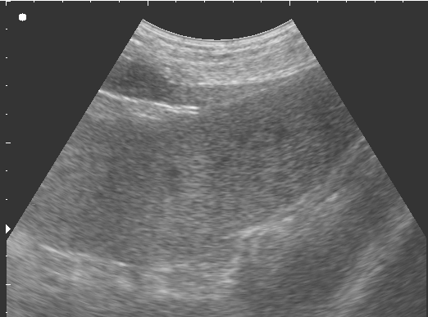
Picture 1. Ultrasonography of the splenomegaly in dogs
As a result of trauma, in some cases, sonographic showed hemorrhages in the parenchyma of the spleen and breaks of the capsule (Pic. 2).
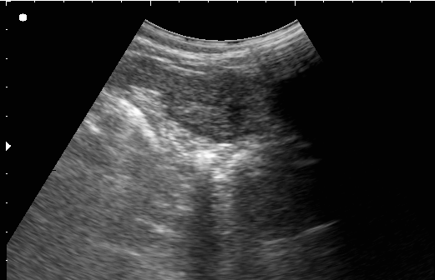
Picture 2. Ultrasonography of spleen parenchyma by the hemorrhage:
a – the place of hemorrhage;
b – rupture of the spleen capsule in the area of the gate; с – free fluid in a crack of the capsule.
Hemorrhagic centers in the spleen looked like anechoic or hypoechoic formation around which the parenchyma of the spleen was swollen, of heterogeneous echogenicity (Pic. 2a). In cases of ruptures of the spleen capsule the pace of the rupture is identified as a violation of hyperechoic contour of the capsule in the area of edges or gate of the spleen (Pic. 2b). Along with the place of the capsule rupture we visualized a small amount of free fluid, regarded as a sign of bleeding into the abdominal cavity (Pic. 2c).
One of pathological conditions of spleen, which are visualized using sonography, is a neoplasm. According to the literature, the spleen is an organ that first holds abnormal tumor cells that eventually are proliferating and create single or multiple centers in the parenchyma (metastasis). These tumors primarily include lymphoma and breast tumors [6, 9]. In these cases the parenchyma of the spleen does not change its echogenicity, with the exception of focal lesions located unevenly (Pic. 3). These centers usually have less echogenicity than the echogenicity of spleen’s parenchyma (Pic. 3b).
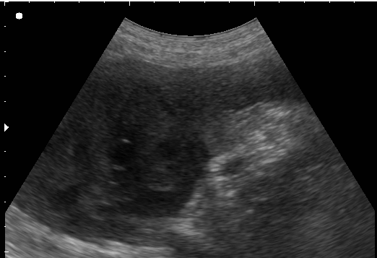
Picture 3. Ultrasonography of the spleen with focal neoplasia: a – unchanged parenchyma of the spleen;
b – metastasis
Also, we recorded diffuse neoplasia of the lien, when all visualized parenchyma of organ was affected (Pic. 4). In such cases, the spleen had the uneven contours, body edges were rounded, the total increased echogenicity of the parenchyma with multiple hypo- and izoechogenic cells of different sizes – from 0,7 to 10 mm. It should be mentioned that the determination of the morphology of tumors of the spleen with ultrasonography is impossible, so this aspect of the problem needs further research in this direction.
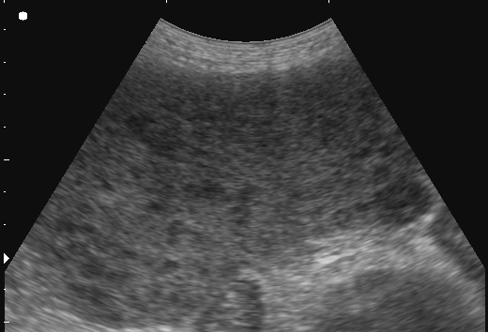
Picture 4. Ultrasonography of the spleen for diffuse neoplasia
Conclusion. Ultrasonography is an informative instrumental auxiliary method of diagnosis that allows to visualize and assess the state of the spleen of clinically healthy dogs and animals with pathological changes of the body. The most frequently registered pathological conditions are splenomegaly of the spleen, trauma, hemorrhage, rupture of the capsule and neoplasia (focal and diffuse).
BIBLIOGRAPHY
1. Берестень Н. Ф. Значение ультразвукового исследования в оценке абсолютных и относительных размеров селезенки при гематологических заболеваниях / Н. Ф. Берестень,
A. C. Глускер, А. И. Нартов // Ультразвуковая диагностика. – 2002. – №2. – С. 197–198.
2. Клінічна діагностика внутрішніх хвороб тварин / [Левченко В. І., Влізло В. В., Кондрахін І. П. та ін.] ; за ред. В. І. Левченка. – Біла Церква, 2004. – 450 с.
3. Кубышкин В. А. Опухоли и кисты селезенки / В. А. Кубышкин, Д. А. Ионкин. – М. : ИД Медпрактика-М, 2007. – 288 с.
4. Локес П. І. Ультразвукова діагностика хвороб дрібних тварин / П. І. Локес, В. Г. Стовба, Л. П. Каришева. – Полтава : ФОП Говоров С. В., 2007. – С. 54–57.
5. Локес П. І. Характеристика окремих чинників спленомегалії у свійських собак / П. І. Локес, С. О. Кравченко // Вісник ПДАА. – Полтава : РВВ ПДАА, 2015. – №3. – С. 89–92.
6. Ультразвуковая диагностика заболеваний мелких домашних животных : [под общ. ред.
П. Манниона ; пер. с англ. Д. Н. Перепелина]. – М. : Аквариум-Принт, 2008. – С. 45–71.
7. Andrews M. W. Ultrasound of the spleen / M. W. Andrews // World S Surg. – 2000. – №24. –
Р. 183–187.
8. Primary angiosarcoma of the spleen-CT, MR, and sonographic characteristics: report of two cases / [Vrachliotis T. G., Bennett W. F., Vaswani K. K. et al.] // Abdom. Imaging. – 2000. – V.25. – P. 283–285.
9. Surgical diseases of the spleen / [Hiatt J. R., Phillips E. H., Morgenstern L. (eds).] // Heidelberg. – Springer. – 1997. – 285 р.

