© 2014
Kharytonov M. M.
Dnipropetrovsk State Agrarian and Economy University
Khlopova V. M.
Dnipropetrovsk Hydrometeorological Center
Stankevich S. A.
Kiev Scientific Centre for Aerospace Research of the Earth
Klymenko O. E.
Nikitsky Botany Garden, National Scientific Center

EVALUATION FIRMNESS OF VARIETIES OF THE STONE FRUIT CROPS TO ACID RAINS CAUSED WITH AEROSOL FORMING
Reviewer: V. M. Zverkovsky, d.b.s., professor, Dnipropetrovsk national university of Gonchar

One MPC a steady exceeding in the level of month nitrogen dioxide average concentration in the atmosphere of industrial cities of Dnipropetrovsk region was fixed. Air NO₂ content changed from 0,03 to 0,08 mg/m³ in Krivoy Rog and from 0,05 to 0,09 mg/m³ – in Dniprodzerzhinsk and Dnipropetrovsk last years.
The data base with remote and ground based sensing of atmosphere pollution with acid aerosols gave possibility to establish level of artificial acid rain forming in model conditions. It was fixed in the experiments different concentrations of aerosols on activity of some components of stone fruit crops antioxidant system for relative firmness of varieties to technogenic stress, to work out the scale of relative firmness of kinds and varieties to acid rains.It was established that on firmness of varieties of to acid rains the stone fruit crops can be disposed in the regression line: plum > myrobalan plum > apricot > pench. Lowest firmness has got varieties early terming of ripening (pench, apricot) in the limits of one kind. An origin took a big place then term of ripening in myrobalan plum. Sometimes the varieties of one fruit crop have distinction to acid rains then other crops. Data obtained allow to manage assortment of firm and relatively firm to air pollution with acid aerosols and acid rains for crops and varieties of Prunus L. in south of Ukraine.
Key words: acid rains, aerosol, varieties firmness, stone fruits crops
Problem statement in general aspect. Nitrogen and sulfur oxides found oneself to troposphere due to anthropogenic activity. These substances are responsible for photochemical smog in summer months in atmosphere of large industrial agglomerations [3]. Acid rains damage the process of plant breathing resulting in [3]. Related with aerosol forming HNO₃ and H₂SO₄ acid rains lead to decreasing pH of soils, surface and underground waters, heavy metals leaching, can make damage for crops, including fruit trees, which are very sensitive to air pollution with acid gases [5]. Input of HNO₃ aerosol to acid rains forming is rising for the last years [4]. Specific peculiarity of acid rains is transfer of acid forming emissions with air flows for large distances. Accepted earlier “policy of high pipes” was as effective measure against ground air pollution. In this connection acid rains reach to relatively clean agricultural territories.
Analyze of last investigations and publications.It is necessary to admit, that stone fruit crops reaction, especially representative of genus Prunus (L.), on acid rains require accurate investigation. It is known, that stone fruit crops are more sensitive to air pollution with acid gases then seed plants [4, 5, 6]. Taking in account that symptoms of plants damage with acid rains is no specific phenomenon, numerous investigations are devoted to investigation of physiological-biochemical indexes, which change under impact of acid precipitations. These substances take part in anti-oxidant organism system and change when external characteristics not fix yet. Main components of this system are vitamin C, glutathione, polyphenols, flavonoids, carotinoids, enzymes of oxidoreductase, etc. They protect plant from extremely impacts, especially from nitrogen oxides, sulfur, other substances – air pollutants [1, 7].
Objective of research was connected with assessment of firmness of stone fruit trees to acid rains, connected with aerosols forming. Main tasks were as following: a) to manage database of remote and ground based sensing of concentration of nitrogen dioxide in ground stratum of atmosphere в in zone of industrial agglomeration activity Dnipropetrovsk province; b) in model experiments with stone fruit crops to determine varieties firmness to acid rains caused with aerosols.
Materials and Methods. The data of remote atmospheric sensing in Dnepropetrovsk region have been obtained within the different periods (2001, 2004, 2005, 2006 and 2010). The observations were carried out in relation to five points, which together cover the territory where the main industrial centers in Dnipropetrovsk region are situated. (picture 1).
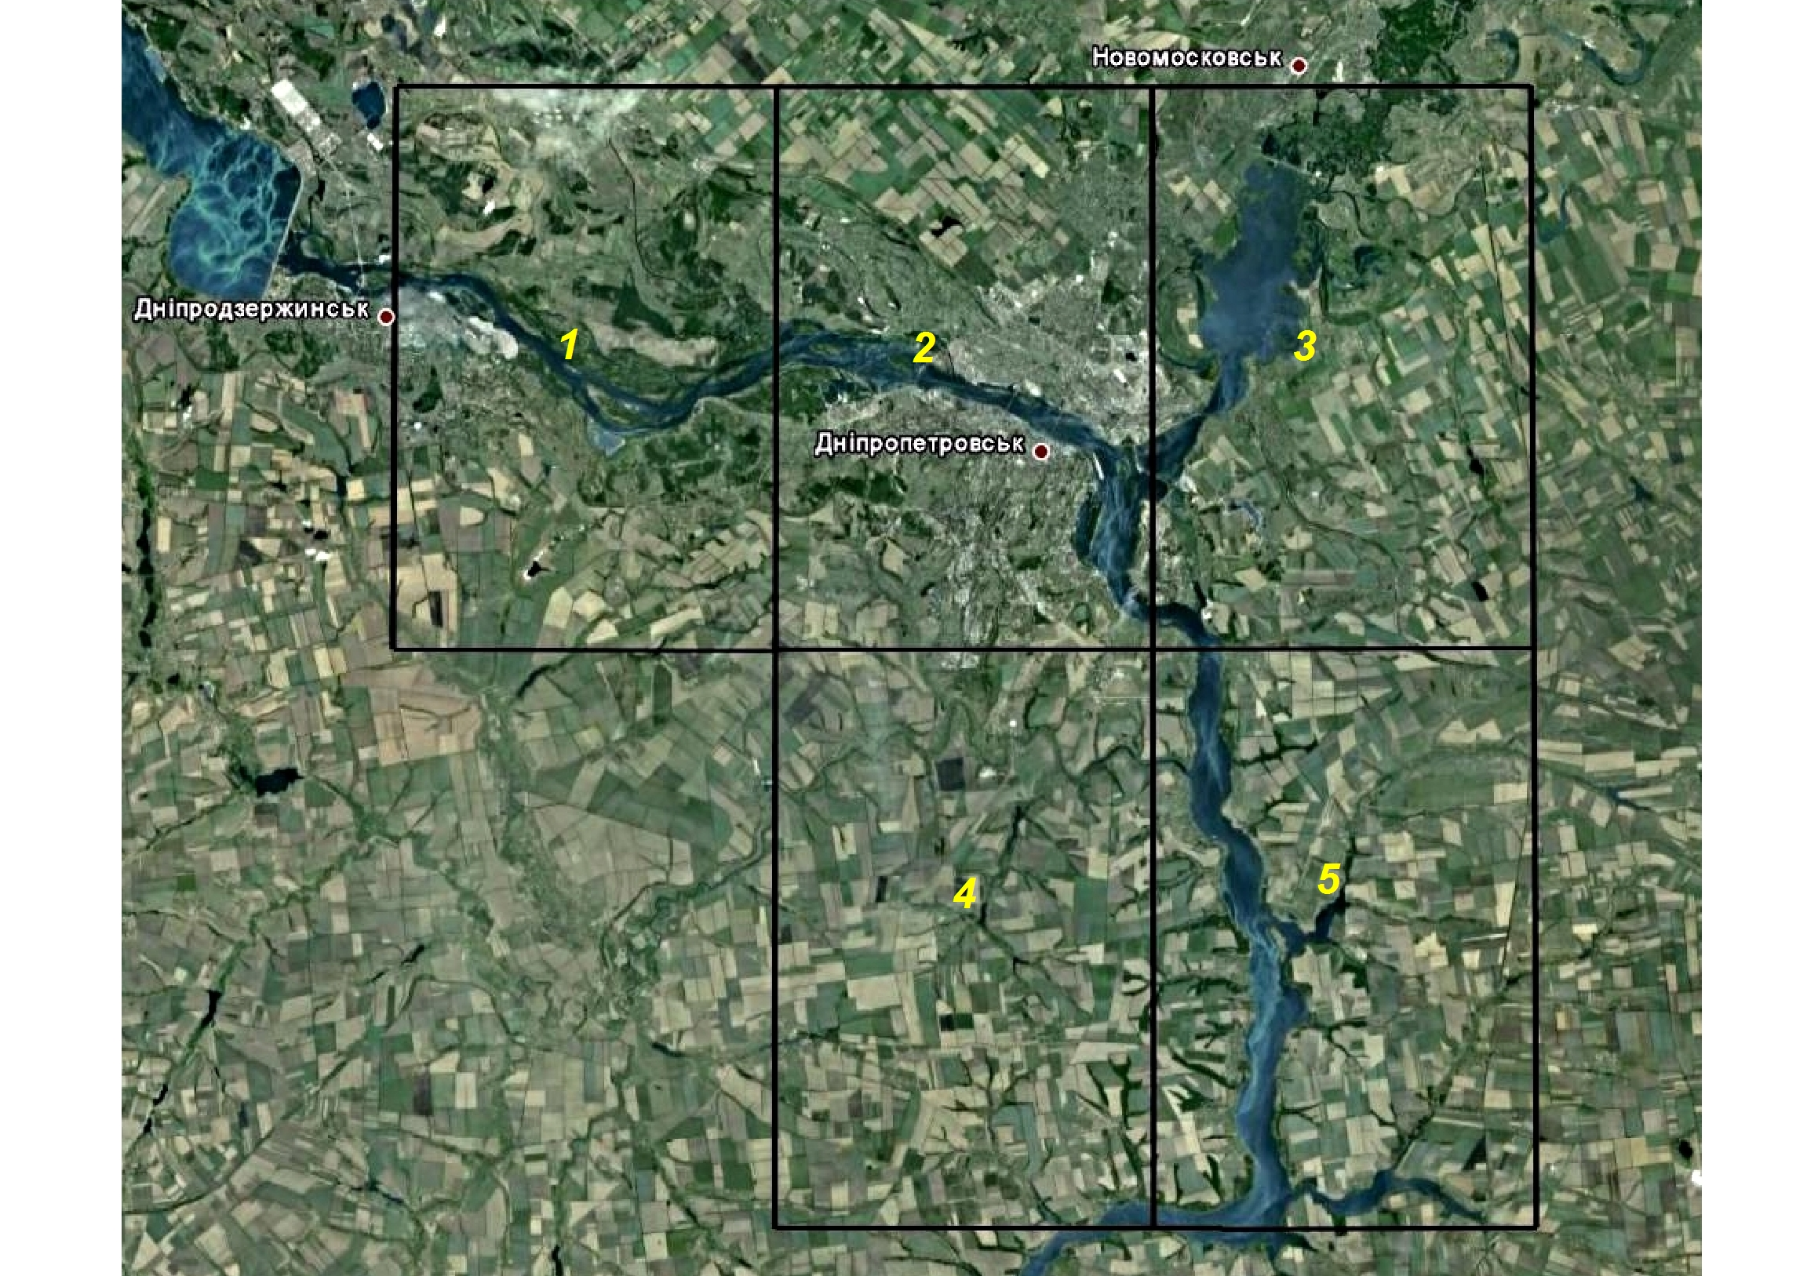
Picture 1. Schematic demonstration differentiation of observation territory pollution in Dnipropetrovsk province
These data have been obtained using five points located within the area of Dnepropetrovsk region. The continual spectrometric recordings carried out using the Envisat/SCIAMACHY and EOS/OMI. Due to these systems permit to obtain daily recordings concerning the NO₂ concentration (density: 10¹⁵ molec./cm²). The monthly data (on a planetary level and on geographic regions) are archived as cartographic representations on the website: www.temis.nl/airpollution and http://disc.sci.gsfc.nasa.gov/Aura/data-holdings/OMI/omno2e_v003.shtml.
The tropospheric column$\frac{n}{S}$, [molec./cm²]conversion to NO₂ concentration C [mg/m³] was recalculated by formula:
$C={\text{10}}^{7}\frac{n}{S} \frac{m_{{\text{NO}}_{2}}}{h N_{A}}$,
where m_{NO2} = 46005.6 mg/mol is the molar mass of NO₂ , N_{A} = 6,022·10²³ mol⁻¹ is the Avogadro constant and h ≈ 12·10³ m is the approximate troposphere depth.
Current ground based stationary research are carried out in three observation laboratories controlling air pollution. These laboratories were created to provide background monitoring in the cities of Dnepropetrovsk (DP), Dneprodzerzhinsk (DZ) and Krivoy Rog (KR). Forecasting and comparing pollution levels with real condition, developing activities aimed to air protection are final objectives of creating station networks on the territories of these cities of industrial region. Systematic information of polluted content in the air is gathered at specially equipped stations. The number and location of stationary observation stations are varied. There are six stationary and two mobile stations in Dnepropetrovsk, five stations are located in Krivoy Rog, and Dneprodzerzhinsk has four ones. Fruit crops sensitivity to acid rains was studied in model experiments, where stone fruit crops were treated with artificial acid rains, and using offered index of antioxidant activity tissue estimate relative varieties firmness of fruit trees for this negative phenomenon [2].
Results and Discussion. The paper is focused on the situation with NO₂ concentration in the troposphere during last decade and its distribution in South-Eastern Ukraine. The data on NO₂ tropospheric column density in two industrial regions Prydneprovye and Donbas are presented in the satellite image (pic.1).
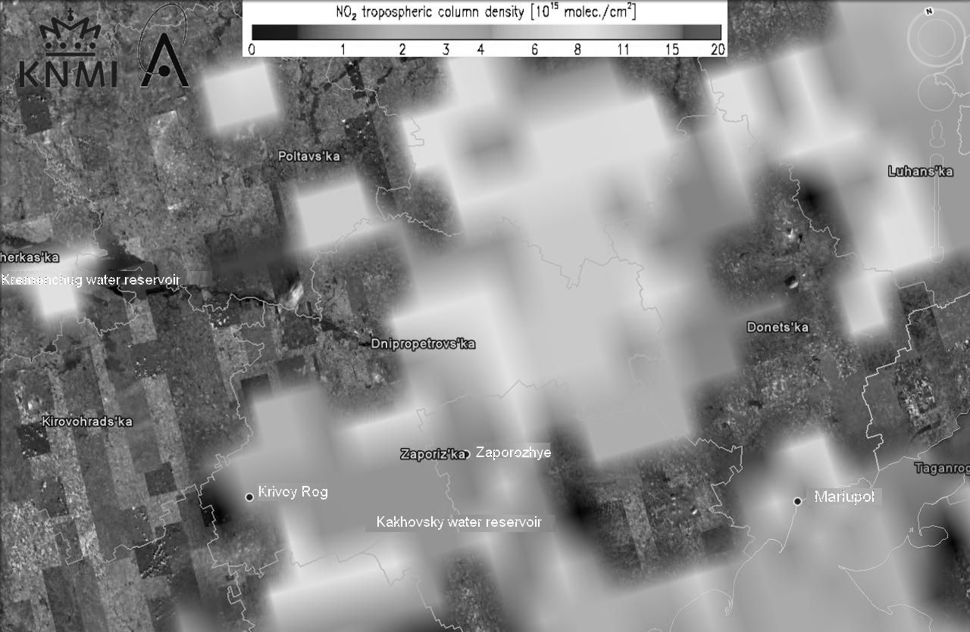
Picture 1. The data on NO₂ tropospheric column density in South-Eastern Ukraine (August 2011)
NO₂ concentration on the most part of study area was within the limits of 8-11∙10¹⁵ molec./cm² in January, 2011. A bit larger concentration of nitrogen dioxide (15-18∙10¹⁵ molec./cm²) in atmosphere over industrial region of Donbas was in December, 2010 [9]. Monthly average of NO₂ concentration for the tropospheric column, obtained as the result of remote sensing data smoothing using five point measurements within the period of 2004, 2005, 2006 и 2010 years is presented in pic. 2.
Picture 2. Monthly average of NO₂ concentration (mg/m³) in 2004, 2005, 2006 и 2010 years in Dnepropetrovsk region, mg/m³.
On average, the highest concentrations of NO₂ were fixed from October till December within 4 years. NO₂ concentrations in February, March and from May till August were 3-4 times as low as at the end of each year.The ground based data on the NO₂ concentration in the years of 2004, 2005, 2006 and 2010 for two industrial cities are presented in the Table 1.
Table 1. NO₂ air pollution in the cities of Dneprodzerzhinsk and Krivoy Rog, mg/m³.
Month | Year
Month | 2004 |  | 2005 |  | 2006 |  | 2010
Month | DZ | KR | DZ | KR | DZ | KR | DZ | KR
Jan | 0.08 | 0.05 | 0.07 | 0.04 | 0.06 | 0.04 | 0.06 | 0.03
Feb | 0.06 | 0.05 | 0.06 | 0.04 | 0.07 | 0.05 | 0.06 | 0.05
March | 0.05 | 0.05 | 0.06 | 0.04 | 0.06 | 0.05 | 0.07 | 0.05
Apr | 0.06 | 0.04 | 0.09 | 0.06 | 0.08 | 0.06 | 0.07 | 0.06
May | 0.08 | 0.04 | 0.08 | 0.06 | 0.07 | 0.04 | 0.07 | 0.05
June | 0.07 | 0.04 | 0.07 | 0.04 | 0.07 | 0.05 | 0.07 | 0.05
July | 0.06 | 0.05 | 0.07 | 0.05 | 0.07 | 0.05 | 0.07 | 0.05
Aug | 0.06 | 0.05 | 0.09 | 0.05 | 0.08 | 0.06 | 0.07 | 0.06
Sept | 0.05 | 0.05 | 0.08 | 0.05 | 0.07 | 0.05 | 0.07 | 0.05
Oct | 0.06 | 0.04 | 0.06 | 0.05 | 0.09 | 0.06 | 0.08 | 0.05
Nov | 0.07 | 0.04 | 0.06 | 0.06 | 0.08 | 0.05 | 0.08 | 0.08
Dec | 0.05 | 0.04 | 0.05 | 0.05 | 0.08 | 0.05 | 0.06 | 0.06

NO₂ concentration varied in the range of 0.05 to 0.09 in Dneprodzerzhinsk, from 0,03 to 0,08 mg/m³ in Krivoy Rog accordingly.
It was established that on degree of firmness to acid rains studied fruit crops were disposed in regressed line: plum > myrobalan plum > apricot > pench. Lowest firmness has got varieties early terming of ripening (pench, apricot) in the limits of one kind. An origin took a big place then term of ripening in myrobalan plum. Sometimes the varieties of one fruit crop have distinction to acid rains then other crops (table 2).

Table 2. Varieties firmness of stone crops varieties to acid rains
Varieties | Ripening data | No firmness | Low firmness | Middle firmness | High firmness
Pench
Aq–Sheftalyu | 2 / IX* | - | + | - | -
Bebi Gold | 3 / VIII | - | - | + | -
Doctorsky | 1 / VIII | - | + | - | -
Candidatsky | 1 / VIII | - | + | - | -
Nebesniy Tikhokhod | 3 / VII | + | - | - | -
Orekhoviy | 3 / VII | - | + | - | -
Ostryakovskiy biliy | 2–3 / VII | - | + | - | -
Pushystiy ranniy | 2 / VII | + | - | - | -
Red haven | 2 / VIII | - | + | - | -
Stenford | 2 / VII | - | + | - | -
Favorita Morettiny | 1 / VII | + | - | - | -
Apricot
Erevany (Shalah) | 1 / VII | - | - | + | -
Vinoslyviy | 3/VII–1/VIII | - | + | - | -
Crimskiy Amur | 3 / VII | - | + | - | -
Crimskiy Medunets | 2 / VII | - | + | - | -
Costinsky | 2 / VII | - | - | + | -
Olimp | 2 / VII | - | + | - | -
Stark ranniy | 2 / VII | + | - | - | -
Tabu | 2–3 / VII | - | + | - | -
Henderson | 2 / VII | - | + | - | -
Myrobalan plum
Desertna | 2 / VIII | - | + | - | -
Lyusha Krupna | 3 / VII | - | + | - | -
Nikitska Zhovta | 2 / VII | - | + | - | -
Obilnya | 3 / VII | - | - | + | -
Subkhy rannya | 1 / VII | - | - | + | -
Plum
Blyufry | lately | - | + | - | -
Gilbert | early | - | + | - | -
Cabardinskaya rannya | early | - | + | - | -
Californiyska | middle | - | - | + | -
Renclod Altnan | middle | - | + | - | -
Stanley | lately | - | - | - | +
* – 10 days / month
Data presented in table 2 allow to manage assortment of firm and relatively firm to air pollution with acid aerosols and acid rains for crops and varieties of Prunus L. in south of Ukraine.
Conclusion. The data base with remote and ground based sensing of atmosphere pollution with acid aerosols gave possibility to establish level of artificial acid rain forming in model conditions. Influence of aerosols different concentrations on some components activity of antioxidant system of stone fruit crops studied in experiment allow to manage assortment of firm and relatively firm to air pollution with acid aerosols and acid rains for crops and varieties of Prunus L. in south of Ukraine. Fixation case of one MPC a steady exceeding in the level of month nitrogen dioxide average concentration made due to using of meteorological network exploration approve the risk of acid rains forming in the atmosphere around industrial agglomerations was fixed.
It was established that on firmness of varieties of to acid rains the stone fruit crops can be disposed in the regression line: plum > myrobalan plum > apricot > pench. Lowest firmness has got varieties early terming of ripening (pench, apricot) in the limits of one kind. An origin took a big place then term of ripening in myrobalan plum. Sometimes the varieties of one fruit crop have distinction to acid rains then other crops.
Thus, taking in account information on wind rose in each place it is possible to make a potential damage forecast for rural areas, to make a choose regarding to planting firm and relatively firm to acid rains crops.

BIBLIOGRAPHY
1. Безсонова В. П. Вплив техногенних умов на вміст аскорбінової кислоти та глютатіону в листках різних рослин / В. П. Безсонова, Ж. Т. Козюкіна, І. І. Лиженко // Український ботанічний журнал. – 1989. – Т. 46, №3. – С. 83–85.
2. Клименко О. Е. Химический состав атмосферных осадков в степном Крыму и влияние его кислотообразующих компонентов на косточковые плодовые культуры / О. Е. Клименко. – К. : Освіта України, 2014. – 144 с.
3. Копач П. И. Техногенез и кислотные дожди / П. И. Копач, А. Г. Шапарь, В. М. Шварцман. – К. : Наукова думка, 2006. – 173 с.
4. Харитонов М. М. Формування кислотних дощів в умовах мегаполісу / М. М. Харитонов, В. М. Хлопова // Вісник Дніпропетровського державного аграрного університету. – Дніпропетровськ, 2011. – №1 – С. 8–14.
5. Bell J. N. B. Air pollution and plant life / J. N. B. Bell, M. Treshow ; ed. M. Treshow. – 2nd ed. – West Sussex, England : J. Wiley & Sons, 2002. – 465 p.
6. Hasebe T. Visible injury to fruit trees due to sulfur dioxide fumigation / T. Hasebe, N. Ichikava, Y. Yamagami, H. Kurocava // Bulletin of Hokkaido Prefectural Agricaltural Experimental Station. – 1987. – V. 56. – P. 9–17.
7. Pell E. J. Secondary metabolites and air pollu-tants / E. J. Pell. – NY : Elsevier Applied Sci, 1988. – P. 22–237.

